Section 05 0520
Post-Installed Concrete and Grouted Masonry Anchors - Normal Confidence

*************************************************************************************************************

LANL MASTER SPECIFICATION SECTION
Rev. 7 Summary of Changes: Edited and updated as required for import into SpecLink.

NOTE TO SPECIFIER ON USAGE IN SPECLINK: Activate the Section by turning on Seq #0000, followed by activating paragraphs in PART 1, Article SECTION INCLUDES. This will activate related articles, paras/subparas in the rest of the Section (i.e., SECTION INCLUDES in PART 1 activates articles and paras/subparas in PARTS 2 and 3). If there are choice fields to edit the entire Section (typically in this first author note or beginning of the Section), make selections at those locations, which will filter through the remaining Section. All Articles, paragraphs and subparagraphs must be activated sequentially from top to bottom, unless noted otherwise.

This template must be edited for each project. In doing so, Specifier must add job-specific requirements. Selections and choice fields are used to indicate designer choices or locations where text must be supplied by the designer. The section must also be edited to remove requirements for processes, items, or designs that are not included in the project.

To seek a variance from applicable requirements in this Section, contact the Engineering Standards Manual (ESM) Structural POC (LANL access only). Please contact POC with suggestions for improvement as well. LANL personnel should submit here: Suggested Change or Request Clarification; subcontractors via email to engstandards@lanl.gov.

When assembling a specification package, include applicable sections from all Divisions, especially Division 1, General Requirements.

Section is developed for ML-3 and ML-4 projects. For ML-3 applications, additional requirements may be added if additional confidence is desired. Section << 05 0521 - Post-Installed Concrete Anchors - Nuclear Safety>>, which is intended for ML-1 and ML-2 installations, has examples of possible changes that can be made to increase confidence, or it may be used as the starting point when the utmost confidence is desired. At a minimum, for ML-3 applications, it is recommended that testing be mandated in this section to provide added assurance as opposed to increased rigor on procurement.¹

==========================================================

This section supersedes LMS 03 1534. It includes field installation and inspection requirements for normal-confidence post-installed (PI) anchors. These inspection requirements are not to be confused with the Special Inspections required by associated ICC-ES reports (ESRs), which should appear in a project’s Statement of Special Inspections.

This section does not apply to anchors that meet the definition of 'Seismically Exempt Anchors'² as defined in LANL ESM Chapter 5 - Structural, Section II, Appendix A. However, seismically exempt anchors must still: (1) comply with the applicable portions of Appendix A that do not pertain to seismic design; (2) be clearly identified as seismically exempt on the construction drawings; and, if applicable, (3) include a note referencing the relevant evaluation report and clarifying that limitations related to use in uncracked concrete and Seismic Design Categories (SDCs) A and B do not apply. For further clarification, refer to the author’s note in PART-1, Article: Definitions.

LANL ESM Chapter 5 - Structural, Section I includes a crosswalk that helps technical personnel transition from PC categories to RC categories used herein.

________________________

¹In accordance with <<ACI 355.2>> paragraph R13.3.4, for ML-3 and/or RC-IV applications using adhesive anchors, regardless of whether or not testing is mandated herein (i.e., ‘quality control’), it is recommended that testing be mandated in the Statement of Special Inspections (i.e., ‘quality assurance;’ ref. LANL ESM Chapter 16 - Building Code Program, IBC-IP, Att. B*).

* As indicated in Attachment B/SSI template, per their respective ESRs, certain adhesive anchors REQUIRE this ‘QA testing’ in certain applications.

²The term “non-structural anchors” was used in these documents prior to Nov 2014 editions.

*************************************************************************************************************
  - PART 1 - GENERAL
    - SECTION INCLUDES

***************************************************************************************

In the following paragraph, select the option(s) that apply to your project from the list provided: Concrete, Grouted Masonry, and/or Grouted Concrete. Choose only those that are relevant to the specific conditions and materials involved in your project.

***************************************************************************************
      - The technical requirements for purchasing post-installed (PI) ​​​​​<< concrete; grouted masonry; grouted concrete; and None - N/A>>​​​​​ anchors for Management Level ​​​​​<< ML-3; and ML-4>>​​​​​ and Risk Category (RC)-I through RC-IV structures, systems, and components (SSC). This Section applies to expansion, adhesive, undercut, and screw anchors.
      - The technical requirements for field ​​​​​​<< installation and inspection; or installation, inspection, and testing >>​​​​​​ of post-installed anchors (including anchor systems consisting of steel reinforcing bars/dowels and grout) in ​​​​​​<< concrete; and grouted masonry>>​​​​​​ for Management Level (ML)-3 and ML-4, and RC-I through RC-IV SSCs. The inspection requirements of this section do not apply to Seismically Exempt Anchors (LANL definition).
      - This Section does not cover cast-in-place anchors, design of post-installed anchorage, or purchase of tools or equipment required for installation or testing.
    - RELATED REQUIREMENTS
      - Section << 01 4000 - Quality Requirements - Non-Nuclear>>.
      - Section ​<< 03 3053 - Miscellaneous Cast-in-Place Concrete>>​.
      - Section << 03 6000 - Grouting>>.
      - Section << 04 2220 - Reinforced Unit Masonry>>.
    - REFERENCE STANDARDS
      - ACI 355.2 - Qualification of Post-Installed Mechanical Anchors in Concrete and Commentary.
      - ACI 355.4 - Qualification of Post-Installed Adhesive Anchors in Concrete.
      - ACI CODE-318 - Building Code for Structural Concrete—Code Requirements and Commentary.
      - AISC 360 - Specification for Structural Steel Buildings.
      - ASTM A36/A36M - Standard Specification for Carbon Structural Steel.
      - ASTM A193/A193M - Standard Specification for Alloy-Steel and Stainless Steel Bolting for High Temperature or High Pressure Service and Other Special Purpose Applications.
      - ASTM A615/A615M - Standard Specification for Deformed and Plain Carbon-Steel Bars for Concrete Reinforcement.
      - ASTM A706/A706M - Standard Specification for Deformed and Plain Low-Alloy Steel Bars for Concrete Reinforcement.
      - ASTM E3121/E3121M - Standard Test Methods For Field Testing Of Anchors In Concrete Or Masonry.
      - ASTM F436/F436M - Standard Specification for Hardened Steel Washers Inch and Metric Dimensions.
      - AWS D1.1/D1.1M - Structural Welding Code - Steel.
      - ICC (IBC) - International Building Code.
      - ICC ESR-1056 - Simpson Strong-Tie Titen HD Screw Anchors.
      - ICC ESR-1545 - Hilti HSL-3 Carbon Steel Heavy Duty Expansion Anchors for Cracked and Uncracked Concrete.
      - ICC ESR-1546 - Hilti HDA Carbon Steel and Stainless Steel Metric Undercut Anchors in Concrete.
      - ICC ESR-2502 - Power-Stud+ SD2 Carbon Steel Anchors, Power-Stud+ SD4 Stainless Steel Anchors and Power-Stud+ SD6 Stainless Steel Anchors in Cracked and Uncracked Concrete (Dewalt).
      - ICC ESR-2508 - Simpson Strong-tie Set-XP epoxy adhesive anchors and post-installed reinforcing bar connections in cracked and uncracked concrete.
      - ICC ESR-2818 - Power-Stud+ SD1 Expansion Anchors in Masonry (Dewalt).
      - ICC ESR-2966 - Power-Stud+ SD1 Expansion Anchors for Cracked and Uncracked Concrete (Dewalt).
      - ICC ESR-3027 - Hilti Kwik HUS-EZ (KH-EZ), Kwik HUS-EZ P (KH-EZ P), Kwik HUS-EZ E (KH-EZ E), and Kwik HUS-EZ I (KH-EZ I) Carbon Steel Screw Anchors for Use in Cracked and Uncracked Concrete.
      - ICC ESR-3814 - Hilti HIT-RE 500 V3 Adhesive Anchors and Post Installed Reinforcing Bar Connections in Cracked and Uncracked Concrete.
      - ICC ESR-4143 - Hilti HIT-HY 270 adhesive anchor system in cracked and uncracked grouted and ungrouted concrete masonry unit walls and clay brick masonry walls.
      - ICC ESR-4236 - Hilti HDI-P TZ and HDI-TZ anchors in cracked and uncracked concrete.
      - ICC ESR-4266 - Hilti Kwik Bolt TZ2 Carbon and Stainless Steel Anchors in Cracked and Uncracked Concrete.
      - ICC ESR-4810 - CCU+™ carbon steel and stainless steel undercut anchors in cracked and uncracked concrete (DEWALT).
      - ICC ESR-4868 - Hilti HIT-HY 200 V3 adhesive anchors and post installed reinforcing bar connections in concrete.
      - ICC-ES AC01 - Acceptance Criteria for Expansion Anchors in Masonry Elements.
      - ICC-ES AC58 - Acceptance Criteria for Adhesive Anchors in Cracked and Uncracked Masonry Elements.
      - ICC-ES AC106 - Acceptance Criteria for Predrilled Fasteners (Screw Anchors) in Masonry.
      - ICC-ES AC193 - Acceptance Criteria for Mechanical Anchors in Concrete Elements.
      - ICC-ES AC308 - Acceptance Criteria for Post-Installed Adhesive Anchors in Concrete Elements.
      - OSHA 29 CFR 1926.1153 - Respirable crystalline silica.
    - DEFINITIONS
      - For definitions and acronyms, refer to COE Glossary of Terms.
      - Definitions of anchors per <<ACI 355.2>> (as amended by <<ICC-ES AC193>>) and <<ACI 355.4>> (as amended by <<ICC-ES AC308>>) apply, and all notations are identical to those used in those documents and in <<ACI CODE-318>> Chapter 17. Where additional terms or notations are used, their definitions are included in this section.
      - Attachment/Baseplate/Fixture: The component/element, in-between the exposed anchor nut and the surface of the concrete/masonry, that is to be anchored (via execution of this section), which is represented herein by the word, “fixture.”
      - Evaluation Report (ER): Document prepared by an internationally-recognized, independent, third-party evaluation agency that attests to the compliance of a given product with the <<ICC (IBC)>>. Examples of such reports include ICC-ES Evaluation Service Report (ESR), and IAPMO Uniform Evaluation Service (UES) Report.

***************************************************************************************

If Project includes an anchorage system consisting of grout and concrete reinforcing steel (i.e., rebar/dowel) then the EOR must ensure completion of the following:

1. Design calculations for the anchorage system(s) in accordance with applicable requirements of ACI 318.

2. Specification of the elements of anchorage system(s) consistent with design calculations:

- Section ​​<< 03 6000 - Grouting>>​​, used (i.e., edit template and include in Project Spec) and its strength stated.

- The rebar specified by editing Anchoring Products Article (below). If the rebar will be welded to (after installation), see ACI 318, para. 3.5.2.

3. The requirements for the installation of the anchorage system are included herein in the PART 3 Article, Installation of Grouted Anchors.

***************************************************************************************
      - Reinforcing Steel: Rebar.

***************************************************************************************

If the Project includes Seismically Exempt Anchors, they must be identified as such by the Engineer of Record (EOR) on the construction drawings. If the Project does not include Seismically Exempt Anchors then omit the following Paragraph.

Per LANL ESM Chapter 5 - Structural, Section II (exception to IBC 1901.3), PI-anchor products limited by independent, 3rd-party evaluation reports for use in uncracked concrete in Seismic Design Categories (SDCs) A and B only (e.g., Hilti KB3 in ICC-ES ESR-2302, etc.) may be used at LANL (which is SDC C and D) for anchorage of seismically-exempt nonstructural components (defined by LANL ESM Chapter 5 - Structural/ASCE 7 Ch. 13). For a project to take advantage of this, in addition to identifying the anchor(s) as being seismically exempt on the drawings, the EOR shall also indicate the respective ER and that its limitations for use in only uncracked concrete and in SDCs A and B isn’t applicable.

Prior to concluding an anchor is seismically exempt, ensure LANL ESM Chapter 5 - Structural, Sect. II, Appendix A, “Consequential Damage” para. has been considered (e.g., interactions, 2-over-1).

***************************************************************************************
      - Seismically Exempt Anchors are defined in LANL ESM Chapter 5 - Structural, Section II, Appendix A. They are used to anchor nonstructural components that meet one of several “exemptions” provided in the definition. The nonstructural component(s) and the associated exemption(s) that these anchors are used for in this Project are as indicated below. These anchors must comply with applicable provisions of Appendix A (i.e., requirements that aren't related to design for seismic loads), to include design and installation in accordance with the respective ER unless modified by LANL; and their use must not conflict with the Conditions of Use in such reports.

The Seismically Exempt Anchors in this Project are used to anchor ​​​<< ______>>​​​. ​​​<< This; or These>>​​​ nonstructural component​​​<< s; or None - N/A>>​​​ meet​​​<< s; or None - N/A>>​​​ the following exemption​​​<< s; or None - N/A>>​​​:
          - ​​​​<< _______>>​​​​
          - ​​​​<< _______>>​​​​
          - ​​​​<< _______>>​​​​
    - ACTION SUBMITTALS
      - Verification Documents: The supplier must submit the following verification documentation for anchors not listed among the pre-approved anchor types in PART 2. Each item applies to each product.
        - Current Evaluation Report (ER).
        - Technical documentation, including, but not limited to anchor design strength in shear and tension, minimum spacing and edge distances, anchor dimensions, materials and coatings used, installation instructions, and all required design parameters.
        - For adhesive anchors, in addition to the above requirements, provide information on characteristic bond stress; effects of elevated temperature on capacity (from 80 degrees F to 350 degrees F); sunlight exposure effects; resistance of cured adhesive to chemicals, Safety Data Sheet; storage instructions; mixing system; injection system; mixing ratios; work time; setting time; shelf life; and hole drilling and cleanliness requirements.
        - For adhesive anchors, technical documentation, as applicable, on anchor element (e.g., threaded rod, deformed reinforcing bar, etc.), including geometry, shape, material properties, and any special requirements.
        - Shipping, handling, and packaging procedures as described in the PART 1 Article PACKAGING, SHIPPING, HANDLING, AND STORAGE, below.

******************************************************************************

Include the following subparagraph if required by the project.

******************************************************************************
        - Cleaning and coating documentation for review.

******************************************************************************

Include the following subparagraph if required by the project.

******************************************************************************
        - Quality assurance program to meet requirements of the related PART 1 article below.

******************************************************************************

Include the following subparagraph if required by the project.

******************************************************************************
        - Certificates of Compliance certifying that the anchors meet the requirements of this Section.

***************************************************************************************

Edit the Article Informational Submittals (below) in conjunction w/ editing of PART 3 Articles on Inspection [And Testing] & Documentation.

***************************************************************************************
    - INFORMATIONAL SUBMITTALS
      - Field Quality-Control Documents
        - << Inspection; or Inspection and testing>> report<< s; or None - N/A>>.
    - QUALITY ASSURANCE
      - Refer to Section ​​<< 01 4000 - Quality Requirements - Non-Nuclear>>​​ for general Quality Assurance (QA) requirements applicable to all items, products, and services.
      - All material shall be procured as commercial material. The same quality assurance requirements shall be passed down to any lower tier Subcontractor.
      - The installation (and associated design) shall be in full compliance with the “Installation” and “Conditions of Use” sections of applicable ER. Any departures must be acknowledged per the variance process of LANL ESM Chapter 1 - General, Section Z10.
      - The inspection, testing, and documentation requirements contained herein are the responsibility of the Subcontractor installing post-installed anchors, as opposed to the post-installed anchor inspection requirements specified in the Statement of Special Inspections for the project, which fall under the responsibility of the LANL Special Inspector.
        - To reduce delays and potentially redundant LANL inspection effort, notify LANL Inspectors at least 24 hours prior to any Subcontractor installation, inspection, or testing activities associated with Special Inspection and treat such tasks as hold/witness points.
    - PACKAGING, DELIVERY, STORAGE, AND HANDLING
      - Establish and maintain controls for material handling and storage during fabrication and preparation for shipment to prevent damage and deterioration.
      - Prior to packaging an item, remove dirt, oil residue, water, metal chips, or other contamination.
      - If nuts, washers, sleeves, and anchors are packaged and shipped unassembled, any components that are damaged during handling, shipping, and storage, or that don’t fit properly (upon assembly during anchor installation), shall be replaced at no cost to LANL.
      - Anchors of different types and/or different sizes shall be packaged separately.
  - PART 2 - PRODUCTS
    - GENERAL
      - Provide post-installed anchors, including nuts and washers, of the type, effective embedment, and diameter indicated on Subcontract drawings. Minimum spacing and concrete edge distances must be as indicated.
      - If more than one type of anchor is to be used on a project, clearly indicate on the drawings where each type of anchor will be used.

***************************************************************************************

Retain the applicable paragraphs from the following four paragraphs, as required by the project.

***************************************************************************************
      - Mechanical anchors for use in concrete must have been tested and qualified to resist static and seismic loads in cracked concrete in accordance with <<ACI 355.2>>.
      - Adhesive anchor systems for use in concrete must have been tested and qualified to resist static and seismic loads in cracked concrete, horizontal and overhead applications, and long term creep in accordance with <<ACI 355.4>>.
      - The acceptance criteria for qualification of concrete anchors shall comply with <<ICC-ES AC193>> for mechanical anchors; and <<ICC-ES AC308>> for adhesive anchors.
      - The acceptance criteria for qualification of masonry anchors shall comply with <<ICC-ES AC01>> for mechanical anchors; <<ICC-ES AC58>> for adhesive anchors; and <<ICC-ES AC106>> for screw anchors.
    - PRE-APPROVED ANCHOR TYPES
      - The following expansion, adhesive, screw, and undercut anchors are pre-approved and do not require action submittals. Use them where applicable, as indicated in the Subcontract drawings.

***************************************************************************************

The products tabulated below are NOT the only ones that are allowed to be used at LANL, rather, as indicated in the author notes in the title of each table, they are examples of anchors that are permitted for use. Any product that complies with LANL ESM Chapter 5 - Structural, Section II can be used.

Conversely, the use of a tabulated product does NOT, in and of itself, ensure compliance with LANL ESM Chapter 5 - Structural, Section II.

Here are examples of typical items for which an ESR must be initially screened when considering a particular anchor product for use on a Project:

1. IBC edition applicable to Project Code of Record must be included in Evaluation Scope (Section 1.0).

2. Intended use of product must be consistent with Uses (Sect. 2.0).

a. Amongst other things, this includes use in cracked/uncracked concrete, or masonry.

b. At the time of writing, there are no products that can be used in cracked masonry.

3. Product must not be precluded from use in either resistance to seismic loads, or in SDC C and D (whichever applies to Project) in Conditions of Use (Sect. 5.0).

4. If product is to be used outdoors, such must not be precluded by Conditions of Use.

5. For grouted-masonry anchors: Evidence Submitted (Section 6.0) must indicate one of the following: ICC-ES AC01, AC58, or AC106.

Once the initial screening is completed, here are examples of items to be alert for that can cause problems during Title II and/or III:

- Some ESRs indicate that a ductile anchorage design cannot be achieved with some portions of a product (e.g., the smallest diameter of a particular screw anchor, the smallest diameter of anchor element of a particular adhesive anchor, etc.). If such a product is selected for use, the EOR must ensure that the design/analysis complies with the provisions for non-ductile anchorage design.

- Some adhesive-anchor ESRs allow more than one type of drill to be used (for creating anchor hole) during installation (i.e., hammer drill vs core dill), and the type of drill selected for use affects the bond strength that the anchor can achieve (since hammer drill results in holes with rough walls, while core drill results in hole walls that are smooth). Thus, EOR must select the drill type, design/analyze the anchor based on the applicable bond strength (for the drill type selected), and then indicate the drill type on the Project Record Documents.

- IBC Sect. 2204, Connections, includes an anchor provision that says, “…the protrusion of the threaded ends through the connected material shall fully engage the threads of the nuts…” If the EOR does not ensure that the product designed and specified is available in a length adequate to satisfy this provision, then the Project could experience delays during construction.

In rad and cleanroom areas, consider using the Hilti HIT-HY 200 adhesive-anchor product since it can be installed without blowing dust from the hole that, in turn, must be vacuumed. PART 3 Article Preparation indicates a product that collects dust.

Edit Table 1 and/or 2 in accordance with Project’s structural design and drawings (to include the author notes in the table titles). If omitting either, also edit 1.5.A submittals reference to same.

***************************************************************************************

Table 1: Pre-approved Concrete Anchors

******************************************************************************

Examples of Permitted Concrete Anchors

******************************************************************************
​  Anchor Type | ​  Manufacturer | ​  Product Name | ​  Evaluation  Report
Drop-in | Hilti | HDI-P TZ  HDI-TZ | <<ICC ESR-4236>>
Heavy-Duty Sleeve | Hilti | HSL-3 | <<ICC ESR-1545>>
Wedge | Hilti | Kwik Bolt TZ2 | <<ICC ESR-4266>>
Wedge | DeWalt | Power-Stud+ SD2, SD4 & SD6 | <<ICC ESR-2502>>
Wedge | DeWalt | Power-Stud+ SD1 | <<ICC ESR-2818>>
Adhesive | Hilti | HIT-RE 500 V3 | <<ICC ESR-3814>>
Adhesive | Hilti | HIT-HY 200-A V3  HIT-HY 200-R V3 | <<ICC ESR-4868>>
Adhesive | Simpson Strong-tie | SET-XP | <<ICC ESR-2508>>
Screw | Hilti | Kwik HUS-EZ | <<ICC ESR-3027>>
Undercut | Hilti | HDA¹ | <<ICC ESR-1546>>
Undercut | DeWalt | CCU+ | <<ICC ESR-4810>>

¹Hilti HDA designed/installed per Section << 05 0521 - Post-Installed Concrete Anchors - Nuclear Safety>> for ML-1/2 and NDC-3 may not be used in lower NPH Design/Risk-Category installations (e.g., this section) without the permission of the LANL STR.

Table 2: Pre-approved Grouted-Masonry Anchors

******************************************************************************

Examples of Permitted Grouted-Masonry Anchors

******************************************************************************
​  Anchor Type | ​  Manufacturer | ​  Product Name | ​  Evaluation  Report
Drop-in | Not allowed | N/A | N/A
Wedge | DeWalt | Power-Stud + SD1 | <<ICC ESR-2966>>
Adhesive | Hilti | HIT-HY 270 | <<ICC ESR-4143>>
Screw | Simpson Strong-tie | Titen HD | <<ICC ESR-1056>>
    - ANCHORING PRODUCTS
      - Mechanical anchors: undercut, expansion (heavy-duty sleeve, and wedge), and screw anchors.
      - Adhesive anchor systems.
      - All material shall be commercial material.
      - Anchors shall have a current ER that contains recommended design capacities.
      - Provide carbon steel or stainless steel anchors as specified. Submit documentation of materials used.
      - Outdoor anchors, or those used in a moist environment, shall be of a material, or possess a protective coating, compliant with the associated Condition of Use in the respective ER.
      - Anchor head shall be stamped, or otherwise permanently marked, with the total anchor length of a length code that can be related to the total anchor length.

***************************************************************************************

The intent of the following paragraph is to prevent the use of quenched (Q, due to brittleness concerns) or grade 36 (blue, due to hardness concerns) post-installed anchors. In bolt and anchor bolt assemblies, markings such as the letter "Q" or the color blue identify specific grades or treatments of the components. However, note that bolt markings evolve with new ASTM editions. For accurate identification, always refer to the manufacturer's documentation or consult relevant ASTM standards.

***************************************************************************************
      - Anchor head, nut, or washer shall not be marked with a letter “Q” or be marked with the color blue. If the letter “Q” is contained in the length code, those anchors shall be excluded from use.

***************************************************************************************

If Project includes an anchorage system consisting of grout and concrete reinforcing steel (i.e., rebar/dowel) then the EOR must ensure completion of the following:

1. Design calculations for the anchorage system(s) in accordance with applicable requirements of ACI 318.

2. Specification of the elements of anchorage system(s) consistent with design calculations:

- Section ​​​<< 03 6000 - Grouting>>​​​, used (i.e., edit template and include in Project Spec) and its strength stated.

- The rebar specified by editing Anchoring Products Article (below). If the rebar will be welded to (after installation), see ACI 318, para. 3.5.2.

3. The requirements for the installation of the anchorage system are included herein in the PART 3 Article, Installation of Grouted Anchors.

Retain the following paragraph if applicable to the project.

***************************************************************************************
      - Rebar/dowel: << ASTM A615/A615M; or ASTM A706/A706M>>, << grade 60>> deformed bars.

***************************************************************************************

Retain the following Article if applicable to the project.

***************************************************************************************
    - ACCESSORIES
      - In radiological and cleanroom areas, for both concrete and grouted masonry substrates, the creation of dust during hole cleaning or blow-out operations for anchor installation is generally prohibited due to contamination and cleanliness control requirements. In all other areas, compliance with, <<OSHA 29 CFR 1926.1153>>​ Table 1 places limits on exposure to respirable crystalline silica generated during drilling and hole cleaning activities. If either of the above conditions applies, and: a non-dust-generating anchor system (e.g., Hilti Safe-Set with HIT-HY 200 or equivalent) is not specified, and a dust collection or vacuum device is not available on site, then a compliant dust collection or vacuum system shall be purchased and used during installation to control dust at the source*.

* NOTE: Hilti Item No. 362323, dust-collection hood, is a vacuum attachment.
    - SOURCE QUALITY CONTROL
      - The anchor supplier is responsible for performing inspections as necessary to ensure compliance with all material and documentation requirements identified in this Section. Make documentation of inspections available to LANL if requested.
      - LANL representative shall have the option of inspecting anchors for finish, workmanship, and dimensional tolerances before any shipment is made.
      - Materials that are not properly marked, have poor workmanship, are corroded, have defective threads, or are improperly documented shall be rejected.
  - PART 3 - EXECUTION
    - INSTALLERS
      - Implement and document a training and/or qualification program for installers. Installers shall be trained on, and made fully familiar with, the manufacturer’s printed installation instructions (MPII), additions from the associated ESR(s), and additional requirements as noted herein (follow most stringent in the event of a conflict).

* NOTE: The applicable MPII is that which is specific to the anchor type and designation. MPII for a given type of anchor type can vary from one designation to another (e.g., Hilti HDA pre-set vs. HDA through-set, etc.).
    - GENERAL

***************************************************************************************

Since the design and performance of PI anchorage is dependent upon the (1) concrete type (i.e., normal- vs. light-weight), (2) compressive strength (i.e., f’_{c}) and (3) thickness, these properties/data are included in the Special Inspections section of the ESRs for these products, as well as appended Table A1. Given this, and the fact the installer and inspector might not know these properties (particularly for projects on/in existing structures), the EOR must indicate them on the construction drawings for every location in which an anchor is to be installed. In the event that none of these properties change from one anchorage location to another, the EOR need only indicate the ‘concrete properties associated with PI anchors’ once on the drawings. Document the source/bases for these data in the anchorage calculation.

This applies to grouted-masonry anchors also (e.g., masonry unit type, grout and mortar compressive strengths, masonry thickness, etc.). See appended Table A2 and the respective ESR for details on performance-affecting attributes that must be specified/indicated. Table items that are blank (__) shall be filled in per the respective ESR.

***************************************************************************************
      - The installation of anchors shall be restricted to the applications and installations indicated. Construction aids are exempt from this requirement.
      - The effective embedment depth (h_{ef}); and the minimum values of spacing, and edge distance shall be as indicated.

***************************************************************************************

The EOR must ensure that the product designed and specified is available in a length adequate to satisfy the following IBC (Ch. 22) “nut-thread-engagement provision.” (Otherwise, the project will likely experience delays and/or additional costs).

***************************************************************************************
      - The nut thread engagement for an anchor stud shall be such that the threads are flush with, or project beyond, the outside face of the nut when completely installed.
      - Nuts and washers for anchors that are lost or damaged during installation shall be replaced with respective manufacturer’s specified component or equivalent as pre-approved by the LANL STR.

***************************************************************************************

Retain the following paragraph if concrete anchors are used in the project.

***************************************************************************************
      - Concrete anchors shall not be installed in new, “28-day-mix concrete” until it has cured for at least seven (7) days and shall not be loaded until the concrete has attained its minimum specified design strength.

******************************************************************************

The following is a designer-choice.

******************************************************************************
        - Exception: If the concrete is “miscellaneous concrete" (i.e., provided/ installed under Section << 03 3053 - Miscellaneous Cast-in-Place Concrete>>​), and the quantity does not exceed two (2) cubic yards, ensuring the minimum specified design strength has been attained is not necessary.

***************************************************************************************

Retain following paragraph as is only if project includes adhesive anchors and either of the following apply:

1. Design uses minimum characteristic bond stress(es) from ACI 318 Table 17.4.5.2, or,

2. Design uses a characteristic bond stress(es) from an ESR and all of the parameters/conditions therein match those in the subparagraph.

Retain and edit the subpara. if design uses a characteristic bond stress(es) from an ESR, and any/all of the parameters/conditions therein differ from those in the subpara.

***************************************************************************************
      - Install adhesive anchors in holes drilled with a rotary impact drill or a rock drill in accordance with MPII. Ensure that the concrete meets the following conditions at the time of adhesive anchor installation:
        - A minimum compressive strength of 2,500 psi.
        - A minimum age of 21 days.
        - A temperature of at least 50 degrees F.
        - The concrete condition and drilling methods are permissible in accordance with MPII.
        - Exception: If the concrete is “miscellaneous concrete" (i.e., provided/ installed under Section << 03 3053 - Miscellaneous Cast-in-Place Concrete>>​), and the quantity does not exceed two (2) cubic yards, ensuring the minimum specified design strength has been attained is not necessary.

***************************************************************************************

Retain the following two paragraphs if masonry anchors are used in the project.

***************************************************************************************
      - Grouted-masonry anchors shall not be installed in new masonry until it has cured for at least seven (7) days and shall not be loaded until the masonry has attained its 28-day specified compressive strength.
      - For grouted-masonry anchors, the masonry unit type, size, compressive strength, mortar, and grout compressive strength shall meet or exceed the properties indicated.
      - Anchors shall be installed in sound concrete/masonry. Surfaces showing obvious distress by way of porosity, disintegration, carbonation, and cracks over 0.02 inches in width and 12 inches or longer and within the distance of h_{efN} shall be reported to the LANL STR for evaluation.
      - Anchors shall not be installed into the sides or bottoms of precast or pre-stressed T-beam stems without the pre-approval of the LANL STR. Strand-cutting/nicking is prohibited.

***************************************************************************************

Retain the following paragraph if applicable to the project.

***************************************************************************************
      - If concrete anchors through steel decking are indicated, and the anchorage includes a fixture that spans two (2) or more decking ribs/flutes, the resulting space(s) in-between the fixture and the decking shall not be filled, or have anything applied to the surfaces therein, unless such is indicated.
      - Bending and welding of PI anchors, except grouted anchors, is prohibited.
    - PREPARATION
      - Anchors shall be installed in accordance with their respective MPII, including any/all components, devices, tools specified therein.*

* This includes “brand-name” drill bits, drills, setting tools, etc.
      - Devices required for installation, inspection, and testing (e.g., torque wrenches, hammer drills, manufacturer’s setting tools, etc.) shall be calibrated and controlled in accordance with LANL Procedure P330-2, Control and Calibration of Measuring and Test Equipment (M&TE), or equivalent.
      - Obtain and comply with LANL Form 2074, Penetration Permit (LANL access only).
      - Locate existing items in the concrete/masonry (that could interfere with proper and safe anchor installation, like rebar and other embedments) prior to drilling using a ground-penetration-radar (GPR) device.* Pilot holes shall be drilled with a carbide-tip bit to avoid rebar damage, and the depth of such holes shall not exceed 66 percent of the specified value of h_{ef}.

*NOTE: Consider purchase of Hilti PS 1000 X-Scan Radar Detection System since it will locate more than just rebar, provides 2-D and 3-D visualization of concealed items, and is effective with concrete as thick as 12 inches.
      - For safety, consider drill bits/drills that automatically shut off when the bit hits metal, particularly in older construction for which electrical configuration is not well-documented.
      - Rebar cutting is only permitted with pre-approval by the LANL STR. Local multi-cutting of the same bar is considered as one cut. Rebar approved to be cut must be shown on as-built drawings at completion of Project.
        - The word “local” herein shall be taken to mean within the footprint of the fixture/baseplate.
        - If the manufacturer stipulates the use of particular devices for hole drilling and/or rebar-cutting then such shall be purchased and used.
      - Rebar is considered cut if:
        - For 1/2 inch through 7/8 inch rebar: Cuts, nicks, or drill into bar body is greater than 1/16 inches
        - For 1 inch and larger rebar: Cuts, nicks, or drill into bar body is greater than 1/8 inches

Note: Cutting of bar deformations is not considered a cut since the area of steel is not reduced.
      - The installation of an anchor through cut rebar shall be performed in accordance with the manufacturer’s written procedure. If there is no such procedure, the anchoring mechanism shall be located at least two (2) anchor diameters clear beyond the cut rebar.
    - DRILLING OF HOLES

***************************************************************************************

The minimum concrete thickness may be significantly greater than the effective embedment depth (h_{ef}), and the drill-hole depth for many post-installed anchors often exceeds h_{ef}. Therefore, the Engineer of Record (EOR) shall ensure that the design-basis value of h_{ef} is achievable in a manner fully compliant with the applicable Evaluation Report (ESR).

***************************************************************************************
      - Install anchors at the specified locations and embedment depths.
      - The drill-hole diameters and depths shall be in accordance with the MPII unless otherwise specified herein. Verify that the concrete/masonry thickness meets or exceeds the minimum required before drilling.
      - Contact the LANL STR in the event of a conflict between/amongst the embedment depth, drill-hole depth, and concrete thickness.
      - Drill holes for anchors in accordance with the MPII.
      - Clean drilled holes of chips, dust, loose material, and water prior to anchor installation. Verify compliance with MPII.
    - INSTALLATION OF ANCHORS
      - Install the nut and washer supplied with each anchor in all cases. If a supplementary washer is specified, install it beneath the supplied washer. Supplementary washers may be trimmed to clear interferences.. Per <<ASTM F436/F436M>>, the trimmed edge shall not be closer than 7/8 of the anchor diameter from the center of the washer.

***************************************************************************************

ACI 355.2 prohibits the reuse of post-installed mechanical anchors.

***************************************************************************************
      - Do not reuse post-installed mechanical anchors. Anchor removal and resetting are not permitted.
      - Anchors shall be installed plumb, which is defined as follows: perpendicular to the nominal concrete surface within a 5-degree tolerance. This criterion may be verified by visual inspection of the nut and washer being properly seated on the nominal surface of the fixture (i.e., flush all around).

***************************************************************************************

If project involves the use of undercut anchors, and the cone nut and stud are separable, retain the option at the end of following paragraph.

***************************************************************************************
      - Care shall be exercised to avoid bending anchors to match baseplate holes or loosening of anchors by prying sideways after tightening. ​<< Care shall also be exercised to ensure that the cone nut of an undercut anchor does not become loose from the stud during the setting or tensioning operation.; or None - N/A>>​

***************************************************************************************

Retain the following paragraph if the project involves a post-installed (PI) anchor that will be installed in an abandoned, grouted hole, meaning the installation requires drilling through fully cured grout.

***************************************************************************************
      - When installing a concrete anchor in a grouted hole, the anchoring mechanism must be in “original concrete.” To ensure this occurs, the anchor setting/installation depth shall be at least two (2) anchor diameters or three (3) inches, whichever is greater, clear beyond the bottom of the grouted hole. If the depth of concrete will not allow for setting/installation this deep, the LANL STR shall be contacted for an alternative.

***************************************************************************************

Retain the following paragraph if masonry anchors are used in the project.

***************************************************************************************
      - Grouted-masonry anchors shall not be installed on pre-existing holes that have been grouted.

***************************************************************************************

Mechanics of Expansion Anchors and Influence of Abandoned Holes

Expansion anchors transfer tensile loads to concrete primarily through friction, and to a lesser extent, mechanical interlock created by the deformation of the concrete around the anchor’s expansion element where pull-out loads are transferred (e.g., the wedge, cone, shell, or expansion sleeve). As such, the tension capacity of expansion anchors may be negatively affected when installed near abandoned holes, especially if those holes are close to or exceed the effective embedment depth of the anchor. This reduction in capacity is attributed to potential microcracking, spalling, or splitting in the concrete surrounding the anchor expansion element (i.e., load transfer zone), which can compromise the frictional resistance required for anchor performance.

During installation, it is not uncommon for interference to prevent the completion of a drilled hole or the proper setting of a wedge anchor. These abandoned holes typically range in depth from ¾ inch to 2 inches, which generally corresponds to the clear concrete cover. If the effective embedment depth of a newly installed anchor is significantly greater than the depth of a nearby abandoned hole—for example, by at least three anchor bolt diameters below the bottom of the abandoned hole—the expansion element and load transfer zone are likely to remain unaffected. As a result, the tensile capacity of the anchor is generally not compromised.

In addition to the above, it is important to consider the anchor failure mode (e.g., concrete breakout cone, pullout, pull-through) and its relation to the effective embedment depth (​h_{ef}). The failure mechanism varies depending on the depth of embedment and can influence anchor performance near abandoned or grouted holes. Based on Chen et al. (2019) research published in the paper titled "Abandoned Hole Effect on Ultimate Strength of Mechanical Anchors in Tension":

- Concrete breakout cone (CB) failure tends to dominate for anchors with shallow embedment depths (​h_{ef} ≈ 3 to 4d).

- Pullout (PO) and pull-through (PT) is the dominant failure mode for expansion anchors with large embedment (​h_{ef} > 6d, where d is the anchor diameter).

Understanding these failure modes is critical when evaluating anchor placement near grouted holes or other discontinuities, as the risk of reduced capacity varies depending on which failure mechanism is likely to govern.

Recommendations Regarding Abandoned Holes and Expansion Anchor Capacity

The following recommendations are based on the research conducted by Burdette et al. on 1982, and presented in the paper titled "Effect of Abandoned Holes on Capacity of Wedge Bolts." In this study, seventy 5/8-inch diameter wedge anchors were tested under direct pull-out loading to evaluate the influence of nearby unused holes and various treatments applied to these holes. Key findings from the study include:

- When abandoned holes were located 2.0 bolt diameters or less from the anchor, a measurable reduction in pull-out strength was observed.

- When the holes were located 3.0 bolt diameters or more from the anchor, no reduction in capacity was recorded.

- When holes located as close as 1.5 bolt diameters were filled with dry-pack mortar, the anchors exhibited no reduction in pull-out capacity and performed as though the adjacent holes were not present.

Note: The effect of abandoned holes near other types of anchors—such as adhesive anchors, undercut anchors, or cast-in-place anchors—is generally expected to be less significant than for expansion anchors. This is because the load transfer mechanisms differ, and the likelihood of microcracking, spalling, or splitting in the concrete surrounding the anchor's load transfer zone is typically lower. As a result, these anchor types are expected to be less sensitive to the presence of nearby abandoned or grouted holes.

***************************************************************************************
      - The center-to-center distance between a new-concrete-anchor hole and an exploratory or unused hole, or an abandoned cut-off anchor, shall be at least three (3) times the diameter of the larger hole or one (1) inch clear distance of concrete between the holes, whichever is greater.

Exception: The clear-distance requirement (i.e., 1 inch of concrete between the holes) need not be considered if an exploratory/unused hole is grouted with a non-shrink grout specified in Section << 03 6000 - Grouting>>, the grout has attained the strength of the surrounding concrete, and if the center-to-center distance between the new hole and the grouted hole, is one and a half (1.5) times the anchor bolt diameter or grouted hole diameter, whichever is greater.
      - The center-to-center distance between a new-grouted-masonry-anchor hole and an exploratory or unused hole, an abandoned cut-off anchor, or an existing anchor shall be at least the minimum spacing indicated in the ER for the new grouted-masonry anchor.

***************************************************************************************

The intent of the minimum spacing indicated in the following paragraph are to ensure there’s no reduction in anchor capacity.

The reason for the 5/8 and hooked anchor limitation below is because the “1.5h_{efN} + 1.5h_{efE}” requirement comes from the Savannah River Site (SRS), and it is based on their tabulation (in Guide 03251) of the capacities of several types, sizes, and shapes of anchors, which does not include steel as strong as A193, diameters > 5/8”, and hooked configuration/shape.

If closely spaced baseplates with tension anchors have overlapping concrete failure cones, divide the shared concrete area equally between the tension groups using a virtual edge, as described in the referenced research and shown in Figure 2.

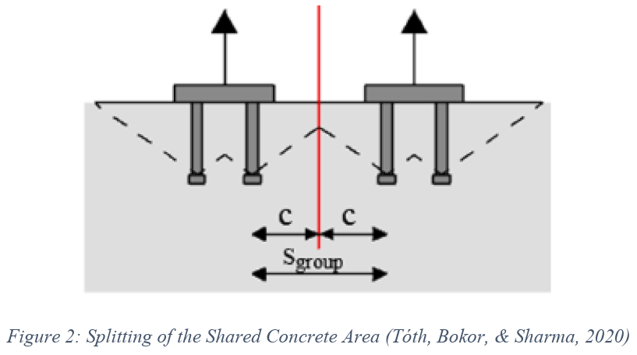

The edge effect modification factor does not need to account for virtual edges.

For additional details refer to:

Tóth, M., Bokor, B., & Sharma, A. (2020). Numerical study on closely spaced anchor groups of identical conﬁgurations under centric tension loading. Engineering Structures, 1-17.

***************************************************************************************
      - The center-to-center distance between a new concrete anchor and an existing anchor shall be at least the sum of 1.5 times the effective embedment depths of the new and existing anchors (i.e., 1.5h_{efN} + 1.5h_{efE}).
        - If h_{efE} cannot be determined, the minimum center-to-center distance shall be 1.5 times h_{efN} plus 15 times the diameter of the existing anchor.
        - If either of the two anchors is of <<ASTM A193/A193M>> material, or greater than 5/8 inch diameter, or if the existing anchor is a hooked (“J,” cast-in-place) anchor rod, contact the LANL STR for evaluation.
      - Non-grouted fixtures or baseplates installed with anchors may have a maximum gap of 1/8 inch at exterior or perimeter edges, provided full bearing is achieved on the remaining concrete surface and the specified anchor installation torque can be applied. If the gap exceeds this limit or prevents proper torque application, perform one of the following procedures:
        - Rework the concrete/masonry surface to achieve full bearing and proper anchor installation.
        - For gaps up to 1 inch, grout the fixture in accordance with the following procedure:
          - Insert anchors and set the fixture.
          - Install nuts to finger-tight condition.
          - Place shims no more than 1/2 inch from each anchor to reduce gaps between fixture and shims to 1/8 inch or less at anchor locations.
          - Apply the specified installation torque slowly to verify proper shim placement. If the fixture bends downward during initial torquing, the shims are not positioned correctly. Release torque, adjust shim locations, and re-torque without causing fixture bending.
          - Fill the gap with a non-shrink grout specified in Section << 03 6000 - Grouting>> leaving the shims in place. For fixtures where grouting is not feasible, fill the gap with shim plates. Shim stacks may include up to four (4) shims per stack.
      - Leveling nuts are not permitted beneath fixtures or baseplates, as they prevent the correct application of the specified installation torque/tension.

***************************************************************************************

Retain the following Article if grouted anchors are used in the project.

***************************************************************************************
    - ADDITIONAL REQUIREMENTS FOR INSTALLATION OF GROUTED CONCRETE ANCHORS
      - In addition to the requirements in the PART 3 Article “Installation of Anchors,” grouted concrete anchors shall be installed in accordance with the requirements in this article.
      - Holes shall be drilled as indicated.
        - For anchors up to 1 inch in diameter, provide 2-inch diameter hole in concrete.
        - For anchors greater than 2 inches in diameter, provide a hole at least 2 inches greater than the anchor diameter.
      - Clean all surfaces of the anchor element of oil, grease, or other foreign material.
      - The hole surfaces shall be wire brushed to clean them and to remove all loose particles. In addition, for core-drilled holes with diamond-tip bits, the holes shall be visually examined to confirm that there is no smooth glazing on the hole surface, and the sides of the hole may be roughened, as required, to ensure proper bond. Remove all debris, dust, cement, and other foreign materials from the hole.
      - Soak the hole to saturation with potable water and keep damp for a minimum of six hours prior to grouting. Immediately prior to grouting, remove all free surface water using oil-free compressed air, sponge, or vacuum.
      - Anchors shall be properly positioned in the hole prior to grouting and supported to maintain that position during grouting.
      - Use a non-shrink grout specified in Section << 03 6000 - Grouting>>. Mix and place the grout, in accordance with same.
      - Cold bending of <<ASTM A36/A36M>> material prior to grouting is permitted if /when necessary to clear an interference(s) (i.e., embedded reinforcing steel and/or other types of embedded items) provided the axis of bent anchor is not more than 30 degrees from straight as shown in appended Figure A1, the surface of the anchor is not cracked, and subject to the following limitations.
        - Cold bending in the field shall not occur more than once per anchor.
        - Field-bent anchors shall not be straightened without pre-approval of LANL STR.
      - Use nut and washer(s) indicated. With respect to the “washer paragraph” in the previous PART - 3 Article “Installation of Anchors,” if more than one (1) washer is indicated for an anchor, then “supplemental/additional washer” shall be taken to mean the washer in-between the fixture and the washer below the nut.
      - If use of a nut above the fixture (i.e., on the anchor projection) is indicated, it shall be installed after the grout has fully cured and using an amount of torque that does not exceed that which is prescribed by the grout manufacturer.

***************************************************************************************

Retain the following Article if adhesive anchors are used in the project.

***************************************************************************************
    - ADDITIONAL REQUIREMENTS FOR INSTALLATION OF ADHESIVE ANCHORS
      - In addition to the requirements in the PART 3 Article "Installation of Anchors", adhesive anchors shall be installed in accordance with the following Paragraph.
      - For adhesive concrete anchors that are indicated as being horizontal or upwardly inclined and supporting sustained tension loads, installation shall be performed by personnel certified by the ACI/CRSI Adhesive Anchor Installer Certification program, or an equivalent program pre-approved by the LANL Building Official.
    - RELOCATING FIXTURE
      - Unless otherwise indicated, a fixture may be relocated up to one (1) inch in any direction with respect to its principal axis to avoid interferences (i.e., embedded reinforcing steel and/or other types of embedded items).

***************************************************************************************

Retaining the following Article is a designer-choice.

***************************************************************************************
    - RELOCATING HOLES WITHIN FIXTURE
      - Individual anchor holes that have not yet been drilled in a fixture may be relocated to avoid interferences (i.e., embedded reinforcing steel and/or other types of embedded items) subject to the following limitations:
        - If tolerances or ranges are not indicated for them, anchor holes in the fixture may be relocated up to one (1) inch in any direction provided the anchor-spacing criteria, and edge-distance criteria for both the fixture and the concrete, will be met.

******************************************************************************

The following subparagraph, to include the figure referred to therein, is based on AISC 360; therefore, if the fixture is something other than “AISC 360 material,” editing is required.

For example, if the fixture is cold-formed steel (CFS) then the applicable standard is AISI S100 (Ch. E). In this example, an edit merely replacing AISC 360 with AISI S100 would not suffice (unless appended Figure A2 and the related sentence(s) below are omitted).

******************************************************************************
        - The minimum edge distance from the center of a hole to the edge of the fixture shall comply with <<AISC 360>> Chapter J Table J3.4.
          - Back-up bars, as shown in Figure A2 (appended herein), may be used to satisfy minimum edge distance requirements. Back-up bars shall be field-cut from stock material matching the fixture material.
          - If feasible and not otherwise prohibited, increasing the fixture size is an acceptable method to meet minimum edge distance requirements.

***************************************************************************************

The major difference between the following paragraph and the previous one is the existence of a hole(s): In former paragraph, the anchor hole does not exist, while in the subsequent paragraph it does (as a result of the project or otherwise).

The 1st and 4th subparagraphs in the following paragraph are based on the fixture being AISC-360 material. Regarding the 1st subparagraph prior to editing (from AISC 360 to AISI S100), EOR must research the closing of CFS holes with welds and whether new holes can be drilled through such welds, and similar applies to the 4th subparagraph on flame cutting.

***************************************************************************************
      - The relocation or abandonment of existing anchor holes in a fixture shall meet the following requirements:
        - Holes may be relocated by abandoning the existing hole and redrilling a new hole. The existing hole may be closed by welded restoration (i.e., for base metal not subjected to cyclic tensile stress) in accordance with <<AWS D1.1/D1.1M>>​. It is permissible to drill a new hole through the hole that was restored by welding.
        - If the existing fixture hole resulted in a drill hole in concrete, the minimum center-to-center spacing between a new concrete-anchor hole and an exploratory/unused hole stipulated in the PART-3 Article, “Installation of Anchors*,” shall be met.

* NOTE: The Paragraph in “Installation of Anchors” that includes the minimum spacing referred to here also includes an exception. That exception is applicable here too (if the conditions associated with it are met).
        - If the existing fixture hole resulted in a drill hole in masonry, the minimum center-to-center spacing between a new grouted-masonry-anchor hole and an exploratory/unused hole stipulated in the PART 3 Article “Installation of Anchors,” shall be met.
        - Flame cutting of holes in the fixture is permitted provided that those holes are reamed and/or ground to the final required dimensions.
    - INSPECTION ​​​​​​<< AND TESTING; or None - N/A>>​​​​​​

***************************************************************************************

For ML-3 anchors, it is recommended that testing also be mandated herein to provide added assurance as opposed to increased rigor on procurement. Refer to the testing requirements contained in Section << 05 0521 - Post-Installed Concrete Anchors - Nuclear Safety>> for examples of possible changes that can be made to increase confidence, or it may be used as the starting point when the utmost confidence is desired.

For ML-4 anchors, testing is required only for grouted concrete anchors; thus, the option in this article title (above), the Testing Para. (below), and the Test-Record Para. in the subsequent Documentation Article can be omitted if grouted concrete anchors are not applicable to project.

***************************************************************************************
      - Inspection
        - Visually inspect each anchor using appended ​​​<< Table A1; or Table A2>>​​​, as applicable, to verify that installation was performed in accordance with this section.
        - If visual inspection reveals that a tabulated provision is not met/satisfied, the infraction shall be remedied in a manner that is consistent with the requirements of this section. If hole drilling has occurred, or if anchor installation has been completed, remediation might consist of anchor relocation, or anchor removal and replacement, in accordance with the subsequent Article, “Rework and Abandonment of Anchors, and Repair.”
        - The inspection(s) and its results shall be documented in an Installation Inspection Record in accordance with the subsequent Article, “Documentation.”
      - Testing
        - Testing of grouted concrete anchors that are permanent (e.g., not temporary construction aids, etc.) is mandatory and shall be witnessed by the LANL Construction Inspector.

******************************************************************************

In the following subparagraph, indicate whether tension and/or shear load must be used during testing, and the amount(s) of the load(s). The amount(s) of load indicated shall be 100% of the required tensile and/or shear strengths (i.e., Nu and/or Vu).

Do not specify a load type (and load amount) if there is no such demand (i.e., N_{u} and/or V_{u}).

******************************************************************************
        - The Proof-load method, in accordance with <<ASTM E3121/E3121M>>, shall be used for testing. Testing may be performed either before or after installation of the fixture. The amount of applied << tension; and shear>> load shall be << xxx pounds; and xxx pounds>><< , respectively; or None - N/A>>.
          - Post-test restoration: If the fixture was removed, or if the nut was loosened, then the fixture and/or nut shall be restored to their pre-test condition in accordance with the following
            - Re-install the fixture.
            - Clean the threads of the anchor projection and nut.
            - Re-install the nut, tightening it to snug-tight or EOR specified torque.
          - Testing frequency: Unless otherwise specified, the following test frequencies shall apply

*************************************************************

Regarding the following subparagraph, if the project includes both RC III/ IV anchors and RC I/ II anchors, be sure the drawings indicate “which anchors are which.”

If the project only includes RC III/IV anchors or RC I/II anchors, in addition to removing brackets and deleting bracketed content accordingly, consider also deleting mention of the respective RC(s).

*************************************************************
            - Randomly select and test << 50% of the RC III/IV anchors in each group; and 10% of RC I/II anchors in each group>>​.
            - A group of anchors consists of a homogeneous population with respect to the anchors themselves and their installation conditions.
            - If the aforementioned criteria results in the number of anchors to be tested being less than one (1), a minimum of one (1) anchor shall be tested.
            - If the tested anchors can achieve/withstand the stipulated proof-load-method loads (and, as applicable, are acceptable per the post-test-restoration provisions), and the concrete surrounding/beyond the anchors does not break out, the other anchors in the group shall be considered satisfactory.
            - If a test anchor fails, double the specified (above) percentage of the anchors in the respective group shall be tested. If another anchor fails, all remaining anchors in the group shall be tested.
        - The testing and its results shall be documented in a Testing Record in accordance with the following Article, “Documentation.”
    - DOCUMENTATION
      - Installation Inspection Record
        - The Installation Inspection Record shall contain the information listed in appended << Table A1; or Table A2>> (as applicable).

***************************************************************************************

Retain the following paragraph if applicable to the project.

***************************************************************************************
      - Test Record
        - The Test Record shall include, at a minimum, the requirements of Section << 01 4000 - Quality Requirements - Non-Nuclear>>, the information listed in the Report section of <<ASTM E3121/E3121M>>, and the following information:
          - Complete anchor identification (as stipulated in Table A1).
          - General location of anchor and description of group represented.
          - Method of testing.
          - Test results (i.e., acceptable/satisfactory or failed/rejected).
          - Names of inspector and installer (if two different people).
          - Date of test.
          - For anchors that failed/were rejected, location of anchor and type of failure/reason for rejection.
    - REWORK AND ABANDONMENT OF ANCHORS, AND REPAIR

***************************************************************************************

Retain the following paragraph if concrete anchors are used in the project. The “Testing option” can be omitted in the following paragraph if grouted anchors are not used.

***************************************************************************************
      - When a concrete anchor(s) does not meet the inspection criteria applicable during or after installation, or the testing criteria stipulated in the PART 3 Article, “Inspection << and Testing; or None - N/A>>,” remediation shall include whichever of the following two (2) options applies. And such anchors shall be re-inspected << and retested; or None - N/A>> afterward
        - Failure due to concrete breakout
          - Remove the concrete debris and concrete damaged by the failure.

**********************************************************************

If the integrity of the concrete surrounding/beyond the damaged concrete is intact, it’s likely a replacement anchor can be installed in the same location (after repair of the damaged concrete).

Refer to ACI Field Guide to Concrete Repair Application Procedures and the videos at ACI Repair Application Procedures and Case Studies for guidance.

**********************************************************************
          - Before repairing the concrete, contact the LANL STR for evaluation of the damage and approval of the proposed repair.
          - Install the replacement anchor with an embedment depth of at least two (2) anchor diameters or three (3) inches, whichever is greater, beyond the depth of the damaged concrete.
          - If the available concrete thickness does not permit the required embedment depth, contact the LANL STR to determine an acceptable alternative. (HOLD POINT).
        - Failure due to anchor breakage, slippage, loosening, bending, inadequate anchor embedment or installation.

**********************************************************************

ACI 355.2 and 318 prohibit the reuse of post-installed mechanical anchors.

**********************************************************************
          - Fully remove the anchor. Do not reuse the removed anchor(s).

**********************************************************************

NOTE 1: Some anchors, such as the Hilti HDA, can be fully removed. Others, like certain wedge anchors, may leave components (e.g., wedges) embedded in the concrete. If an anchor type other than the HDA is used, consult the manufacturer’s guidance to determine removal requirements. Even if full removal is possible, removed anchors shall not be reused unless both the manufacturer and the LANL Structural Engineer (LANL STR) explicitly permit re-use.

NOTE 2: The Bolt Extractor, manufactured by Drillco Devices Ltd., may be used to remove installed anchors—such as the KB-TZ and KB-TZ2—if not already available, it can be purchased for this purpose.

**********************************************************************
          - If the concrete surrounding and beyond the defective anchor remains intact, a replacement anchor may be installed in the same location after the hole has been re-drilled.

**********************************************************************

Regarding the following subparagraph, determining an appropriate replacement anchor can range from straightforward to quite challenging.

In many cases, selecting an anchor one size larger—both in diameter and embedment depth, as recommended by Hilti—may be sufficient in theory.

However, in practice, the limited availability of Hilti HDAs approved for nuclear applications can make identifying a suitable replacement a complex task.

**********************************************************************
          - Before re-drilling the hole, contact the LANL STR for evaluation of the failure, the removed anchor location, and determination of the appropriate replacement anchor.
          - If the location of the failed anchor cannot be reused due to insufficient concrete depth or compromised integrity, proceed as follows:
            - Fill/Grout the existing hole using non-shrink grout in accordance with Section << 03 6000 - Grouting>>.
            - Relocate the replacement anchor per the minimum center-to-center spacing requirements between a new hole and an unused hole specified in the PART 3 Article “Installation of Anchors.”

*************************************************************

Note: The paragraph in “Installation of Anchors” that defines the minimum spacing also includes a waiver, which applies here if the associated conditions are met.

*************************************************************
            - If an additional relocation (i.e., subsequent to that described above) is deemed necessary, obtain written approval from the LANL STR before proceeding.

***************************************************************************************

Retain the following paragraph if masonry anchors are used in the project.

***************************************************************************************
      - When a grouted-masonry anchor(s) does not meet the inspection criteria applicable during or after installation (listed in Table A2), remediation shall be as follows. And such anchors shall be re-inspected afterward:
        - Remove the defective anchor.*

* NOTE: Some products cannot be fully removed (e.g., some wedge anchors will leave wedges behind, etc.). Even if full removal is possible, the removed anchor shall not be re-used unless re-use is permitted by the manufacturer and LANL STR.
        - Grout the existing hole with a non-shrink grout specified in Section << 03 6000 - Grouting>> and relocate the replacement anchor in accordance with the minimum center-to-center spacing between a new grouted-masonry-anchor hole and an unused hole stipulated in the prior Article “Installation of Anchors.”
          - If another relocation (i.e., after that described above) is believed to be necessary, prior to proceeding, obtain written permission from the LANL STR.
      - Mislocated anchors, or anchors installed for temporary purposes, need not be removed if they do not interfere with project-related work (e.g., subsequent anchor or fixture installations, etc.), pose a safety hazard to personnel, or are not “aesthetically offending.” Unremoved mislocated anchors shall be cut off flush with the concrete/masonry surface.
        - Anchors that will be covered by a fixture may also be cut off flush with the concrete/masonry surface.

***************************************************************************************

Regarding the following “trimming paragraph,” for products that have an excess projection (i.e., a portion of the anchor/anchor element extending beyond the nut on top of the fixture), although removing excess projection does not affect structural integrity, if that projection has a length-indicator/head-marking on it, it will be lost.

The reason for requiring a thread projection after trimming is to ensure full nut-thread engagement (that is clearly visible to, for example, an inspector).

***************************************************************************************
      - After installation is complete, if the anchor has a projection, the portion of the projection that extends beyond the nut (on top of the fixture) may be trimmed per the following stipulations. The projection before trimming* and the length trimmed must be recorded on the inspection record. The projection after trimming shall not be less than one (1) thread beyond the top of the nut. All trimming must be saw-cut, and the trimmed area shall be painted if the anchor is outdoors, or in a wet or corrosive area/environment.

* NOTE 1: The projection before trimming is the distance from the tip of the exposed end of the anchor to the concrete/masonry surface.

NOTE 2: If the projection has a length-indicator/head-marking, trimming will result in the loss of it.
      - Concrete/masonry surface repairs: Repair concrete/masonry surfaces that haven’t been previously addressed herein and have been damaged as a result of the work/project, using a non-shrink grout specified in Section << 03 6000 - Grouting>>​. Repaired surfaces shall be touched up with a paint acceptable to LANL STR.
        - Locally spalled areas not more than 1/4 inch away from an anchor, and not more than 3/4 inch depth and 3/4 inch width, are considered undamaged and do not require repair.
        - Areas less than two (2) square inches, and not exceeding a nominal depth of 1/4 inch, are considered undamaged and do not require repair provided that they do not intersect/overlap with item 1 (above).
        - If the area exceeds 20 square inches, or if the nominal depth exceeds 3/4 inch, contact the LANL STR for evaluation of the damage and approval of the proposed repair

***************************************************************************************

Retain the following paragraph if masonry anchors are used in the project.

***************************************************************************************
      - Masonry joint repairs: Repair mortar joint in-between masonry units that have been damaged by the Work/Project by repointing in accordance with Section ​<< 04 2220 - Reinforced Unit Masonry>>​. Prior to proceeding with repointing, present the LANL STR with the proposed procedure, and obtain permission from same to execute the procedure.
  - END OF MAIN SECTION; APPENDIX FOLLOWS

**********************************************************************************************

Do not omit the following reference information:

**********************************************************************************************
  - THE FOLLOWING STATEMENT IS FOR LANL USE ONLY
  - THIS PROJECT SPECIFICATION SECTION IS BASED ON LANL MASTER SPECIFICATION SECTION 05 0520, REV. 7, DATED APRIL 15, 2026.

appendix A

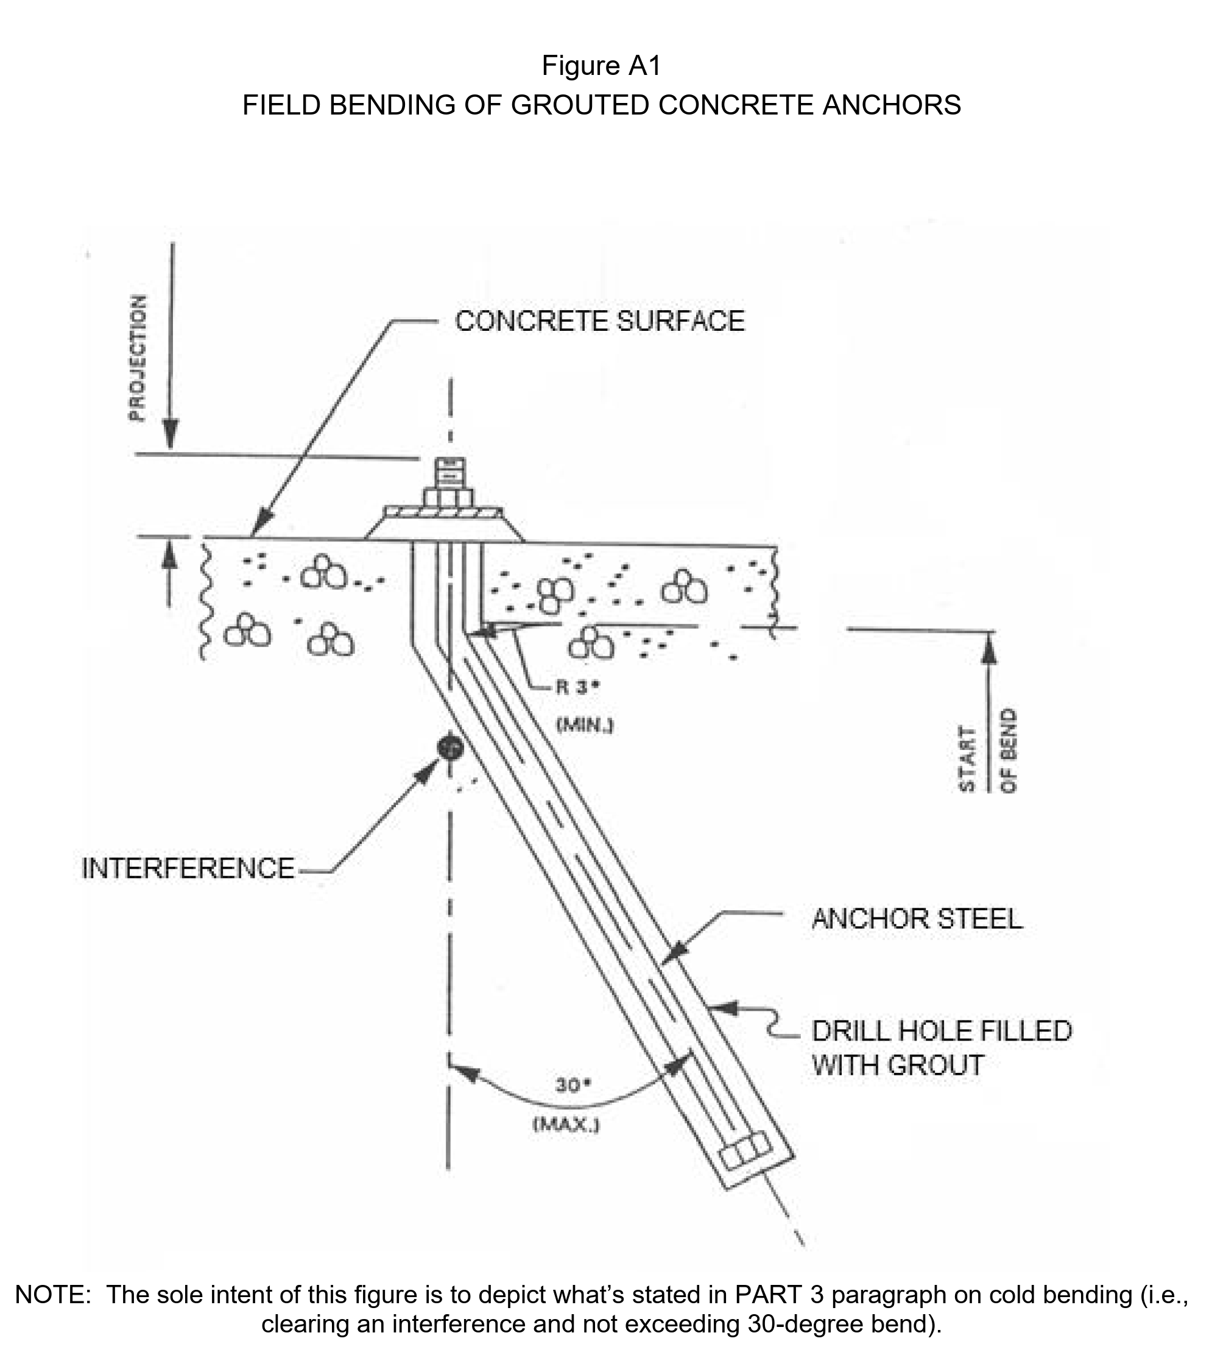

  - 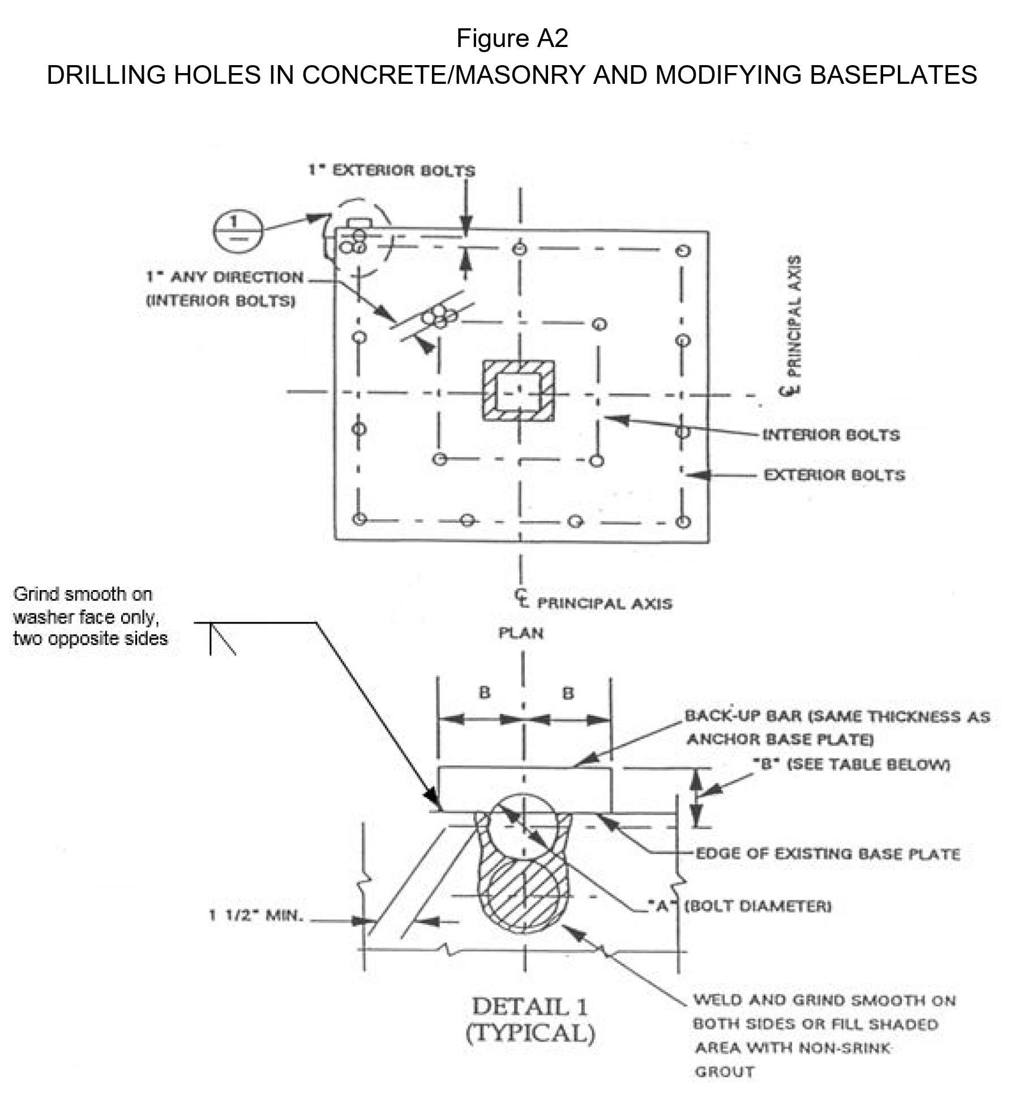
  - 

  - 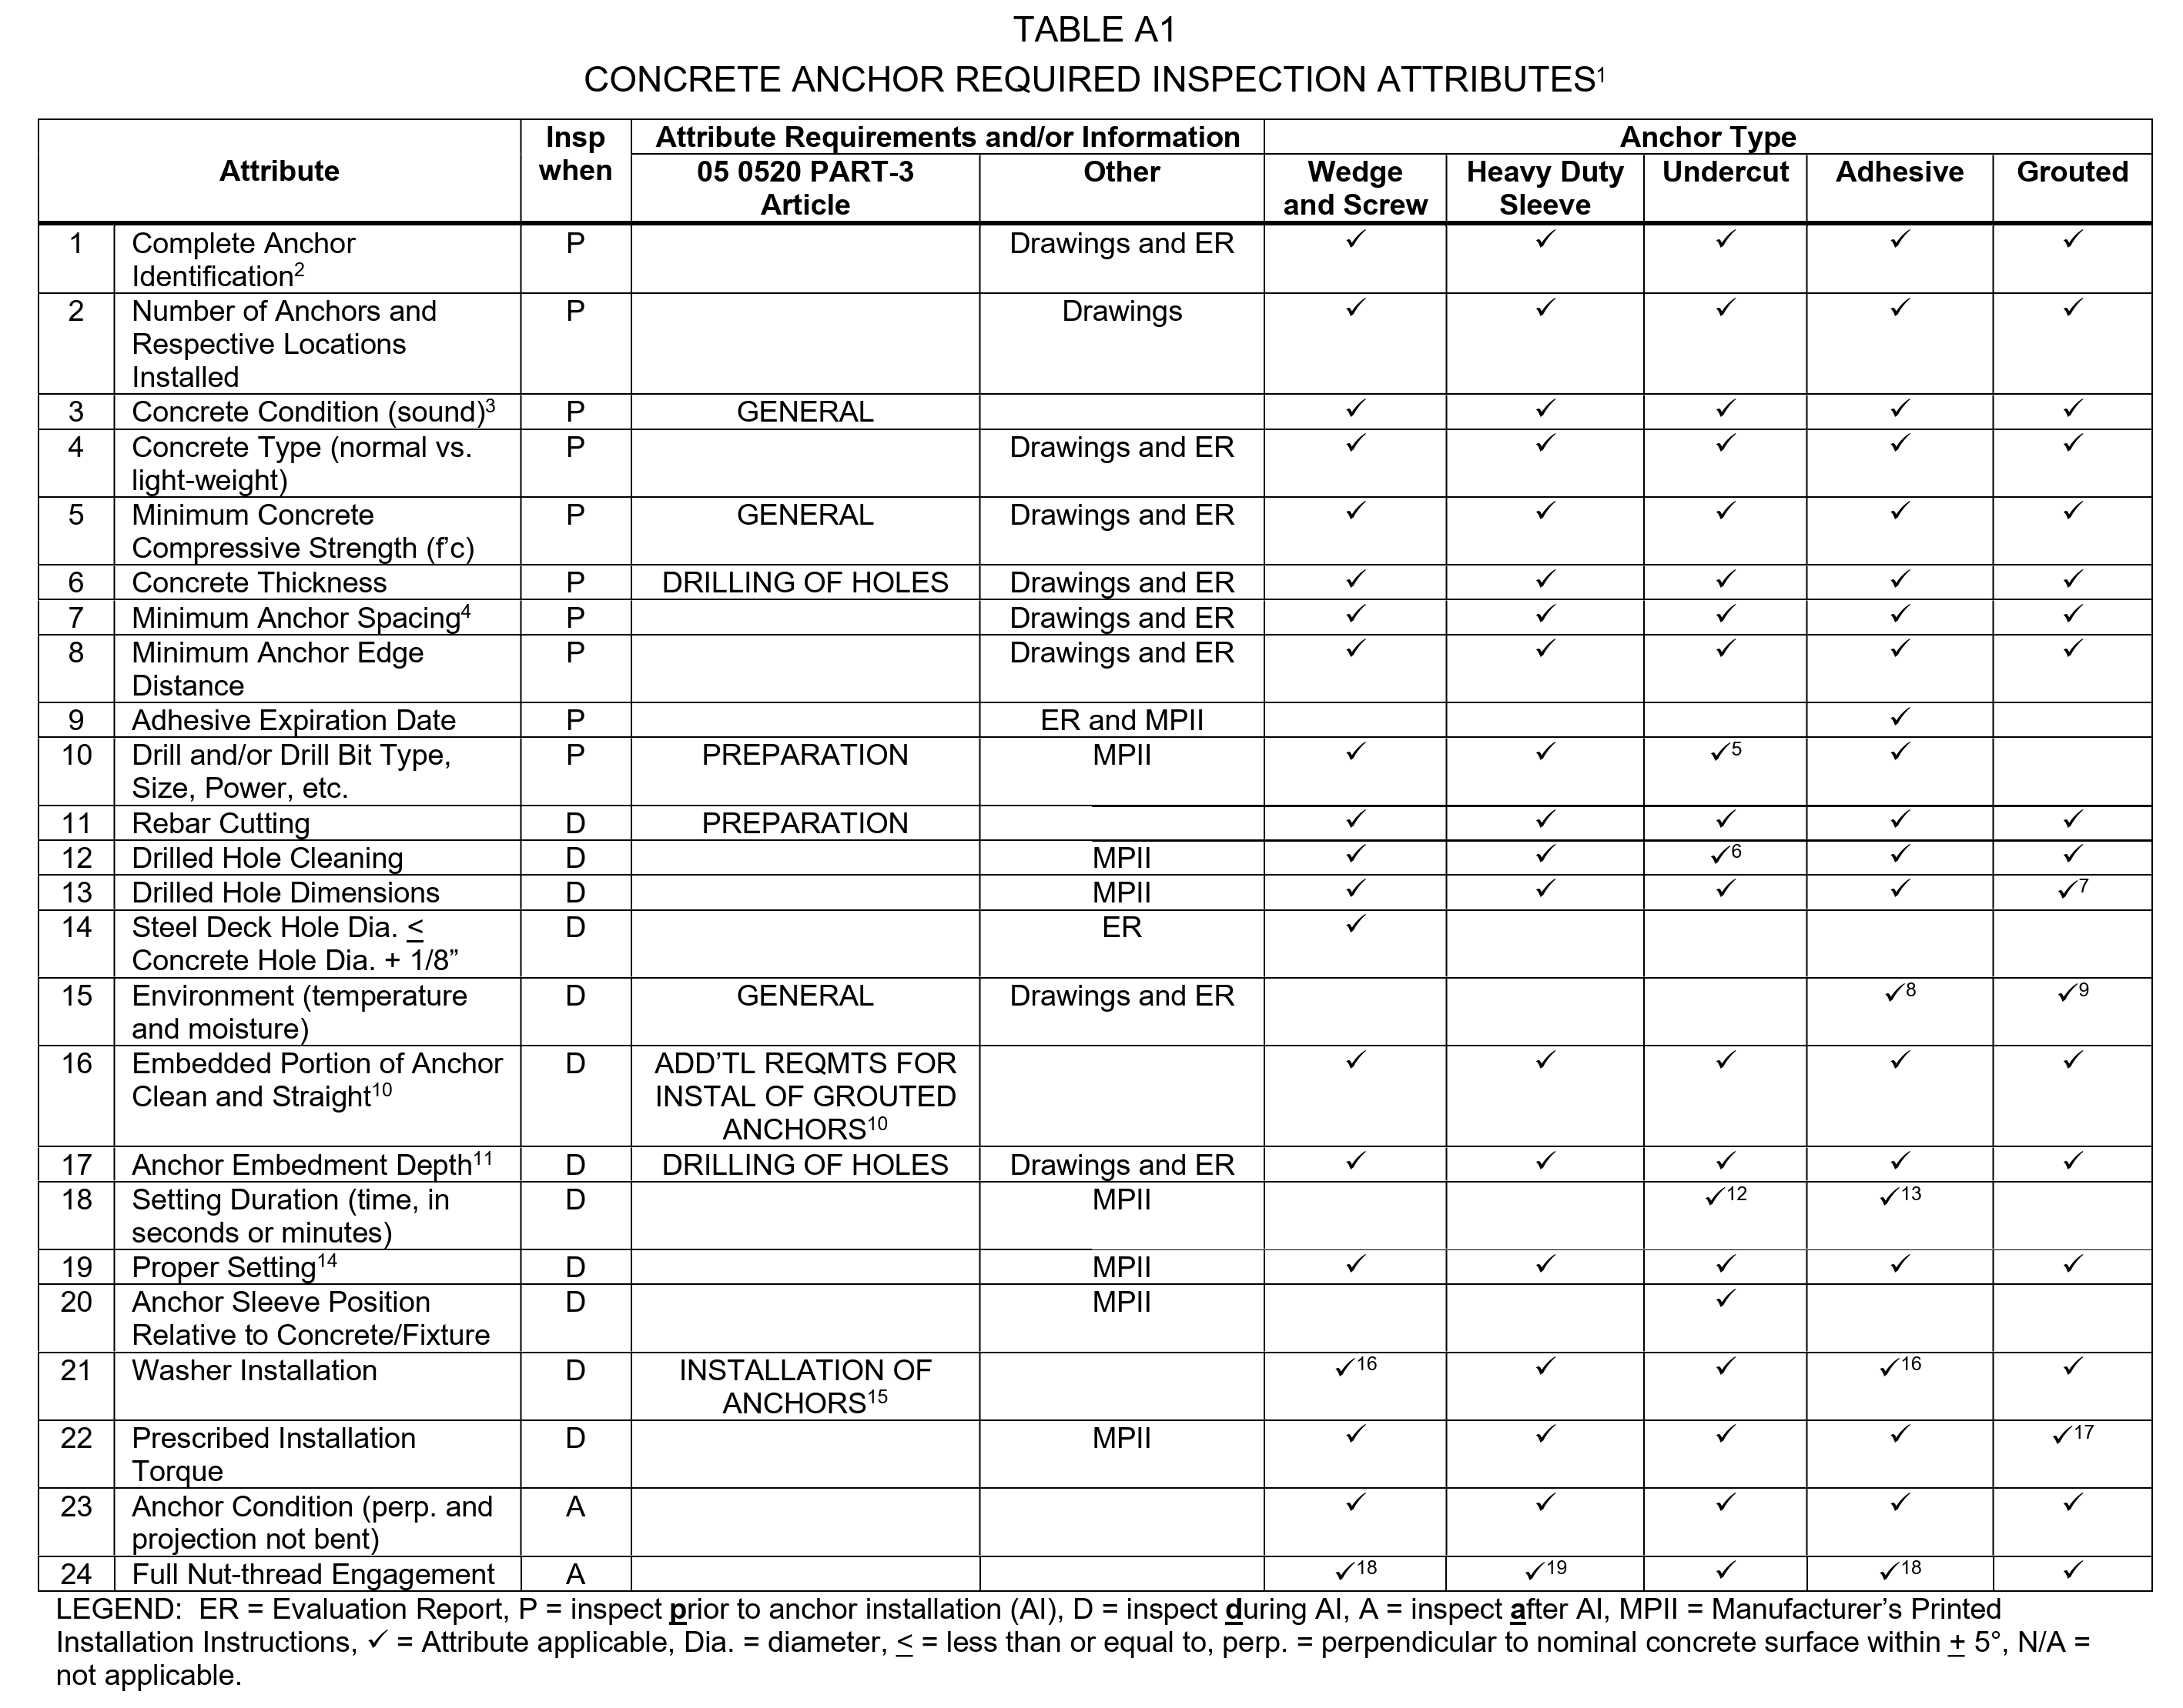
  - 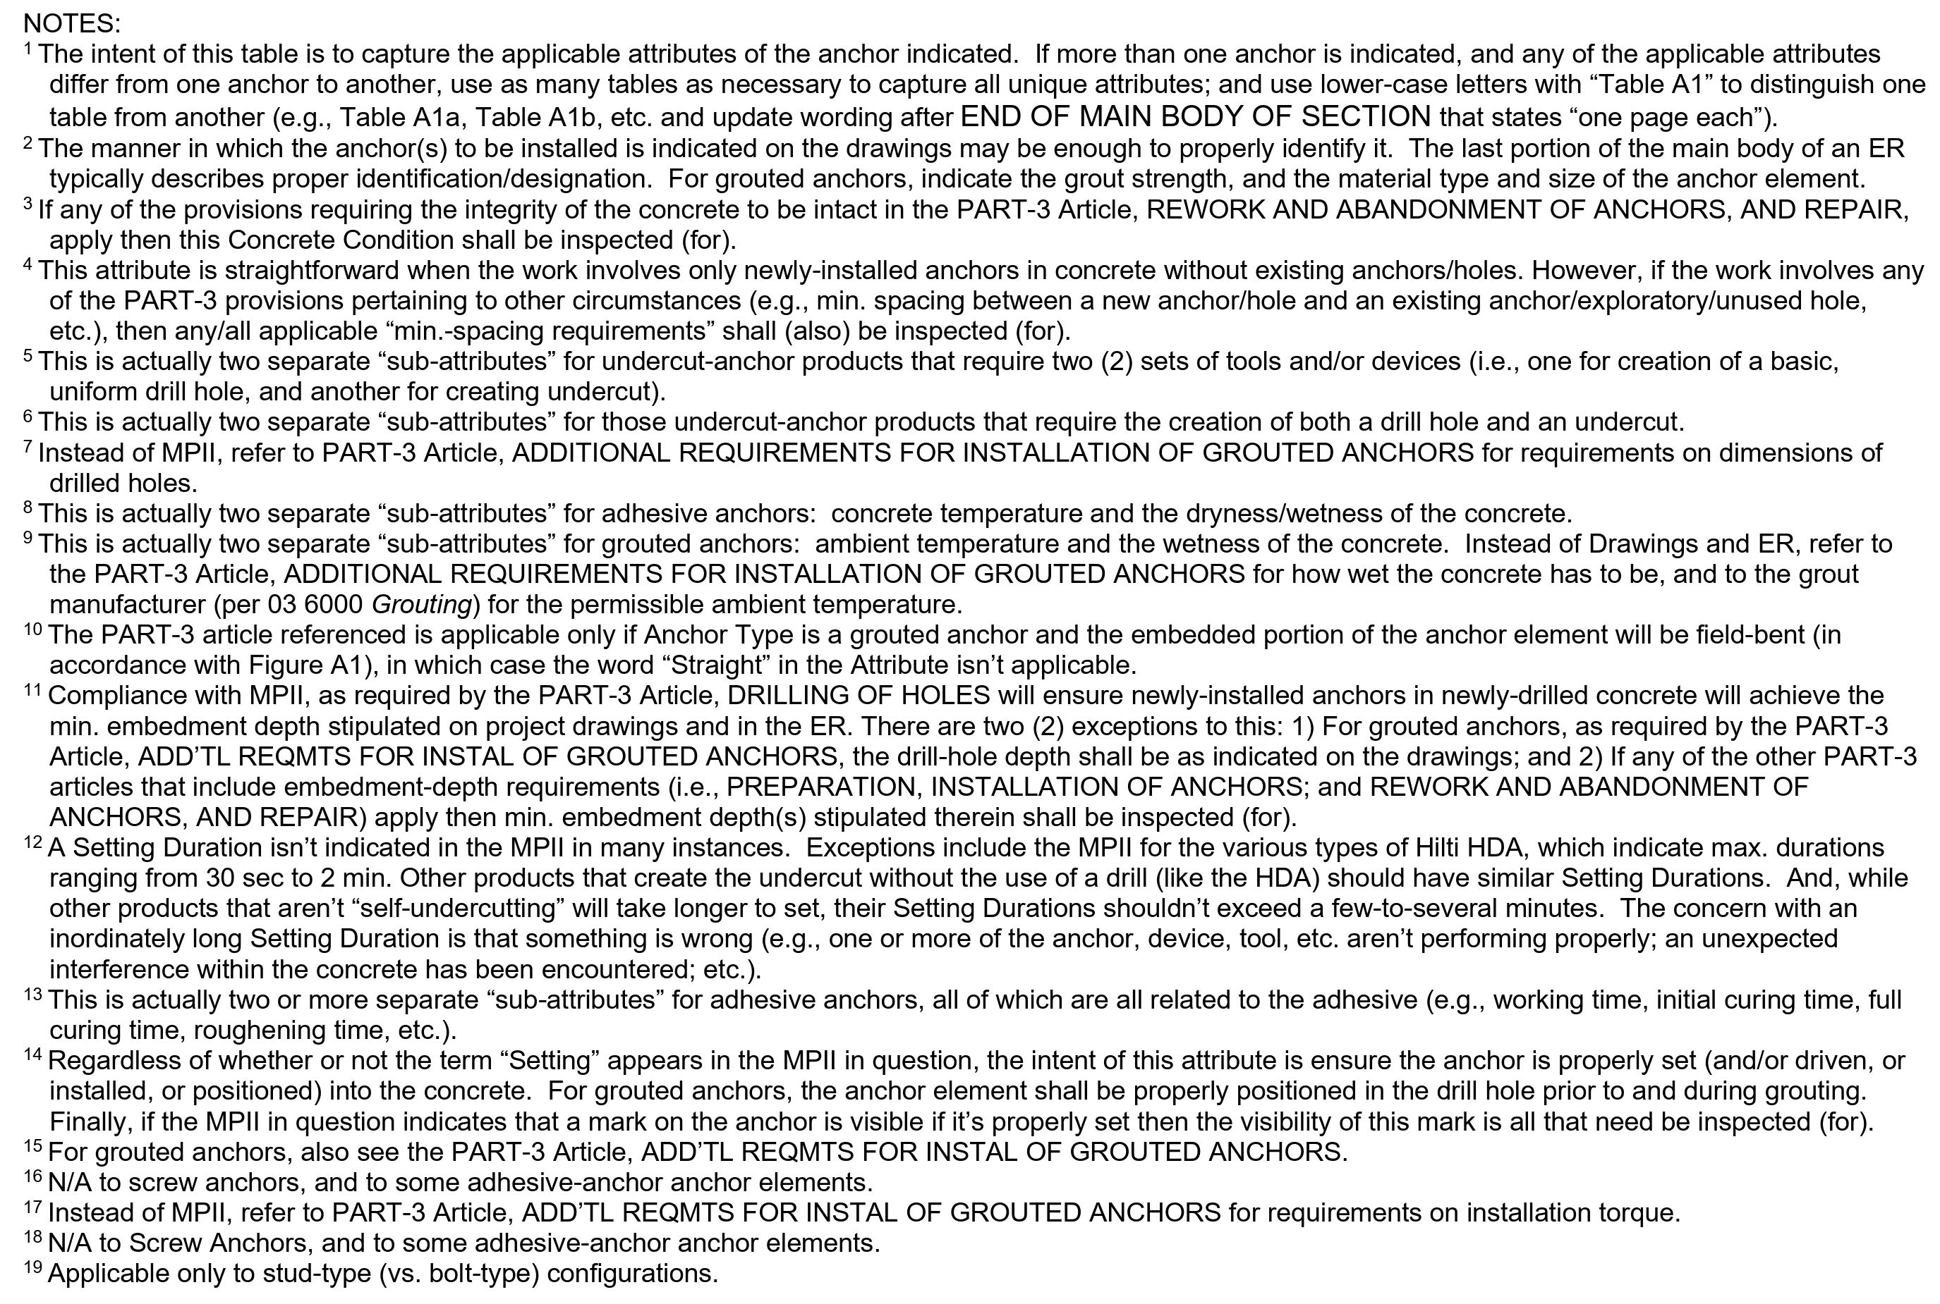

  - 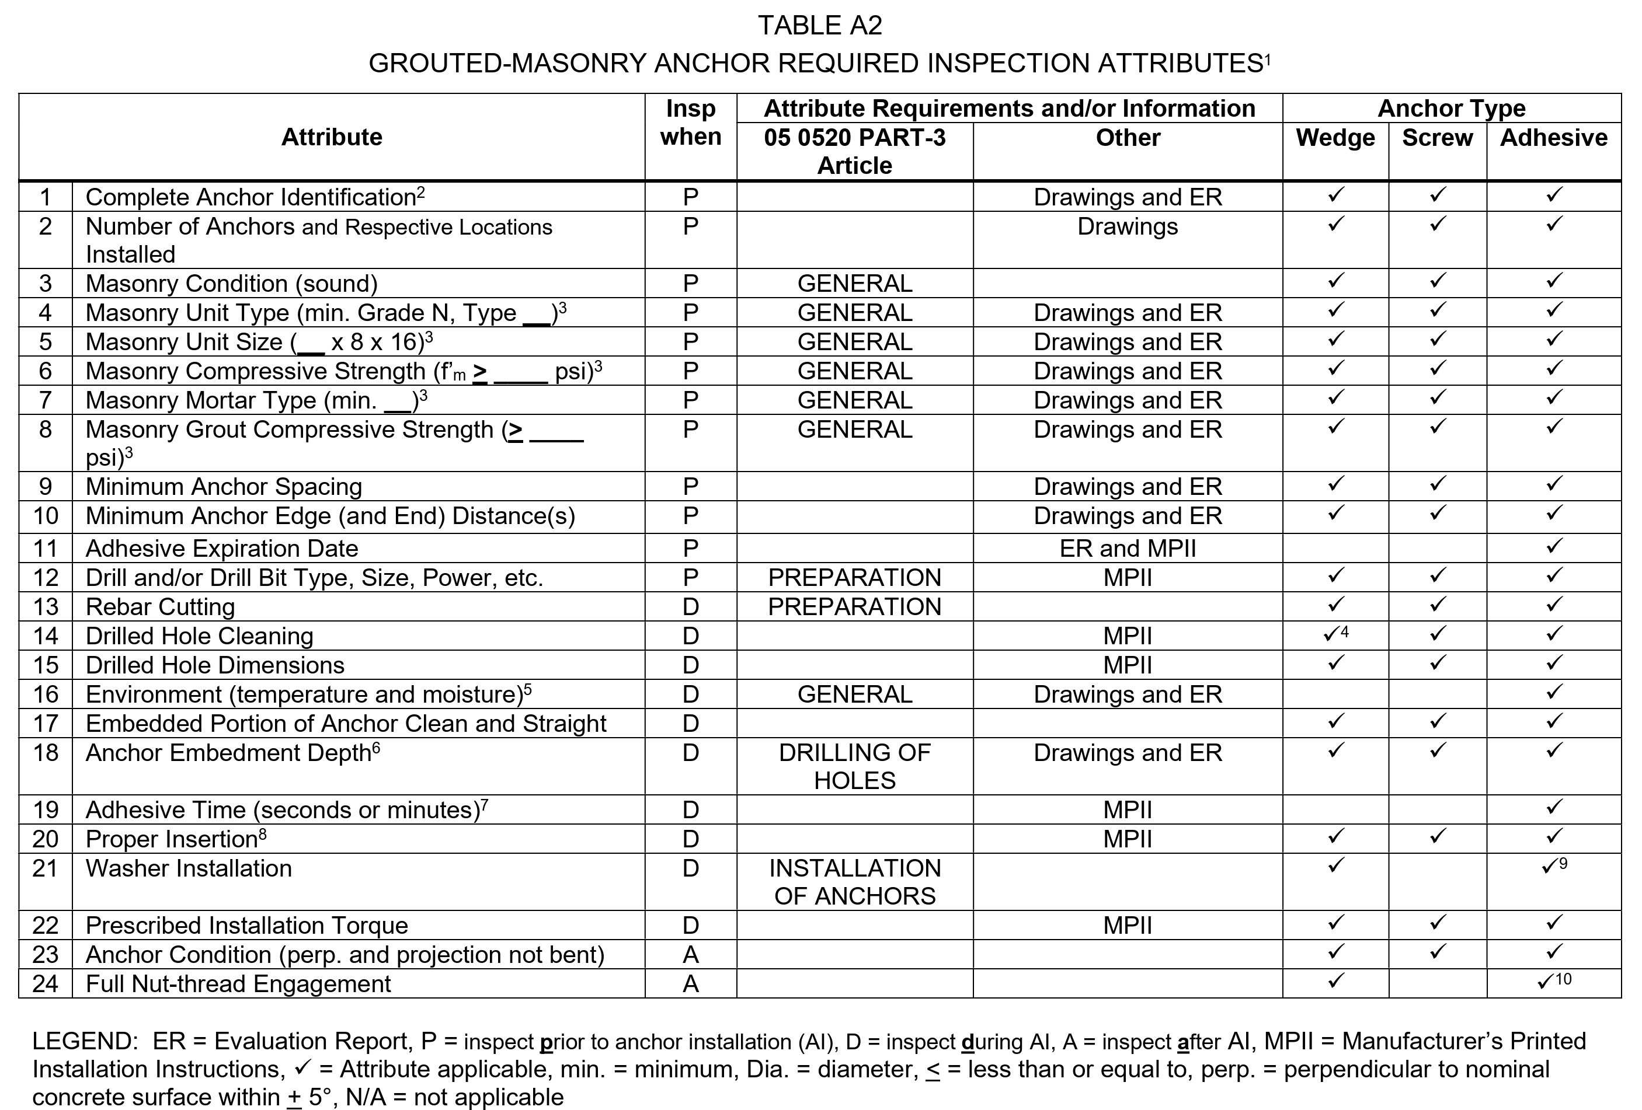
  - 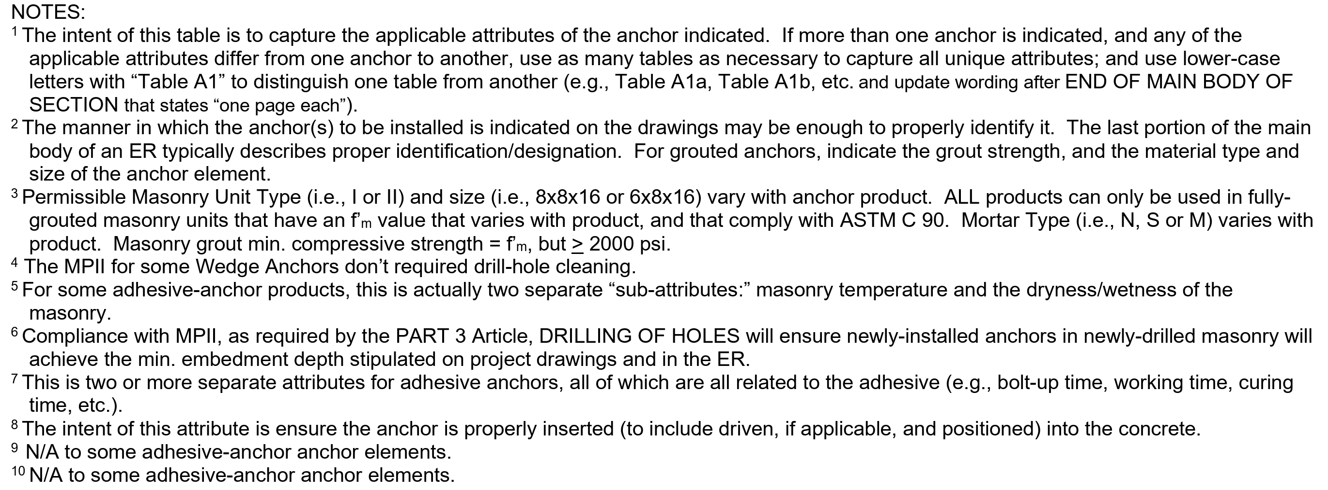
END OF SECTION

