Section 05 4000
Cold-Formed Metal Framing

*************************************************************************************************************

LANL MASTER SPECIFICATION SECTION
Rev. 8 Summary of Changes: Edited and updated as required for import into SpecLink.

NOTE TO SPECIFIER ON USAGE IN SPECLINK: Activate the Section by turning on Seq #0000, followed by activating paragraphs in PART 1, Article SECTION INCLUDES. This will activate related articles, paras/subparas in the rest of the Section (i.e., SECTION INCLUDES in PART 1 activates articles and paras/subparas in PARTS 2 and 3). If there are choice fields to edit the entire Section (typically in this first author note or beginning of the Section), make selections at those locations, which will filter through the remaining Section. All Articles, paragraphs and subparagraphs must be activated sequentially from top to bottom, unless noted otherwise.

This template must be edited for each project. In doing so, Specifier must add job-specific requirements. Selections and choice fields are used to indicate designer choices or locations where text must be supplied by the designer. The section must also be edited to remove requirements for processes, items, or designs that are not included in the project.

To seek a variance from applicable requirements in this Section, contact the Engineering Standards Manual (ESM) Structural POC (LANL access only). Please contact POC with suggestions for improvement as well. LANL personnel should submit here: Suggested Change or Request Clarification; subcontractors via email to engstandards@lanl.gov.

When assembling a specification package, include applicable specifications from all Divisions, especially Division 1, General Requirements.

This Section is for use with LANL ESM Chapter 5 - Structural, Sections I and II in particular; therefore, it is primarily applicable to ML-4 projects. For ML-1, ML-2², and some ML-3, additional requirements and independent reviews may be required; see LANL ESM Chapter 1 - General, Section Z10 Specifications and Quality sections.

==========================================================

This Section specifies cold-formed metal (CFS) structural¹ framing including exterior and interior walls, floor and roof framing that are part of the structure gravity load-resisting system, lateral force-resisting system, or building envelope. Members comprising such framing typically have a minimum base metal thickness, t, of 0.0329 - 0.118 inches, although the maximum thickness of a member can be as large as 1 inch (under the AISI definition of “structural CFS”).

CFS trusses; CFS special bolted moment frames; proprietary CFS (e.g., Unistrut, B-Line, etc.); Z- or C-shaped purlin or girt components; cold-formed stainless-steel framing; and interior nonstructural¹, CFS are not included in this section. Interior nonstructural Studs are covered in Section << 09 2116 - Gypsum Board Systems>>. CFS floor and roof decking are covered in Section << 05 3000 - Metal Decking>>.

LANL ESM Chapter 5 - Structural, Part II, through reference to IBC Chapter 22³, governs the quality, design, fabrication, and erection of structural steel in buildings and structures. This section and other METAL specification sections address provisions related to quality, fabrication, and erection. However, the specifier is responsible for ensuring full compliance with all provisions of LANL ESM Chapter 5 - Structural, Section II and IBC Chapter 22 for the Project.

____________________________

¹According to AISI 240, a “Nonstructural Member” is defined as a steel-framed system member not part of the gravity load-resisting system, lateral force-resisting system, or building envelope. Therefore, exterior curtain walls, as part of the building envelope, must be considered structural.

² If using a modified version of this Section for ML-1/2 nuclear safety related installations, based on TRP II project experience, projects should not purchase B-Line (and possibly not competitor U-channel products) based on them coming through a distributor who is on the LANL IESL to consider it as meeting NQA-1 (material traceability problems). Instead, use the CGD method for all safety-credited components and have sufficient testing and documentation with traceability to allow use. The exception may be Unistrut if procured through NOVA Machine Products, their sole IESL/NQA-1 nuclear-pedigree-line distributor (verify before using).

³ IBC Chapter 22 requires the use of CFS to comply with the North American Specification for the Design of CFS Structural Members (i.e., AISI S100) and, in some instances, several AISI standards too (i.e., for light-frame construction, which is defined by IBC as “…a system of repetitive members” w/ t < 0.118”).

Sustainable design: This Section includes reference to SD that only applies to certain larger projects and other projects having SD goals, refer to LANL ESM Chapter 14 - Sustainable Design for details and applicability. Do not use it if not applicable.

************************************************************************************************************
  - PART 1 - GENERAL
    - SECTION INCLUDES

***************************************************************************************

Retain the paragraphs below that apply to the project. Connections are always required for CFS framing.

***************************************************************************************
      - Bearing/shear wall framing.
      - Exterior curtain wall framing.
      - Floor joist framing.
      - Roof rafter framing.
      - Ceiling joist framing.
      - Soffit framing.
      - Connections.
      - Sheathing.
      - Lateral force-resisting system elements.

***************************************************************************************

Refer to Section ​<< 09 2116 - Gypsum Board Systems>>​ for interior non-load- bearing, metal-stud-framed wall assemblies, and metal-channel-framed ceiling assemblies. Refer to Section ​<< 05 3000 - Metal Decking>>​ for CFS floors and roofs.

***************************************************************************************
    - RELATED REQUIREMENTS
      - Section ​<< 01 4000 - Quality Requirements - Non-Nuclear>>​
      - Section << 01 4444 - Offsite Welding, Brazing and Joining Requirements>>.
      - Section << 01 4455 - Onsite Welding, Brazing and Joining Requirements>>.
      - Section << 01 8113.13 - Sustainable Design>>.
      - Section << 06 1000 - Rough Carpentry>>.
      - Section ​​​<< 07 2100 - Thermal Insulation>>​​​.
      - Section ​<< 09 2116 - Gypsum Board Systems>>​.
    - REFERENCE STANDARDS
      - AISI S100 - North American Specification for the Design of Cold-Formed Steel Structural Members.
      - AISI S202 - Code of Standard Practice for Cold-Formed Steel Structural Framing.
      - AISI S240 - North American Standard for Cold-Formed Steel Structural Framing.
      - AISI S400 - North American Standard for Seismic Design of Cold-Formed Steel Structural Systems.
      - ANSI A208.1 - American National Standard for Particleboard.
      - ASCE 7 - Minimum Design Loads and Associated Criteria for Buildings and Other Structures.
      - ASTM A36/A36M - Standard Specification for Carbon Structural Steel.
      - ASTM A123/A123M - Standard Specification for Zinc (Hot-Dip Galvanized) Coatings on Iron and Steel Products.
      - ASTM A153/A153M - Standard Specification for Zinc Coating (Hot-Dip) on Iron and Steel Hardware.
      - ASTM A563/A563M - Standard Specification for Carbon and Alloy Steel Nuts (Inch and Metric).
      - ASTM A653/A653M - Standard Specification for Steel Sheet, Zinc-Coated (Galvanized) or Zinc-Iron Alloy-Coated (Galvannealed) by the Hot-Dip Process.
      - ASTM A780/A780M - Standard Practice for Repair of Damaged and Uncoated Areas of Hot-Dip Galvanized Coatings.
      - ASTM A1003/A1003M - Standard Specification for Steel Sheet, Carbon, Metallic- and Nonmetallic-Coated for Cold-Formed Framing Members.
      - ASTM B695 - Standard Specification for Coatings of Zinc Mechanically Deposited on Iron and Steel.
      - ASTM C208 - Standard Specification for Cellulosic Fiber Insulating Board.
      - ASTM C955 - Standard Specification for Cold-Formed Steel Structural Framing Members.
      - ASTM C1396/C1396M - Standard Specification for Gypsum Board.
      - ASTM C1513 - Standard Specification for Steel Tapping Screws for Cold-Formed Steel Framing Connections.
      - ASTM E119 - Standard Test Methods for Fire Tests of Building Construction and Materials.
      - ASTM F436/F436M - Standard Specification for Hardened Steel Washers Inch and Metric Dimensions.
      - ASTM F1554 - Standard Specification for Anchor Bolts, Steel, 36, 55, and 105-ksi Yield Strength.
      - AWS B5.1 - Specification for the Qualification of Welding Inspectors.
      - AWS D1.1/D1.1M - Structural Welding Code - Steel.
      - AWS D1.3/D1.3M - Structural Welding Code - Sheet Steel.
      - ICC (IBC) - International Building Code.
      - PS 1 - Structural Plywood.
      - SSPC-Paint 20 - Zinc-Rich Coating (Type I - Inorganic, and Type II - Organic).
      - UL (FRD) - Fire Resistance Directory.
    - DEFINITIONS
      - For definitions and acronyms, refer to COE Glossary of Terms.
      - Bearing wall: any metal stud wall that supports more than 100 lb/ft of vertical load in addition to its own weight.
      - Cold-Formed Steel (CFS): The industry-standard term for cold-formed metal.
      - Cold-Formed Steel Structural Member: A structural shape produced by either press braking blanks cut from sheets, coils, or plates, or by roll forming cold- or hot-rolled sheet steel. Both methods are carried out at room temperature, without the application of heat typically required for hot forming.
      - Component Assemblies :These are cold-formed steel elements that are fabricated by a manufacturer before they arrive at the jobsite.
      - Curtain Wall. A structural steel-framed exterior wall system that transfers transverse (out-of-plane) loads and is limited to a superimposed axial load, exclusive of sheathing materials, of not more than 100 lb/ft, or a superimposed axial load of not more than 200 lbs per stud.
      - Installer: Party responsible for the installation of CFS light-frame construction.

***************************************************************************************

Per NIST GCR 16-917-38, LFRS is a broader term than Seismic Force-Resisting System (SFRS); the LFRS transfers and resists lateral forces and includes the SFRS as well as the other elements and connections in the lateral load path.

For the content of the following Paragraph to make sense, EOR shall designate on Drawings as “LFRS” any/all structural elements (e.g., shear walls, strap braced walls, diaphragms, etc.) and connections required to resist racking and overturning because of wind forces, or seismic forces, or other predominantly horizontal forces, or combinations thereof, imposed upon the structure.

If Project does not include LFRS, omit LFRS paragraph.

***************************************************************************************
      - Lateral Force-Resisting System (LFRS): The structural elements and connections designated as "LFRS” on the Drawings.
      - Nonbearing Wall: Any wall that is not a bearing wall.
      - Nonstructural Member: A member in a steel-framed system that is not a part of the gravity load-resisting system, lateral force-resisting system or building envelope. For instance partition walls.
      - Other Than Component Assemblies: This refers to site-built CFS elements constructed in the field by the installer.
      - Shear Wall: A wall, bearing or non-bearing, that provides resistance to lateral loads in the plane of the wall.
      - Structural Member: A member that resists design loads, as required by the applicable building code, except when defined as a nonstructural member.
    - ACTION SUBMITTALS
      - Installation Drawings.

***************************************************************************************

Retain the applicable subparagraphs and options, from following paragraph.

***************************************************************************************
      - Product Data/ Test Reports
        - Provide data on cold-formed steel structural members; include << material descriptions; base steel thickness; corrosion protection; dimensions; and _____>>.
        - Provide manufacturer's data on << factory-made connectors; mechanical fasteners; and _____>>, showing compliance with requirements.
        - For lateral-force resisting systems, provide product data sheets on hold-down, showing compliance with requirements.

***************************************************************************************

Retain the applicable options and subparagraphs from following paragraph.

***************************************************************************************
      - Shop Drawings: Indicate component details, ​​<< framed openings; bearing; anchorage; loading; welds; type and location of fasteners; and _____>>​​, and accessories or items required of related work.
        - Indicate ​<< stud; floor joist; ceiling joist; roof joist; roof rafter; roof truss; and _____>>​ layout.
        - Indicate reinforcing channels, opening framing, supplemental framing, strapping, bracing, bridging, splices, accessories, connection details, and attachment to adjoining work.
        - Describe method for securing ​<< studs; or _____>>​ to tracks and for ​<< bolted; welded; or _____>>​ framing connections.

***************************************************************************************

Retain the applicable subparagraphs from following paragraph.

***************************************************************************************
      - Steel Framing Industry Association (SFIA) Certification:
        - Submit documentation that metal studs and connectors used on project meet or exceed requirements of International Building Code.
        - Submit current documentation of installer certification.

***************************************************************************************

Retain the applicable subparagraphs from following paragraph.

***************************************************************************************
      - Design Data:
        - Shop drawings signed and sealed by a professional structural engineer.
        - Design calculations sufficient to demonstrate compliance with design criteria; signed and sealed by a professional structural engineer.
        - Details and calculations for factory-made connectors, signed and sealed by a professional structural engineer.

***************************************************************************************

Choose the applicable option(s) in the following paragraph.

***************************************************************************************
      - Evaluation Service Reports: Provide reports indicating compliance with specified requirements for ​​<< cold-formed steel structural members; connectors; mechanical fasteners; hold-downs; and _____>>​​.

***************************************************************************************

The following two Paragraphs apply to LFRSs designed in accordance with AISI S240 and/or S400. Thus used to resist wind, seismic and other in-plane lateral loads.

NOTE 1: If Project includes such LFRS(s), but either of the following apply, these submittals are not required:

- The sheathing of the shear wall is gypsum board or fiberboard.

- The sheathing is wood structural sheathing or steel sheet sheathing on only one side of the shear wall or diaphragm assembly and the fastener spacing of the sheathing is > 4” o.c.

NOTE 2: The welding-related submittals in the following "Component Assemblies" paragraph are not required if/when an assembly is commercial off-the-shelf (COTS) as defined by (as defined by LANL ESM Chapter 13 - Welding, Joining & NDE, Volume 1, GWS 1-02).

Component Assemblies refers to cold-formed steel (CFS) lateral force–resisting system (LFRS) elements that are fabricated by a manufacturer before they arrive at the jobsite. Examples include prefabricated shear wall panels, prefabricated framing modules, or proprietary shear wall systems. Because the manufacturer produces them off-site, the manufacturer is responsible for providing certain documentation showing the system is fabricated correctly and meets code requirements.

Other Than Component Assemblies refers to site-built CFS LFRS elements—that is, the walls or bracing are constructed in the field by the installer (contractor). Since they are not manufactured off-site, the installer has responsibility for documentation related to installation procedures and product information.

***************************************************************************************
      - Component Assemblies That Are Part of the LFRS: Submit the following documents for approval before installing CFS LFRS elements.

******************************************************************************

Retain the following subparagraph if applicable.

******************************************************************************
        - Welding procedure specifications.
        - Mechanical fastener installation procedures.
        - Product data sheets, catalog data or independent evaluation reports on hold-downs.
      - Other Than Component Assemblies part of the LFRS: Submit the following documents for approval before installing CFS LFRS elements.
        - Mechanical fastener installation procedures.
        - Product data sheets, catalogue data or independent evaluation reports on hold-downs.

***************************************************************************************

Retain the following paragraph and applicable subparagraphs when welding, brazing or joining is required.

***************************************************************************************
      - Per the requirements of << Section 01 4444 - Offsite Welding, Brazing and Joining Requirements; and Section 01 4455 - Onsite Welding, Brazing and Joining Requirements>>, submit:

******************************************************************************

When offsite only, omit submittals below regarding onsite welding. For high risk applications such as ML-1 or ML-2, add submittals for “Weld Filler Material Control Procedures” and “Filler Material Certified Material Test Reports (CMTRs)” when required. Add “Post-Weld Heat Treatment Procedures” when required.

For Onsite welding use of LANL WPS/PQR is the default; coordinate usage with the LANL CWI; no submittal required.

For Onsite, welders are tested by LANL who will produce WPQR and track continuity; this includes brazing, bonding, and fusing; no submittal required.

******************************************************************************
        - Welding Procedure Specification (WPS) and supporting Procedure Qualification Record (PQR).
        - Welder Performance Qualification Records (WPQR) including continuity.
        - Inspector qualification records
        - Inspection procedures
        - Shop drawings with weld details/symbols

***************************************************************************************

Retain the following paragraph only if required by the project.

Coordinate paragraph below with qualification requirements in Section ​<< 01 4000 - Quality Requirements - Non-Nuclear>>​.

The source of some of this Para. is the SPECTEXT-version of 05 4000, & the rest comes from AIA MasterSpec-version of 05 4000 (i.e., Article QA, Product Tests Para.).

***************************************************************************************
      - Mill Certifications: Submit mill certifications for steel sheet. Certify base steel thickness in 0.001 inch, yield strength, tensile strength, total elongation in 2-inch gauge length, chemical analysis, and galvanized coating thickness.

***************************************************************************************

The following paragraph on Sustainable Design only applies to certain larger projects and other projects having SD goals, refer to LANL ESM Chapter 14 - Sustainable Design for details and applicability. Do not include if not applicable.

***************************************************************************************
      - Sustainable Design Submittals

******************************************************************************

Choose the applicable option(s) in the following subparagraph.

******************************************************************************
        - Sustainable Design (SD) Submittals: Provide material content documentation in accordance with the requirements of this Section.​​​​<< Submit any additional documentation for this product category, as applicable under Section 01 8113.13 - Sustainable Design with this Section's submittal.; or None - N/A>>​​​​
        - Manufacturer's Certificate: Certify products meet or exceed specified sustainable design requirements.

**********************************************************************

Edit material certifications list to suit products specified in this section and Project sustainable design requirements. Specific certificate submittal and supporting data requirements are specified in LANL ESM Chapter 14 - Sustainable Design.

**********************************************************************
          - Materials Resources Certificates
            - Certify source and origin for ​​<< salvaged; and reused>>​​ products.
            - Certify recycled material content for recycled content products.
            - Certify source for local and regional materials and distance from Project site.
          - Indoor Air Quality Certificates
            - Certify volatile organic compound content for each interior paint and coating.
        - Product Cost Data: Submit cost of products to verify compliance with Project sustainable design requirements. Exclude cost of labor and equipment to install products.
          - Provide cost data for the following products:

**********************************************************************

Edit list of material cost data to suit products specified in this section and Project sustainable design requirements. Specific cost data requirements are specified in LANL ESM Chapter 14 - Sustainable Design.

**********************************************************************

Salvaged, refurbished, and reused products.

Products with recycled material content.

Regional products.

​<< _______>>​.

***************************************************************************************

Informational submittals must be limited to those necessary for adequate quality control (QC). The importance of an item, or complexity, in the context of the Project should determine whether a submittal is required.

***************************************************************************************
    - INFORMATIONAL SUBMITTALS

***************************************************************************************

Retain the following paragraph and applicable subparagraphs, as applicable.

***************************************************************************************
      - Make the following documents available in electronic or printed form for review before installing cold-formed steel (CFS) light-frame construction, when requested:

******************************************************************************

Choose the applicable option(s) in the following subparagraph.

******************************************************************************
        - Manufacturer's Installation Instructions: Provide installation instructions for ​​​<< connectors; hold-downs; mechanical fasteners; and _____>>​​​.
        - Manufacturer’s product data sheets or catalog data for welding consumables, filler metals, and fluxes. Include product description, use limitations, recommended or typical welding parameters, and storage and exposure requirements.

******************************************************************************

AISI S240 and S400 include detailed inspection procedures for materials verification, welding, mechanical fastening, and cold-formed steel light-frame construction.

******************************************************************************
        - Inspection Reports: Provide Inspection Reports for << welding; mechanical fastening; cold-formed steel light-frame construction; lateral force-resisting systems; and _____>> in accordance with requirements of << AISI S240; and AISI S400>> .
        - Written quality control (QC) programs from the component manufacturer and installer. Include material control procedures, inspection procedures, and nonconformance procedures.
        - Quality control inspector qualifications for the component manufacturer and installer.
        - Designer's Qualification Statement.
        - Manufacturer's Qualification statement.
        - Testing Agency Qualification Statement.
    - QUALITY CONTROL

***************************************************************************************

AISI S240-15 Ch. D distinguishes between quality control (QC) and quality assurance (QA):

- QC is what is contained herein and is the responsibility of the Component Manufacturer & the Installer.

- QA (which is also required by IBC Chapter, 17) is contained in the EOR’s Statement of Special Inspections (SSI), & is the responsibility of LANL (i.e., execution of the SSI). The SSI template is found in LANL ESM Chapter 16 - Building Code Program, Sect. IBC-IP, Attach. B.

***************************************************************************************

***************************************************************************************

Retain the following paragraph if applicable.

***************************************************************************************
      - Designer Qualifications: Design framing system under direct supervision of a professional structural engineer experienced in designing this work and licensed in State of New Mexico.

***************************************************************************************

Retain the following paragraph if applicable.

***************************************************************************************
      - Manufacturer Qualifications: Company specializing in manufacturing the types of products specified in this section, and with minimum << 3 years; or ______>>​ of << documented; _____; or None - N/A>> experience.

***************************************************************************************

Retain the following paragraph if applicable.

***************************************************************************************
      - Welder Qualifications: Welding processes and welding operators qualified in accordance with <<AWS D1.1/D1.1M>> and <<AWS D1.3/D1.3M>> and dated no more than ​<< 12 months; or ____>>​ before start of scheduled welding work.

***************************************************************************************

Choose the applicable option(s) in the following paragraph.

***************************************************************************************
      - Installer Qualifications: Company specializing in performing the work of this section with minimum ​<< three; or ______>>​ years​<< documented; _____; or None - N/A>>​ experience​<< and approved by manufacturer; _____; or None - N/A>>​.

***************************************************************************************

Retain applicable subparagraphs of the following paragraph, as required by the project

***************************************************************************************
      - QC Inspector (QCI) Qualifications: The qualifications of the QCI(s) engaged by the component manufacturer and the Installer shall comply with the applicable provisions in Section ​<< 01 4000 - Quality Requirements - Non-Nuclear>>​, and the following, as applicable:
        - QC welding inspection personnel shall be qualified in accordance with the component manufacturer’s or installer’s QC program, as applicable, and in accordance with one of the following:
          - Associate Welding Inspector (AWI) or higher as defined in <<AWS B5.1>>.
          - Qualified by training or experience, or both, in CFS light-frame construction component manufacturing, installation, inspection, or testing and competent to perform inspection of the work.
        - QC mechanical fastener inspection personnel shall be qualified in accordance with the installer’s QC program based on training and experience in installation of similar fasteners and shall be competent to perform inspection of the work.
      - Comply with applicable provisions of the following standards and documents.

******************************************************************************

Retain references in subparagraphs below if applicable. Insert others to suit Project.

******************************************************************************
        - <<AISI S100>>.
        - <<AISI S240>>.
        - <<AISI S400>>.
    - DELIVERY, STORAGE, AND HANDLING
      - Comply with all applicable portions of <<AISI S202>> Section F3, Delivery, Handling and Storage of Materials.
      - Protect cold-formed steel framing from corrosion, moisture staining, deformation, and other damage during delivery, storage, and handling.
  - PART 2 - PRODUCTS

**********************************************************************************************

Retain the following Article, along with applicable paragraphs, as required by the project.

Use this article only if you intend to list manufacturers with the capability of providing all products specified in this section. If the section includes several different products produced by different sets of manufacturers, include a separate manufacturer subparagraph under each product article. The list can include specific model numbers or product names if desired.

Edit the following descriptive specifications to identify project requirements and eliminate any conflict with the specified manufacturer's products.

The manufacturers listed are representative of those offering the products of this section. Verify each manufacturer's ability to provide products specified for each project.

**********************************************************************************************
    - MANUFACTURERS
      - Structural Framing:
        - CEMCO<< ; _______; or None - N/A>>.
        - ClarkDietrich<< ; _______; or None - N/A>>.
        - Jaimes Industries<< ; ____; or None - N/A>>.
        - MarinoWARE<< ; ____; or None - N/A>>.
        - MRI Steel Framing<< ; _____; or None - N/A>>​.
        - SCAFCO Corporation<< ; _______; or None - N/A>>.
        - Steel Construction Systems<< ; _______; or None - N/A>>.
        - Super Stud Building Products, Inc<< ; _____; or None - N/A>>.
        - Telling Industries<< ; _____; or None - N/A>>.
        - The Steel Network, Inc<< ; _____; or None - N/A>>:
        - ​<< __________>>​.
      - Connectors:
        - Same manufacturer as metal framing.
        - ClarkDietrich<< ; _______; or None - N/A>>.
        - MarinoWARE<< ; ____; or None - N/A>>​.
        - MRI Steel Framing<< ; _____; or None - N/A>>​.
        - Simpson Strong-Tie<< ; ____; or None - N/A>>​.
        - Telling Industries<< ; _____; or None - N/A>>​.
        - ​<< __________>>​.

***************************************************************************************

Retain the following Article, along with applicable paragraphs and subparagraphs, as required by the project.

***************************************************************************************
    - PERFORMANCE REQUIREMENTS

***************************************************************************************

Retain the following paragraph if required by the project.

***************************************************************************************
      - Design Requirements: Design cold-formed framing systems, components and connectors to withstand specified design loads in compliance with ​​​<< ICC (IBC); ASCE 7; AISI S100; AISI S240; AISI S400; and _____>>​​​.

***************************************************************************************

Retain the following paragraph and applicable subparagraphs, as required by the project

Typically, indicate design loads on the structural drawings.

***************************************************************************************
      - Design Criteria: ​<< As indicated on the drawings.; In accordance with LANL ESM Chapter 5, Structural.; In accordance with LANL TSM Chapter 5, Structural.; or _______ .>>​
        - Able to tolerate movement of components without damage, failure of joint seals, undue stress on fasteners, or other detrimental effects when subject to seasonal or cyclic day/night temperature ranges.
        - Able to accommodate construction tolerances, deflection of building structural members, and clearances of intended openings.
      - Fabrication:
        - Shop-fabricate cold-formed framing systems and connectors to the greatest extent possible.
        - Deliver to project site in largest practical sections.

***************************************************************************************

Retain the following paragraph only if products specified are part of a fire-resistance-rated assembly. Indicate rating, testing agency, and testing agency's design designation on Drawings.

***************************************************************************************
      - Fire-Resistance Ratings: Comply with <<ASTM E119>>; testing by a qualified testing agency. Identify products with appropriate markings of applicable testing agency.
        - Indicate design designations from <<UL (FRD)>> or from the listings of another qualified testing agency.
    - MATERIALS
      - Framing components shall comply with <<ASTM C955>>.
      - Steel Sheet: <<ASTM A1003/A1003M>>; Structural Grade, Type H, metallic coated, of grade and coating weight as follows:

******************************************************************************

Retain minimum grade requirements from options in "Grade" subparagraph below. If more than one grade option is required, indicate location of each on Drawings.

Grade designations indicate yield strength in ksi.

******************************************************************************
        - Grade: ​<< ST33H; ST50H; or _______>>​.

******************************************************************************

Minimum coating requirement for Structural Grade, Type H steel is G60 or equivalent, for details refer to AISI S240 Table A4-1 Coating Designations. Retain first option in subparagraphs below if ASTM A 1003's listing of minimum coating thicknesses is required. This minimum coating designation assumes normal exposure conditions and construction practices. When more severe exposure conditions are probable, consider specifying G90, which is a heavier (& costlier) coating. The Brick Industry Association recommends G90 coating for stud backup applications. Verify availability of heavier-coated steel. If more than one coating option is required, indicate location of each on Drawings

******************************************************************************
        - Coating: ​<< G60, A60, AZ50, or GF30; G90 or equivalent; or _______>>​.

***************************************************************************************

Retain Para. below if applicable. Vertical-deflection clips are typically used in CFS applications in which the CFS is not to be subjected to compression loads. One such example would be the connection of CFS-curtain-wall studs to a building floor slab; although the CFS relies on the slab for support, it cannot tolerate axial load resulting from to slab deflection. These clips allow for the CFS to move vertically on the order of 2” (i.e., 1” up & 1” down). Drift clips allow for the same vertical movement, & also permit limited lateral movement (e.g., 1” left & 1” right). These might be necessary for connection between the top of a CFS wall & the underside of a member in the LFRS, as well as for some curtain walls.

***************************************************************************************
      - Steel Sheet for << Vertical Deflection; Drift; or None - N/A>> Clips: <<ASTM A653/A653M>>, Structural steel, zinc coated, of grade and coating as follows:

******************************************************************************

Retain grade requirements from options in subpara. below. Class 1 (in Gr 50) has Fu = 65 ksi, which is not the case with the other classes that are available.

******************************************************************************
        - Grade: ​<< 33; 50, Class 1; or _______>>​​.
        - Coating: ​<< G60; G90; or _______>>​.

***************************************************************************************

Retain the following Article, along with applicable paragraphs and subparagraphs, as required by the project.

Retain this if steel studs are used for bearing walls and/or shear wall framing. Clearly distinguish bearing and shear wall framing from exterior curtain wall framing, either in this Section or on the Drawings.

***************************************************************************************
    - BEARING/SHEAR WALL FRAMING

***************************************************************************************

Indicate stud and track web depth on Drawings or insert here.

***************************************************************************************
      - Steel Studs: Manufacturer's standard C-shaped steel studs, of web depths as indicated on the drawings, punched, with stiffened flanges, and as follows

******************************************************************************

Retain one steel thickness from subpara. below or revise to suit Project. Sequence corresponds to common thickness designators 33, 43, 54, 68, and 97 and obsolete 20-, 18-, 16-, 14-, and 12-gage designations. If retaining different thicknesses for different components, indicate locations here or in framing Articles below.

******************************************************************************
        - Minimum Base-Steel Thickness: ​<< 0.0329 inch; 0.0428 inch; 0.0538 inch; 0.0677 inch; 0.0966 inch; or _______>>​.

******************************************************************************

Flange widths vary with application. If sheathing or masonry ties are required, consider minimum flange width of 1-5/8 inches. Sequence corresponds to common flange width designators 137, 162, 200, and 250.

******************************************************************************
        - Flange Width: ​<< 1-3/8 inches; 1-5/8 inches; 2 inches; 2-1/2 inches; or _______>>​.

******************************************************************************

Retain the following subparagraph if applicable. Provide values of properties indicated in subparagraph below, and state whether they are “gross” or “effective.”

******************************************************************************
        - ​<< Gross; Effective; or _______>>​ Section Properties: ​<< Insert minimum allowable calculated section modulus, moment of inertia, and allowable moment>>​.
      - Steel Track: Manufacturer's standard U-shaped steel track, of web depths as indicated on the drawings, unpunched, with straight flanges, and as follows

******************************************************************************

Retain one steel thickness from subparagraph below or revise to suit Project.

******************************************************************************
        - Minimum Base-Steel Thickness: ​<< 0.0329 inch; 0.0428 inch; 0.0538 inch; 0.0677 inch; 0.0966 inch; Matching steel studs; or _______>>​.
        - Flange Width: ​<< 1-1/4 inches; or Insert dimension if manufacturer's standard width is insufficient>>​.
      - Steel Box or Back-to-Back Headers: Manufacturer's standard C-shapes used to form header beams, of web depths as indicated on the drawings, unpunched, with stiffened flanges, and as follows

******************************************************************************

Retain one steel thickness from subpara. below or revise to suit Project. If retaining different thicknesses for different locations, indicate locations here or in the framing Articles below.

******************************************************************************
        - Minimum Base-Steel Thickness: << 0.0329 inch; 0.0428 inch; 0.0538 inch; 0.0677 inch; 0.0966 inch; or _______>>.

******************************************************************************

Flange widths vary with application, coordinate with wall width.

******************************************************************************
        - Flange Width: << 1-3/8 inches; 1-5/8 inches; 2 inches; 2-1/2 inches; or _______>>.

******************************************************************************

Retain the following subparagraph if applicable. Provide values of properties indicated in subpara. below, and state whether they are “gross” or “effective.”

******************************************************************************
        - << Gross; Effective; or _______>> Section Properties: << Insert minimum allowable calculated section modulus, moment of inertia, and allowable moment>>​.
      - Steel Single- or Double-L Headers: Manufacturer's standard L-shapes used to form header beams, of web depths as indicated on the drawings, and as follows

******************************************************************************

Retain one steel thickness from subpara. below or revise to suit Project. If retaining different thicknesses for different locations, indicate locations here or in the framing Articles below.

******************************************************************************
        - Minimum Base-Steel Thickness: ​<< 0.0329 inch; 0.0428 inch; 0.0538 inch; 0.0677 inch; 0.0966 inch; or _______>>​.

******************************************************************************

First option in subparagraph below is min. top flange width recognized by AISI S240/S400. Coordinate with wall width.

******************************************************************************
        - Flange Width: ​<< 1-1/2 inches; 1-5/8 inches; 2 inches; 2-1/2 inches; or _______>>​​.

******************************************************************************

Retain the following subparagraph if applicable. Provide values of properties indicated in subparagraph below, and state whether they are “gross” or “effective.”

******************************************************************************
        - ​<< Gross; Effective; or _______>>​ Section Properties: ​<< Insert minimum allowable calculated section modulus, moment of inertia, and allowable moment>>​.

***************************************************************************************

Retain the following Article, along with applicable paragraphs and subparagraphs, as required by the project.

Retain if exterior curtain wall framing is required. Specify stud and track web depths on the Drawings or include them in this Section.

***************************************************************************************
    - EXTERIOR CURTAIN WALL FRAMING
      - Steel Studs: Manufacturer's standard C-shaped steel studs, of web depths as indicated on the drawings, punched, with stiffened flanges, and as follows

******************************************************************************

Retain one steel thickness from subpara. below or revise to suit Project. Sequence corresponds to common thickness designators 33, 43, 54, 68, and 97 and obsolete 20-, 18-, 16-, 14-, and 12-gage designations.

******************************************************************************
        - Minimum Base-Steel Thickness: << 0.0329 inch; 0.0428 inch; 0.0538 inch; 0.0677 inch; 0.0966 inch; or _______>>.

******************************************************************************

Flange widths vary with application. If sheathing or masonry ties are required, consider minimum flange width of 1-5/8 inches. Sequence corresponds to common flange width designators 137, 162, 200, and 250.

******************************************************************************
        - Flange Width: << 1-3/8 inches; 1-5/8 inches; 2 inches; 2-1/2 inches; or _______>>​.

******************************************************************************

Retain the following subparagraph if applicable. Provide values of properties indicated in subparagraph. below, and state whether they are “gross” or “effective.”

******************************************************************************
        - << Gross; Effective; or _______>> Section Properties: << Insert minimum allowable calculated section modulus, moment of inertia, and allowable moment>>.
      - Steel Track: Manufacturer's standard U-shaped steel track, of web depths as indicated on the drawings, unpunched, with straight flanges, and as follows

******************************************************************************

Retain one steel thickness from subpara. below or revise to suit Project.

******************************************************************************
        - Minimum Base-Steel Thickness: ​<< 0.0329 inch; 0.0428 inch; 0.0538 inch; 0.0677 inch; 0.0966 inch; Matching steel studs; or _______>>​.
        - Flange Width: ​<< 1-1/4 inches; or Insert dimension if manufacturer's standard width is insufficient>>​.

***************************************************************************************

Retain "Vertical Deflection Clips," "Single Deflection Track," or "Double Deflection Tracks" Para. below for components to cope with vertical deflection of the primary structure.

Retain "Vertical Deflection Clips" Para. below if required; revise to add displacement if deflection of primary structure is not indicated on drawings. Head clips are used at the top of a CFS wall, while bypass clips are used at other locations along the height of a wall.

***************************************************************************************
      - Vertical Deflection Clips: Manufacturer's standard ​​<< bypass; or head>>​​ clips, capable of accommodating upward and downward vertical displacement of primary structure through positive mechanical attachment to stud web.

***************************************************************************************

Retain "Single Deflection Track" Paragraph below if required. Revise description, as applicable, if limiting types of single-leg track.

***************************************************************************************
      - Single Deflection Track: Manufacturer's single, deep-leg, U-shaped steel track; unpunched, with unstiffened flanges, of web depth to contain studs while allowing free vertical movement, with flanges designed to support horizontal loads and transfer them to the primary structure, and as follows

******************************************************************************

Retain one steel thickness from subpara. below or revise to suit Project.

Deflection track flange is usually designed to be thicker than corresponding studs to resist transverse loading. Coordinate flange width with deflection of primary structure to ensure that structure does not bear on framing.

******************************************************************************
        - Minimum Base-Steel Thickness: ​<< 0.0428 inch; 0.0538 inch; 0.0677 inch; 0.0966 inch; or _______>>​.
        - Flange Width: ​​​​<< 1 inch plus the design gap for one-story structures; 1 inch plus twice the design gap for other applications; and _______>>​​​​.
      - Double Deflection Tracks: Manufacturer's double, deep-leg, U-shaped steel tracks, consisting of nested inner and outer tracks; unpunched, with unstiffened flanges.

******************************************************************************

Retain one steel thickness from subpara. below or revise to suit Project.

Deflection track flange is usually designed to be thicker than corresponding studs to resist transverse loading. Coordinate flange width with deflection of primary structure to ensure that structure does not bear on framing.

******************************************************************************
        - Outer Track: Of web depth to allow free vertical movement of inner track, with flanges designed to support horizontal loads and transfer them to the primary structure, and as follows
          - Minimum Base-Steel Thickness: << 0.0329 inch; 0.0428 inch; 0.0538 inch; 0.0677 inch; 0.0966 inch; or _______>>.
          - Flange Width: ​​​<< 1 inch plus the design gap for one-story structures; 1 inch plus twice the design gap for other applications; and _______>>​​​.
        - Inner Track: Of web depth indicated, and as follows
          - Minimum Base-Steel Thickness: << 0.0428 inch; 0.0538 inch; 0.0677 inch; 0.0966 inch; or _______>>.
          - Flange Width: << Insert dimension equal to sum of outer deflection track flange width plus 1 inch>>.

***************************************************************************************

Retain Paragraph below if drift clips are required to accommodate horizontal and vertical deflection of the primary structure. Head clips are used at the top of a CFS wall, while bypass clips are used at other locations along the height of a wall.

***************************************************************************************
      - Drift Clips: Manufacturer's standard bypass or head clips, capable of isolating wall stud from upward and downward vertical displacement and lateral drift of primary structure through positive mechanical attachment to stud web and structure.

***************************************************************************************

Retain the following Article, along with applicable paragraphs and subparagraphs, as required by the project.

Retain if steel joists are required. If joist and joist-track depth are not indicated on the drawings, revise paragraphs below and insert depth required.

***************************************************************************************
    - FLOOR JOIST FRAMING
      - Steel Joists: Manufacturer's standard C-shaped steel joists, of web depths as indicated on the drawings, ​<< unpunched; punched; or punched, with enlarged service holes>>​ with stiffened flanges, and as follows

******************************************************************************

Retain one steel thickness from subparagraph below or revise to suit Project. Sequence corresponds to common thickness designators 33, 43, 54, 68, and 97 and obsolete 20-, 18-, 16-, 14-, and 12-gage designations.

******************************************************************************
        - Minimum Base-Steel Thickness: ​<< 0.0329 inch; 0.0428 inch; 0.0538 inch; 0.0677 inch; 0.0966 inch; or _______>>​.

******************************************************************************

Retain one flange width from subpara. below. Flange widths may vary with application. Sequence corresponds to common flange width designators 162, 200, and 250.

******************************************************************************
        - Flange Width: ​​<< 1-5/8 inches; 2 inches; 2-1/2 inches; or _______>>​​ minimum.

******************************************************************************

Retain the following subparagraph if applicable. Provide values of properties indicated in subparagraph below, and state whether they are “gross” or “effective.”

******************************************************************************
        - ​​<< Gross; Effective; or _______>>​​ Section Properties: ​​<< Insert minimum allowable calculated section modulus, moment of inertia, and allowable moment>>​​.
      - Steel Joist Track: Manufacturer's standard U-shaped steel joist track, of web depths indicated on the drawings, unpunched, with unstiffened flanges, and as follows

******************************************************************************

Retain one steel thickness from subpara. below or revise to suit Project.

******************************************************************************
        - Minimum Base-Steel Thickness: ​<< 0.0329 inch; 0.0428 inch; 0.0538 inch; 0.0677 inch; 0.0966 inch; Matching steel joists; or _______>>​.

******************************************************************************

Retain one flange width from subpara. below.

******************************************************************************
        - Flange Width: ​<< 1-1/4 inches; 1-1/2 inches; 2 inches; or _______>>​​ minimum.

***************************************************************************************

Retain the following Article, along with applicable paragraphs and subparagraphs, as required by the project.

Retain if steel rafters are required. If rafter web depth is not shown on the Drawings, revise the paragraph below to include the required depth.

***************************************************************************************
    - ROOF RAFTER FRAMING
      - Steel Rafters: Manufacturer's standard C-shaped steel sections, of web depths indicated on the drawings, with stiffened flanges, and as follows

******************************************************************************

Retain one steel thickness from the subparagraph below or revise to suit the Project. The sequence aligns with common thickness designators 33, 43, 54, 68, and 97, as well as the obsolete 20-, 18-, 16-, 14-, and 12-gauge designations.

******************************************************************************
        - Minimum Base-Steel Thickness: ​<< 0.0329 inch; 0.0428 inch; 0.0538 inch; 0.0677 inch; 0.0966 inch; or _______>>​.

******************************************************************************

Retain one flange width from the subparagraph below. Select flange width based on application. Sequence corresponds to common flange width designators 162, 200, and 250.

******************************************************************************
        - Flange Width: ​<< 1-5/8 inches; 2 inches; 2-1/2 inches; or _______>>​ minimum.

******************************************************************************

Retain the following subparagraph if required for the project. Provide values of properties indicated in subpara. below, and state whether they are “gross” or “effective.”

******************************************************************************
        - << Gross; Effective; or _______>> Section Properties: << Insert minimum allowable calculated section modulus, moment of inertia, and allowable moment>>.

***************************************************************************************

Retain the following Article, along with applicable paragraphs and subparagraphs, as required by the project.

Retain if steel joists are required. If joist and joist-track depth are not indicated, revise Para. below and insert depth required.

***************************************************************************************
    - CEILING JOIST FRAMING
      - Steel Ceiling Joists: Manufacturer's standard C-shaped steel sections, of web depths indicated on the drawings, ​<< unpunched; punched, with enlarged service holes; punched, with standard holes; or _______>>​ with stiffened flanges, and as follows

******************************************************************************

Retain one steel thickness from subpara. below or revise to suit Project. Sequence corresponds to common thickness designators 33, 43, 54, 68, and 97 and obsolete 20-, 18-, 16-, 14-, and 12-gage designations.

******************************************************************************
        - Minimum Base-Steel Thickness: ​<< 0.0329 inch; 0.0428 inch; 0.0538 inch; 0.0677 inch; 0.0966 inch; or _______>>​.

******************************************************************************

Retain one flange width from subpara. below. Flange widths may vary with application. Sequence corresponds to common flange width designators 162, 200, and 250.

******************************************************************************
        - Flange Width: ​<< 1-5/8 inches; 2 inches; 2-1/2 inches; or _______>>​ minimum.

******************************************************************************

Retain the following subparagraph if required by the project. Provide values of properties indicated in subpara. below, and state whether they are “gross” or “effective.”

******************************************************************************
        - ​<< Gross; Effective; or _______>>​ Section Properties: ​<< Insert minimum allowable calculated section modulus, moment of inertia, and allowable moment>>​.

***************************************************************************************

Retain the following Article, along with applicable paragraphs and subparagraphs, as required by the project.

Retain if soffit framing is required. If soffit frame web depth is not indicated, revise Para. below and insert depth required.

***************************************************************************************
    - SOFFIT FRAMING
      - Exterior Soffit Frame: Manufacturer's standard C-shaped steel sections, of web depths indicated on the drawings, with stiffened flanges, and as follows

******************************************************************************

Retain one steel thickness from subpara. below or revise to suit Project. Sequence corresponds to common thickness designators 33, 43, 54, 68, and 97 and obsolete 20-, 18-, 16-, 14-, and 12-gage designations.

******************************************************************************
        - Minimum Base-Steel Thickness: ​<< 0.0329 inch; 0.0428 inch; 0.0538 inch; 0.0677 inch; 0.0966 inch; or _______>>​.

******************************************************************************

Retain one flange width from subpara. below. Flange widths may vary with application. Sequence corresponds to common flange width designators 162, 200, and 250.

******************************************************************************
        - Flange Width: ​<< 1-5/8 inches; 2 inches; 2-1/2 inches; or _______>>​​ minimum.

******************************************************************************

Retain the following subparagraph if applicable. Provide values of properties indicated in subpara. below, and state whether they are “gross” or “effective.”

******************************************************************************
        - ​<< Gross; Effective; or _______>>​ Section Properties: ​<< Insert minimum allowable calculated section modulus, moment of inertia, and allowable moment>>​.

***************************************************************************************

Retain the following Article, along with applicable paragraphs and subparagraphs, as required by the project.

​Specifying factory-made framing connectors forestalls the use of scrap sheet metal formed on the job, which is unlikely to be adequate and certainly not engineered.

***************************************************************************************
    - CONNECTIONS

*************************************************************************************

Choose the applicable option(s) in the following subparagraph.

***************************************************************************************
      - Performance Requirements: Provide connections in compliance with requirements of << AISI S240; and AISI S400>>.
      - Fabricate connections from steel sheet, <<ASTM A1003/A1003M>>, Structural Grade, Type H, metallic coated, of same grade and coating weight used for framing members.
      - Structural Performance: Maintain load and movement capacity required by ​​<< ICC (IBC); applicable building code; or _____>>​​ and specified design criteria.

***************************************************************************************

Retain the following paragraph and applicable subparagraphs, as required by the project

There are several methods of handling partition head to structure connections. Select this paragraph if factory-made clips with slotted holes are required. If not, the connection should be detailed on the drawings.

***************************************************************************************
      - Movement Connections: Provide mechanical anchorage devices that accommodate movement using slotted holes, ​<< shouldered screws; screws; or _____>>​ and ​<< anti-friction; stepped; or _____>>​ bushings, while maintaining structural performance of framing. Provide movement connections ​<< where indicated on drawings.; at the following locations:; or ______ .>>​
        - Where continuous studs bypass elevated floor slab, connect stud to slab in manner allowing vertical​<< and horizontal; or None - N/A>>​ movement of slab without affecting studs; allow for minimum movement of ​<< 1/2 inch; or ___ inch>>​.
        - Where top of stud wall terminates below structural floor or roof, connect studs to structure in manner allowing vertical​<< and horizontal; or None - N/A>>​ movement of slab without affecting studs; allow for minimum movement of ​<< 1/2 inch; or ___ inch>>​.
        - Provide top track preassembled with connection devices spaced to fit stud spacing indicated on drawings; minimum track length of ​<< 10 feet; 12 feet; or ____ feet>>​.
        - Provide top track with long leg track and head of wall movement connectors; minimum track length of ​<< 10 feet; 12 feet; or ____ feet>>​.
      - Fixed Connections: Provide nonmovement devices for tie-down to foundation, floor-to-floor tie-down, roof-to-wall tie-down, joist hangers, gusset plates, and stiffeners.
      - Bridging Connections: Provide mechanical load-transferring devices that accommodate torsion due to applied loads and weak axis buckling induced by axial compression loads. Provide bridging connectors << where indicated on the drawings; at the following locations: ________; or __________>>.

***************************************************************************************

Retain the following Article, along with applicable paragraphs, as required by the project.

***************************************************************************************
    - SHEATHING
      - Plywood; <<PS 1>>, Grade ​<< C-D, Exposure I; C-C, Exterior Exposure; or ________>>​.
      - Particleboard; <<ANSI A208.1>>, Grade M-3 EXTERIOR GLUE.
      - Fiberboard; <<ASTM C208>>, Type IV, ​<< Grade 1 - Regular; Grade 2 - Structural; or _____>>​, ​<< square; V-shaped; or ________>>​ edges.
      - Gypsum Board Wall Sheathing: See Section << 09 2116 - Gypsum Board Systems>>.
      - Wall Sheathing: See Section << 06 1000 - Rough Carpentry>>.
      - Gypsum board; complying with requirements of <<ASTM C1396/C1396M>> for gypsum sheathing, ​<< square; V-shaped; or _____>>​ long edges, ​<< 1/2 inch; 5/8 inch; or ___ inch>>​ thick​<< , Type X - Fire-Resistant; , _____; or None - N/A>>​.
    - FRAMING ACCESSORIES

***************************************************************************************

Revise minimum yield strength of accessories as required.

***************************************************************************************
      - Fabricate steel-framing accessories from steel sheet, <<ASTM A1003/A1003M>>, Structural Grade, Type H, metallic coated, of same grade and coating weight used for framing members.
      - Provide accessories of manufacturer's standard thickness and configuration, unless otherwise indicated, as follows

******************************************************************************

Revise list below to suit Project.

******************************************************************************
        - Supplementary framing.
        - Bracing, bridging, and solid blocking.
        - Web stiffeners.
        - Anchor clips.
        - End clips.
        - Foundation clips.
        - Gusset plates.
        - Stud kickers and knee braces.
        - Joist hangers and end closures.
        - Hole reinforcing plates.
        - Backer plates.
        - << _______>>
    - ANCHORS, CLIPS, AND FASTENERS

***************************************************************************************

Omit the paragraph below if rolled steel shapes and clips are not required or are specified in another section.

***************************************************************************************
      - Steel Shapes and Clips: <<ASTM A36/A36M>>, zinc coated by hot-dip process according to <<ASTM A123/A123M>>.

***************************************************************************************

Retain the grade of the cast-in-place anchor bolt, head type, and type of protective coating from the paragraph below. Revise if using high-strength, low-alloy anchor bolts.

***************************************************************************************
      - Anchor Bolts: <<ASTM F1554>>, ​​<< Grade 36; or Grade 55>>​​, threaded carbon-steel ​​<< heavy-hex-headed bolts; headless, hooked bolts; or headless bolts, with encased end threaded>>​​ and <<ASTM A563/A563M>> heavy-hex carbon-steel nuts; and flat <<ASTM F436/F436M>>, Type 1, hardened-carbon-steel washers; zinc coated by ​​<< hot-dip process according to ASTM A153/A153M Class C; or mechanically deposition according to ASTM B695 Class 50>>​​.

***************************************************************************************

Omit Para. below if expansion anchors are not required or are specified in another Section.

If retaining Para, indicate name of product, the corresponding ICC-ES Report, steel type, etc. Refer to LANL ESM Chapter 5 - Structural, Sect. II App. A for details that must be indicated either here or on Drawings.

***************************************************************************************
      - Expansion Anchors: ​<< _______>>​.

***************************************************************************************

Omit Para. below if power-actuated fasteners are not required or are specified in another Section.

If retaining Para, indicate name of product, the corresponding ICC-ES Report, etc. Refer to LANL ESM Chapter 5 - Structural, Sect. II App. A for limitations of use and details that must be indicated either here or on Drawings.

***************************************************************************************
      - Power-Actuated Fasteners: ​<< _______>>​.
      - Mechanical Fasteners: <<ASTM C1513>>, corrosion-resistant-coated, self-drilling, self-tapping, steel drill screws.
        - Head Type: Low-profile head beneath sheathing, manufacturer's standard elsewhere
      - Welding Electrodes: Comply with <<AWS D1.3/D1.3M>><< and, as applicable, AWS D1.1/D1.1M; or None - N/A>> .

***************************************************************************************

Retain the following Article, along with applicable paragraphs, as required by the project.

***************************************************************************************
    - MISCELLANEOUS MATERIALS
      - Galvanizing Repair Paint: ​​<< SSPC-Paint 20; or ASTM A780/A780M>>​​.
      - Shims: Load bearing, high-density multimonomer plastic, and nonleaching; or of CFS of same grade and coating as framing members supported by shims.
      - Sealer Gaskets: Closed-cell neoprene foam, ¼-inch thick, selected from manufacturer's standard widths to match width of bottom track or rim track members.

***************************************************************************************

Retain the following Article, along with applicable paragraphs and subparagraphs, as required by the project.

Retain for examples of shop or field fabrication including panelized load-bearing and non-load-bearing walls.

***************************************************************************************
    - FABRICATION
      - Fabricate CFS framing and accessories plumb, square, and true to line, and with connections securely fastened, according to referenced AISI documents, manufacturer's written instructions, and requirements in this Section.
        - Fabricate framing assemblies using jigs or templates.
        - Cut framing members by sawing or shearing; do not torch cut.
        - Fasten CFS framing members by welding, screw fastening, clinch fastening, pneumatic pin fastening, or riveting as standard with fabricator. Wire tying of framing members is not permitted
          - Comply with <<AWS D1.3/D1.3M>> requirements and procedures for welding, appearance and quality of welds, and methods used in correcting welding work.
          - Locate mechanical fasteners and install according to Shop Drawings, with screw penetrating joined members by no fewer than three exposed screw threads.
        - Fasten other materials to CFS framing by welding, bolting, pneumatic pin fastening, or screw fastening, according to Shop Drawings.
      - Reinforce, stiffen, and brace framing assemblies to withstand handling, delivery, and erection stresses. Lift fabricated assemblies to prevent damage or permanent distortion.

***************************************************************************************

Revise Para. below to suit Project.

***************************************************************************************
      - Fabrication Tolerances: Fabricate assemblies level, plumb, and true to line to a maximum allowable tolerance variation of << 1/8 inch in 10 feet (1:960)>> and as follows:
        - Spacing: Space individual framing members no more than plus or minus << 1/8 inch>> from plan location. Cumulative error shall not exceed minimum fastening requirements of sheathing or other finishing materials.
        - Squareness: Fabricate each CFS framing assembly to a maximum out-of-square tolerance of << 1/8 inch>>.

***************************************************************************************

Retain the following Article, along with applicable paragraphs, as required by the project.

***************************************************************************************
    - SOURCE QUALITY CONTROL
      - See Article FIELD/ INSTALLER QUALITY CONTROL (in PART 3 herein).
      - << _______>>
  - PART 3 - EXECUTION
    - EXAMINATION
      - Examine supporting substrates and abutting structural framing for compliance with requirements for installation tolerances and other conditions affecting performance of the Work.
      - Proceed with installation only after unsatisfactory conditions have been corrected.

***************************************************************************************

Retain the following Article, along with applicable paragraphs, as required by the project.

***************************************************************************************
    - PREPARATION

***************************************************************************************

Retain first two Paras. below if sprayed fire-resistive materials are required.

***************************************************************************************
      - Before sprayed fire-resistive materials are applied, attach continuous angles, supplementary framing, or tracks to structural members indicated to receive sprayed fire-resistive materials.
      - After applying sprayed fire-resistive materials, remove only as much of these materials as needed to complete installation of cold-formed framing without reducing thickness of fire-resistive materials below that are required to obtain fire-resistance rating indicated. Protect remaining fire-resistive materials from damage.

***************************************************************************************

Retain Para. below if bottom track of load-bearing walls requires a uniform-bearing surface on concrete or masonry construction.

***************************************************************************************
      - Install load bearing shims or grout between the underside of load-bearing wall bottom track and the top of foundation wall or slab at locations with a gap larger than 1/4 inch to ensure a uniform bearing surface on supporting concrete or masonry construction.

***************************************************************************************

Retain Para. below if sealing the gap between framing and concrete or masonry construction.

***************************************************************************************
      - Install sealer gaskets at the underside of wall bottom track or rim track and at the top of foundation wall or slab at stud or joist locations.
      - Complete framing ready to receive ​<< _______>>​.

***************************************************************************************

Retain the following Article with each specific framing classification in articles elsewhere below.

***************************************************************************************
    - INSTALLATION, GENERAL
      - CFS framing may be shop or field fabricated for installation, or it may be field assembled.
      - Install CFS framing according to <<AISI S202>> and to manufacturer's written instructions unless more stringent requirements are indicated.

***************************************************************************************

Retain Para. below for shop- or field-fabricated wall panels.

***************************************************************************************
      - Install shop-fabricated or field-fabricated, CFS framing and securely anchor to supporting structure.
        - Screw, bolt, or weld wall panels at horizontal and vertical junctures to produce flush, even, true-to-line joints with maximum variation in plane and true position between fabricated panels not exceeding 1/16 inch.
      - Install CFS framing and accessories plumb, square, and true to line, and with connections securely fastened.
        - Cut framing members by sawing or shearing; do not torch cut.
        - Fasten CFS framing members by welding, screw fastening, clinch fastening, or riveting. Wire tying of framing members is not permitted.

**********************************************************************

Retain the following subparagraph if required.

**********************************************************************
          - Comply with <<AWS D1.3/D1.3M>> requirements and procedures for welding, appearance and quality of welds, and methods used in correcting welding work.
          - Locate mechanical fasteners and install according to Shop Drawings, and complying with requirements for spacing, edge distances, and screw penetration.
      - Install framing members in one-piece lengths unless splice connections are indicated for track or tension members.
      - Install temporary bracing and supports in accordance with <<AISI S202>>. Maintain braces and supports in place, undisturbed, until entire integrated supporting structure has been completed and permanent connections to framing are secured.

***************************************************************************************

Include details on Drawings showing expansion-joint construction and locations.

***************************************************************************************
      - Do not bridge building expansion joints with CFS framing. Independently frame both sides of joints.

***************************************************************************************

Retain Para. below if insulation for exterior framing is required.

***************************************************************************************
      - Install insulation, specified in Section ​​<< 07 2100 - Thermal Insulation>>​​, in built-up exterior framing members, such as headers, sills, boxed joists, and multiple studs at openings, that are inaccessible on completion of framing work
      - Fasten hole reinforcing plate over web penetrations that exceed size of manufacturer's approved or standard punched openings.

***************************************************************************************

Revise Para. below to suit Project. Coordinate with limitations of subsequent finish materials.

***************************************************************************************
      - Erection Tolerances: Install CFS framing level, plumb, and true to line to the maximum allowable tolerance indicated in <<AISI S202>> and as follows:
        - Deviation from plan location for the spacing of individual framing members shall not exceed that permitted by <<AISI S202>>​. Cumulative error shall not exceed minimum fastening requirements of sheathing or other finishing materials.

***************************************************************************************

If this Article is required, retain with Article "Installation, General".

***************************************************************************************
    - BEARING/SHEAR WALL INSTALLATION
      - Install continuous top and bottom tracks sized to match studs. Align tracks accurately and securely anchor at corners and ends, and at spacings as indicated.
      - Squarely seat studs against top and bottom tracks with gap not exceeding of 1/8 inch between the end of wall framing member and the web of track. Fasten both flanges of studs to top and bottom tracks. Space studs as indicated on the drawings.
      - Set studs plumb, except as needed for diagonal bracing or required for non-plumb walls or warped surfaces and similar configurations.
      - Align studs vertically where floor framing interrupts wall-framing continuity. Where studs cannot be aligned, continuously reinforce track to transfer loads.
      - Align floor and roof framing over studs according to <<AISI S202>>​, Section C1. Where framing cannot be aligned, continuously reinforce track to transfer loads.
      - Anchor studs abutting structural columns or walls, including masonry walls, to supporting structure as indicated on the drawings.
      - Install headers over wall openings wider than stud spacing. Locate headers above openings as indicated on the drawings. Fabricate headers of compound shapes indicated or required to transfer load to supporting studs, complete with clip-angle connectors, web stiffeners, or gusset plates.
        - Frame wall openings with not less than a double stud at each jamb of frame as indicated on Shop Drawings. Fasten jamb members together to uniformly distribute loads.
        - Install runner tracks and jack studs above and below wall openings. Anchor tracks to jamb studs with clip angles or by welding, and space jack studs same as full-height wall studs.
      - Install supplementary framing, blocking, and bracing in stud framing indicated on the drawings to support fixtures, equipment, services, casework, heavy trim, furnishings, and similar work requiring attachment to framing.
        - If type of supplementary support is not indicated, comply with stud manufacturer's written recommendations and industry standards in each case, considering weight or load resulting from item supported.
      - Install horizontal bridging in stud system, spaced vertically as indicated on the drawings. Fasten at each stud intersection.

******************************************************************************

Retain type of bridging required from 3 subparagraphs below or revise to suit Project. Insert locations if > 1 type of bridging is required. Insert min. size of flat steel strap, such as 1-1/2” x 0.0329”, if default size is required.

******************************************************************************
        - Bridging: Cold-rolled steel channel, welded or mechanically fastened to webs of punched studs with a minimum of two screws into each flange of the clip angle for framing members up to 6 inches deep.

*** OR ***
        - Bridging: Combination of flat, taut, steel sheet straps of width and thickness indicated and stud-track solid blocking of width and thickness to match studs. Fasten flat straps to stud flanges and secure solid blocking to stud webs or flanges.

*** OR ***
        - Bridging: Proprietary bridging bars installed according to manufacturer's written instructions.

***************************************************************************************

Retain para. below only if required. Revise bracing type and reinforcement at terminations to suit Project. Description below usually applies to shear walls. Insert track reinforcing or gusset plate requirements to Drawings if applicable, particularly for shear walls. If sheathing provides bracing to one or both stud flanges, revise to suit Project.

***************************************************************************************
      - Install steel sheet diagonal bracing straps to both stud flanges, terminate at and fasten to reinforced top and bottom tracks. Fasten clip-angle connectors to multiple studs at ends of bracing and anchor to structure.
      - Install miscellaneous framing and connections, including supplementary framing, web stiffeners, clip angles, continuous angles, anchors, and fasteners, to provide a complete and stable wall-framing system.

***************************************************************************************

If this Article is required, retain with Article "Installation, General".

***************************************************************************************
    - EXTERIOR CURTAIN WALL INSTALLATION
      - Install continuous tracks sized to match studs. Align tracks accurately and securely anchor to supporting structure as indicated.

***************************************************************************************

Retain para. below only if required. Do not fasten studs to deflection track, such as in infill wall framing.

***************************************************************************************
      - Fasten both flanges of studs to​​<< top and; or None - N/A>>​​ bottom tracks unless otherwise indicated. Space studs as indicated on the drawings.
      - Set studs plumb, except as needed for diagonal bracing or required for nonplumb walls or warped surfaces and similar requirements.

***************************************************************************************

Indicate isolation details on Drawings or insert detailed description here.

***************************************************************************************
      - Isolate non-gravity-load-bearing steel framing from building structure to prevent transfer of vertical loads while providing lateral support.

******************************************************************************

Retain 1 of first 2 subparas. below if using deflection track with infill wall framing.

Omit both subparas. and retain 3rd if deflection clips are required for bypassing or infill wall framing.

Vertical deflection clips are used if wall is stick built or panelized.

Single deflection track is used if stud wall is stick built; double deflection track is used with wall panels.

Head clips are used at the top of a CFS wall, while bypass clips are used at other locations along the height of a wall.

Drift clips are required to accommodate horizontal and vertical deflection of the primary structure.

******************************************************************************
        - Install single deep-leg deflection tracks and anchor to building structure.
        - Install double deep-leg deflection tracks and anchor outer track to building structure.
        - Connect vertical deflection clips to ​​<< bypassing; or infill>>​​ studs and anchor to building structure.
        - Connect drift clips to CFS framing and anchor to building structure.
      - Install horizontal bridging in wall studs, spaced vertically in rows indicated on Shop Drawings but less than 48 inches. Fasten at each stud intersection.

******************************************************************************

Retain subparagraph below if required.

******************************************************************************
        - Top Bridging for Single Deflection Track: Install row of horizontal bridging within ​​<< 12 inches; or 18 inches>>​​ of single deflection track. Install a combination of bridging and stud or stud-track solid blocking of width and thickness matching studs, secured to stud webs or flanges.
          - Install solid blocking at ​​<< 96-inch centers; centers indicated on Shop Drawings; or _______>>​​.

******************************************************************************

Retain type of bridging required from 3 subparas. below or revise to suit Project. Insert locations if > 1 type of bridging is required. Insert min. size of flat steel strap, such as 1-1/2” x 0.0329”, if default size is required.

******************************************************************************
        - Bridging: Cold-rolled steel channel, welded or mechanically fastened to webs of punched studs.

*** OR ***
        - Bridging: Combination of flat, taut, steel sheet straps of width and thickness indicated and stud-track solid blocking of width and thickness to match studs. Fasten flat straps to stud flanges and secure solid blocking to stud webs or flanges.

*** OR ***
        - Bridging: Proprietary bridging bars installed according to manufacturer's written instructions.
      - Install miscellaneous framing and connections, including stud kickers, web stiffeners, clip angles, continuous angles, anchors, and fasteners, to provide a complete and stable wall-framing system.

***************************************************************************************

If this Article is required, retain with Article "Installation, General".

***************************************************************************************
    - JOIST INSTALLATION
      - Install perimeter joist track sized to match joists. Align and securely anchor or fasten track to supporting structure at corners, ends, and spacings indicated on Shop Drawings.
      - Install joists bearing on supporting frame, level, straight, and plumb; adjust to final position, brace, and reinforce. Fasten joists to both flanges of joist track.

******************************************************************************

Revise min. end bearing in 1st subpara. below if joists bearing on flange of joist track are acceptable. Web stiffeners will usually be required to reinforce joist web.

******************************************************************************
        - Install joists over supporting frame with a minimum end bearing of << 1-1/2 inches>>.
        - Reinforce ends and bearing points of joists with web stiffeners, end clips, joist hangers, steel clip angles, or steel-stud sections as indicated on Shop Drawings.
      - Space joists not more than 2 inches from abutting walls, and as indicated on the drawings.
      - Frame openings with built-up joist headers consisting of joist and joist track, or another combination of connected joists if indicated on the drawings.

***************************************************************************************

Retain para. below if joists reinforcement is required.

***************************************************************************************
      - Install joist reinforcement at interior supports with single, short length of joist section located directly over interior support, with lapped joists of equal length to joist reinforcement, or as indicated on the drawings.
        - Install web stiffeners to transfer axial loads of walls above.
      - Install bridging at intervals indicated on the drawings. Fasten bridging at each joist intersection as follows:

******************************************************************************

Retain type of bridging required from 2 subparas. below or revise to suit Project. Insert locations if > 1 type of bridging is required. Insert min. size of flat steel strap, such as 1-1/2” x 0.0329”, if default size is required. Revise if also fastening flat steel strap bridging to top flange of joists.

******************************************************************************
        - Bridging: Joist-track solid blocking of width and thickness indicated, secured to joist webs.

*** OR ***
        - Bridging: Combination of flat, taut, steel sheet straps of width and thickness indicated and joist-track solid blocking of width and thickness indicated. Fasten flat straps to bottom flange of joists and secure solid blocking to joist webs.
      - Secure joists to load-bearing interior walls to prevent lateral movement of bottom flange.
      - Install miscellaneous joist framing and connections, including web stiffeners, closure pieces, clip angles, continuous angles, hold-down angles, anchors, and fasteners, to provide a complete and stable joist framing assembly.

***************************************************************************************

Insert additional Article titles here if other framing classifications warrant more detailed installation requirements than those in Article "Installation, General" .

***************************************************************************************

***************************************************************************************

Retain the following Article, along with applicable paragraphs and subparagraphs, as required by the project.

***************************************************************************************
    - INSTALLATION OF WALL SHEATHING
      - Install wall sheathing with long dimension ​<< parallel; perpendicular; or _____>>​ to wall studs, with ends over firm bearing​<< and staggered; or None - N/A>>​, using self-tapping screws.

******************************************************************************

When using gypsum or insulating sheathing, consider including either of the following two subparagraphs for structurally rigid building corners.

******************************************************************************
        - Provide ​​<< plywood; particleboard; fiberboard; or _____>>​​ wall sheathing at least ​​<< 32 inches; 48 inches; or ___ inches>>​​ wide at building corners, measured horizontally.
        - Provide steel diagonal bracing at corners with foam insulation or gypsum board wall sheathing.

******************************************************************************

Include the following installation requirement if the siding section of the project does not already require a water-resistive barrier (WRB) such as building paper, or if the panels being used are not weather-resistant on their own.

******************************************************************************
        - Place water-resistive barrier horizontally over wall sheathing, weather lapping edges, and ends.
    - FIELD QUALITY CONTROL

***************************************************************************************

Provisions below include shop/ source and field/ installation testing and inspecting in accordance with AISI S240-15 Ch. D and S400-15 Ch. G.

***************************************************************************************
      - QCI: Perform the tests and inspections required by the component manufacturer’s and installer’s quality control program.
        - Provide QCI with access to places where CFS is being fabricated or produced, and is being installed, to perform tests and inspections.
      - The QCI shall inspect the following as a minimum, as applicable
        - Material verification, welding, mechanical fastening, CFS light-frame construction, and lateral force-resisting systems in accordance with Appendix A herein.
      - Remove and replace material and/ or work where test and inspection results indicate that it is noncompliant.
      - Additional testing and inspecting, at Subcontractor's expense, will be performed to determine compliance of replaced or additional material and/ or work.
    - REPAIRS AND PROTECTION

***************************************************************************************

Retain para. below if applicable.

***************************************************************************************
      - Galvanizing Repairs: Prepare and repair damaged galvanized coatings on fabricated and installed CFS framing with galvanized repair paint according to <<ASTM A780/A780M>> and manufacturer's written instructions.
      - Provide final protection and maintain conditions, in a manner acceptable to manufacturer and installer that ensure that CFS framing is without damage or deterioration at time of Substantial Completion.
  - END OF MAIN SECTION; APPENDIX FOLLOWS

**********************************************************************************************

Do not omit following reference information:

**********************************************************************************************
  - THE FOLLOWING STATEMENT IS FOR LANL USE ONLY
  - THIS PROJECT SPECIFICATION SECTION IS BASED ON LANL MASTER SPECIFICATION SECTION 05 4000, REV. 8, DATED APRIL 15, 2026.

Appendix A Quality Control (QC) Inspection Tasks

1.0 GENERAL
      - Inspection tasks and documentation for quality control shall be in accordance with the tables in Sections 3, 4, 5, 6, and 7. These tables specify distinct inspection tasks as follows:
        - Observe. Observe shall mean to perform inspection of these items on an intermittent basis. Operations that do not interfere with the ability to perform inspection of these items need not be delayed pending these inspections. Frequency of observations shall be adequate to confirm that the work has been performed in accordance with the applicable documents.
        - Perform. Perform shall mean to execute these tasks prior to final acceptance for each item or element.
        - Document. Within the listed tasks, document shall mean the inspector shall prepare reports or other written documentation indicating that the work has or has not been performed in accordance with the construction documents.

2.0 QUALITY CONTROL INSPECTION TASKS
      - Quality control inspection tasks shall be performed by the component manufacturer’s or installer’s quality control inspector, as applicable, in accordance with Sections 3 through 7. Tasks in the tables in Sections 3 through 7 listed for QC shall be those inspections performed by the quality control inspector to ensure that the work is performed in accordance with the construction documents.

3.0 MATERIAL VERIFICATION
      - The component manufacturer’s quality control inspector shall perform inspections of the cold-formed steel structural members and connectors used in component assemblies to verify compliance with the details shown on the shop drawings.
      - The installer’s quality control inspector shall perform inspections of the cold-formed steel structural members and connectors that are not part of a component assembly to verify compliance with the details shown on the installation drawings.
      - Inspection tasks shall be in accordance with Tables 3-1 and 3-2.

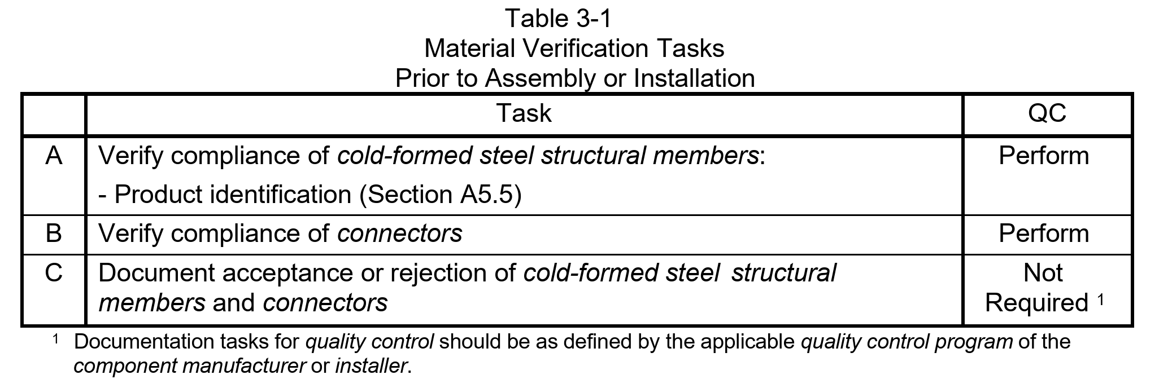

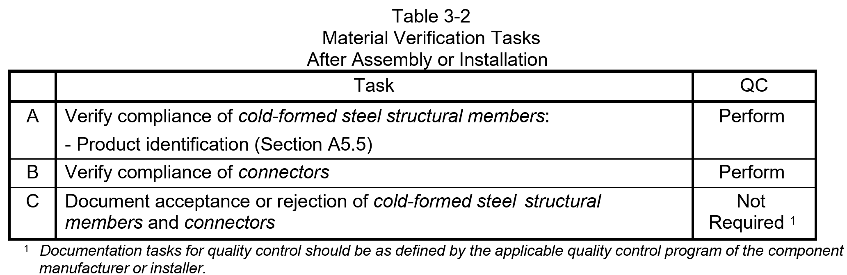

4.0 INSPECTION OF WELDING
      - Observation of welding operations and visual inspection of in-process and completed welds shall be the primary method to confirm that the materials, procedures and workmanship are in conformance with the construction documents and <<AWS D1.3/D1.3M>>.
      - Welding inspection tasks shall be in accordance with Tables 4-1, 4-2 and 4-3.

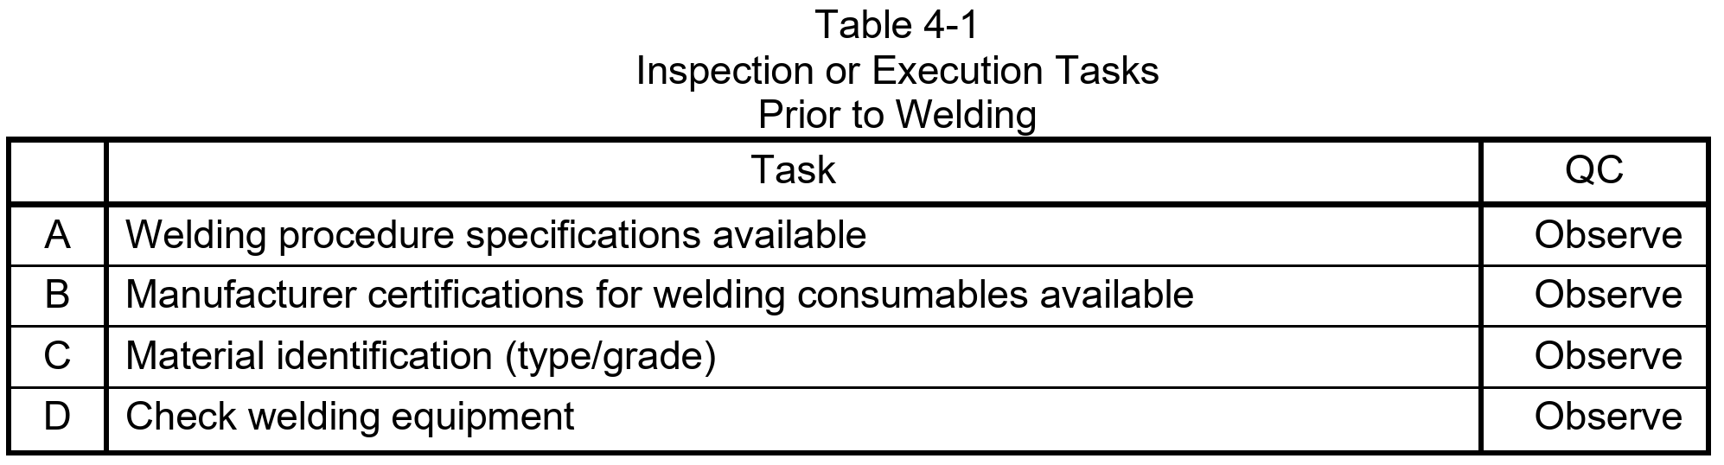

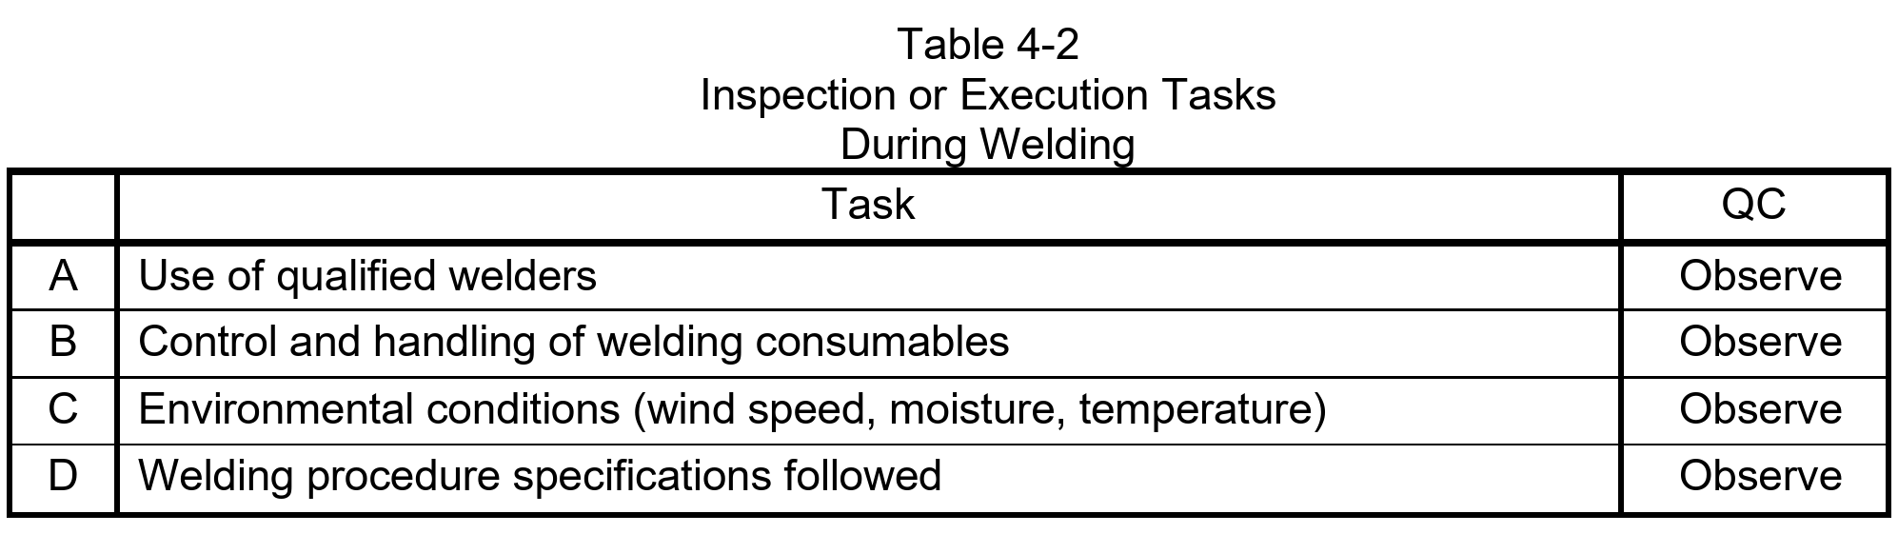
      - 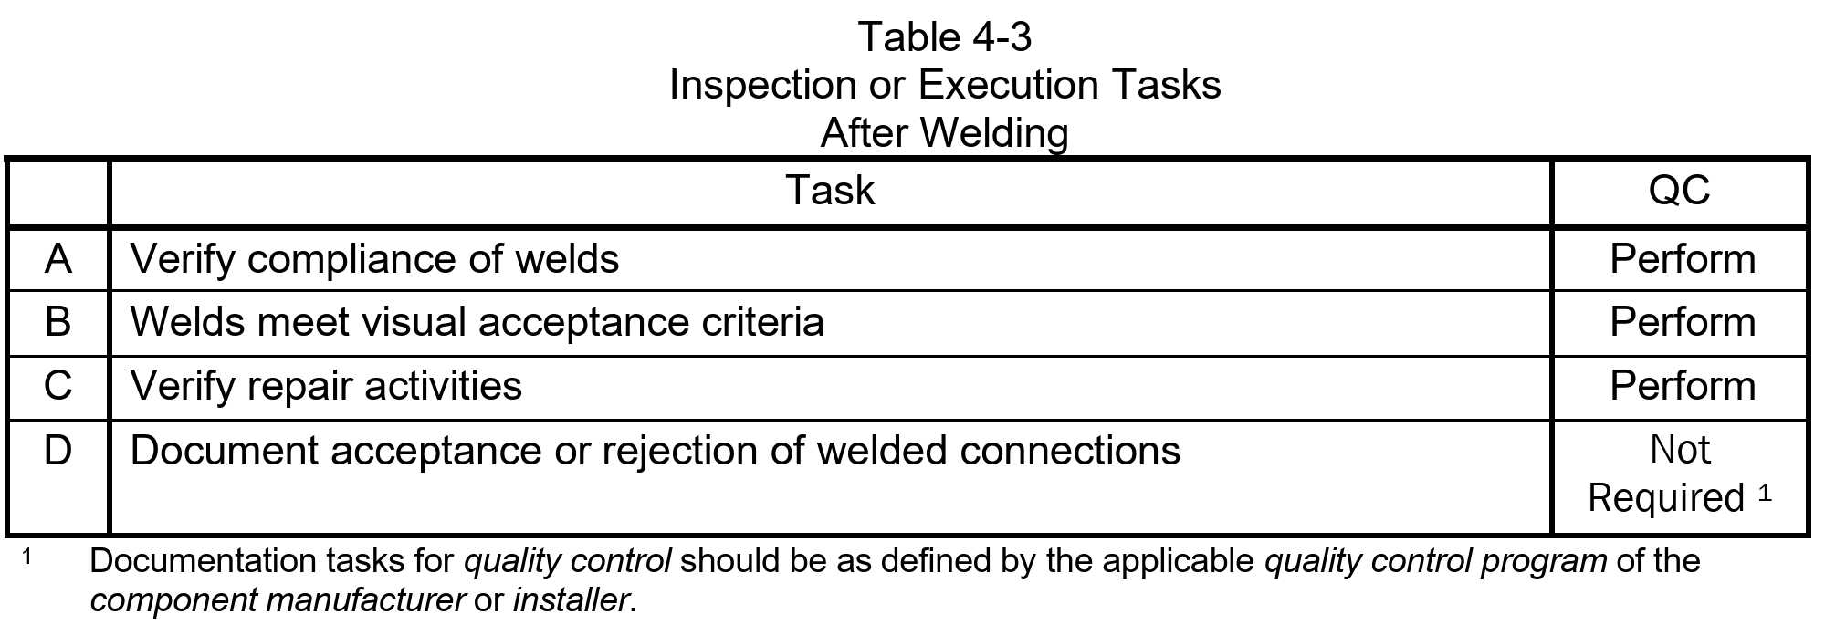

5.0 INSPECTION OF MECHANICAL FASTENING
      - Observation of mechanical fastening operations and visual inspection of in-process and completed connections shall be the primary method to confirm that the materials, procedures and workmanship are in conformance with the construction documents and manufacturer’s installation instructions.
      - Mechanical fastening inspection tasks shall be in accordance with Tables 5-1, 5-2 and 5-3.

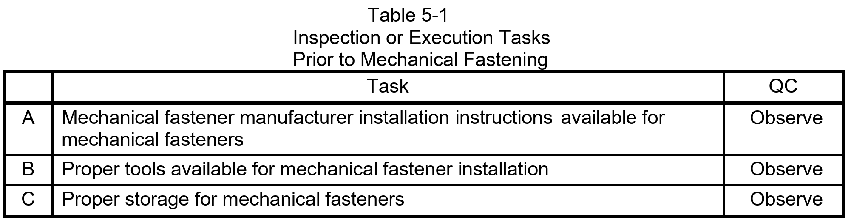

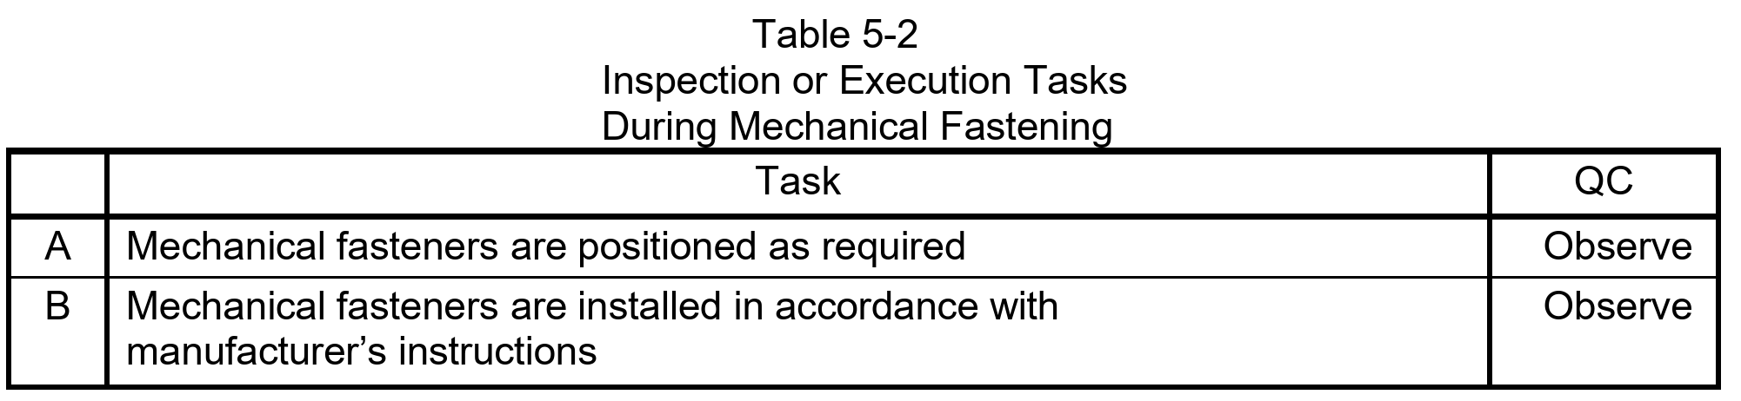

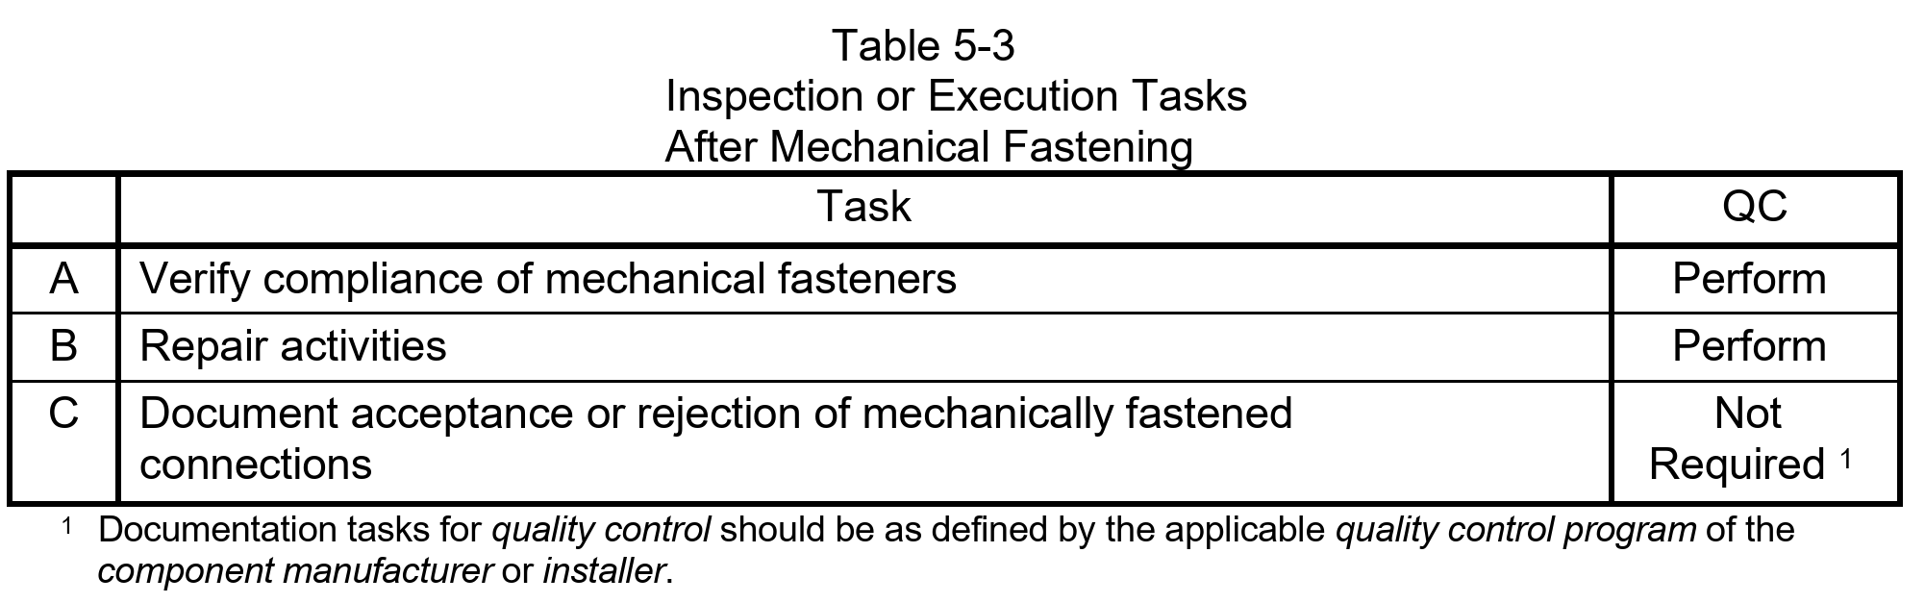

6.0 INSPECTION OF COLD-FORMED STEEL LIGHT-FRAME CONSTRUCTION
      - The component manufacturer’s quality control inspector shall perform inspections of the component assemblies to verify compliance with the details shown on the shop drawings.
      - The installer’s quality control inspector shall perform inspections of the field-installed cold-formed steel structural members, component assemblies and connectors to verify compliance with the details shown on the installation drawings.
      - Inspection tasks shall be in accordance with Table 6-1.

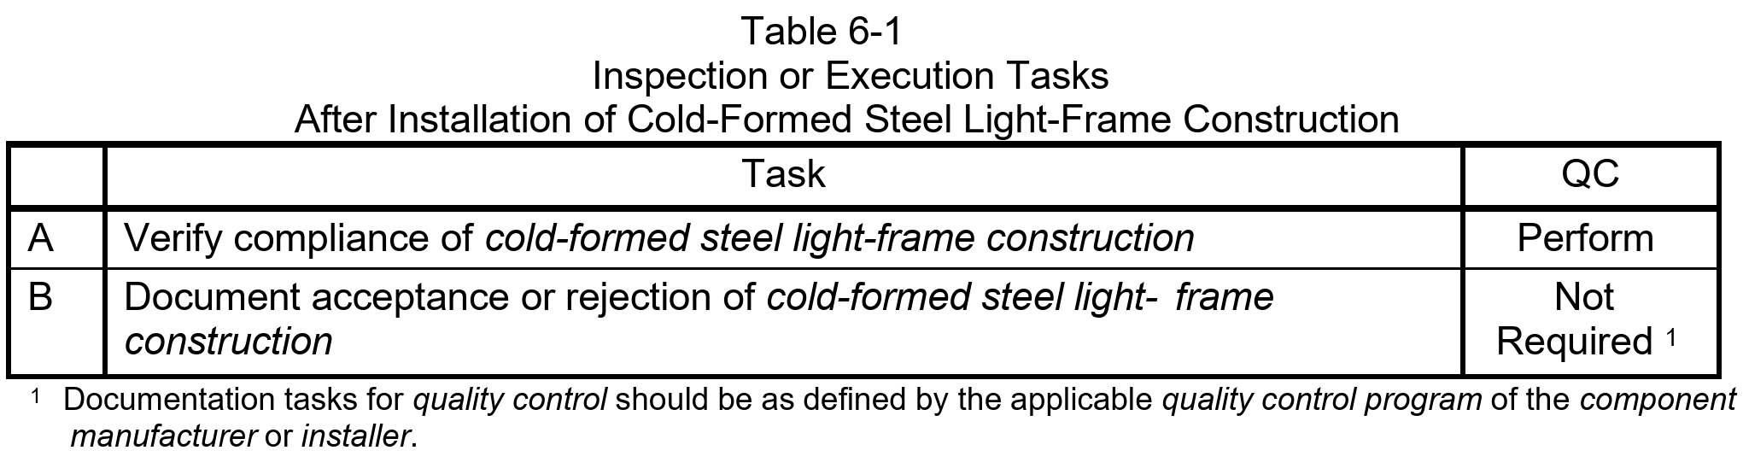

7.0 ADDITIONAL REQUIREMENTS FOR LATERAL FORCE RESISTING SYSTEMS
      - Additional inspection tasks for cold-formed steel lateral force resisting systems shall be in accordance with Tables 7-1 through 7-5.

Exception: The requirements in Section 7 are not required for cold-formed steel lateral force resisting systems where either of the following apply:
        - The sheathing of the shear wall is gypsum board or fiberboard.
        - The sheathing is wood structural sheathing or steel sheet sheathing on only one side of the shear wall or diaphragm assembly and the fastener spacing of the sheathing is more than 4 inches on center (o.c.).
      - Fit-up of Welds

In Table 7-2, following performance of the inspection task for ten welds made by a given welder, with the welder demonstrating understanding of requirements and possession of skills, the Perform designation of this task shall be reduced to Observe.

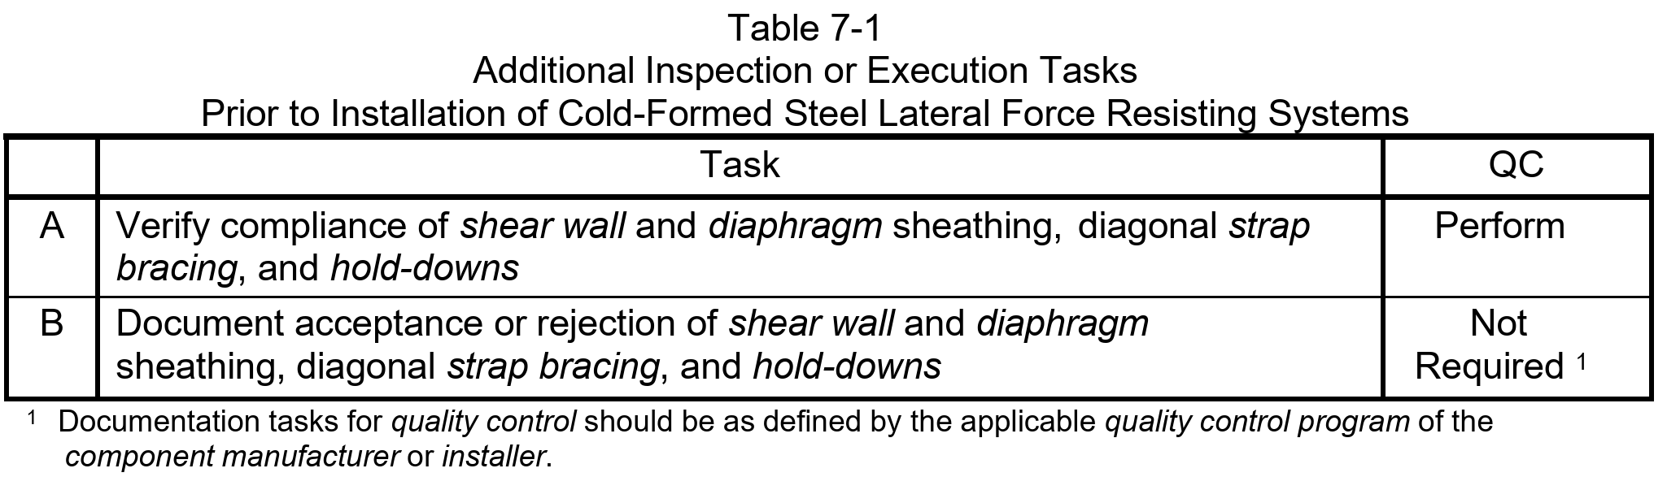

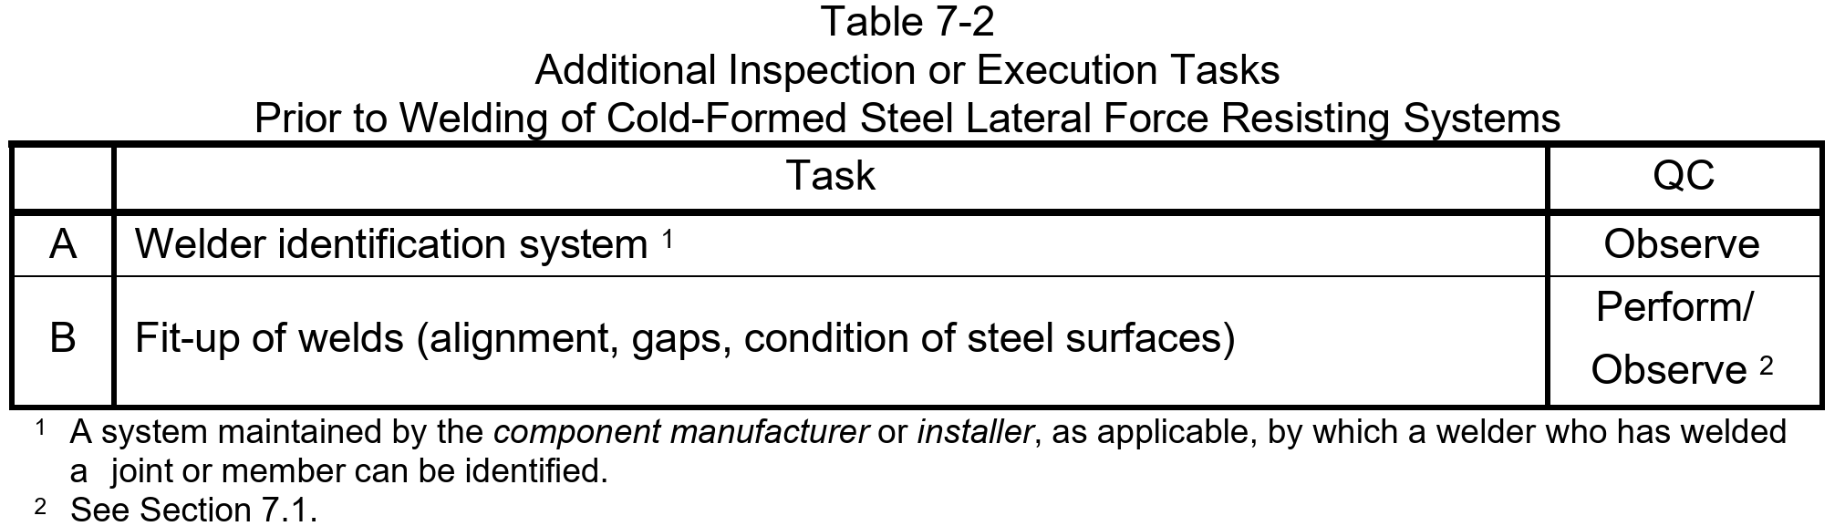

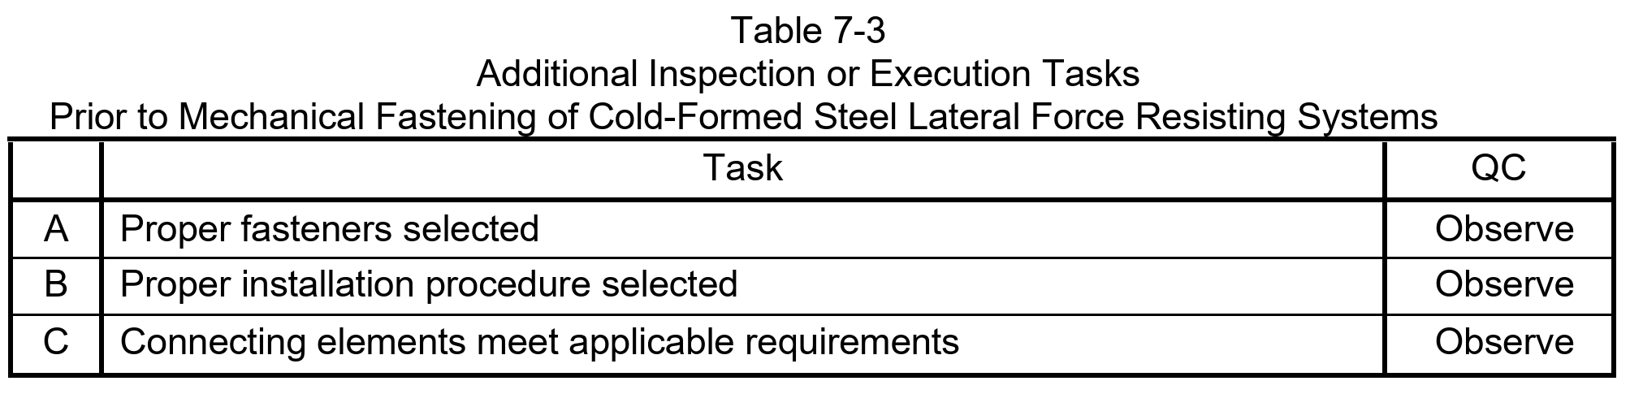

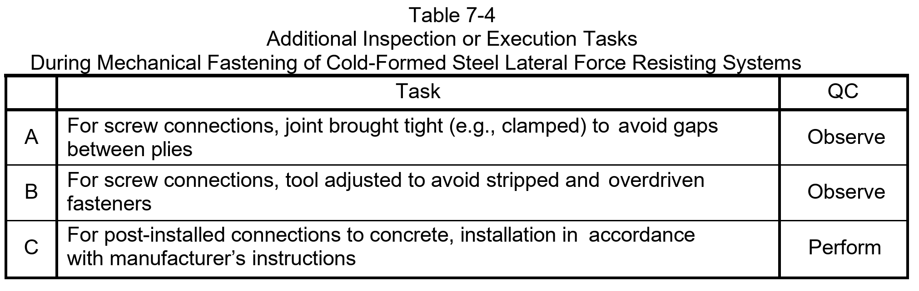

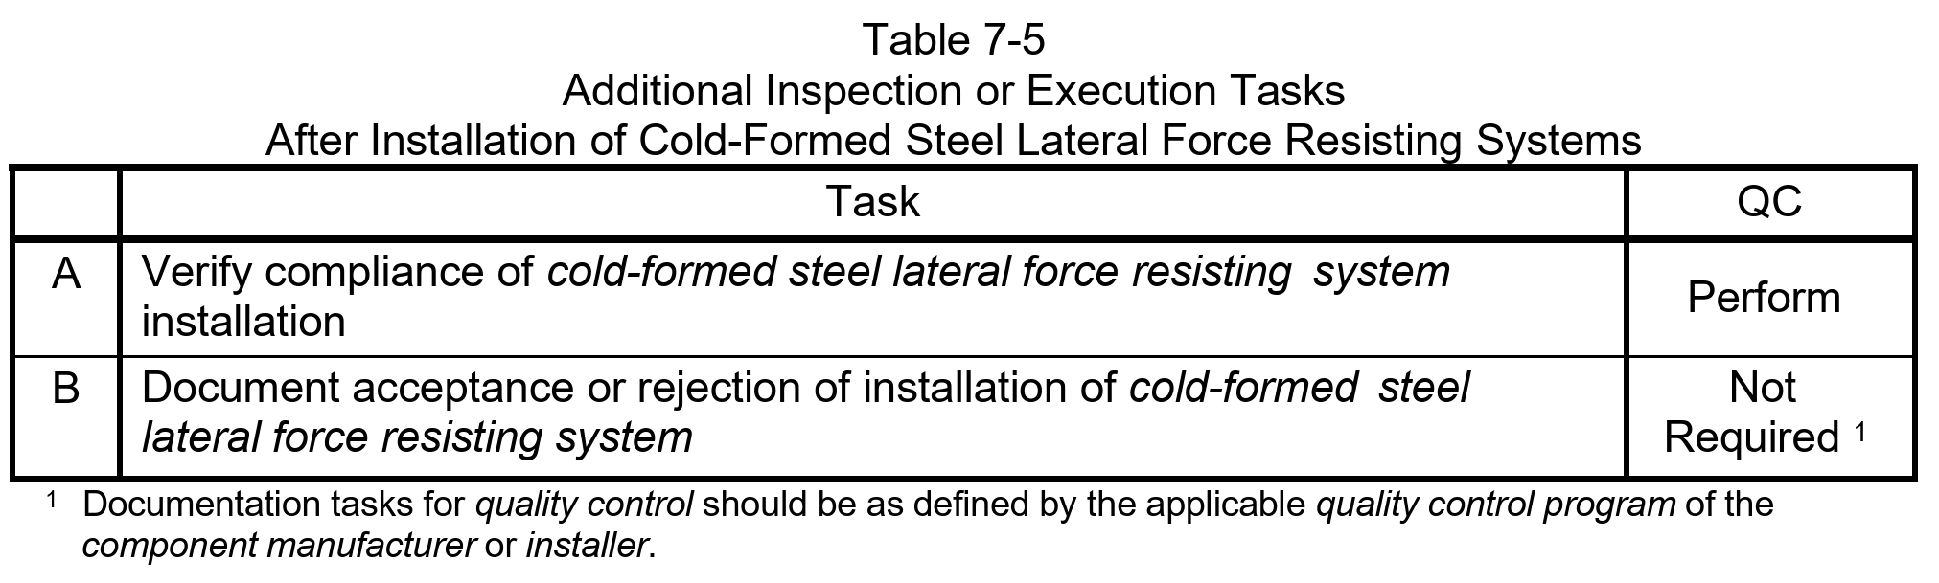
END OF SECTION

