Section 09 5100
Acoustical Ceilings

************************************************************************************************************

LANL MASTER SPECIFICATION SECTION
Rev. 8 Summary of Changes: Edited and updated as required for import into SpecLink.

NOTE TO SPECIFIER ON USAGE IN SPECLINK: Activate the Section by turning on Seq #0000, followed by activating paragraphs in PART 1, Article SECTION INCLUDES. This will activate related articles, paras/subparas in the rest of the Section (i.e., SECTION INCLUDES in PART 1 activates articles and paras/subparas in PARTS 2 and 3). If there are choice fields to edit the entire Section (typically in this first author note or beginning of the Section), make selections at those locations, which will filter through the remaining Section. All Articles, paragraphs and subparagraphs must be activated sequentially from top to bottom, unless noted otherwise.

This template must be edited for each project. In doing so, Specifier must add job-specific requirements. Selections and choice fields are used to indicate designer choices or locations where text must be supplied by the designer. The section must also be edited to remove requirements for processes, items, or designs that are not included in the project.

To seek a variance from applicable requirements in this Section, contact the Engineering Standards Manual (ESM) Structural/Architectural POC (LANL access only). Please contact POC with suggestions for improvement as well. LANL personnel should submit here: Suggested Change or Request Clarification; subcontractors via email to engstandards@lanl.gov.

When assembling a specification package, include applicable specifications from all Divisions, especially Division 1, General Requirements.

Section is developed for ML-4 projects. For ML-1, 2, and 3 applications, additional requirements and independent reviews should be added if increased confidence in procurement or execution is desired; see LANL ESM Chapter 1 - General, Section Z10 Specifications and Quality sections.

==========================================================

Sustainable Design:

This Section includes reference to SD that only applies to certain larger projects (e.g., Total Estimated Cost > $5 million) and other projects having SD goals (Ref. LANL ESM Chapter 14 - Sustainable Design). Omit if not applicable.

Seismic Design:

This Specification includes requirements for seismic design in accordance with ASCE 7, Section 13.5.6, Suspended Ceilings. The following provisions in Section 13.5.6 may exempt a suspended ceiling from seismic design:

1. Suspended ceilings with an area less than or equal to 144 ft² (13.4 m²) that are surrounded by walls or soffits laterally braced to the structure above are exempt.

2. Suspended ceilings consisting of screw- or nail-attached gypsum board on a single level, surrounded by and connected to walls or soffits that are laterally braced to the structure above, are exempt.

If the Project ceiling qualifies for either exception, omit all seismic design requirements from this Specification.

For suspended ceilings requiring seismic qualification (i.e., non seismically-exempt), ASCE 7 Sect. 13.2 includes two methods for achieving compliance:

1) Project-specific design and documentation (PSDD), or

2) Manufacturer’s certification (MC).

If the project selects PSDD, the EOR may prepare the documentation, or delegate the design to the Construction Subcontractor if permitted by the EOR’s subcontract.

If the project selects MC, the Manufacturer must provide certification that the component is seismically qualified, and indicate whether certification is based on actual test of assembled components, supports and attachments, or on calculation/analysis of them.

The Statement of Special Inspections (SSI) for Projects that require seismic qualification (i.e., non seismically-exempt) of suspended ceilings must include all inspections required by the applicable ICC-ES Report (or similar) for the suspended-ceiling system specified for use. And, for Projects using MC, the SSI must also include the Certificate of Compliance. Refer to LANL ESM Chapter 16 - Building Code Program, Section IBC-IP, Attachment B, Tables 1705.1.1 (special cases), 1704.5 (steel), and 1705.13 (seismic resistance) -- as applicable.

***********************************************************************************************************
  - PART 1 - GENERAL
    - SECTION INCLUDES

***************************************************************************************

Retain the following paragraphs and applicable subparagraphs, as required by the project.

***************************************************************************************
      - Acoustical tiles and panels.
      - Metal suspension systems.
        - Lay-In Grid Suspension System

*** OR ***
        - Concealed Grid Suspension System
      - Accessories
      - Supplementary acoustic insulation over system units.
      - Mockups

***************************************************************************************

Omit the following paragraph If the acoustic ceiling is exempt from seismic qualification/design. It not exempt coordinate with the Structural EOR and choose between project-specific design and documentation (PSDD) and manufacturer’s certification (MC) based on the project’s seismic performance requirements and the designated importance of the ceiling system:

Project-Specific Design and Documentation (PSDD):

PSDD can be prepared by the Engineer of Record (EOR) or delegated to the Subcontractor, depending on contract provisions.

Manufacturer’s Certification (MC):

Choose this option if the project allows for compliance through manufacturer-provided documentation demonstrating that the ceiling system meets the seismic requirements of ASCE 7-16. This is typically suitable when the manufacturer has prequalified systems.

***************************************************************************************
      - <<ASCE 7>> compliance requirements based on << Delegated project-speciﬁc design and documentation; Manufacturer’s certiﬁcation; EOR project-speciﬁc design and documentation; or choose a seismic qualification option>>.

***************************************************************************************

Subcontractor might expect to find in this Section requirements that are specified in the following Sections.

Section ​​​<< 01 8734 - Seismic Qualification of Nonstructural Components (IBC)>>​​​.

Section ​​​<< 09 2116 - Gypsum Board Systems>>​​​.

Section ​​​<< 21 1300 - Fire-Suppression Sprinkler Systems>>​​​ for Sprinkler Heads in Ceiling Systems.

Section ​​​​<< 23 3101 - HVAC Ducts>>​​​​ for HVAC devices in ceiling Systems.

Section 23 3700 Air Outlets and Inlets: Air Diffusion Devices in Ceiling Systems

Section ​​​<< 26 5100 - Interior Lighting>>​​​ for Light Fixtures in Ceiling System.

Section ​​​<< 27 3000 - Voice Communications>>​​​ for Speakers in Ceiling System.

Section ​​<< 28 4600 - Fire Detection and Alarm>>​​ for Fire Alarm Components in Ceiling System.

***************************************************************************************
    - RELATED REQUIREMENTS
      - Section ​​<< 01 4000 - Quality Requirements - Non-Nuclear>>​​.
      - Section ​<< 01 8113.13 - Sustainable Design>>​.
      - Section ​​​<< 05 0520 - Post-Installed Concrete and Grouted Masonry Anchors - Normal Confidence>>​​​.
      - Section ​<< 07 2100 - Thermal Insulation>>​.
      - Section << 07 9200 - Joint Sealants>>.

**********************************************************************************************

The standards listed below are provided for reference only and are not listed within the body of this Section. It is a designer-choice to include these standards.

<<UL (DIR)>>

**********************************************************************************************
    - REFERENCE STANDARDS
      - ACI CODE-318 - Building Code for Structural Concrete—Code Requirements and Commentary.
      - ASCE 7 - Minimum Design Loads and Associated Criteria for Buildings and Other Structures.
      - ASTM A580/A580M - Standard Specification for Stainless Steel Wire.
      - ASTM A641/A641M - Standard Specification for Zinc-Coated (Galvanized) Carbon Steel Wire.
      - ASTM A653/A653M - Standard Specification for Steel Sheet, Zinc-Coated (Galvanized) or Zinc-Iron Alloy-Coated (Galvannealed) by the Hot-Dip Process.
      - ASTM B164 - Standard Specification for Nickel-Copper Alloy Rod, Bar, and Wire.
      - ASTM C635/C635M - Standard Specification for Manufacture, Performance, and Testing of Metal Suspension Systems for Acoustical Tile and Lay-in Panel Ceilings.
      - ASTM C636/C636M - Standard Practice for Installation of Metal Ceiling Suspension Systems for Acoustical Tile and Lay-In Panels.
      - ASTM E84 - Standard Test Method for Surface Burning Characteristics of Building Materials.
      - ASTM E119 - Standard Test Methods for Fire Tests of Building Construction and Materials.
      - ASTM E580/E580M - Standard Practice for Installation of Ceiling Suspension Systems for Acoustical Tile and Lay-in Panels in Areas Subject to Earthquake Ground Motions.
      - ASTM E795 - Standard Practices for Mounting Test Specimens during Sound Absorption Tests.
      - ASTM E1264 - Standard Classification for Acoustical Ceiling Products.
      - CAL (CDPH SM) - Standard Method for the Testing and Evaluation of Volatile Organic Chemical Emissions from Indoor Sources Using Environmental Chambers Version 1.2.
      - ICC (IBC) - International Building Code.
      - NFPA 286 - Standard Methods of Fire Tests for Evaluating Contribution of Wall and Ceiling Interior Finish to Room Fire Growth.
      - UL (DIR) - Online Certifications Directory.
      - UL (FRD) - Fire Resistance Directory.
    - DEFINITIONS
      - For definitions and acronyms, refer to COE Glossary of Terms. This Section follows the notation, symbols and definitions in <<ASCE 7>>. Where additional terms or notations are used, their definitions are included in this Section.
      - Attachments: Means by which nonstructural components or their supports are secured or connected to the seismic force-resisting system of the structure. These attachments include anchor bolts, welded connections, and mechanical fasteners.
      - Designated Seismic System (DSS): Nonstructural components that must be designed in accordance with <<ASCE 7>> Chapter 13 and for which the component Importance Factor, I_{p}, is greater than 1.0.
      - Noncritical components: All components that have/are assigned I_{p} = 1.0.
      - Seismic Deformations: Drifts, deflections and seismic relative displacements determined in accordance with the applicable seismic requirements of the Building Codes currently in at LANL.
      - Seismic Forces: Forces acting in any direction on a nonstructural component and related system due to the action of an earthquake as defined in the Building Codes currently in effect at LANL.
      - Seismic Restraint: Structural members or assemblies of members or manufactured elements specifically designed and applied for transmitting seismic forces between components and the seismic force-resisting system of the structure.
      - Supports: Structural members, assemblies of members, or manufactured elements—such as braces, frames, legs, lugs, snubbers, hangers, saddles, struts, and their associated fasteners—that transfer loads between nonstructural components and their connections to the main structure.

***************************************************************************************

Include the following Article as required to coordinate acoustical ceiling installation with other trades.

***************************************************************************************
    - ADMINISTRATIVE REQUIREMENTS
      - Pre-installation Conference: Conduct conference at the project site ​<< one week; or ______>>​​ before starting work to:
        - Review interfaces and coordinate with mechanical and electrical systems.

******************************************************************************

Retain the following subparagraph if applicable.

******************************************************************************
        - Review and finalize the construction schedule.
        - Verify availability of materials, installer personnel, equipment, and facilities required to meet the schedule and prevent delays.
    - ACTION SUBMITTALS

***************************************************************************************

Edit submittals to include only those absolutely necessary to assure the requirements and features that are important for the specific project will be met. Coordinate with Article Section Includes, PART 2 and PART 3.

***************************************************************************************
      - Product Data: Provide data for ​​<< suspension system components; acoustical units; panels/tiles; accessories; and electrical resistance characteristics and ground connection requirements>>​​.
      - Shop Drawings: Indicate ceiling layout, interruptions to grid,​​​​<< special-sized panels/tiles,; or None - N/A>>​​​​ panels or tiles requiring drilling or cut-out for services, appurtenances or interruptions, edge details,​​​​<< elevation differences; location of mechanical and electrical interfaces; and ______>>​​​​.

******************************************************************************

Omit the following paragraph If the acoustic ceiling is exempt from seismic qualification/design.

Include if ceilings require seismic design and PSDD will be provided. Don’t include subparagraph if MC is applicable. Refer to author note on page 1 for details.

******************************************************************************
        - Indicate installation details required for seismic restraint.

***************************************************************************************

Include the following two paragraphs for submission of physical samples for selection of finish, color, texture, and other properties unless selected during design and as specified.

***************************************************************************************
      - Samples: Submit ​​<< two; or ______>>​​ samples ​​<< __by__ inch>>​​ in size illustrating material, finish and color of acoustical units.
      - Samples: Submit ​​​<< two; or ______>>​​​ samples each, ​​​<< ____ inches>>​​​ long, of suspension system ​​​<< main runner; cross runner; perimeter molding; and ______>>​​​.
      - Manufacturer's Installation Instructions: Submit special procedures, perimeter conditions requiring special attention​<< , and ______; or None - N/A>>​.

***************************************************************************************

Include the following paragraph if ceilings are (1) not exempt from seismic design and (2) PSDD will be the responsibility of the Subcontractor. Don’t include paragraph if PSDD will be provided by EOR, or if MC applies to Project. Refer to author note on page 1 for details.

***************************************************************************************
      - Delegated-Design Submittal: For seismic restraints for ceiling systems.
        - Include design calculations and analysis data, signed and sealed by the professional engineer, registered in the State of New Mexico, responsible for their preparation.

***************************************************************************************

Omit the following paragraph only if ceilings are exempt from seismic design.

***************************************************************************************
      - Independent Evaluation Reports: Show compliance with specified requirements, for each acoustical panel ceiling suspension system​​​<< and fastener type; or None - N/A>>​​​, from ICC-ES or similar.
      - Field quality-control reports.

***************************************************************************************

Retain the following paragraph if required by the project.

***************************************************************************************
      - Sustainable Design Submittals:
        - Sustainable Design (SD) Submittals: Provide material content documentation in accordance with the requirements of this Section.​​​<< Submit any additional documentation for this product category, as applicable under Section 01 8113.13 - Sustainable Design with this Section's submittal.; or None - N/A>>​​​
        - Manufacturer's Certificate: Certify products meet or exceed specified sustainable design requirements.

**********************************************************************

Edit material certifications list to suit products specified in this section and Project sustainable design requirements.

**********************************************************************
          - Materials Resources Certificates:
            - Certify source and origin for ​​​<< salvaged; and reused>>​​​ products.
            - Certify recycled material content for recycled content products.
            - Certify source for local and regional materials and distance from Project site.
          - Indoor Air Quality Certificates: Certify volatile organic compound content for each interior sealant and related primer.
    - INFORMATIONAL SUBMITTALS

***************************************************************************************

Retain the following paragraph if seismic qualification of the ceiling(s) is done via project-specific delegated design.

***************************************************************************************
      - Submit credentials for the Professional Engineer responsible for the seismic design of the acoustic ceiling. Documentation shall verify licensure and relevant experience in seismic design of acoustic ceiling systems.

***************************************************************************************

Retain the following paragraph if compliance with ASCE 7 Chapter 13 is done through Manufacturer’s Certification, without requiring project-specific design and documentation. When compliance is based on manufacturer’s certification, items must be installed per the manufacturer’s requirements. Evidence of compliance may be a signed statement from the manufacturer’s representative or a registered design professional confirming the component or system is seismically qualified.

If retained, identify each distinct component type requiring qualification either by listing it in Table 2.1(a) or by indicating it on the construction Drawings.

***************************************************************************************
      - Manufacturer's Certification:
        - Provide manufacturer’s certification that the ​​​​​​​<< noncritical; DSS; and None - N/A>>​​​​​​​ acoustic ceiling ​​​​​​​<< system; or systems>>​​​​​​​ ​​​​​​​<< listed in Table 2.1(a); or shown on drawings>>​​​​​​​, including all accessories and subcomponents, ​​​​​​​<< is; or are>>​​​​​​​ seismically qualified. Indicate whether qualification is based on physical testing of assembled components, supports, and attachments, or on engineering analysis and calculations.
        - Submit dimensioned outline drawings of Acoustical Ceilings. Clearly indicate mounting, support, and attachment provisions.
        - Provide specifications and installation drawings for components, supports, and attachments necessary to ensure installation is consistent with the seismic certification.

******************************************************************************

Retain the following subparagraph if anchorage to concrete is required.

******************************************************************************
        - Submit a detailed description of anchorage products or devices used for component attachment. Include installation requirements and demonstrate how the anchorage complies with <<ACI CODE-318>>.
      - At Closeout:
        - Operation and Maintenance Data.
        - Warranty Documentation.
        - Project Records Documentation.
    - EXTRA MATERIALS
      - Furnish ​​<< ____>>​​ sq. ft. of extra ​​<< tiles; panels; and metal pans>>​​ to the LANL Subcontract Technical Representative (STR).

*** OR ***
      - Furnish ​​<< ____>>​​ percent of total acoustic unit area of extra ​​<< tiles; panels; and metal pans>>​​ to the LANL Subcontract Technical Representative (STR).
    - QUALITY ASSURANCE
      - Refer to Section ​<< 01 4000 - Quality Requirements - Non-Nuclear>>​ for general Quality Assurance (QA) requirements applicable to all items, products, and services.
      - Qualifications:

******************************************************************************

Retain the following subparagraph if seismic qualification of the ceiling(s) is done via project-specific delegated design.

******************************************************************************
        - Designer: Perform seismic design under the direct supervision of a licensed Professional Structural Engineer experienced in designing acoustic ceiling systems of the type required.
        - Manufacturer: Company specializing in manufacturing Products specified in this section with minimum three years​​​<< documented; or None - N/A>>​​​ experience.
        - Installer: Company specializing in performing Work of this section with minimum ​<< ____>>​ years​<< documented; or None - N/A>>​ experience ​<< approved by manufacturer; or None - N/A>>​.
      - Surface-Burning Characteristics: Comply with <<ASTM E84>>; testing by a qualified testing agency. Identify products with appropriate markings of applicable testing agency.
      - Fire-Resistance Ratings: Comply with <<ASTM E119>>; testing by a qualified testing agency. Identify products with appropriate markings of applicable testing agency.
        - Indicate design designations from <<UL (FRD)>> or from the listings of another qualified testing agency.

***************************************************************************************

Include following paragraph if a mock-up is required for approval of final acoustical ceiling design.

***************************************************************************************
      - Mockups: Build mockups to verify selections made under sample submittals and to demonstrate aesthetic effects and set quality standards for materials and execution.
        - Construct mock-up, 12 feet x 12 feet, including typical field and edge conditions.
        - Locate where indicated on Drawings.
        - Approved mockups may become part of the completed Work if undisturbed up to time of Substantial Completion.
    - DELIVERY, STORAGE, AND HANDLING
      - Deliver acoustical panels/tiles, suspension-system components, and accessories to Project site in original, unopened packages and store them in a fully enclosed, conditioned space where they will be protected against damage from moisture, humidity, temperature extremes, direct sunlight, surface contamination, and other causes.
      - Before installing acoustical panels or tiles, permit them to reach room temperature and stabilized moisture content.
      - Handle acoustical panels and tiles carefully to avoid chipping edges or damaging units in any way.
    - SITE CONDITIONS
      - Install ceiling panels/tiles only after building is enclosed, sufficient heat is provided, dust generating activities have been finished, overhead work is completed, tested and approved, and interior wet work is dry.
      - Maintain uniform temperature of minimum ​​<< 60 degrees F; or ____ degrees F>>​​, and maximum humidity of ​​<< 40; or ______>>​​ percent prior to, during, and after acoustical unit installation.
    - WARRANTY
      - Provide manufacturer’s standard, all inclusive warranty.
  - PART 2 - PRODUCTS
    - MANUFACTURERS

***************************************************************************************

Retain the following paragraphs as required by the project.

***************************************************************************************
      - Armstrong World Industries, Inc.​<< ; Model ____; or None - N/A>>​.
      - CertainTeed Corporation​​<< ; Model ____; or None - N/A>>​​.
      - USG Corporation​​<< ; Model ____; or None - N/A>>​​.
      - Rockfon​​<< ; Model ____; or None - N/A>>​​.
      - ​​<< ____>>​​​​<< ; Model ____; or None - N/A>>​​.
      - Source Limitations: Obtain ceiling system through one source from a single manufacturer.
    - PERFORMANCE REQUIREMENTS
      - Design for maximum deflection of ​<< 1/360; 1/240; or ______>>​ of span.

***************************************************************************************

IBC requires surface burning to be tested in accordance with ASTM E84 for individual materials or NFPA 286 for wall and ceiling assemblies.

***************************************************************************************
      - Surface Burning Characteristics: Maximum ​​​<< 25/450; 75/450; or 200/450>>​​​ flame spread/smoke developed index when tested in accordance with <<ASTM E84>>.
      - Surface Burning Characteristics: Comply with the following when tested in accordance with <<NFPA 286>>.
        - During 40 kW Exposure: No flame spread to ceiling.
        - During 160 kW Exposure: No flame spread to perimeter of tested sample and no flashover.
        - Total Smoke Release: Maximum 1,000 cu m.

***************************************************************************************

Fire-rated ceiling system includes all elements above ceiling including floor or roof construction and can include specially constructed gypsum box or acoustic panel surrounding light fixtures and mechanical work.

***************************************************************************************
      - Fire Rated ​​​​​​<< Ceiling-Floor; and Ceiling-Roof>>​​​​​​ Construction: ​​​​​​<< Rating as indicated on Drawings; or ___ hour rating>>​​​​​​.
        - Tested Rating: Determined in accordance with <<ASTM E119>>.

******************************************************************************

Refer to IBC for tables of fire resistance ratings for various material and assemblies. Tables use item numbers to identify each assembly.

******************************************************************************
        - Prescriptive Rating: ​​​​<< Item number ____; ___; or None - N/A>>​​​​; determined in accordance with ​​​​<< applicable; or ______>>​​​​ code.
        - Installed System: Conform to ​​<< UL; or WH>>​​ Design ​​<< ____>>​​ for ​​<< ceiling and floor; ceiling and roof; or ______>>​​ assembly.

***************************************************************************************

Omit the following seismic performance paragraph if the ceiling(s) is exempt from seismic qualification/design. Edit the paragraph in accordance with related edits made in PART 1 regarding PSDD (EOR or delegated) or MC.

In short, the seismic performance requirements are as follows:

DSS: The extent of damage to the ceiling caused by the design-basis earthquake shall not result in the loss of functionality/operability of the facility, or “ceiling-ed room.” What this means is that no part of the ceiling falls and, as applicable, “services” that are part of the ceiling (e.g., lights, HVAC, sprinkler heads, etc.) will be operable/functional.

Non-DSS w/o a sprinkler head: The extent of damage to the ceiling caused by the design-basis earthquake can be severe up to, but not including, falling of its parts and pieces.

Non-DSS w/ a sprinkler head: Same as “w/o;” however, any/all sprinkler heads must be operable following the design-basis earthquake.

For a detailed discussion on the performance of ceilings in past earthquakes and recommended seismic detailing, refer to FEMA E-74, Section 6.3.4.1. The following FEMA-74 recommended details and figures are for Seismic Design Category D, E and F where the total ceiling weight does not exceed 4 psf or Seismic Design Category C where the total ceiling weight is between 2.5-4 psf. See sources for additional information, updates, or for connection details and special conditions not shown.

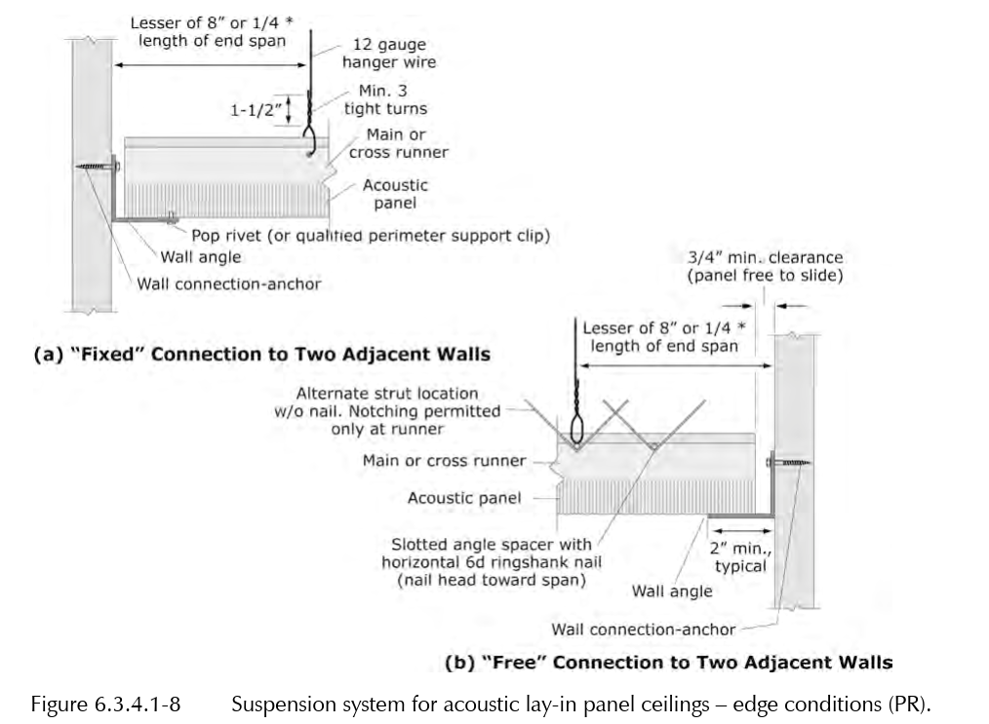

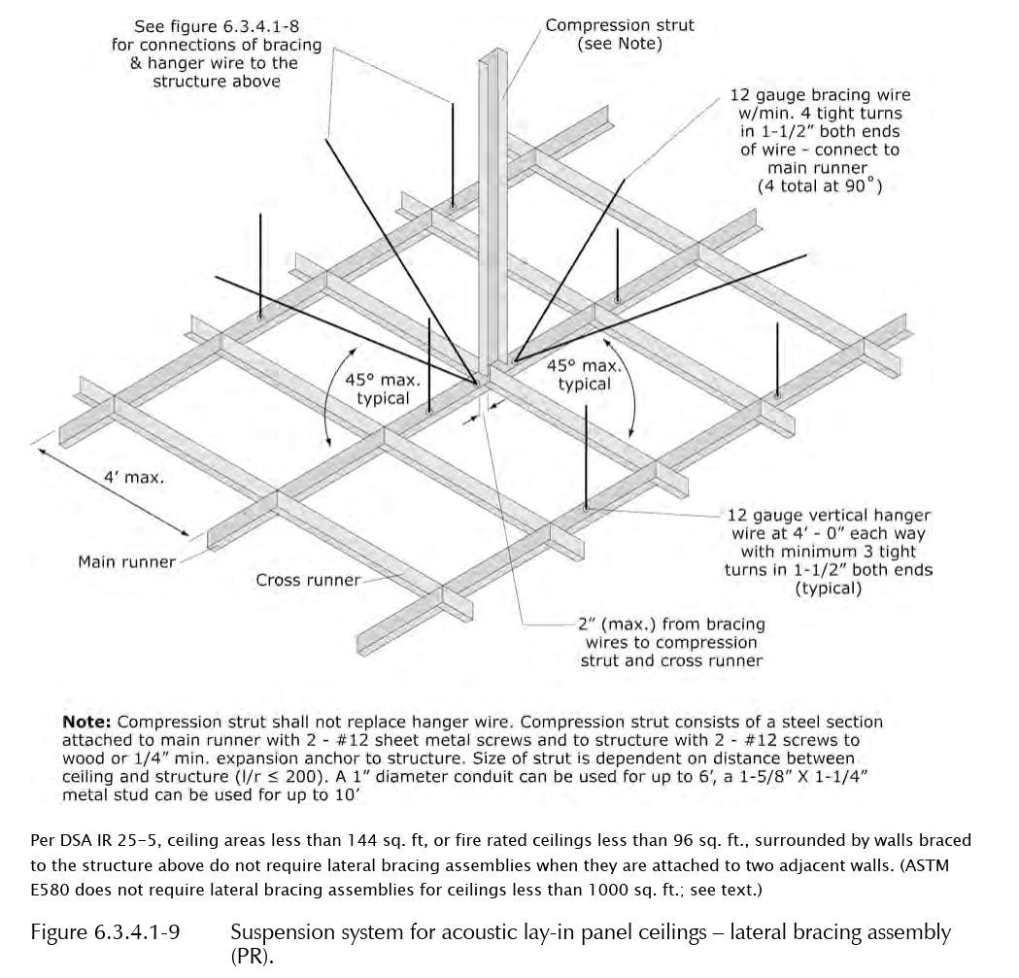

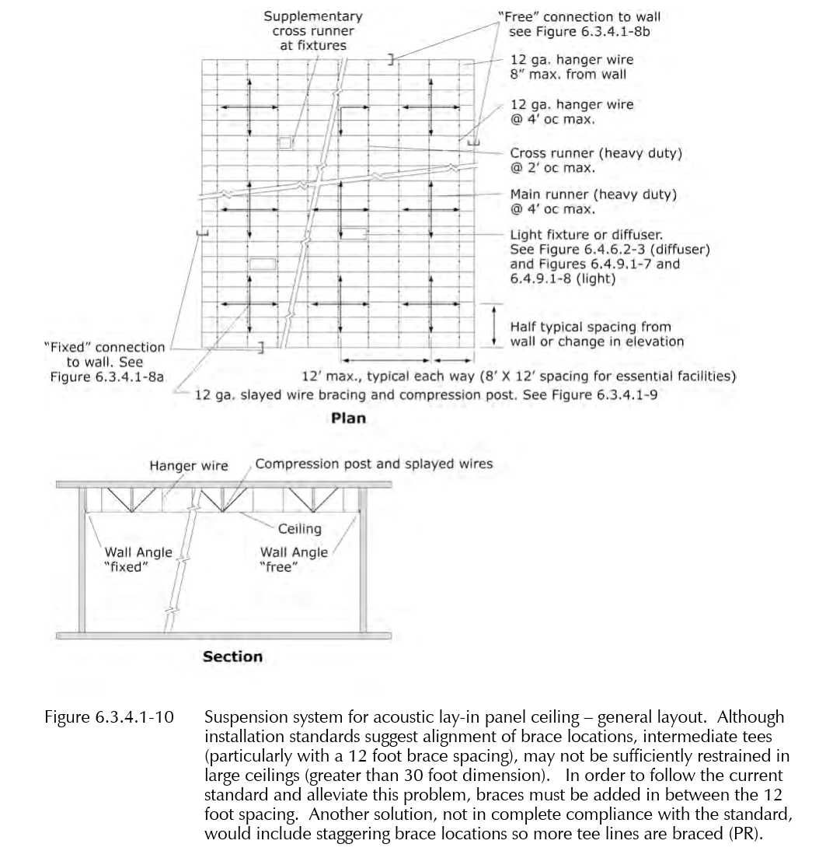

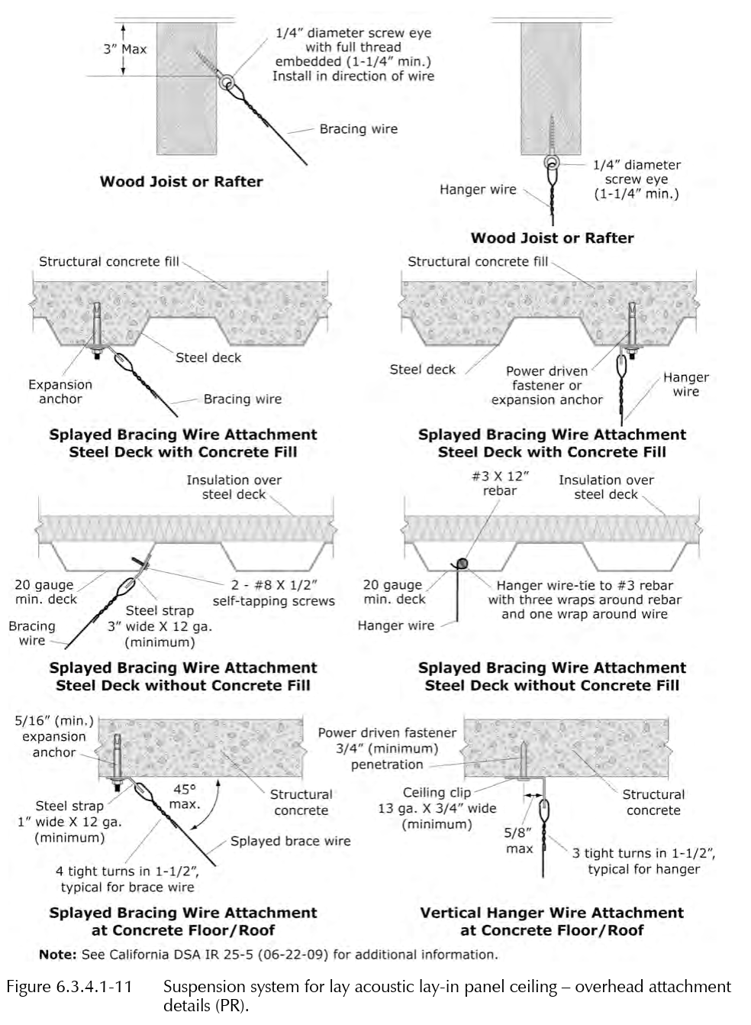

***************************************************************************************
      - Seismic Performance Requirements

******************************************************************************

Retain the following subparagraph if applicable.

******************************************************************************
        - Delegated Design: Engage a qualified Professional Engineer, to prepare the seismic design of the acoustical ceiling system.
        - Design the ceiling system to withstand earthquake effects in accordance with <<ASCE 7>> seismic design requirements.
        - For fire protection sprinkler (FPS) heads, “withstand” means no head shall sustain damage caused by ceiling motion or ceiling damage to the extent that it becomes inoperable following the specified earthquake motions.

******************************************************************************

Retain the following subparagraph if seismic design using PSDD is the Subcontractor’s responsibility (delegated design), or if MC applies to Project. Omit if PSDD will be provided by EOR.

******************************************************************************
        - Determine seismic design loads in accordance with <<ICC (IBC)>> Section 1613.

**********************************************************************

Select one of the following two subparagraphs.

**********************************************************************
          - Seismic design parameters for Acoustical Ceiling supports and attachments are specified in Tables 2.1(a) and 2.1(b) and as follows:

*************************************************************

Refer to LANL ESM Chapter 5 - Structural, Section II or LANL Tailored Standards Manual, Chapter 5, Earthquake Loads for the source of the criteria/data listed in the following subparas, and for editing of them.

*************************************************************
            - Building Risk Category: ​​​​​​​​​​<< I; II; III; IV; or ______>>​​​​​​​​​​.
            - Site Class: ​​​​​​​<< D; or ___>>​​​​​​​.
            - Design Spectral Response Acceleration at Short Periods, S_{DS}, gravity (g): ​​​​​​​​​<< ____>>​​​​​​​​​.
            - Design Spectral Response Acceleration at 1.0-Sec. Period, S_{D1}, gravity (g): ​​​​​​​​​<< ____>>​​​​​​​​​.
            - Seismic Design Category (SDC): ​​​​​​​<< D; C; or ______>>​​​​​​​.
          - Seismic design parameters for Acoustical Ceiling supports and attachments are specified on drawings.

**********************************************************************

Edit the following tables to include all acoustic ceiling components requiring seismic design. Add or remove rows as necessary.

**********************************************************************

Table 2.1(a): Acoustical Ceilings (AC)
​  ID | ​I_{p} | ​  Description
AC-1 | 1.0
AC-2 | 1.0

Table 2.1(b): Acoustical Ceiling Qualification Requirements
​  ID | ​  h  (feet) | ​  z  (feet) | ​  a_{p} | ​  R_{p}
AC-1
AC-2
    - ACOUSTICAL TILES AND PANELS
      - General

******************************************************************************

Retain the following subparagraph if required by the project.

******************************************************************************
        - Low-Emitting Materials: Acoustical tile and panel ceilings shall comply with the testing and product requirements of <<CAL (CDPH SM)>>.

******************************************************************************

Retain the following subparagraph if required by the project.

******************************************************************************
        - Recycled Content
          - Minimum 20 percent recycled content.
        - Glass-Fiber-Based Tiles and Panels: Made with binder containing no urea formaldehyde.

******************************************************************************

Biobased acoustical tiles and panels are Designated Green Products for Federal Procurement by the EPA. However biobased acoustical tiles and panels are currently a cost premium to industry standard mineral or glass fiber acoustical tiles and panels. In addition, use of biobased products in wet areas, clean rooms and/or laboratories should be used with caution. Include following subparagraph only if use of biobased product is cost effective and will not impact the environmental quality or programmatic requirements of the proposed usage.

******************************************************************************
        - Biobased Tiles and Panels: Minimum 37 percent biobased content.
        - Acoustical Tile and Panel Standard: Provide manufacturer’s standard tiles and panels of configuration indicated that comply with <<ASTM E1264>> classifications as designated by types, patterns, acoustical ratings, and light reflectance unless otherwise indicated.
          - Mounting Method for Measuring NRC: Type E-400; plenum mounting in which face of test specimen is 15-3/4 inches away from test surface according to <<ASTM E795>>.
        - Acoustical Tiles and Panel Colors and Patterns: Match appearance characteristics indicated for each product type.
          - Where appearance characteristics of acoustical tiles and panels are indicated by referencing pattern designations in <<ASTM E1264>> and not manufacturer’s proprietary product designations, provide products selected by Architect from each manufacturer’s full range that comply with requirements indicated for type, pattern, color, light reflectance, acoustical performance, edge detail, and size.

***************************************************************************************

Retain one or both of the following paragraphs if applicable.

***************************************************************************************
      - Acoustic Tiles: ​​​<< ASTM E1264>>​​​, conforming to the following:
        - Size: 12 x 12 inches.
        - Thickness: ​<< 5/8; or ______>>​ inches.
        - Composition: ​<< Mineral; or ______>>​.
        - Density: << _______>> lb/cu.ft.
        - Light Reflectance: << _______>> percent.
        - NRC Range: << _______>> to << _______>>.
        - STC Range: << _______>> to << _______>>.
        - Joint: ​<< Kerfed; Rabbeted; or ______>>​.
        - Edge: ​<< Square; or Beveled>>​.
        - Surface Color: ​<< White; or ______>>​.
        - Surface Finish: ​<< Perforated; Non-directional fissured; Directional fissured; or ______>>​​<< , plastic wrapped; or None - N/A>>​.

*** AND/OR ***
      - Acoustic Panels: ​​<< ASTM E1264>>​​ conforming to the following:
        - Size: ​<< 12 x 24; 24 x 48; 24 x 24; or ______>>​ inches.
        - Thickness: ​<< 3/4; 5/8; or ______>>​ inch.
        - Composition: ​<< Mineral; or ______>>​.
        - Density: << _______>> lb/cu.ft.

******************************************************************************

Comply with LANL ESM Chapter 7 - Electrical, Section D5020, paragraph 7.1.B to obtain initial surface reflectance recommended in the IES Lighting Handbook (90%).

******************************************************************************
        - Light Reflectance: << _______>> percent.
        - NRC Range: << _______>> to << _______>>.
        - STC Range: << _______>> to << _______>>.
        - Edge: ​<< Square; Rabbeted; or ______>>​.
        - Surface Color: ​<< White; Color​ as selected​; or ______>>​.
    - METAL SUSPENSION SYSTEMS
      - General

******************************************************************************

Retain the following subparagraph if required by the project.

******************************************************************************
        - Recycled Content
          - Steel: Minimum 25 percent recycled content.
          - Aluminum: Minimum 50 percent recycled content.
        - Metal Suspension-System Standard: Provide manufacturer’s standard direct-hung metal suspension system and accessories according to <<ASTM C635/C635M>> and designated by type, structural classification, and finish indicated.

**********************************************************************

Retain the following subparagraph if required by the project.

**********************************************************************
          - High-Humidity Finish: Comply with <<ASTM C635/C635M>> requirements for “Coating Classification for Severe Environment Performance” where high-humidity finishes are indicated.

***************************************************************************************

Retain one or both of the following paragraphs if applicable.

***************************************************************************************
      - Non-fire Rated Grid: <<ASTM C635/C635M>>, ​​​<< light; intermediate; or heavy>>​​​ duty; ​​​<< exposed T; exposed T/one direction; concealed T and G; concealed H and T; paired access T; downward access removable T; concealed Z; concealed T; metal pan T; or ______>>​​​; components die cut and interlocking.

*** AND/OR ***
      - Fire Rated Grid: <<ASTM C635/C635M>>, ​​​<< light; intermediate; or heavy>>​​​ duty; listed by UL for use in ​​​<< ____>>​​​ hour assembly, ​​​<< two directional concealed; exposed T; exposed T/one direction; or ______>>​​​; components die cut and interlocking.

***************************************************************************************

Only steel grid material can be used in fire rated systems.

***************************************************************************************
      - Grid Materials: ​​<< Commercial quality cold rolled steel with galvanized coating; Cold rolled aluminum; Extruded aluminum; or ______>>​​.
      - Exposed Grid Surface Width: ​​<< 15/16; 9/16; or ______>>​​ inch​​<< with reveal; or None - N/A>>​​.

***************************************************************************************

Omit the “seismic-design option” in following paragraph if ceiling is exempt from seismic design.”

***************************************************************************************
      - Perimeter/Edge Molding and Trim: Type and profile indicated or, if not indicated, manufacturer's standard moldings for edges and penetrations​​​<< that comply with seismic design requirements; or None - N/A>>​​​; formed from sheet metal of same material, finish, and color as that used for exposed flanges of suspension-system runners.

******************************************************************************

If ceiling is exempt from seismic design, include the 1st & 3rd of the following subparagraphs.

If ceiling is not exempt, omit these subparagraphs and retain the 2nd one.

If retaining the 2nd subparagraph, select the 1st option if SDC D applies, and select the 2nd option if SDC C applies.

NOTE 1: With regard to 2nd subparagraph, if SDC D applies there is more to compliance with ASCE 7 subparagraph 13.5.6.2.2.a, than merely providing min. 2”-width perimeter support if/ when perimeter support clips are used. And, for ceiling areas > 2500 ft², “the more” might be required for compliance with 13.5.6.2.2.b.

NOTE 2: With regard to 3rd subparagraph, ASCE 7 paragraph 13.5.6.3 does not require large clearances around sprinkler piping penetrations for “non-exempt ceilings” if “Integral Construction” is used in lieu of “Industry Standard Construction.”

******************************************************************************
        - Perimeter Molding Width: Match grid width.
        - Perimeter Molding Width: Minimum ​<< 2; or 7/8>>​ inches.
        - For circular penetrations of ceiling, provide edge moldings fabricated to diameter required to fit penetration exactly.
      - Grid Finish: << White; Anodized; Color as selected; or ___>>
    - ACCESSORIES

***************************************************************************************

Omit the “seismic-design option” in following paragraph if ceiling is “exempt from seismic design.”

***************************************************************************************
      - Attachment Devices: Size for five times the design load indicated in <<ASTM C635/C635M>>, Table 1, "Direct Hung," unless otherwise indicated.​​​<< Comply with seismic design requirements.; or None - N/A>>​​​

******************************************************************************

Include the following subparagraph if post-installed (P-I) anchors are to be used to attach the ceiling to the supporting structure. If this is the case, then the P-I anchors shall be specified in the appropriate Division-3 Section.

******************************************************************************
        - Post-Installed Anchors: Provide anchors indicated and specified in Section ​​<< 05 0520 - Post-Installed Concrete and Grouted Masonry Anchors - Normal Confidence>>​​.

******************************************************************************

PAFs: If power-actuated fasteners are to be used to attach the ceiling to the supporting structure, include the following subparagraph and select from the options provided.

Each option is backed by an ICC-ES Report that requires design calculations. Use of other products is allowed provided they have similar “backing.”

If the ceiling is not exempt from seismic design, and if the SDC is D, then ASCE 7 para. 13.4.5 limits the use of PAFs in concrete and steel to service loads, on any individual fastener, of 90 and 250 lb., respectively.

******************************************************************************
        - Power-Actuated Fasteners in Concrete: ​<< Hilti Low-velocity Power-actuated Fasteners; Ramset and Duo-Fast Power-Actuated Fasteners and Ceiling Clip Assemblies; or ______>>​.
      - Wire Hangers, Braces, and Ties: Provide wires complying with the following requirements

******************************************************************************

Include 1 or more of the next 3 subparagraphs. If more than 1 type of wire is required, indicate locations for each type on Drawings. Revise hangers to strap type if required by LANL STR.

******************************************************************************
        - Zinc-Coated, Carbon-Steel Wire: <<ASTM A641/A641M>>, Class 1 zinc coating, soft temper.
        - Stainless-Steel Wire: <<ASTM A580/A580M>>, Type 304, nonmagnetic.
        - Nickel-Copper-Alloy Wire: <<ASTM B164>>, nickel-copper-alloy UNS No. N04400.

******************************************************************************

Retain 2nd option in "Size" (12 gauge = 0.106 in, 10 gauge = 0.135, 12 gauge) subparagraph below if required by LANL STR or if desired for extra security and quality (including an allowance for corrosion). Large sizes are difficult to work with, and could result in difficulty leveling the ceiling.

******************************************************************************
        - Size: Select wire diameter such that its stress at three times hanger design load (per <<ASTM C635/C635M>>, Table 1, “Direct Hung”) is less than the wire’s yield stress. Provide a minimum wire diameter of ​<< 0.106-inch; 0.135-inch; or ______>>​.

***************************************************************************************

If retaining paragraph below, select an option, and insert sizes or indicate on Drawings.

***************************************************************************************
      - ​<< Hanger Rods; or Flat Hangers>>​: Mild steel, zinc coated or protected with rust-inhibitive paint.

***************************************************************************************

If retaining paragraph below, select an option, and insert sizes or indicate on Drawings.

***************************************************************************************
      - Angle Hangers: Angles with legs not less than 7/8 inch wide; formed with 0.04-inch thick, galvanized-steel sheet complying with <<ASTM A653/A653M>>, G90 coating designation; with bolted connections and 5/16-inch diameter bolts.

***************************************************************************************

Retain the following paragraph if ceiling is direct-concealed suspended system, is not exempt from seismic, and if SDC D applies. For more detail, refer to ASTM E580 Section 5.2.5.

If ceiling is exempt from seismic, but stabilizer bars are needed to improve stability of the suspension system and unit alignment, retain Paragraph and revise as necessary.

***************************************************************************************
      - Seismic Stabilizer Bars: Manufacturer’s standard perimeter stabilizers designed to accommodate seismic forces.

***************************************************************************************

Retain paragraph below if ceiling is not exempt from seismic & if SDC D applies. Coordinate with manufacturer's requirements and LANL STR.

***************************************************************************************
      - Seismic Struts: Manufacturer’s standard compression struts designed to accommodate seismic forces.

***************************************************************************************

Retain paragraph below if ceiling is not exempt from seismic and if SDC D applies. For more detail, refer to ASCE 7 para. 13.5.6.2.2.a. Coordinate with manufacturer's requirements and LANL STR.

***************************************************************************************
      - Seismic Clips: Manufacturer’s standard seismic clips designed to secure acoustical panels in place during a seismic event.

***************************************************************************************

Retain paragraph below if required. Fire-resistance-rated panels generally weigh more than 1 lb/sq. ft., and hold-down clips are not required to comply with UL design requirements. Verify weight of panels selected for UL fire-resistant designs, and revise below to require hold-down clips for fire-resistance-rated ceilings with panels weighing less than 1 lb/sq. ft.

***************************************************************************************
      - Hold-Down Clips: Manufacturer’s standard hold-down.

***************************************************************************************

Retain paragraph below if required.

***************************************************************************************
      - Impact Clips: Manufacturer’s standard impact-clip system designed to absorb impact forces against acoustical panels.

***************************************************************************************

Acoustic batt insulation placed over acoustic suspension ceiling systems may absorb moisture over time and induce loads or collapse ceiling systems. Use with caution.

***************************************************************************************
      - Acoustic Batt Insulation: Specified in Section ​<< 07 2100 - Thermal Insulation>>​.

***************************************************************************************

Retain the following paragraph if applicable.

***************************************************************************************
      - Gypsum Board: Fire rated type; ​​<< 5/8; or ______>>​​ inch thick, ends and edges square, paper faced.
      - Acoustic Sealant For Perimeter Moldings: Specified in Section ​<< 07 9200 - Joint Sealants>>​.
      - Gasket for Perimeter Moldings: ​<< Closed cell rubber sponge tape; or ______>>​.

***************************************************************************************

Touch-up paint is required when field cutting and exposing edges of tegular acoustic units.

***************************************************************************************
      - Touch-up Paint: Type and color to match acoustic and grid units.
  - PART 3 - EXECUTION
    - EXAMINATION
      - Examine substrates, areas, and conditions, including structural framing to which acoustical ceilings attach or abut, with Installer present, for compliance with requirements specified in this and other Sections that affect ceiling installation and anchorage and with requirements for installation tolerances and other conditions affecting performance of acoustical ceilings.
      - Examine acoustical tiles and/or panels before installation. Reject acoustical materials that are physically damaged, wet, moisture damaged, or mold damaged.
      - Verify layout of hangers will not interfere with other work.
      - Proceed with installation only after unsatisfactory conditions have been corrected.

***************************************************************************************

Retain the following Article, along with applicable paragraphs and subparagraphs, as required by the project.

Use this article for demolition work of limited scope. For major or complicated demolition, consider specifying demolition in Section ​​<< 02 4119 - Selective Structure Demolition>>​​ only.

Carefully coordinate work specified in this article to avoid duplication in other sections.

***************************************************************************************
    - DEMOLITION
      - Extend existing acoustical ceiling installations using materials and methods as specified.
      - Clean and repair existing acoustical ceilings which remain or are to be reinstalled.
      - Ceiling tile or panel removal.
        - Verify with LANL STR that asbestos and radiological surveys have been completed and the results allow free release.
        - Remove ceiling tiles or panels and separate clean (untreated, unpainted, and uncontaminated with water, adhesives, oils, solvents, mastics, and like products) ceiling tile or panels for recycling. Coordinate potential LANL reuse with LANL STR.
        - Stack clean ceiling tiles or panels on pallets for handling.
        - Store clean ceiling tiles or panels off ground and under cover to prevent contamination of materials by water, freezing, foreign matter or other causes.
    - PREPARATION
      - Measure each ceiling area and establish layout of acoustical tiles or panels to balance border widths at opposite edges of each ceiling. Avoid using less-than-half-width tiles or panels at borders and comply with layout shown on reflected ceiling plans.
      - Layout openings for penetrations centered on the penetrating items.
    - INSTALLATION
      - General: Install acoustical panel ceilings to comply with <<ASTM C636/C636M>> and manufacturer’s written instructions.
        - Fire-Rated Assembly: Install fire-rated ceiling systems according to tested fire-rated design.

***************************************************************************************

Select and edit on of the following two paragraphs for lay-in or concealed grid.

***************************************************************************************
      - Lay-In Grid Suspension System

******************************************************************************

Omit the following two (2) subparagraphs for ceilings exempt from seismic design.

In the 2nd subparagraph, retain the 1st option (Section 5) if SDC is D, and retain 2nd option if SDC is C (Section 4).

******************************************************************************
        - Install suspension system in accordance with <<ASTM C635/C635M>>, <<ASTM C636/C636M>>​, and as supplemented in this Section.
        - Install suspension system in accordance with <<ASTM E580/E580M>>, Section << 5; or 4>>.

******************************************************************************

Match the deflection limit specified in the following subparagraph with the requirements in Article Performance Requirements in PART 2.

******************************************************************************
        - Install system capable of supporting imposed loads with a maximum deflection of ​​<< 1/360; 1/240; or ______>>​​​​​ .

******************************************************************************

Include 1st subparagraph below when reflected ceiling plan is not included with drawings; or subsequent subparagraph when reflected ceiling plan is included.

******************************************************************************
        - Lay out the system to balanced grid design with edge units no less than 50 percent of acoustic unit size. Arrange system with long dimension of panel ​<< parallel; or perpendicular>>​ to long dimension of the space.

*** OR ***
        - Locate system on room axis according to reflected ceiling plan.
        - Install after major above-ceiling work is complete. Coordinate hanger locations with other trades.

******************************************************************************

Certain metal deck types are fabricated to accommodate ceiling hanger tabs. When tabs are not provided, include following subparagraph.

******************************************************************************
        - Install hanger clips during steel deck erection. Install additional hangers and inserts as required.
        - Hang suspension system independent of walls, columns, ducts, pipes and conduit. Where carrying members are spliced, avoid visible displacement of face plane of adjacent members.
        - Where ducts or other equipment prevent regular spacing of hangers, reinforce nearest affected hangers​<< and related carrying channels; or None - N/A>>​​ to span extra distance.
        - Do not support components on main runners or cross runners when weight causes total dead load to exceed deflection capability. ​​<< Support fixture loads by supplementary hangers located within 6 inches of each corner; or support components independently; or None - N/A>>​​
        - Do not eccentrically load system or produce rotation of runners.
        - Perimeter Molding:
          - Install edge molding at intersection of ceiling and vertical surfaces ​<< into bed of acoustic sealant; or with continuous gasket>>​.
          - Use longest practical lengths.
          - ​​​<< Miter; Overlap; or Overlap and rivet>>​​​​​​​​​ corners.
          - Install at junctions with other interruptions.
        - Form expansion joints ​<< as detailed; or ______>>​. Form to accommodate plus or minus ​<< 1; or ______>>​ inch movement. Maintain visual closure.

******************************************************************************

UL requirements for fire-rated ceilings may necessitate constructing gypsum board boxes over ceiling light fixtures to ensure continuity of fire resistance at suspension system level. Refer to assembly requirements.

******************************************************************************
        - Install light fixture boxes constructed of ​<< gypsum board; or acoustic panel>>​ above light fixtures in accordance with UL assembly requirements and light fixture ventilation requirements.

*** OR ***
      - Concealed Grid Suspension System
        - Install suspension system in accordance with <<ASTM C635/C635M>>, <<ASTM C636/C636M>> and as supplemented in this Section.

******************************************************************************

Omit the following subparagraph for ceilings exempt from seismic design. Retain the 1st option (Section 5) if SDC is D, and retain 2nd option (Section 4) if SDC is C.

******************************************************************************
        - Install system in accordance with the Subcontract Drawings and <<ASTM E580/E580M>> Section << 5; or 4>>.

******************************************************************************

Match the deflection limit specified in the following subparagraph with the requirements in Article Performance Requirements in PART 2.

******************************************************************************
        - Install system capable of supporting imposed loads with a maximum deflection of ​​<< 1/360; 1/240; or ______>>​​.

******************************************************************************

Include 1st subparagraph below when reflected ceiling plan is not included with drawings; or subsequent subparagraph when reflected ceiling plan is included.

******************************************************************************
        - Lay out system to balanced grid design with edge units no less than 50 percent of acoustic unit size.

*** OR ***
        - Locate system on room axis according to reflected ceiling plan.
        - Install after major above-ceiling work is complete. Coordinate hanger locations with other trades.

******************************************************************************

Certain metal deck types are fabricated to accommodate ceiling hanger tabs. When tabs are not provided, include following subparagraph.

******************************************************************************
        - Install hanger clips during steel deck erection. Install additional hangers and inserts as required.
        - Hang suspension system independent of walls, columns, ducts, pipes and conduit. Where carrying members are spliced, avoid visible displacement of face plane of adjacent members.
        - Where ducts or other equipment prevent regular spacing of hangers, reinforce nearest affected hangers​<< and related carrying channels; or None - N/A>>​ to span extra distance.
        - Do not support components on main runners or cross runners when weight causes total dead load to exceed deflection capability. Support fixture loads by supplementary hangers located within ​<< 6; or ______>>​ inches of each corner, or support components independently.
        - Do not eccentrically load system or produce rotation of runners.
        - Perimeter Molding:
          - Install ​<< concealed; or None - N/A>>​ edge molding at intersection of ceiling and vertical surfaces ​<< into bed of acoustic sealant; or with continuous gasket>>​.
          - Use longest practical lengths.
          - ​<< Miter; Overlap; or Overlap and rivet>>​ corners.
          - Install​<< concealed; or None - N/A>>​ at junctions with other interruptions.
        - Form expansion joints ​<< as detailed; or ______>>​. Form to accommodate plus or minus​<< 1; or ______>>​ inch movement. Maintain visual closure.
      - Acoustic Units
        - Fit acoustic units in place, free from damaged edges or other defects detrimental to appearance and function.
        - Lay directional patterned units ​​​<< one way with pattern parallel to longest room axis; one way with pattern parallel to shortest room axis; or in basket weave pattern>>​​​. Fit border trim neatly against abutting surfaces.
        - Install units after above ceiling work is complete.
        - Install acoustic units level, in uniform plane, and free from twist, warp, and dents.
        - Cutting Acoustic Units
          - Cut to fit irregular grid and perimeter edge trim.
          - Cut ​<< square reveal; or bevel>>​ edges to field cut units.

**********************************************************************

Retain the following subparagraph if applicable.

**********************************************************************
          - Double cut and field paint exposed edges of tegular units.
        - Where ​​​<< bullnose concrete block corners; or round obstructions>>​​​ occur, install preformed closures to match perimeter molding.

******************************************************************************

Include the following subparagraph when acoustic insulation is required above suspended ceiling system and adjacent to acoustic partitions. Coordinate with partition section.

******************************************************************************
        - Lay acoustic insulation for distance of ​​​<< 48; or ______>>​​​ inches on both sides of acoustic partitions​<< as indicated on Drawings; or None - N/A>>​.

******************************************************************************

Include the following subparagraph for fire rated ceiling assemblies; most UL assemblies require hold-down clips throughout system. This subparagraph may be waived when acoustic units are in excess of 1 lb/sq.ft, depending on UL rating.

******************************************************************************
        - Install hold-down clips to retain panels tight to grid system within ​​<< within 20 ft of exterior door; or ______>>​​.

***************************************************************************************

Retain this article for installation tolerances more restrictive than required by ASTM C 636, which requires ¼” in 10’ for the main runners only. Consult manufacturers before inserting tighter tolerances.

***************************************************************************************
    - ERECTION TOLERANCES
      - Suspended Ceilings: Install main- and cross-runners level to a tolerance of ​​<< 1/8 inch in 12 feet; or ______>>​​, non-cumulative.
      - Moldings and Trim: Install moldings and trim to substrate and level with ceiling suspension system to a tolerance of ​​<< 1/8 inch in 12 feet; or ______>>​​, non-cumulative.

***************************************************************************************

Omit the following Article if ceiling is seismically exempt. The primary purpose of the Article is to alert the Subcontractor that he/she is responsible for quality control (QC) and that, in addition to QC, the ceiling is subject to the quality assurance (QA) indicated in the Project’s Statement of Special Inspections.

***************************************************************************************
    - FIELD QUALITY CONTROL
      - Inspection Agency: Engage a qualified third-party inspection agency to perform inspections.
      - Perform inspections during the installation of suspended ceiling grids as necessary to ensure that the applicable provisions of <<ASCE 7>> are met.
      - Prepare an inspection report.
      - Acoustical panel ceiling hangers, braces, anchors, and fasteners will be considered defective if they do not pass the Special Inspections indicated in the Project’s Statement of Special Inspections.
    - CLEANING
      - Clean exposed surfaces of acoustical panel ceilings, including trim, edge moldings, and suspension-system members. Comply with manufacturer’s written instructions for cleaning and touchup of minor finish damage.
      - Remove and replace ceiling components that cannot be successfully cleaned and repaired to permanently eliminate evidence of damage.
  - END OF SECTION

**********************************************************************************************

Do not omit the following reference information:

**********************************************************************************************
  - THE FOLLOWING STATEMENT IS FOR LANL USE ONLY
  - THIS PROJECT SPECIFICATION SECTION IS BASED ON LANL MASTER SPECIFICATION SECTION 09 5100, REV. 8, DATED APRIL 15, 2026.

