Section 09 6900
Access Flooring

*************************************************************************************************************

LANL MASTER SPECIFICATION SECTION
Rev. 6 Summary of Changes: Edited and updated as required for import into SpecLink.

NOTE TO SPECIFIER ON USAGE IN SPECLINK: Activate the Section by turning on Seq #0000, followed by activating paragraphs in PART 1, Article SECTION INCLUDES. This will activate related articles, paras/subparas in the rest of the Section (i.e., SECTION INCLUDES in PART 1 activates articles and paras/subparas in PARTS 2 and 3). If there are choice fields to edit the entire Section (typically in this first author note or beginning of the Section), make selections at those locations, which will filter through the remaining Section. All Articles, paragraphs and subparagraphs must be activated sequentially from top to bottom, unless noted otherwise.

This template must be edited for each project. In doing so, Specifier must add job-specific requirements. Selections and choice fields are used to indicate designer choices or locations where text must be supplied by the designer. The section must also be edited to remove requirements for processes, items, or designs that are not included in the project.

To seek a variance from applicable requirements in this Section, contact the Engineering Standards Manual (ESM) Structural/Architectural POC (LANL access only). Please contact POC with suggestions for improvement as well. LANL personnel should submit here: Suggested Change or Request Clarification; subcontractors via email to engstandards@lanl.gov.

When assembling a specification package, include all applicable sections from all Divisions, especially Division 1, General Requirements.

Section is developed for ML-4 projects. For ML-1, 2, and 3 applications, additional requirements and independent reviews should be added if increased confidence in procurement or execution is required; see LANL ESM Chapter 1 - General, Section Z10 for specifications and quality requirements.

==========================================================

Seismic Requirements:

This specification includes seismic design requirements in accordance with ASCE 7-16, Section 13.5.7, Access Floors. Note that ASCE 7 Chapter 13 compliance is mandatory for access floor seismic design, with no exceptions.

Each access floor (AF) must be assigned a Component Importance Factor (Ip). An I_{p} of 1.5 is required for access floors that must remain functional after an earthquake; these are classified as Designated Seismic Systems (DSS). All other access floors (i.e., noncritical) shall be assigned an I_{p} of 1.0. The performance objectives for DSS and non-DSS access floors are as follows:

DSS Access floors: Damage to the AF caused by the design-basis earthquake shall not result in loss of functionality or operability of the facility or the AF-equipped room. This means the AF must not collapse, and any services located on, in, or beneath the AF (e.g., computers, cabling, HVAC systems) must remain functional and operable despite any deformation or damage to the AF.

Noncritical / Non-DSS Access floors: Damage to the AF caused by the design-basis earthquake may be severe but must not result in collapse.

ASCE 7 Section 13.2 provides two compliance methods for access floors independently of the access floor importance factor:

(1) Project-specific design and documentation (PSDD), or

(2) Manufacturer’s certification (MC).

If the project selects PSDD, the EOR may prepare the documentation, or delegate the design to the Construction Subcontractor if permitted by the EOR’s subcontract.

If the project selects MC, the Manufacturer must provide certification that the component is seismically qualified, and indicate whether certification is based on actual test of assembled components, supports and attachments, or on calculation/analysis of them.

For projects including access floors, the Statement of Special Inspections (SSI) must include anchorage inspection as required by the IBC. For projects using MC, the SSI must also include the Certificate of Compliance. Refer to LANL ESM Chapter 16 - Building Code Program, Section IBC-IP, Attachment B, Tables 1705.1.1 (special cases), 1704.5 (steel), and 1705.13 (seismic resistance), as applicable.

************************************************************************************************************
  - PART 1 - GENERAL
    - SECTION INCLUDES

***************************************************************************************

Retain the applicable subparagraphs from following paragraph.

***************************************************************************************
      - Access flooring and accessories including:
        - Pedestal Adhesives

*** OR ***
        - Post-Installed Anchors
        - Cutouts
        - Floor Grilles
        - Air Grilles
        - Cavity Dividers
        - Vertical Closures
        - Ramps
        - Steps
        - Railings

***************************************************************************************

Retain the following paragraph if applicable.

***************************************************************************************
      - Mockups

***************************************************************************************

Coordinate with the Structural EOR and choose between project-specific design and documentation (PSDD) and manufacturer’s certification (MC) based on the project’s seismic performance requirements and the designated importance of the access floor system:

Project-Specific Design and Documentation (PSDD):

PSDD can be prepared by the Engineer of Record (EOR) or delegated to the Subcontractor, depending on subcontract provisions.

Manufacturer’s Certification (MC):

Choose this option if the project allows for compliance through manufacturer-provided documentation demonstrating that the access floor system meets the seismic requirements of ASCE 7-16. This is typically suitable for noncritical systems (I_{p} = 1.0) when the manufacturer has prequalified systems.

***************************************************************************************
      - <<ASCE 7>> compliance requirements based on ​<< Delegated project-speciﬁc design and documentation; Manufacturer’s certiﬁcation; EOR project-speciﬁc design and documentation; or choose a seismic qualification option>>​.

***************************************************************************************

Retain the following paragraph if required by the project.

***************************************************************************************
      - Electrostatic Discharge Control Properties.

***************************************************************************************

Subcontractor might expect to find in this Section related requirements that are specified in the following Sections.

Section ​​​​​​​<< 01 8734 - Seismic Qualification of Nonstructural Components (IBC)>>​​​​​​​.

Section ​​​​​​<< 07 9200 - Joint Sealants>>​​​​​​.

Section ​​​​​<< 26 0526 - Grounding and Bonding for Electrical Systems>>​​​​​ - Grounding and bonding of access floor system to building grounding system.

Section ​​​​​​<< 26 0548.16 - Seismic Controls for Electrical Systems>>​​​​​​

Section ​​​​​​<< 26 2726 - Wiring Devices>>​​​​​​.

***************************************************************************************
    - RELATED REQUIREMENTS
      - Section ​<< 01 4000 - Quality Requirements - Non-Nuclear>>​​
      - Section ​<< 01 8113.13 - Sustainable Design>>​
      - Section ​<< 05 0520 - Post-Installed Concrete and Grouted Masonry Anchors - Normal Confidence>>​​
      - Section ​<< 05 0521 - Post-Installed Concrete Anchors - Nuclear Safety>>​​
      - Section ​<< 05 5213 - Pipe and Tube Railings>>​​
      - Section ​<< 09 6500 - Resilient Flooring>>​​
      - Section << 09 6813 - Tile Carpeting>>.

**********************************************************************************************

The standards listed below are provided for reference only and are not listed within the body of this Section. It is a designer-choice to include these standards.

<<UL (FRD)>>

**********************************************************************************************
    - REFERENCE STANDARDS
      - AATCC Test Method 134 - Test Method for Electrostatic Propensity of Carpets.
      - ACI CODE-318 - Building Code for Structural Concrete—Code Requirements and Commentary.
      - ASCE 7 - Minimum Design Loads and Associated Criteria for Buildings and Other Structures.
      - ASTM E84 - Standard Test Method for Surface Burning Characteristics of Building Materials.
      - ASTM E2322 - Standard Test Method for Conducting Transverse and Concentrated Load Tests on Panels used in Floor and Roof Construction.
      - ASTM F150 - Standard Test Method for Electrical Resistance of Conductive and Static Dissipative Resilient Flooring.
      - CISCA (AF) - Recommended Test Procedures for Access Floors.
      - ICC (IBC) - International Building Code.
      - ICC-ES AC151 - Acceptance Criteria for Fixed-Height, Low-Profile, Raised Floor Systems.
      - ICC-ES AC300 - Acceptance Criteria for Access Floors.
      - NEMA LD 3 - High-Pressure Decorative Laminates.
      - NFPA 75 - Standard for the Fire Protection of Information Technology Equipment.
      - SCAQMD 1168 - Adhesive and Sealant Applications.
      - UL (FRD) - Fire Resistance Directory.
      - UL 94 - Tests for Flammability of Plastic Materials for Parts in Devices and Appliances.
    - DEFINITIONS
      - For definitions and acronyms, refer to COE Glossary of Terms. This Section follows the notation, symbols and definitions in <<ASCE 7>>. Where additional terms or notations are used, their definitions are included in this Section.
      - Attachments: Means by which nonstructural components or their supports are secured or connected to the seismic force-resisting system of the structure. These attachments include anchor bolts, welded connections, and mechanical fasteners.
      - Designated Seismic System (DSS): Nonstructural components that must be designed in accordance with <<ASCE 7>> Chapter 13 and for which the component Importance Factor, I_{p}, is greater than 1.0.
      - ESD – Electrostatic Discharge. The transfer of electric charge between bodies at different potentials.
      - Noncritical components: All components that have/are assigned I_{p} = 1.0.
      - Seismic Deformations: Drifts, deflections and seismic relative displacements determined in accordance with the applicable seismic requirements of the Building Codes currently in at LANL.
      - Seismic Forces: Forces acting in any direction on a nonstructural component and related system due to the action of an earthquake as defined in the Building Codes currently in effect at LANL.
      - Seismic Restraint: Structural members or assemblies of members or manufactured elements specifically designed and applied for transmitting seismic forces between components and the seismic force-resisting system of the structure.
      - Supports: Structural members, assemblies of members, or manufactured elements—such as braces, frames, legs, lugs, snubbers, hangers, saddles, struts, and their associated fasteners—that transfer loads between nonstructural components and their connections to the main structure.
    - COORDINATION
      - Coordinate the location of mechanical and electrical systems within the underfloor cavity to prevent interference with access flooring installation.
      - Mark pedestal locations on the subfloor prior to mechanical and electrical work to ensure access-flooring pedestals can be installed without conflict after completion of MEP installations.

***************************************************************************************

Retain the following Article, along with applicable subparagraphs, as required by the project.

***************************************************************************************
    - ADMINISTRATIVE REQUIREMENTS
      - Pre-installation Conference: Conduct conference at the project site << one week; or ______>> before starting access floor work to:
        - Review interfaces and coordinate with mechanical and electrical systems.

******************************************************************************

Retain the following subparagraph if applicable.

******************************************************************************
        - Review and finalize the construction schedule.
        - Verify availability of materials, installer personnel, equipment, and facilities required to meet the schedule and prevent delays.
    - ACTION SUBMITTALS

***************************************************************************************

Edit submittals to include only those absolutely necessary to assure the requirements and features that are important for the specific project will be met.

***************************************************************************************
      - Product Data: Unless providing exactly as specified, submit data for grid system, panels, and accessories; electrical resistance characteristics and ground connection requirements.
      - Shop Drawings: Indicate floor layout, interruptions to grid,​<< special sized panels,; or None - N/A>>​ panels requiring drilling or cut-out for services, appurtenances or interruptions, edge details, ​<< elevation differences; stairs; ramps; grilles; registers; location of perforated panels; and _______>>​.

***************************************************************************************

Include the following paragraph for submission of physical samples for selection of finish, color, texture, and other properties unless selected during design and specified in PART 2 Article MANUFACTURERS, below.

***************************************************************************************
      - Samples: Submit two << _______>> x << _______>>​ inch in size of floor grid and panel, illustrating finishes and color.
      - Manufacturer's Certificate: Certify products meet or exceed specified requirements<< including specified design strength and electrical resistance requirements; or ___>>.

***************************************************************************************

Include the following paragraph if PSDD will be the responsibility of the Subcontractor. Do not include paragraph if PSDD will be provided by EOR, or if MC applies to Project. Refer to author note on page 1 for details.

***************************************************************************************
      - Delegated Design Submittal: For seismic design for access floor.
        - Include design calculations and analysis data, signed and sealed by the professional engineer, registered in the State of New Mexico, responsible for their preparation.
      - Manufacturer's Installation Instructions: Submit special procedures, perimeter conditions requiring special attention​<< , and _______; or None - N/A>>​.
      - Field quality-control reports.

***************************************************************************************

Retain the following paragraph if required by the project.

***************************************************************************************
      - Sustainable Design Submittals:

******************************************************************************

Include only sustainable design submittals that are appropriate for the project’s sustainable design goals, if any.

******************************************************************************
        - Sustainable Design (SD) Submittals: Provide material content documentation in accordance with the requirements of this Section.<< Submit any additional documentation for this product category, as applicable under Section 01 8113.13 - Sustainable Design with this Section's submittal.; or None - N/A>>
        - Manufacturer's Certificate: Certify products meet or exceed specified sustainable design requirements.

**********************************************************************

Edit material certifications list to suit products specified in this section and Project sustainable design requirements.

**********************************************************************
          - Materials Resources Certificates:
            - Certify source and origin for ​​​<< salvaged; and reused>>​​​ products.
            - Certify recycled material content for recycled content products.
            - Certify source for local and regional materials and distance from Project site.
          - Indoor Air Quality Certificates: Certify volatile organic compound content for each interior ​<< adhesive; sealant; and related primer>>​.
    - INFORMATIONAL SUBMITTALS

***************************************************************************************

Retain the following paragraph if seismic qualification of the access floor(s) is done via project-specific delegated design.

***************************************************************************************
      - Submit credentials for the Professional Engineer responsible for the seismic design of the access floor. Documentation shall verify licensure and relevant experience in seismic design of access floor systems.

***************************************************************************************

Retain the following paragraph if compliance with ASCE 7 Chapter 13 is done through Manufacturer’s Certification, without requiring project-specific design and documentation. When compliance is based on manufacturer’s certification, items must be installed per the manufacturer’s requirements. Evidence of compliance may be a signed statement from the manufacturer’s representative or a registered design professional confirming the component or system is seismically qualified.

If retained, identify each distinct ceiling system type requiring qualification either by listing it in Table 2.1(a) or by indicating it on the construction Drawings.

***************************************************************************************
      - Manufacturer's Certification:
        - Provide manufacturer’s certification that the ​​​<< noncritical; DSS; and None - N/A>>​​​ access floor ​​​<< system; or systems>>​​​​ ​​<< listed in Table 2.1(a); or shown on drawings>>​​​, including all accessories and subcomponents, ​​​<< is; or are>>​​​ seismically qualified. Indicate whether qualification is based on physical testing of assembled components, supports, and attachments, or on engineering analysis and calculations.
        - Submit dimensioned outline drawings of access floor. Clearly indicate mounting, support, and attachment provisions.
        - Provide specifications and installation drawings for components, supports, and attachments necessary to ensure installation is consistent with the seismic certification.

******************************************************************************

Retain the following subparagraph if anchorage to concrete is required.

******************************************************************************
        - If anchorage to concrete is required, submit a detailed description of anchorage products or devices used for component attachment. Include installation requirements and demonstrate how the anchorage complies with <<ACI CODE-318>>.
      - Closeout Submittals
        - Operation and Maintenance Data
        - Warranty Documentation
        - Project Records Documentation.
    - Extra Stock Materials

******************************************************************************

Order extra stock for products difficult to get or match in future, such as finish materials and components needed in large quantities.

******************************************************************************
      - Supply an additional ​<< 5 (five); or _____>>​ percent of access flooring system components.

*** OR ***
      - Furnish ​​​<< four; or _______>>​​​ of each size of floor panel.

*** AND ***
      - Furnish ​​​<< four; or _______>>​​​ spare pedestals​​​<< and ​​​four stringers; _______; or None - N/A>>​​​.
      - Panel Lifting Devices: ​​<< One; Two; or _______>>​​, ​​<< of manufacturer's standard type; or _______>>​​.
    - QUALITY ASSURANCE
      - Refer to Section ​​​​​<< 01 4000 - Quality Requirements - Non-Nuclear>>​​​​​ for general Quality Assurance (QA) requirements applicable to all items, products, and services.
      - Qualifications:
        - Manufacturer: Company specializing in manufacturing the types of products specified in this Section, with minimum three years << documented; or None - N/A>> experience.
        - Installer: Company specializing in the installation of access flooring systems, with a minimum of << five>> years << documented experience; approved by manufacturer; and _______>>.

******************************************************************************

Retain the following subparagraph if applicable.

******************************************************************************
        - Designer: Design the floor system structural layout under the direct supervision of a licensed Professional Structural Engineer experienced in designing floor systems of the type required.
      - Source Limitations: Obtain the complete access floor system from a single manufacturer to ensure compatibility and uniformity.
      - Provide floor panels clearly and permanently marked on the underside with panel type and concentrated load rating.

***************************************************************************************

Retain the following paragraph and applicable subparagraphs, as required by the project.

***************************************************************************************
      - Mockups: Build mockups to verify selections made under sample submittals and to demonstrate aesthetic effects and set quality standards for materials and execution.
        - Build mockup of typical access flooring assembly as shown on Drawings. Size to be an area no less that << five; or _______>> floor panels in length by << five; or _______>> floor panels in width.
        - Locate ​<< where directed; or ________>>​.
        - Approved mockups may become part of the completed Work if undisturbed up to time of Substantial Completion.
    - SITE CONDITIONS
      - Do not install access flooring until the space is enclosed,<< subfloor has been sealed,; or None - N/A>> ambient temperature is maintained between 40 degrees F and 90 degrees F, and relative humidity does not exceed 70 percent.
    - WARRANTY
      - Provide manufacturer’s standard, all inclusive warranty.
  - PART 2 - PRODUCTS
    - Manufacturers
      - ASM Modular Systems, Inc; Model ​<< _______>>​, Color ​<< _______>>​.
      - Global IFS; Model ​<< _______>>​, Color ​<< _______>>​.
      - Tate Access Floors, Inc; Model ​<< _______>>​, Color ​<< _______>>​.
      - FreeAxez; Model ​<< _______>>​, Color ​<< _______>>​.
      - Lindner USA, Inc.; Model ​​​​<< _______>>​​​​, Color ​​​​<< _______>>​​​​.
      - ​​​<< _______>>​​​; Model ​​​<< _______>>​​​, Color ​​​<< _______>>​​​.
    - DESCRIPTION

***************************************************************************************

The following figures show the main components and layout of a typical access floor installation. For a general description of access floor refer to this video: All You Need to Know About Raised Floor / Access Floor

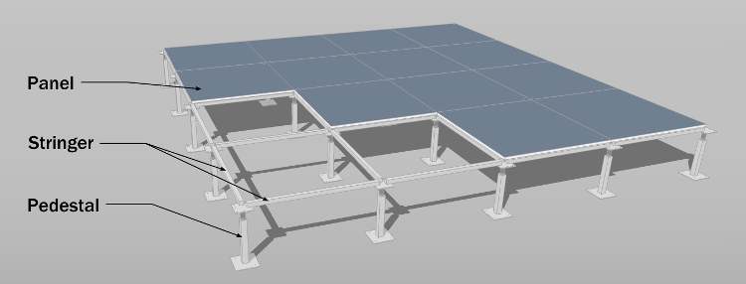

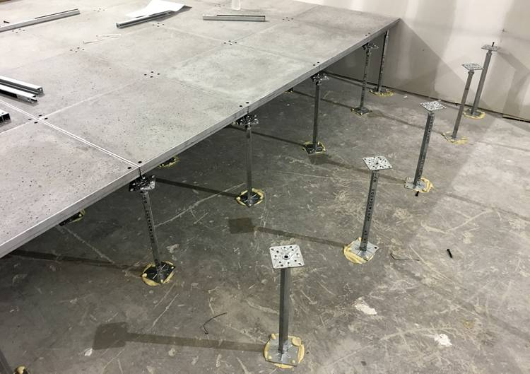

Source: https://www.archtoolbox.com/raised-access-flooring/

Panels

Function: Form the walking surface and provide structural support.

Materials: Typically made of high-density particleboard, steel, aluminum, or calcium sulfate.

Features: Modular and removable. Surface finishes vary: carpet, vinyl, laminate, or bare steel. Often include edge trims for durability and alignment. Standard sizes: 600 mm × 600 mm (24" × 24") is common.

Stringers

Function: Provide lateral stability and support between pedestals.

Materials: Usually made of steel or aluminum.

Features: Connect pedestals horizontally. Help distribute loads and resist lateral movement. May be used in heavier-duty systems or where seismic or vibration resistance is needed.

Pedestals

Function: Vertical supports that elevate the panels above the subfloor.

Materials: Steel with adjustable height mechanisms.

Features: Anchored to the subfloor. Height adjustable to accommodate different service space requirements. Topped with a head that supports the panels directly or via stringers.

System Types

Stringer System: Includes pedestals and stringers; offers higher load capacity and stability.

Stringerless System: Panels rest directly on pedestals; faster installation, suitable for lighter loads.

Hybrid Systems: Combine features of both for specific performance needs.

***************************************************************************************
      - System: << Stringerless; Panel lock; Snap-on grid; Clamped stringer; Rigid grid; or _______>> system. Access flooring system to achieve finished floor elevation of << _______>> inches nominal height above building structural floor. Floor Panel Size: << 24 x 24; or _______>> inches.

***************************************************************************************

Retain the following two paragraphs if required by the project.

***************************************************************************************
      - Regulatory Requirements: Fabricate and install access flooring to comply with <<NFPA 75>> requirements for raised flooring.
      - Sustainability Characteristics:
        - Provide access floor system with minimum 20 percent recycled content and minimum 10 percent post consumer content.
        - Adhesives: Maximum volatile organic compound content in accordance with <<SCAQMD 1168>>.
    - PERFORMANCE REQUIREMENTS

***************************************************************************************

Set general performance testing and requirements here. If necessary, specify values for uniform load, concentrated load, ultimate loads, rolling loads, etc. under access flooring types and component descriptions. Verify values for each manufacturer's specified system.

CISCA tests are standard for adjustable height pedestal systems. For low-profile fixed height systems, most performance requirements reference the IBC and/or ICC-ES AC151.

For low-profile fixed height systems, most performance requirements reference the IBC and/or ICC-ES AC151.

***************************************************************************************
      - General: Comply with the following system requirements and as indicated for specified components.
        - Test in accordance with <<CISCA (AF)>>.

******************************************************************************

Include this subparagraph for applications associated with spaces containing information technology equipment.

******************************************************************************
        - Comply with requirements of <<NFPA 75>>.

******************************************************************************

AC300 establishes guidelines for evaluation of access floors (adjustable height) which consist of panels supported by structural assemblies placed directly on structural floors and used to provide access to electrical and other accessories installed below the floor-panel surface.

******************************************************************************
        - Comply with requirements of <<ICC-ES AC300>>.

******************************************************************************

AC151 establishes guidelines for determining the load capacities of fixed-height, low-profile, raised floor systems where the maximum height of the subfloor space is 2 inches (51 mm), and the systems are placed directly on concrete or masonry floors. The document also deals with fire hazards of such systems.

******************************************************************************
        - Comply with requirements of <<ICC-ES AC151>>.
        - Structural Design Live Loads: Comply with requirements of <<ICC (IBC)>>.
          - Uniformly Distributed Loads: In compliance with ​<< ICC (IBC) Table 1607.1, for access floor systems; or _____>>​.
            - Office Use: ​<< 50 pounds per sq ft; or _____ pounds per sq ft>>​.
            - Computer Use: ​<< 100 pounds per sq ft; or _____ pounds per sq ft>>​.

**********************************************************************

The requirement for a concentrated load rating over an area of 2.5 by 2.5 feet of an access floor panel is found in the International Building Code, Chapter 16, for access floor systems for office and computer use.

**********************************************************************
          - Concentrated Loads: Over an area of << 2.5 feet by 2.5 feet>>, << 2000 pounds; 3000 pounds; or _____ pounds>> minimum, in compliance with << ICC (IBC) Table 1607.1, for access floor systems; or _____>>.
        - Seismic Performance: Design access flooring to withstand earthquake effects in accordance with <<ASCE 7>> seismic design requirements.
        - Lateral Stability: Design system for lateral stability in all directions, with or without panels in place.

******************************************************************************

Verify flame spread and smoke developed requirements for specific project. Flame spread of 25 and smoke developed rating of 450 represents Class A.

******************************************************************************
        - Surface Burning Characteristics: Flame spread index of 25, maximum; smoke developed index of 75, maximum; when tested in accordance with <<ASTM E84>>.
      - Structural Performance: Provide access flooring complying with the following performance requirements according to testing procedures in <<CISCA (AF)>>:

******************************************************************************

The choices for loads indicated below represent common standard load ratings of the listed manufacturers. If the specified manufacturer’s standard product, as determined by the Project Structural Engineer of Record the Project, does not meet the Project requirements for these types of loads, provide the required load ratings in the empty brackets.

******************************************************************************
        - Uniform Load: ​<< 100 pounds per square foot; 200 pounds per square foot; 250 pounds per square foot; 300 pounds per square foot; 400 pounds per square foot; 500 pounds per square foot; or ____ pounds per square foot>>​, when tested in accordance with ​<< CISCA (AF); ASTM E2322; and _____>>​.
          - Maximum Deflection: ​<< 0.04 inch; or ____ inch>>​.

******************************************************************************

These values are typical for adjustable height and pedestal systems.

CISCA Testing: Section 1: Concentrated Loads: The purpose of this test is to determine the maximum deflections and permanent sets of an access floor under load.

******************************************************************************
        - Concentrated Load: Over an area of << 1 inch by 1 inch>>, << 900 pounds; 1000 pounds; 1250 pounds; 1500 pounds; 2000 pounds; 2500 pounds; or _____ pounds>> at any location, when tested in accordance with <<CISCA (AF)>>.
          - Maximum Deflection: ​<< 0.04 inch; 0.08 inch; 0.1 inch; or ____ inch>>​.
          - Permanent Deformation: ​<< 0.02 inch; 0.06 inch; or ____ inch>>​ maximum at design load.

******************************************************************************

CISCA Testing: Section 2: Ultimate Loading: The purpose of this test is to verify the ability of an access floor to accept the manufacturer's published ultimate load.

******************************************************************************
        - Ultimate Load: Over an area of << 1 inch by 1 inch>>: Not less than << twice; or _______>> design load or << 1800 pounds; 2000 pounds; 2500 pounds; 3000 pounds; 4000 pounds; or _____ pounds>>, when tested in accordance with <<CISCA (AF)>>.

******************************************************************************

Coordinate loads specified in subparagraph below with loads specified in "Structural Performance" Paragraph above to avoid failure in panels with insufficient concentrated- and ultimate-load capability.

CISCA Testing: Section 3: Rolling Loads: The purpose of this test is to determine the durability and deformation of access floor systems when exposed to commercially anticipated caster traffic using a specified load.

******************************************************************************
        - Rolling Loads: Permanent deformation not to exceed ​<< 0.04 inch; or ____ inch>>​, when tested in accordance with <<CISCA (AF)>>.

**********************************************************************

Retain the applicable subparagraphs from the following.

1st subparagraph below simulates low-repetition, small-wheel loads similar to equipment move-in on dollies; 2nd subparagraph below simulates high-repetition, large-wheel loads similar to recurring office cart traffic.

Wheel A is 3 inches (76 mm) diameter by 1-13/16 inches (46 mm) width, with phenolic tread.

Wheel B is 6 inches (152 mm) diameter by 2 inches (51 mm) width, with molded urethane tread. This test is for loads up to 1500 pounds (680 kg).

Wheel C is 10 inches (254 mm) diameter by 4 inches (102 mm) width, with molded urethane tread. This test is for loads over 1500 pounds (680 kg).

**********************************************************************
          - Wheel A: 10 passes, with loading of ​<< 400 pounds; 500 pounds; 600 pounds; 800 pounds; 1000 pounds; 1200 pounds; 1250 pounds; 2000 pounds; or _____ pounds>>​.
          - Wheel B: 10,000 passes, with loading of ​<< 400 pounds; 500 pounds; 600 pounds; 800 pounds; 1000 pounds; 1200 pounds; 1250 pounds; 1500 pounds; or _____ pounds>>​.
          - Wheel C: 10,000 passes, with loading of ​<< 1500 pounds; 1750 pounds; 2000 pounds; 2500 pounds; or _____ pounds>>​.

******************************************************************************

CISCA Testing: Section 8: Drop Impact Load Test: The purpose of this test is to show the effect upon access floor panels and supporting understructure systems when subject to impact from heavy loads being accidentally dropped onto the floor panel.

******************************************************************************
        - Drop Impact Load: << 75 pounds; 100 pounds; 125 pounds; 150 pounds; 175 pounds; or _____ pounds>>, when tested in accordance with <<CISCA (AF)>>.
        - Stringer Load Testing: ​​<< 75; 225; 350; 450; or _______>>​​ lbf at center of span with a permanent set not to exceed 0.010 inch.
        - Pedestal Axial Load Test: << 5000; 6000; or _______>> lbf.

******************************************************************************

The lateral-load resistance of pedestals is typically determined by the CISCA pedestal-overturning-moment test, and how the pedestal is attached to the supporting floor slab has a significant effect on it. Attachment methods include adhered (via adhesives) and mechanically fastened. 1000 in-lb is an “industry-standard value” for adhered pedestals; however, it’s possible that more capacity will be required by the seismic design. Coordinate with manufacturer, and/or structural EOR, as necessary. There are author notes related to this topic in the subsequent “Accessories” and “Installation” Articles.

******************************************************************************
        - Pedestal Overturning Moment Test: ​<< 1000 lbf-in; or _______>>​.
      - Seismic Performance Requirements

******************************************************************************

For a detailed discussion on the performance of access floors in past earthquakes and recommended seismic detailing, refer to FEMA E-74, Section 6.5.3.1.

Typical Causes of Damage

Access floors may collapse if not adequately braced and anchored.

Equipment placed on unanchored or untethered access floors may slide, collide with walls or other equipment, and sustain internal damage.

Equipment with casters can become lodged in floor openings, leading to additional hazards.

Enhanced seismic performance can be achieved by specifying “Special Access Floors.” The following figures from FEMA E-74 illustrate recommended seismic mitigation details for access floor systems.

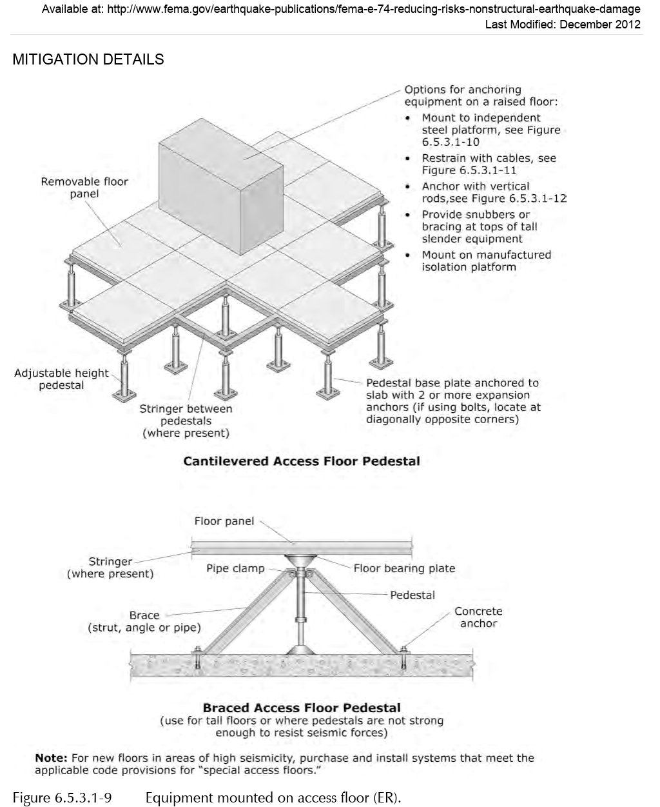

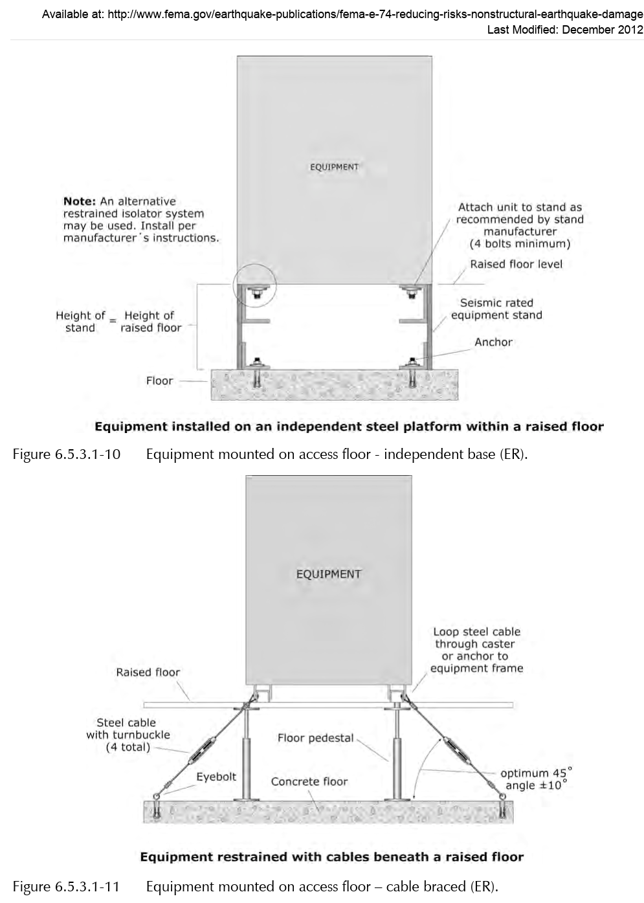

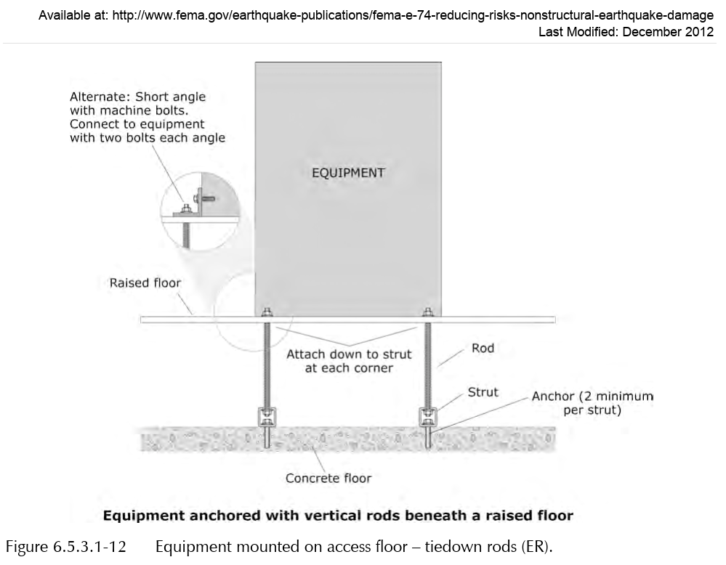

******************************************************************************

Retain the following subparagraph if applicable.

******************************************************************************
        - Delegated Design: Engage a qualified Professional Engineer, to prepare the seismic design of the access floor system.

******************************************************************************

Per ASCE 7 Section C13.5.7.2, “Special access floors are designed for smaller lateral forces [given their larger R_{p} value], and their use is encouraged at facilities with higher nonstructural performance objectives.”

******************************************************************************
        - Design the access flooring system to comply with the requirements for “Special Access Floors” as defined in <<ASCE 7>>, Section 13.5.7.2.
        - Base design loads on the parameters and data provided, including all loads imposed by equipment and other items installed on the access flooring system.

******************************************************************************

Retain the following subparagraph if seismic design using PSDD is the Subcontractor’s responsibility (delegated design), or if MC applies to Project. Omit if PSDD will be provided by EOR.

******************************************************************************
        - Determine seismic design loads in accordance with <<ICC (IBC)>> Section 1613.

**********************************************************************

Select one of the following two subparagraphs.

**********************************************************************
          - Seismic design parameters for Access Floor supports and attachments are specified in Tables 2.1(a) and 2.1(b).

*************************************************************

Refer to LANL ESM Chapter 5 - Structural, Section II or LANL TSM Chapter 5 - Structural, Earthquake Loads for the source of the criteria/data listed in the following subparas, and for editing of them.

*************************************************************
            - Building Risk Category: ​​​​​​​​<< I; II; III; IV; or ______>>​​​​​​​​.
            - Site Class: ​​​​<< D; or _______>>​​​​.
            - Design Spectral Response Acceleration at Short Periods, S_{DS}, gravity (g): ​​​​​​​​<< ____>>​​​​​​​​.
            - Design Spectral Response Acceleration at 1.0-Sec. Period, S_{D1}, gravity (g): ​​​​​​​​<< ____>>​​​​​​​​.
            - Seismic Design Category (SDC): ​​​​​<< D; C; or ___>>​​​​​.

*** OR ***
          - Seismic design parameters for Access Floor supports and attachments are specified on drawings.

**********************************************************************

Edit the following tables to include all components requiring seismic design. Add or remove rows as necessary.

**********************************************************************

Table 2.1(a): Access Floors (AF)
​  ID | ​I_{p} | ​  Description
AF-1 | 1.0
AF-2 | 1.0

Table 2.1(b): Access Floors Qualification Requirements
​  ID | ​  h  (feet) | ​  z  (feet) | ​  a_{p} | ​  R_{p}
AF-1
AF-2

***************************************************************************************

Retain the following paragraph if required by the project.

***************************************************************************************
      - ESD Control Properties: Provide floor coverings with ESD control properties indicated as determined by testing identical products per test method indicated by an independent testing and inspection agency.

******************************************************************************

Retain the following subparagraph if required by the project.

******************************************************************************
        - Static Dissipative Floor Covering Properties:
          - Electrical Resistance: Test per <<ASTM F150>> with 100V applied voltage.
            - Average greater than 1 megohm and less than or equal to 1000 megohms when test specimens are tested surface to ground.
            - Average greater than 1 megohm and less than or equal to 1000 megohms when installed floor coverings are tested surface to ground.
          - Static Generation: Less than << 300; or ______>> V when tested per <<AATCC Test Method 134>> at 20 percent relative humidity with conductive footwear.
          - Static Decay: 5000 to 0V in less than << 0.25; or _______>>​ seconds.

******************************************************************************

Retain the following subparagraph if required by the project.

******************************************************************************
        - Static Conductive Floor Covering Properties:
          - Electrical Resistance: Test per <<ASTM F150>> with 500V applied voltage.
            - Average greater than 25,000 ohms and less than 1 megohm when test specimens and installed floor coverings are tested surface to surface (point to point).
            - Average no less than 25,000 ohms with no single measurement less than 10,000 ohms when installed floor coverings are tested surface to ground.
          - Static Generation: Less than << 100; or _______>> V when tested per <<AATCC Test Method 134>> at 20 percent relative humidity with conductive footwear.
          - Static Decay: 5000 to 0V in less than << 0.03; 0.01; or _______>> seconds.

******************************************************************************

Retain the following subparagraph if required by the project.

******************************************************************************
        - Antistatic Floor Covering Properties:
          - Electrical Resistance: Average greater than 25,000 ohms and less than 1,000 megohm when test specimens and installed floor coverings are tested surface to surface (point to point).
          - Static Generation: Less than << 100; or _______>> V when tested per <<AATCC Test Method 134>> at 20 percent relative humidity with conductive footwear.
        - Panel to Understructure Resistance: Not more than 10 ohms as measured without floor coverings.
    - MATERIALS
      - Pedestals: << Steel; or Aluminum>> with flat bottom base plate, threaded supporting rod, << vibration proof,; or None - N/A>> lock nut to permit << 1-1/2; or _______>> inch adjustment, << galvanized; or manufacturer's standard>> finish.

***************************************************************************************

Include the following paragraph only when stringer system is specified.

***************************************************************************************
      - Frame Grid Stringers: << Continuous; or Removable>> type, consisting of << steel; or aluminum>> channels, box, or tee sections.
      - Floor Panels:
        - Die formed<< galvanized; or None - N/A>> steel top and bottom plates; steel reinforcement stiffeners.

*** OR ***
        - Cast aluminum, with ribbed stiffeners.

*** OR ***
        - Sheet steel plates, composite << lightweight concrete; gypsum; or _______>> core.
      - Panel Edge: << Vinyl trim; or _______>>​<< , slip-on type; _______; or None - N/A>>.<< Mechanically locked to panels.; _______; or None - N/A>>
      - Floor Panel Finish Adhesive: << Moisture resistant; Waterproof; or Electrically conductive>> type recommended by floor finish manufacturer. Maximum volatile organic compound content in accordance with <<SCAQMD 1168>>.
      - Perforated Floor Panels: Same material, size, and construction as floor panels<< with slide dampers for controlled air circulation; or None - N/A>>.
    - FABRICATION TOLERANCES

***************************************************************************************

Reference product manufacturer's tolerances prior to editing the following paragraphs.

***************************************************************************************
      - Floor Panel Flatness: Plus or minus << 0.02; or _______>> inch in any direction.
      - Floor Panel Width or Length from Specified Size: Plus or minus << 0.02; or _______>> inch.
      - Floor Panel Squareness: Plus or minus << 0.03; or _______>> inch difference between opposite diagonal dimensions.
    - FINISHES
      - Floor Panel Finish:
        - Vinyl tile<< , static conductive type ; or None - N/A>><< 1/8; or ______>> inch thick, as specified in << Section 09 6500 - Resilient Flooring; or _______>>; color<< as selected; or _______>>.

*** OR ***
        - Melamine phenolic laminate, <<NEMA LD 3>>, Type HW120, ​​<< ____>>​​ inch thick; ​​<< ___; or None - N/A>>​​ color​​<< as selected; or _______>>​​.

*** OR ***
        - Carpet tile, as specified in << Section 09 6813 - Tile Carpeting; or ___>>; color << as selected; or ___>>.
      - Exposed Metal Surfaces: << Baked enamel finish; or _______>>; color<< as selected; or _______>>.
      - Fascia Panel: << Baked enamel finish; or ______>>; color<< as selected; or _______>>.

***************************************************************************************

Retain the following paragraph if applicable.

***************************************************************************************
      - ​<< Ramp; and Stair Tread>>​ Surface: ​<< Sheet rubber; or _______>>​; color​<< as selected; or _______>>​.
    - ACCESSORIES

***************************************************************************************

Retain "Adhesives" or "Post-Installed Anchors" Paragraph below. ASCE 7 prohibits the use of adhesives in the transmission of seismic loads for Special Access Floors (i.e., R_{p} = 2.5). Otherwise (i.e., R_{p} = 1.5), installations are possible with either adhesives or post-installed anchors, depending on Project conditions. Structural EOR must verify anchor requirements with access-flooring manufacturer and coordinate with Article "Installation". Insert more detailed requirement for type of material in "Adhesives" Subparagraph if necessary.

***************************************************************************************
      - Adhesives: Manufacturer's standard adhesive for bonding pedestal bases to subfloor.

***************************************************************************************

Post-installed anchors shall be specified in the appropriate Division-05 Section

***************************************************************************************
      - Post-Installed Anchors: For anchoring pedestal bases to subfloor, provide anchors indicated and specified in Section << 05 0520 - Post-Installed Concrete and Grouted Masonry Anchors - Normal Confidence; or 05 0521 - Post-Installed Concrete Anchors - Nuclear Safety>>.

***************************************************************************************

Retain the following paragraph if required by the project.

***************************************************************************************
      - Cutouts: Provide cutouts in floor panels for cable penetrations and service outlets. Provide reinforcement or additional support, if needed, to make panels with cutouts comply with specified performance requirements.
        - Number, Size, Shape, and Location: As shown on Drawings.
        - Trim edge of cutouts with manufacturer’s standard plastic molding.
        - Fit cutouts with manufacturer’s standard grommets in sizes indicated or, if size of cutouts exceeds maximum grommet size available, trim edge of cutouts with manufacturer’s standard plastic molding having tapered top flange.<< Furnish removable covers for grommets.; or None - N/A>>
        - Provide foam rubber pads for sealing annular space formed in cutouts by cables.
      - Floor Grilles: Standard load-bearing grilles formed from aluminum to produce removable one-piece unit precisely fitted in factory prepared openings of standard field panels, << with adjustable/removable; or without>> dampers and complying with the following requirements.
        - Air Distribution Characteristics: 468 cfm at 0.10-inch wg static pressure.
        - Structural Performance: Capable of supporting a 1000-lbf concentrated load.
        - Fire Test Response Characteristics: Classified 94V-0 per <<UL 94>>.
      - Air Grilles: << Galvanized sheet steel; or Extruded aluminum>>; << ______>> inch blade size; with << straight; or deflecting>>​vanes and shut-off damper<< ; with integral fire damper; or None - N/A>>.
      - Cavity Dividers: Provide manufacturer’s standard metal dividers located where indicated to divide underfloor cavities.
      - Vertical Closures (Fascia): Where underfloor cavity is not enclosed by abutting walls or other construction, provide metal closure plates with << manufacturer's standard; or _______>> finish.
      - Ramps: Manufacturer’s standard ramp construction of width and slope indicated but not steeper than 1:12, with raised disc or textured rubber or vinyl floor coverings, and of same materials, performance, and construction requirements as access flooring.
      - Steps: Provide steps of size and arrangement indicated with floor coverings to match access flooring. Apply nonslip aluminum nosing to treads, unless otherwise indicated.
      - Railings: Standard extruded aluminum railings, at ramps and open sided perimeter of access flooring where indicated. Include handrail, intermediate rails, posts, brackets, end caps, wall return, wall and floor flanges, plates, and anchorages where required. Railings shall comply with structural performance requirements specified in Section << 05 5213 - Pipe and Tube Railings>>.
      - Panel Lifting Device: Manufacturer’s standard portable lifting device of type required for specified panels. Provide ​<< provide quantity of>>​ lifting device[s] per room of each type required.
      - Perimeter Support: Where indicated, provide manufacturer’s standard method for supporting panel edge and forming transition between access flooring and adjoining floor coverings at same level as access flooring.
      - Electrostatic Grounding Connectors: Solid copper.
  - PART 3 - EXECUTION
    - EXAMINATION

***************************************************************************************

Coordinate requirements specified in other Sections for subfloor construction and tolerances to ensure that they are appropriate for pedestal installation.

***************************************************************************************
      - Examine substrates, with Installer and manufacturer’s representative present, for compliance with requirements for installation tolerances and other conditions affecting performance of work.
        - Verify that substrates comply with tolerances and other requirements specified in other Sections and that substrates are free of cracks, ridges, depressions, scale, foreign deposits, and debris that might interfere with system installation.

***************************************************************************************

Retain the following paragraph if required by the project.

***************************************************************************************
      - Verify substrates comply with minimum subfloor flatness (FF) and subfloor levelness (FL) as specified in the construction drawings.
      - Verify that required utilities are available, in proper location, and are ready for use.
      - Proceed with installation only after unsatisfactory conditions have been corrected.
    - PREPARATION
      - Lay out floor panel installation to keep the number of cut panels at floor perimeter to a minimum. Avoid using panels cut to less than 6 inches in any direction.
      - Locate each pedestal, complete any necessary subfloor preparation, and vacuum clean subfloor to remove dust, dirt, and construction debris before beginning installation.
    - INSTALLATION
      - Install access flooring system and accessories under supervision of access-flooring manufacturer’s authorized representative to produce a rigid, firm installation that complies with performance requirements and is free of instability, rocking, rattles, and squeaks.

***************************************************************************************

Retain "Adhesive Attachment of Pedestals" or "Mechanical Attachment of Pedestals" paragraph below. Retain 1st paragraph for more common adhesive attachment of pedestals. Retain second paragraph if bolted attachment of pedestal bases is required for Special Access Floors or where increased rigidity is needed. Coordinate with Article "Accessories".

***************************************************************************************
      - Adhesive Attachment of Pedestals: Set pedestals in adhesive, according to access-flooring manufacturer’s written instructions, to provide full bearing of pedestal base on subfloor; and as required to meet seismic design requirements.

*** OR ***
      - Mechanical Attachment of Pedestals: Attach pedestals to subfloor with post-installed mechanical anchors as required to meet seismic design requirements.
      - Adjust pedestals to permit top of installed panels to be set flat, level, and to proper height.
      - Stringer Systems: Secure stringers to pedestal heads according to access-flooring manufacturer’s written instructions.
      - Install additional pedestals where grid pattern is interrupted by room appurtenances or at cut-outs.
      - Install flooring panels securely in place, properly seated with panel edges flush. Do not force panels into place.<< For carpeted panels, install panels with carpet pile in same direction.; or None - N/A>>
      - Scribe perimeter panels to provide a close fit with adjoining construction with no voids greater than 1/8 inch where panels abut vertical surfaces. Finish field cut floor panels with edge trim.
      - Cut and trim access flooring and perform other dirt and debris producing activities at a remote location or as required to prevent contamination of subfloor under access flooring already installed.
      - Ground flooring system as recommended by manufacturer and as needed to comply with performance requirements for electrical resistance of floor coverings.
      - Underfloor Dividers: Scribe and install underfloor cavity dividers to closely fit against subfloor surfaces, and seal with mastic.

***************************************************************************************

Retain the following paragraph if required by the project.

***************************************************************************************
      - Closures: Scribe vertical closures to closely fit against subfloor and adjacent finished floor surfaces. Set in mastic and seal to maintain plenum effect within underfloor cavity.
      - Clean dust, dirt, and construction debris caused by floor installation, and vacuum subfloor area as installation of floor panels proceeds.

***************************************************************************************

Retain the following paragraph if required by the project.

***************************************************************************************
      - Install ​​​<< grilles; perforated panels; and ______>>​​​, ​​​<< as indicated on Drawings; as indicated on Shop Drawings; or where directed>>​​​.

***************************************************************************************

Include the following paragraph to ensure reasonable quantity of hole cuts are included in Subcontract. Omit this paragraph when inapplicable.

***************************************************************************************
      - Cut << ten; or _______>> holes in floor panels to accommodate specified equipment. Provide cable cut-out protection.

***************************************************************************************

Retain the following paragraph if required by the project.

***************************************************************************************
      - Install floor, ​​<< ramp; stairs; and None - N/A>>​​ with edge trim and end closures.​​<< Install lateral braces at stair edges and other locations where pedestals are not braced.; or None - N/A>>​​

***************************************************************************************

Coordinate the following paragraph with appropriate electrical sections.

***************************************************************************************
      - Provide positive electrical earth grounding of entire floor assembly in accordance with << NFPA 75; or _______>>.

***************************************************************************************

Retain the applicable paragraphs from the following four paragraphs, if required by the project.

***************************************************************************************
      - Extend railing posts through floor panels to structural floor; secure to flange fittings anchored to structural floor.
      - Brace posts in position at floor panels with floor collar retainers.
      - Secure railings at walls with flanged fittings anchored to walls.
      - Electrically ground railings to << floor system; or building grounding system>>.
    - ERECTION TOLERANCES
      - Install access flooring without change in elevation between adjacent panels and within the following tolerances:
        - Plus or minus << 1/16; 1/8; or _______>> inch in any 10-ft. distance.
        - Plus or minus << 1/8; 1/4; or _______>> inch from a level plane over entire access flooring area.

***************************************************************************************

The primary purpose of the following Article is to alert the Subcontractor that he/she is responsible for quality control (QC) and that, in addition to QC, the access floor is subject to the quality assurance (QA) indicated in the Project’s Statement of Special Inspections.

***************************************************************************************
    - FIELD QUALITY CONTROL

***************************************************************************************

Retain the following paragraph if required by the project.

***************************************************************************************
      - Manufacturer's Field Service: Engage a factory-authorized service representative to test and inspect components, assemblies, and equipment installations, including connections.
      - Inspection Agency: Engage a qualified 3rd party inspection agency to perform inspections.
      - Perform inspections during the installation of access flooring as necessary to ensure that the applicable provisions of <<ASCE 7>>are met.
      - Prepare an inspection report.
      - Access floors will be considered defective if they do not pass the Special Inspection indicated in the Project’s Statement of Special Inspections.
    - ADJUSTING, CLEANING, AND PROTECTION
      - Prohibit traffic on access flooring for 24 hours and removal of floor panels for << 72; or _______>> hours after installation to allow pedestal adhesive to set.
      - After completing installation, vacuum clean access flooring and cover with continuous sheets of reinforced paper or plastic. Maintain protective covering until time of Substantial Completion.
      - Replace access flooring panels that are stained, scratched, or otherwise damaged or that do not comply with specified requirements.

***************************************************************************************

The following Article is a designer-choice. Include schedule when differing types of floor panels, finishes, fascia or ramp components, railings, or accessories are required.

***************************************************************************************
    - SCHEDULES

***************************************************************************************

Consider the following examples when developing access flooring schedule.

Computer Room 308: 24 x 24-inch floor panel, 18 inch above floor slab, ramp, fascia panels, tubular aluminum hand railing; plastic laminate floor panel finish.

Printer Room 309: 30 x 30-inch floor panels, 6 inches above floor slab; vinyl finish; two stair risers at door to Room 308.

***************************************************************************************
      - ​<< _______>>​
      - ​<< _______>>​
  - END OF SECTION

**********************************************************************************************

Do not omit the following reference information:

**********************************************************************************************
  - THE FOLLOWING STATEMENT IS FOR LANL USE ONLY
  - THIS PROJECT SPECIFICATION SECTION IS BASED ON LANL MASTER SPECIFICATION SECTION 09 6900, REV. 6, DATED APRIL 15, 2026.

