Section 13 3419
Metal Building Systems

************************************************************************************************************

LANL MASTER SPECIFICATION SECTION
Rev. 7 Summary of Changes: Edited and updated as required for import into SpecLink.

NOTE TO SPECIFIER ON USAGE IN SPECLINK: Activate the Section by turning on Seq #0000, followed by activating paragraphs in PART 1, Article SECTION INCLUDES. This will activate related articles, paras/subparas in the rest of the Section (i.e., SECTION INCLUDES in PART 1 activates articles and paras/subparas in PARTS 2 and 3). If there are choice fields to edit the entire Section (typically in this first author note or beginning of the Section), make selections at those locations, which will filter through the remaining Section. All Articles, paragraphs and subparagraphs must be activated sequentially from top to bottom, unless noted otherwise.

This template must be edited for each project. In doing so, Specifier must add job-specific requirements. Selections and choice fields are used to indicate designer choices or locations where text must be supplied by the designer. The section must also be edited to remove requirements for processes, items, or designs that are not included in the project.

To seek a variance from applicable requirements in this Section, contact the Engineering Standards Manual (ESM) Structural/Architectural POC (LANL access only). Please contact POC with suggestions for improvement as well. LANL personnel should submit here: Suggested Change or Request Clarification; subcontractors via email to engstandards@lanl.gov.

When assembling a specification package, include applicable Sections from all Divisions, especially those in Division 1, General Requirements.

Section is developed for ML-4 projects. For ML-1, 2, and 3 applications, additional requirements and independent reviews should be added if increased confidence in procurement or execution is desired; see LANL ESM Chapter 1 - General, Section Z10 Specifications and Quality sections.

==========================================================

This Section specifies basic metal building systems, including structural framing, metal roofing, siding, and soffit panels. While other components of the building envelope such as insulation, personnel doors, overhead sectional and coiling doors, sliding doors, windows, accessories, and MEP systems are typically available from metal building system manufacturers, these are specified in other ESM standard specification sections. Also, this Section does not specify footings, foundations, slabs, or interior finished spaces, nor does it specify other types of metal structures such as portable buildings, booths, small utility or storage buildings, or greenhouses.

Structural design of RC II and RC IV buildings must comply with the IBC subject to amendments to it by LANL TSM/ ESM. The IBC places the following seismic requirements on structural steel structures in Seismic Design Categories D and C:

- SDC = D: Design and detailing shall be in accordance with AISC 341, except as permitted by ASCE 7, Table 15.4-1 (i.e., some of the Non-building Structures Similar to Buildings).

- SDC = C: Design and detailing shall be in accordance with AISC 341 unless R < 3 and the seismic force-resisting system is other than a cantilever column system.

- NOTE: Although the IBC (and LANL ESM) permits the use of cold-formed steel structures, this construction type is not included in this template)

While IBC-compliant seismic design is included herein, the EOR is responsible for ensuring that any/all requirements/provisions are specifically addressed during his/her review of the Project Record Documents submittals. Refer to IBC Ch. 22 and LANL Master Spec Sections << 05 1000 - Structural Steel Framing>> and << 05 3000 - Metal Decking>> for details on seismic-related requirements.

Refer to the following figure and references for metal building systems terminology and information.

MBMA: Metal Building Manufacturers Association.

MBMA Education Resources

Videos: Metal Building Terms and Loads; Metal Building Systems 101; How It’s Built: Metal Building Construction; Accreditation; Energy Codes & Fire-Resistance; Earthquake Testing Metal Buildings.

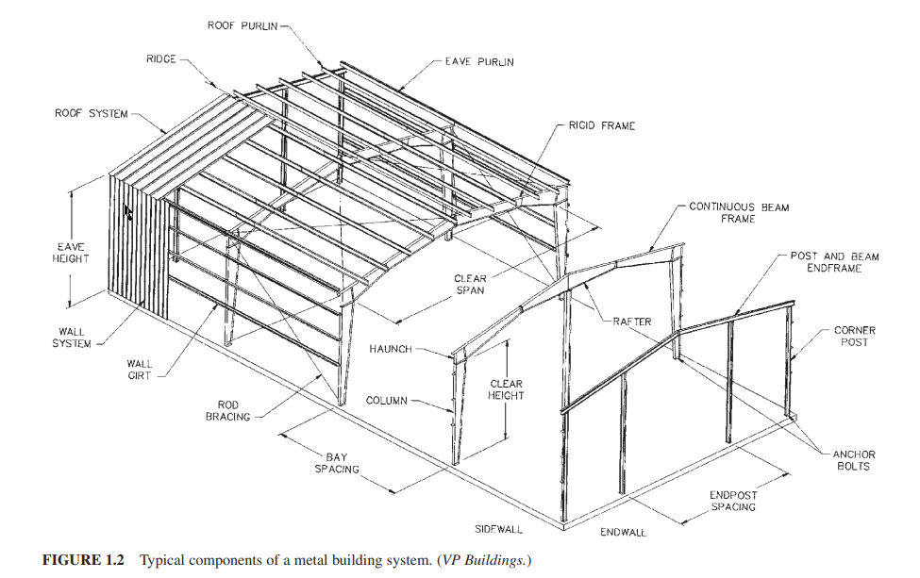

Source: Newman, A. (2015). Metal building systems : design and specifications (Third edition). McGraw Hill Education.

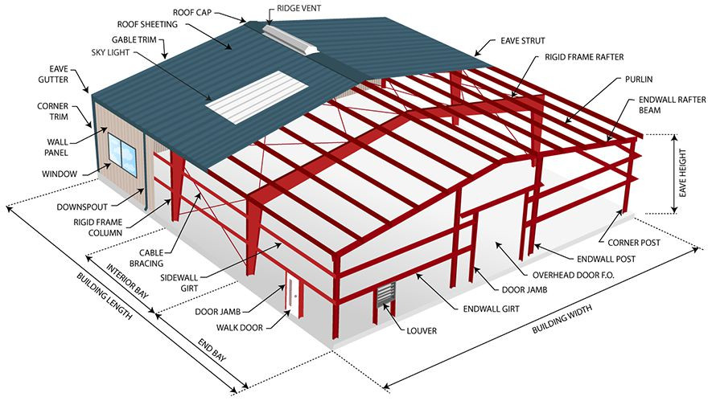

Source: https://ludwigbuildings.com/parts-of-a-metal-building

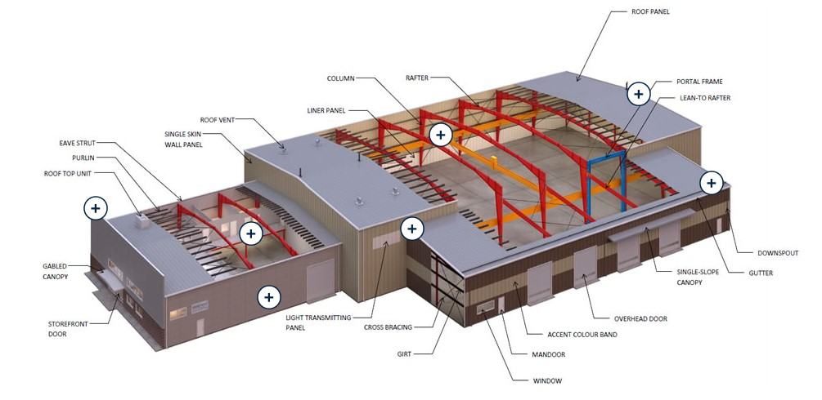

Source: https://www.ferrobuildings.com/2019/05/erect-steel-building-vancouver/

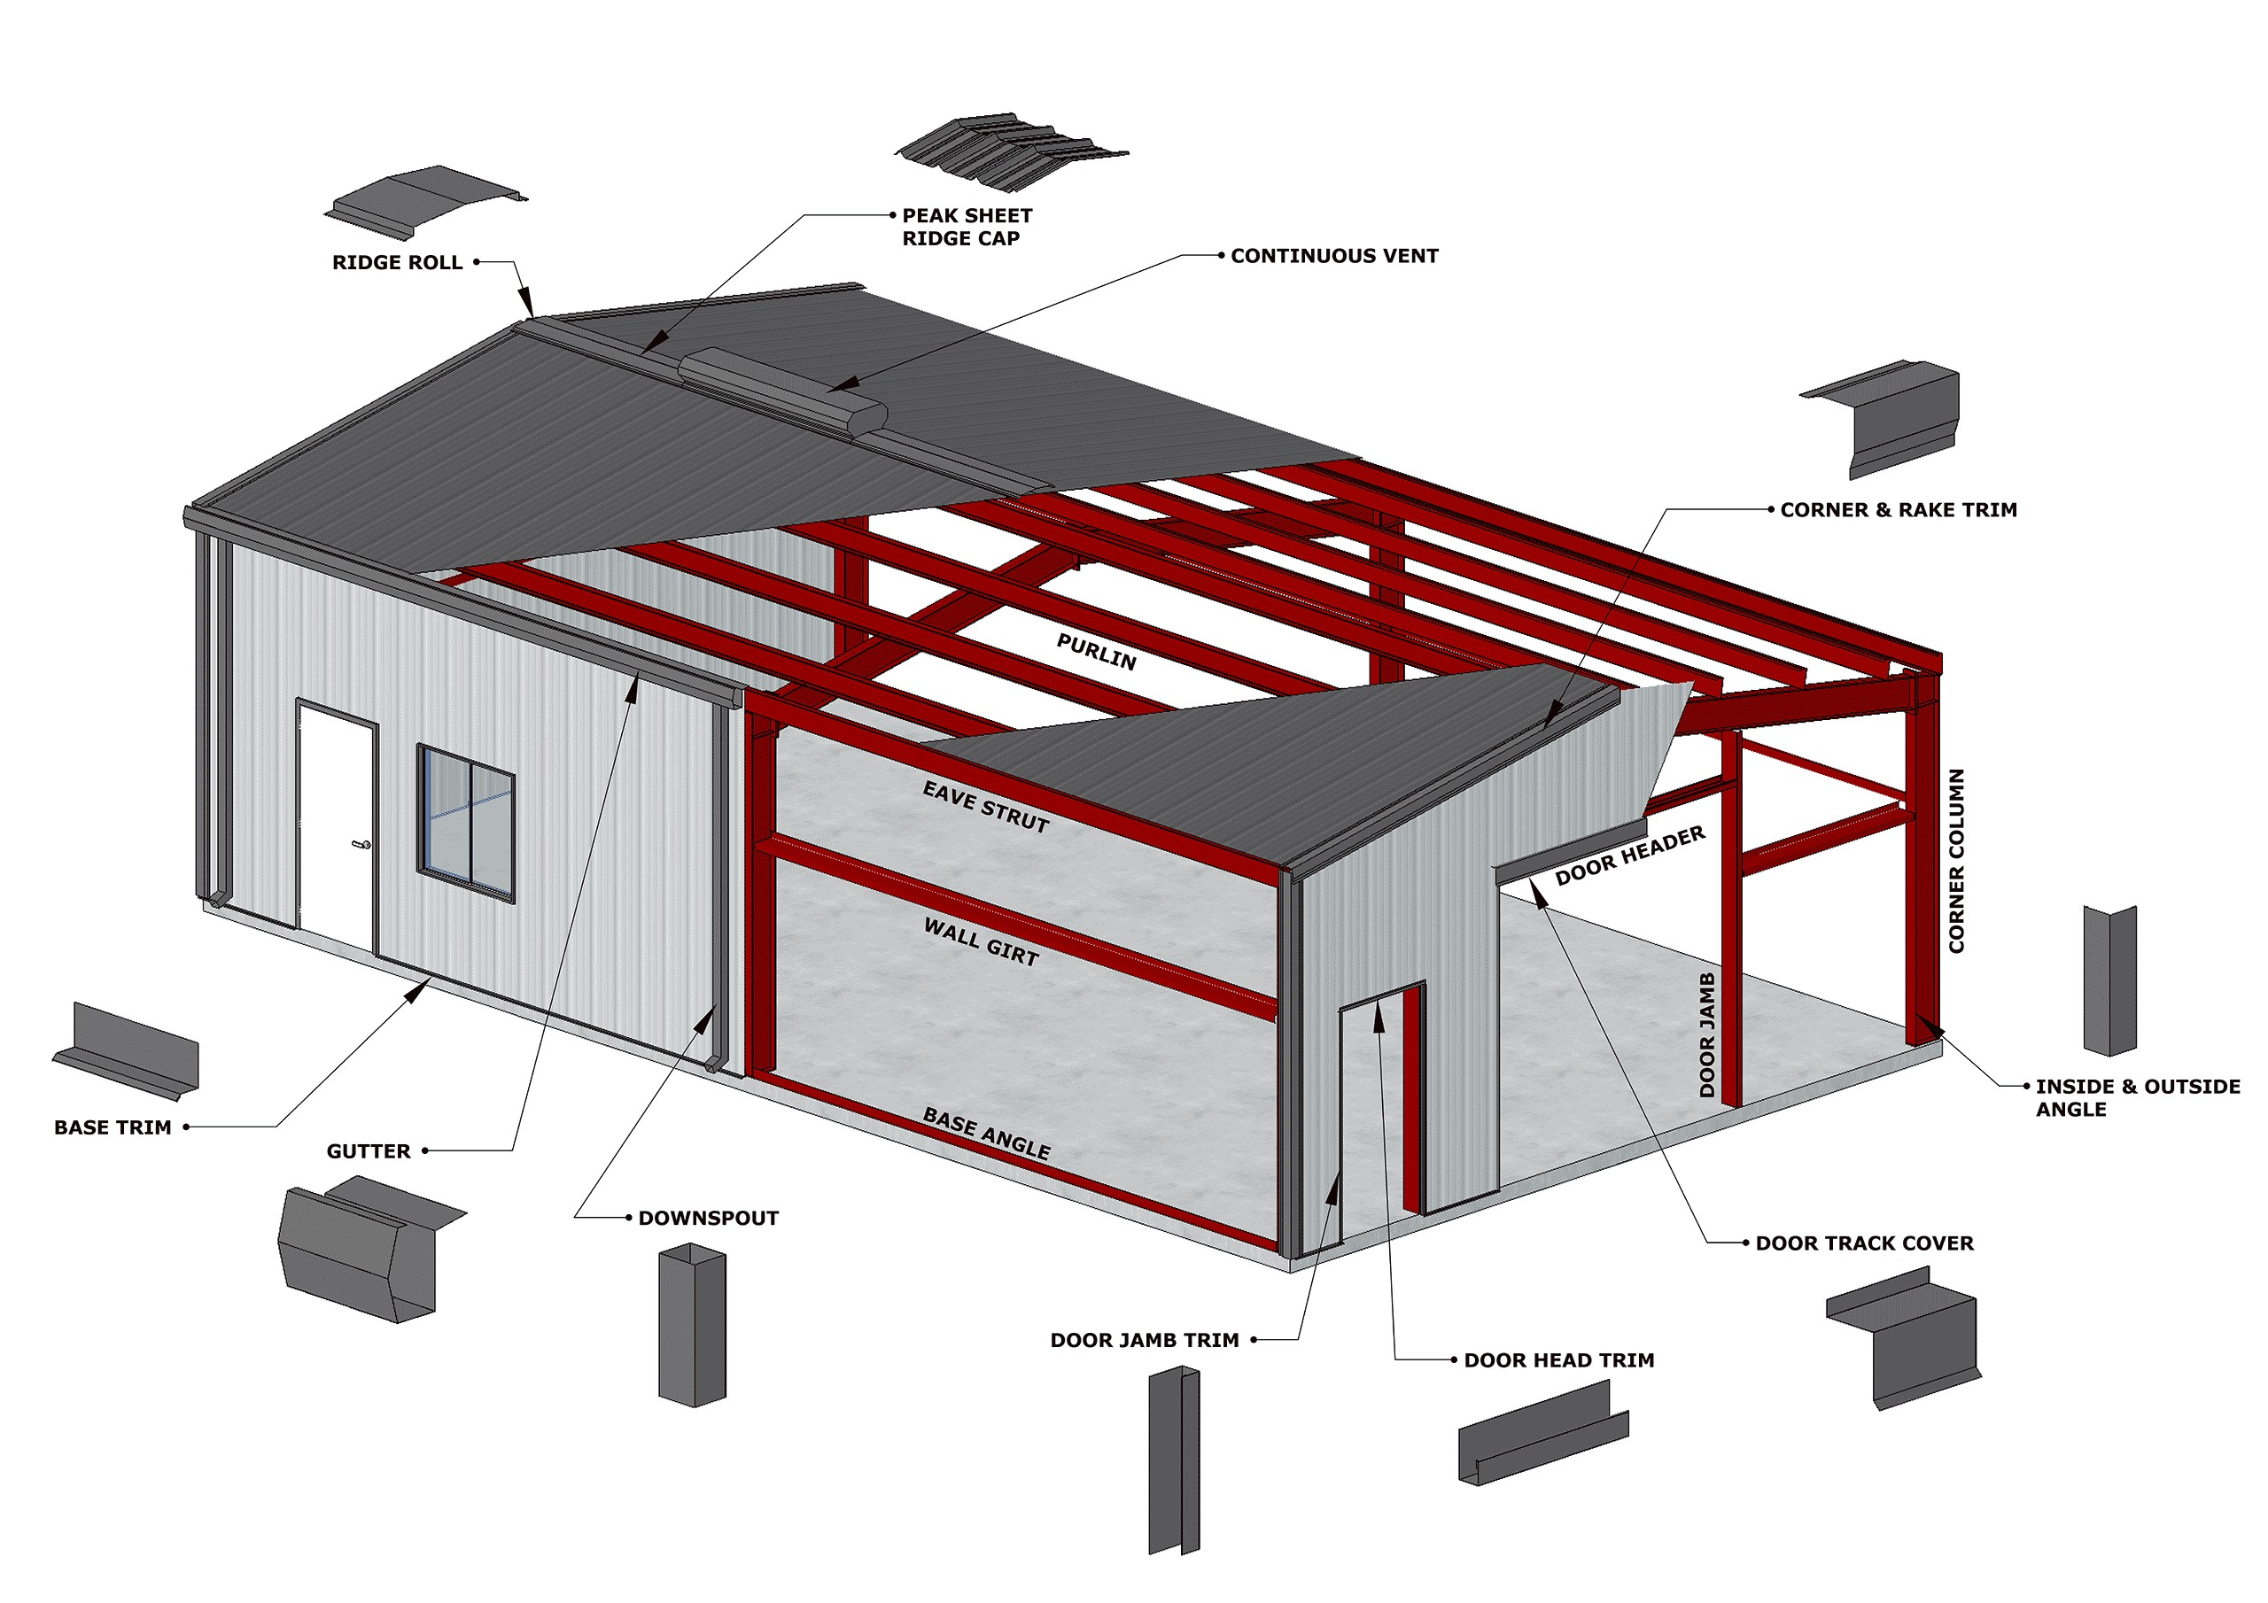

Source: https://primebldg.com/product/house-roof-rake-rpn/

************************************************************************************************************
  - PART 1 - GENERAL
    - SECTION INCLUDES
      - Structural steel framing.
      - Metal roof panels.

***************************************************************************************

Retain the following five paragraphs as required by the project.

***************************************************************************************
      - Metal wall panels.
      - Field installed insulation.
      - Foamed-insulation-core metal wall panels.
      - Translucent panels.
      - Metal Soffit panels.
      - Metal building system manufacturers’ standard accessories​​​<< .; or including:>>​​​
        - Gutters and downspouts.

******************************************************************************

Retain the following subparagraphs as required by the project.

******************************************************************************
        - Service Walkways.
        - Roof ventilators.
        - Louvers.
    - RELATED REQUIREMENTS
      - Section << 01 4000 - Quality Requirements - Non-Nuclear>>.
      - Section << 01 4444 - Offsite Welding, Brazing and Joining Requirements>>.
      - Section << 01 4455 - Onsite Welding, Brazing and Joining Requirements>>.
      - Section << 01 7839 - Project Record Documents>>.
      - Section << 07 9200 - Joint Sealants>>.
      - Section << 09 9100 - Painting>>.
    - REFERENCE STANDARDS
      - AAMA 2605 - Voluntary Specification, Performance Requirements and Test Procedures for Superior Performing Organic Coatings on Aluminum Extrusions and Panels (with Coil Coating Appendix).
      - AISC 303 - Code of Standard Practice for Steel Buildings and Bridges.
      - AISC 341 - Seismic Provisions for Structural Steel Buildings.
      - AISC 360 - Specification for Structural Steel Buildings.
      - AISI S100 - North American Specification for the Design of Cold-Formed Steel Structural Members.
      - ASTM A36/A36M - Standard Specification for Carbon Structural Steel.
      - ASTM A53/A53M - Standard Specification for Pipe, Steel, Black and Hot-Dipped, Zinc-Coated, Welded and Seamless.
      - ASTM A193/A193M - Standard Specification for Alloy-Steel and Stainless Steel Bolting for High Temperature or High Pressure Service and Other Special Purpose Applications.
      - ASTM A307 - Standard Specification for Carbon Steel Bolts, Studs, and Threaded Rod 60 000 PSI Tensile Strength.
      - ASTM A500/A500M - Standard Specification for Cold-Formed Welded and Seamless Carbon Steel Structural Tubing in Rounds and Shapes.
      - ASTM A529/A529M - Standard Specification for High-Strength Carbon-Manganese Steel of Structural Quality.
      - ASTM A563/A563M - Standard Specification for Carbon and Alloy Steel Nuts (Inch and Metric).
      - ASTM A572/A572M - Standard Specification for High-Strength Low-Alloy Columbium-Vanadium Structural Steel.
      - ASTM A653/A653M - Standard Specification for Steel Sheet, Zinc-Coated (Galvanized) or Zinc-Iron Alloy-Coated (Galvannealed) by the Hot-Dip Process.
      - ASTM A755/A755M - Standard Specification for Steel Sheet, Metallic Coated by the Hot-Dip Process and Prepainted by the Coil-Coating Process for Exterior Exposed Building Products.
      - ASTM A780/A780M - Standard Practice for Repair of Damaged and Uncoated Areas of Hot-Dip Galvanized Coatings.
      - ASTM A792/A792M - Standard Specification for Steel Sheet, 55% Aluminum-Zinc Alloy-Coated by the Hot-Dip Process.
      - ASTM A992/A992M - Standard Specification for Structural Steel Shapes.
      - ASTM A1008/A1008M - Standard Specification for Steel, Sheet, Cold-Rolled, Carbon, Structural, High-Strength Low-Alloy, High-Strength Low-Alloy with Improved Formability, Required Hardness, Solution Hardened, and Bake Hardenable.
      - ASTM A1011/A1011M - Standard Specification for Steel, Sheet and Strip, Hot-Rolled, Carbon, Structural, High-Strength Low-Alloy, High-Strength Low-Alloy with Improved Formability, and Ultra-High Strength.
      - ASTM B695 - Standard Specification for Coatings of Zinc Mechanically Deposited on Iron and Steel.
      - ASTM C273/C273M - Standard Test Method for Shear Properties of Sandwich Core Materials.
      - ASTM C423 - Standard Test Method for Sound Absorption and Sound Absorption Coefficients by the Reverberation Room Method.
      - ASTM C518 - Standard Test Method for Steady-State Thermal Transmission Properties by Means of the Heat Flow Meter Apparatus.
      - ASTM C920 - Standard Specification for Elastomeric Joint Sealants.
      - ASTM C955 - Standard Specification for Cold-Formed Steel Structural Framing Members.
      - ASTM C1107/C1107M - Standard Specification for Packaged Dry, Hydraulic-Cement Grout (Nonshrink).
      - ASTM C1363 - Standard Test Method for Thermal Performance of Building Materials and Envelope Assemblies by Means of a Hot Box Apparatus.
      - ASTM D1494 - Standard Test Method for Diffuse Light Transmission Factor of Reinforced Plastics Panels.
      - ASTM D1621 - Standard Test Method for Compressive Properties of Rigid Cellular Plastics.
      - ASTM D1622 - Standard Test Method for Apparent Density of Rigid Cellular Plastics.
      - ASTM D2244 - Standard Practice for Calculation of Color Tolerances and Color Differences from Instrumentally Measured Color Coordinates.
      - ASTM D3841 - Standard Specification for Glass-Fiber-Reinforced Polyester Plastic Panels.
      - ASTM D4214 - Standard Test Methods for Evaluating the Degree of Chalking of Exterior Paint Films.
      - ASTM D6226 - Standard Test Method for Open Cell Content of Rigid Cellular Plastics.
      - ASTM E84 - Standard Test Method for Surface Burning Characteristics of Building Materials.
      - ASTM E108 - Standard Test Methods for Fire Tests of Roof Coverings.
      - ASTM E119 - Standard Test Methods for Fire Tests of Building Construction and Materials.
      - ASTM E283/E283M - Standard Test Method for Determining Rate of Air Leakage Through Exterior Windows, Skylights, Curtain Walls, and Doors Under Specified Pressure Differences Across the Specimen.
      - ASTM E331 - Standard Test Method for Water Penetration of Exterior Windows, Skylights, Doors, and Curtain Walls by Uniform Static Air Pressure Difference.
      - ASTM E1592 - Standard Test Method for Structural Performance of Sheet Metal Roof and Siding Systems by Uniform Static Air Pressure Difference.
      - ASTM E1646 - Standard Test Method for Water Penetration of Exterior Metal Roof Panel Systems by Uniform Static Air Pressure Difference.
      - ASTM E1680 - Standard Test Method for Rate of Air Leakage through Exterior Metal Roof Panel Systems.
      - ASTM E1980 - Standard Practice for Calculating Solar Reflectance Index of Horizontal and Low-Sloped Opaque Surfaces.
      - ASTM F436/F436M - Standard Specification for Hardened Steel Washers Inch and Metric Dimensions.
      - ASTM F844 - Standard Specification for Washers, Steel, Plain (Flat), Unhardened for General Use.
      - ASTM F1554 - Standard Specification for Anchor Bolts, Steel, 36, 55, and 105-ksi Yield Strength.
      - ASTM F2329/F2329M - Standard Specification for Zinc Coating, Hot-Dip, Requirements for Application to Carbon and Alloy Steel Bolts, Screws, Washers, Nuts, and Special Threaded Fasteners.
      - ASTM F3125/F3125M - Standard Specification for High Strength Structural Bolts and Assemblies, Steel and Alloy Steel, Heat Treated, Inch Dimensions 120 ksi and 150 ksi Minimum Tensile Strength, and Metric Dimensions 830 MPa and 1040 MPa Minimum Tensile Strength.
      - ASTM F3148 - Standard Specification for High Strength Structural Bolt Assemblies, Steel and Alloy Steel, Heat Treated, 144ksi Minimum Tensile Strength, Inch Dimensions.
      - AWS B2.1/B2.1M - Specification for Welding Procedure and Performance Qualification.
      - AWS D1.1/D1.1M - Structural Welding Code - Steel.
      - AWS D1.3/D1.3M - Structural Welding Code - Sheet Steel.
      - AWS D1.8/D1.8M - Structural Welding Code - Seismic Supplement.
      - CRRC-1 - CRRC-1 Roof Product Rating Program Manual.
      - FM (AG) - FM Approval Guide.
      - FM 4471 - Examination Standard for Class 1 Panel Roofs.
      - IAS AC472 - Accreditation Criteria for Inspection Programs for Manufacturers of Metal Building Systems.
      - ICC (IBC) - International Building Code.
      - MBMA (CIP) - Common Industry Practices.
      - MBMA (MBSM) - Metal Building Systems Manual.
      - NFPA 285 - Standard Fire Test Method for Evaluation of Fire Propagation Characteristics of Exterior Wall Assemblies Containing Combustible Components.
      - RCSC - Specification for Structural Joints Using High-Strength Bolts.
      - SJI 100 - Standard Specifications for K-Series, LH-Series, and DLH-Series Open Web Steel Joists, and for Joist Girders.
      - SMACNA (ASMM) - Architectural Sheet Metal Manual.
      - SSPC-SP 2 - Hand Tool Cleaning.
      - SSPC-SP 3 - Power Tool Cleaning.
      - UL (FRD) - Fire Resistance Directory.
      - UL 580 - Standard for Tests for Uplift Resistance of Roof Assemblies.
    - DEFINITIONS
      - For definitions and acronyms, refer to COE Glossary of Terms.

***************************************************************************************

MBMA uses the terms “Manufacturer,” “Erector” and “General Contractor.”

- Manufacturer is responsible for the design and fabrication of the building.

- Erector is responsible for the construction/installation of the building.

- General Contractor is responsible for construction of the overall Project involving the building.

In the context of this Section, the term “Subcontractor” is used in lieu of General Contractor.

***************************************************************************************
      - Terminology Standard: Refer to <<MBMA (CIP)>> for definitions of terms related to metal building system construction not otherwise defined in this Section or in referenced standards.
    - COORDINATION
      - Coordinate the sizes and locations of concrete foundations and the placement of embedded items, anchor rods, sleeves, and mechanical/electrical penetrations. Refer to applicable Specification Sections for requirements related to anchor rod installation, concrete materials, reinforcement, and formwork.
      - Provide opening and framing locations and loads to the Engineer of Record (EOR) prior to foundation design. Do not cut primary members in the field without written approval from the EOR.

***************************************************************************************

Retain the following paragraph if required by the project.

***************************************************************************************
      - Coordinate insulation thickness and support method with purlin/girt depths, clip heights, and thermal blocks.
      - Coordinate metal panel assemblies with rain drainage systems, flashing, trim, structural supports, and adjoining construction to ensure a secure, watertight, and noncorrosive installation.

***************************************************************************************

Retain this article if the scope or complexity of the Work under this Section warrants a coordination conference, otherwise omit.

***************************************************************************************
    - PRE-INSTALLATION MEETINGS
      - Pre-Installation Conference: Conduct conference at ​​<< Project site; or _______>>​​ a minimum of ​​<< two weeks; one week; or _______>>​​ weeks prior to start of erection; attendees to include, and attended by ​​<< Owner/Customer; Owner Architect/Engineer; PEMB manufacturer; Erector; Roofer; MEP trades; Testing Agency; LBO Inspector; and _______>>​​ to address the following items.
        - Review methods and procedures related to metal building systems including, but not limited to, to the following:
          - Verify readiness and condition of foundations, anchor rod placement, and other preparatory work performed by other trades.
          - Confirm structural load limitations, construction and erection sequence, and the requirements for temporary bracing.
          - Review the construction schedule. Verify availability of materials, erector’s personnel, equipment, and facilities necessary to maintain progress and avoid delays.

**********************************************************************

Coordinate first subparagraph below with Section << 01 4000 - Quality Requirements - Non-Nuclear>>, and with Articles “Source Quality Control” and “Field Quality Control” in this Section. Insert requirements to suit Project.

**********************************************************************
          - Identify required tests, inspections, and certifications.
          - Evaluate unfavorable weather and forecasted weather conditions and their impact on the construction schedule.
        - Review methods and procedures related to metal roof panel assemblies, including but not limited to the following:
          - Verify compliance with requirements for purlin and rafter conditions, including flatness and attachment to structural members.
          - Confirm structural limitations of purlins and rafters during and after roofing.
          - Review flashings, special roof details, roof drainage, roof penetrations, sealing, equipment curbs, and conditions of other construction affecting metal roof panels.
          - Identify temporary protection requirements for metal roof panel assemblies during and after installation.
          - Procedures for roof observation and repair after metal roof panel installation.
        - Review methods and procedures related to metal wall panel assemblies including, but not limited to the following:
          - Verify compliance with requirements for support conditions, including alignment and attachment to structural members.
          - Confirm structural limitations of girts and columns during and after wall panel installation.
          - Review flashings, special siding details, wall penetrations, openings, sealing, and conditions of other construction affecting metal wall panels.
          - Identify temporary protection requirements for metal wall panel assemblies during and after installation.
          - Procedures for wall observation and repair after metal wall panel installation.
    - ACTION SUBMITTALS

***************************************************************************************

Edit submittals to include only those absolutely necessary to assure requirements and features that are important for the specific project will be met.

***************************************************************************************
      - Submit product data, specifications, and installation instructions for all building components and accessories. ​​<< Include construction details, material descriptions, dimensions of individual components and profiles, and finishes for the following:; or None - N/A>>​​

******************************************************************************

If the option to include construction details, material descriptions, dimensions of individual components and profiles, and finishes is selected in the above paragraph, select or add other items as necessary from the following:

******************************************************************************
        - Metal roof panels.
        - Metal wall panels.
        - Foamed-insulation-core metal panels.
        - Metal soffit panels.
        - Translucent roof panels.
        - Roof ventilators.
        - Louvers and vents.
        - Doors and frames
        - Windows and glazing
        - Fasteners and anchors
        - Equipment supports and roof curbs
      - Shop/Erection Drawings: Submit shop drawings sealed by the manufacturer’s professional engineer. Comply with <<ICC (IBC)>> Section 1603, Construction Documents. Include plans, elevations, sections, details, connection details, bracing layout, anchor bolt plans, openings and framed supports, gutter and downspout sizing, panel layouts, flashing details, clip types, thermal movement provisions, and identification of components provided by others.

******************************************************************************

Include the following subparagraphs and its subparagraphs only if applicable or required to ensure that essential project requirements and features are met. Edit to retain only those necessary for the specific project.

******************************************************************************
        - Anchor-Rod Plans: Submit anchor-rod plans and templates before foundation work begins. Include location, diameter, and minimum required projection of anchor rods required to attach metal building to foundation. Provide unfactored column reactions at each location and for each design load (e.g., dead, live, snow, wind, seismic, crane, etc.).
        - Structural-Framing Drawings: Show complete fabrication of primary and secondary framing; include provisions for openings. Indicate welds and bolted connections, distinguishing between shop and field applications. Include transverse cross-sections
          - Show provisions for attaching ​<< mezzanines; roof curbs; service walkways; platforms; and pipe racks>>​.
        - Metal ​<< Roof; and Wall>>​ Panel Layout Drawings: Show layouts of panels including methods of support. Include details of edge conditions, joints, panel profiles, corners, anchorages, clip spacing, trim, flashings, closures, and special details. Distinguish between factory- and field-assembled work; ​<< show locations of exposed fasteners – metal wall panels only; or None - N/A>>​.

**********************************************************************

Metal building manufacturers layout drawings often do not include the items in first subparagraph below. Retain if subcontractor must insert this information.

**********************************************************************
          - Show roof-mounted items (specified elsewhere) including roof hatches, equipment supports, pipe supports and penetrations, lighting fixtures, and items mounted on roof curbs.
          - Show wall-mounted items (specified elsewhere) including doors, windows, louvers, and lighting fixtures.
          - Show translucent panels.

******************************************************************************

Retain subparagraph and its subparagraphs below for large-scale details if product data from manufacturer are inadequate. Retain specific scale if required.

******************************************************************************
        - Accessory Drawings: Include details of the following items (as specified elsewhere), at a scale of not less than << 1-1/2 inches per 12 inches (1:8); or _______>>.
          - Flashing and Trim.
          - Gutters.
          - Downspouts.
          - Roof ventilators.
          - Louvers.
          - Service walkways.

***************************************************************************************

Include the following paragraph only if applicable or required by the project. Edit to retain only those subparagraphs that are essential to ensure compliance with project-specific requirements and to achieve critical performance or functional objectives.

***************************************************************************************
      - Samples

******************************************************************************

Include the first and/or the second subparagraph below for submission of physical samples for selection of finish, color, texture, and other properties. Omit “Samples for Initial Selection” subparagraph if colors and other characteristics are preselected and specified or scheduled. Regardless of this decision, retain “Samples for Verification” subparagraph.

******************************************************************************
        - Samples for Initial Selection: For units with factory-applied color finish.
        - Samples for Verification: For each type of exposed finish required, prepared on samples of sizes indicated thusly:
          - Metal Panels: Nominal 12 inches long x actual panel width. Include fasteners, closures, and other exposed panel accessories.
          - Translucent Panels: Nominal 12 inches long x actual panel width.
          - Flashing and Trim: Nominal 12 inches long. Include fasteners and other exposed accessories.
          - Accessories: Nominal 12-inch-long samples for each type of accessory.

***************************************************************************************

The first Design Submittal (below) is the manufacturer's responsibility according to the MBMA MBSM. It is useful in ensuring compliance with requirements and in comparing competitive quotes from several manufacturers.

***************************************************************************************
      - Design Submittals
        - Letter of Design Certification: Signed and sealed by a professional engineer who is legally qualified to practice in New Mexico. Include the following:
          - Name and location of Project.
          - Order Number.
          - Name of Manufacturer.
          - Name of Subcontractor.
          - Building dimensions including width, length, height, and roof slope.
          - Compliance with governing version of <<ICC (IBC)>>.
          - Design Loads: Include dead load, roof live load, collateral loads, roof snow load, wind loads/speeds and exposure, seismic loads, and auxiliary loads (cranes).
          - Compliance with serviceability criteria limiting and seismic drift.
          - Building Risk Category: Indicate <<ICC (IBC)>>​ Risk Category, and load importance factors.
        - Submit structural design calculations for the metal building system, signed and sealed by the professional engineer responsible for their preparation and legally qualified to practice in New Mexico. Design calculations shall demonstrate that the strength and serviceability requirements of this Specification are met. Include the following, at a minimum:
          - Summary of Design Criteria: list all codes, design loads, and load combinations used for the building design, as required by <<ICC (IBC)>>​ Section 1603.
          - Deflection and Drift Calculations.

**********************************************************************

Include the following subparagraph only if applicable or required by the project.

**********************************************************************
          - Crane/Hoist Supporting Member Calculations.
          - Foundation Reactions.
        - Submit anchor rod placement plans and column reactions ​<< and ___; or None - N/A>>​ in advance of shop/erection drawings for each design load, including dead, live, snow, wind, seismic, crane, and other project-specific loads.

***************************************************************************************

Include only sustainable design submittals that are appropriate for the project’s sustainable design goals, if any.

***************************************************************************************
      - Sustainable Design Submittals
        - Manufacturer’s Certificate: Certify products meet or exceed specified sustainable design requirements.
          - Sustainable Sites Certificates
            - Certify roofing materials solar reflectance index.
          - Materials Resources Certificates
            - Certify recycled material content for recycled content products.
            - Certify source for local and regional materials and distance from Project site.
          - Indoor Air Quality Certificates
            - Certify volatile organic compound content for each interior finish and coating not specified elsewhere.
        - Product Cost Data: Submit cost of products to verify compliance with Project sustainable design requirements. Exclude cost of labor and equipment to install products.
          - Provide cost data for the following products:

*************************************************************

Edit list of material cost data to suit products specified in this section and Project sustainable design requirements. Specific cost data requirements are specified in LANL ESM Chapter 14 - Sustainable Design.

*************************************************************
            - Products with recycled material content.
            - Local and regional products.
            - ​<< _______>>​.
    - INFORMATIONAL SUBMITTALS

***************************************************************************************

Only request informational submittals needed to verify compliance with Project requirements.

Retain "Qualification Data" Paragraph with qualification requirements in Section << 01 4000 - Quality Requirements - Non-Nuclear>>, and as supplemented in PART 1 Article QUALITY ASSURANCE.

***************************************************************************************
      - Qualification Data: For ​​<< erector; manufacturer; and land surveyor>>​​.

***************************************************************************************

Retain the following paragraph if required by the project.

***************************************************************************************
      - Welders’ Qualification Statement: Welders’ certificates in accordance with <<AWS B2.1/B2.1M>> and dated no more than 12 months before start of scheduled welding work.
      - Material Test Reports (MTR) for all steel material used in the manufacture of primary and secondary framing members, panels and bolts specified in this section.

***************************************************************************************

Retain the following paragraph and its subparagraphs for material test reports that are Subcontractor’s responsibility.

***************************************************************************************
      - Submit material test reports for items under the subcontractor’s responsibility, including, as applicable:
        - Structural steel including chemical and physical properties.
        - Bolts, nuts, and washers including mechanical properties and chemical analysis.
        - Tension-control, high-strength, bolt-nut-washer assemblies.
        - Shop primers.
        - Non-shrink grout.

***************************************************************************************

Retain the following paragraph if required by the project. Coordinate with PART 2 Article SOURCE QUALITY CONTROL.

***************************************************************************************
      - Source quality-control reports.

***************************************************************************************

Retain the following paragraph if required by the project.

***************************************************************************************
      - Buy America Compliance Letter of Certification.
      - Provide manufacturer’s installation instructions, including but not limited << preparation requirements (e.g., storage, material layout, foundation a anchors requirements); assembly sequence; temporary bracing; erection of primary and secondary Structural members; insulation; sheeting; and doors and accessories>> .

***************************************************************************************

Retain the following Paragraph if survey is required, or if not provided by LANL. If retaining, include "Land Surveyor Qualifications" Paragraph in PART 1 Article QUALITY ASSURANCE.

***************************************************************************************
      - Surveys: Show final elevations and locations of major members. Indicate discrepancies between actual installation and the Subcontract Documents. Have surveyor who performed surveys certify their accuracy.
      - Warranties: Provide manufacturer’s warranties for all pre-engineered building systems and components, including standard weathertightness and finish warranties.
      - Closeout Submittals
        - Maintenance Data: for metal panel finishes to include in maintenance manuals.

******************************************************************************

Retain the following subparagraph if required by the project.

******************************************************************************
        - Record Drawings: Submit drawings showing actual locations of concealed components and utilities per Section ​<< 01 7839 - Project Record Documents>>​.
    - QUALITY ASSURANCE

***************************************************************************************

There is a difference between quality control (QC) and quality assurance (QA) that applies herein:

QC is what is contained in this Section, and is the responsibility of the Subcontractor, the metal building manufacturer, and whoever erects the metal building.

QA (required by IBC Ch, 17) is contained in the EOR’s Statement of Special Inspections (SSI), and its execution is the responsibility of LANL. The SSI template is found in LANL ESM Chapter 16 - Building Code Program, Sect. IBC-IP, Att. B.

Special inspections (SSI) are not required for fabrication shop activities if the manufacturer is an LBO-approved fabricator and the Seismic Force-Resisting System (SFRS) is an Ordinary Moment Frame (refer to MBMA Spring 2012 Technical Bulletin, IBC Special Inspection Requirements – Approved Fabricators are Exempted!).

Note: Manufacturers that have IAS AC472 accreditation are much more likely to be LBO approved than those that don’t.

If the SFRS is an intermediate or special moment frame then nondestructive testing (NDT) of the CJP groove welds in material > 5/16” will be required (regardless of whether or not manufacturer is AC472 accredited or LBO-approved).

Whether or not fab-shop inspections and/or NDT of welds are included in the SSI, if erection of the building requires field-bolted connections then the special inspections required by AISC 360 for such must be included in the SSI. Finally, any/all applicable special inspections required by AISC 341 for field work/erection also must be included unless AISC 341 isn't applicable per the portion of the author note on pp. 1 pertaining to SDC C.

***************************************************************************************
      - Refer to Section ​<< 01 4000 - Quality Requirements - Non-Nuclear>>​ for general Quality Assurance (QA) requirements applicable to all items, products, and services.
      - Manufacturer Qualifications: The metal building manufacturer and the manufacturer’s professional engineer shall have a minimum of five (5) years of experience in the successful design and fabrication of pre-engineered metal buildings of the size and complexity specified in the Subcontract documents.
        - The metal building manufacturer shall be a member of the Metal Building Manufacturers Association (MBMA) and maintain an Accredited Metal Building Inspection Program in accordance with <<IAS AC472>>.
        - The manufacturer shall be responsible for quality control of all materials and workmanship.
        - Engineering calculations, analysis and shop drawings shall be prepared by a professional engineer legally qualified to practice in New Mexico.
      - Erector Qualifications: Company specializing in performing the work of this section ​​<< with minimum _____ years experience; with minimum _____ years documented experience; or approved by manufacturer>>​​.

***************************************************************************************

Retain the following paragraph if required by the project.

***************************************************************************************
      - The construction superintendent shall have a minimum of five (5) years of experience in the erection of pre-engineered metal buildings, including at least two (2) years of experience with buildings of the size and complexity specified in the Subcontract documents.
      - Quality Control Inspector (QCI) Qualifications: The qualifications of the QCI engaged by the erector shall comply with the applicable provisions in Section << 01 4000 - Quality Requirements - Non-Nuclear>>, and <<AISC 360>> Section N4.1.

******************************************************************************

Always retain the following subparagraph, unless AISC 341 is not applicable based on Seismic Design Category (SDC) C with R < 3 and the seismic force-resisting system is other than a cantilever column system.

Although AISC 360 and AISC 341 define nondestructive testing (NDT) as a quality assurance (QA) responsibility, the scope paragraphs in Chapters N (360) and J (341) permit the Licensed Building Official (LBO) to delegate NDT to an LBO-approved fabricator. This option is not exercised herein for the following reasons:

NDT qualification requirements from AISC 360 would need to be added as a new paragraph.

NDT qualification requirements from AISC 341 would need to be incorporated into the subparagraph below.

The Source Quality Control paragraph in Part 2 would need to include project-specific NDT requirements, including applicable methods, extent of testing, and differentiation between seismic and non-seismic applications., and

Welds completed by the erector aren’t included in the allowance (so they must be “QA-ed”, which would “blur the lines” between QA and QC in this Section).

******************************************************************************
        - SFRS QCI Qualifications: In addition to QCI Qualifications (stated above), the qualifications of the QCI engaged by the erector of the SFRS shall comply with the following:
          - Visual welding inspection shall be conducted by personnel qualified in accordance with <<AWS D1.8/D1.8M>>, Clause 7.2.

***************************************************************************************

Coordinate the following paragraph with the “WPQR” paragraph in the Article informational Submittals. Select the applicable option and retain the appropriate subparagraph(s) where additional shop and/or field welding requirements apply.

***************************************************************************************
      - Welder Qualifications: Welding processes and welding operators qualified in accordance with <<AWS D1.1/D1.1M>> and dated no more than ​<< 12 months; or ______>>​ before start of scheduled welding work. ​<< Comply with the following additional requirements:; or None - N/A>>​
        - Shop: refer to Section ​<< 01 4444 - Offsite Welding, Brazing and Joining Requirements>>​.
        - Field: Refer to Section ​<< 01 4455 - Onsite Welding, Brazing and Joining Requirements>>​.

******************************************************************************

Retain subparagraph below if SFRS consists of intermediate or special moment frames consisting of material > 5/16” thick that requires welding unless AISC 341 isn't applicable per the portion of the author note on pp. 1 pertaining to SDC C.

******************************************************************************
        - Welders and welding operators performing work on bottom-flange, demand-critical welds shall pass the supplemental welder qualification testing, as required by <<AWS D1.8/D1.8M>>. FCAW-S and FCAW-G shall be considered separate processes for welding personnel qualification.

***************************************************************************************

Omit the following paragraph if LANL is providing the land survey.

***************************************************************************************
      - Land Surveyor Qualifications: A professional land surveyor who practices in New Mexico and who is experienced in providing surveying services of the kind indicated.

***************************************************************************************

Omit the following paragraph if mockups are not requested

***************************************************************************************
      - Mockups: Build mockups to verify selections made under sample submittals and to demonstrate aesthetic effects and set quality standards for materials and execution.

******************************************************************************

Retain subparagraph below for large-scale mockup. Indicate portion of wall represented by mockup on Drawings or draw mockup as separate element.

******************************************************************************
        - Build mockup of typical wall area as shown on Drawings.

******************************************************************************

Retain subparagraph below for limited-scale mockups.

******************************************************************************
        - Build mockups for typical wall metal panel including accessories.
          - Mockup size: << 48 inches; or _______>> long x << 48 inches; or _______>> wide.

******************************************************************************

Retain subparagraph below if mockups are not only for establishing appearance factors.

******************************************************************************
        - Approval of mockups does not constitute approval of deviations from the Subcontract Documents contained in mockups unless LANL STR specifically approves such deviations in writing.
    - DELIVERY, STORAGE, AND HANDLING
      - Deliver components, sheets, panels, and other manufactured items so as not to be damaged or deformed. Package metal panels for protection during transportation and handling.
      - Protect materials and finish during storage, handling, and installation to prevent damage.
      - Stack metal panels horizontally on platforms or pallets, covered with suitable weathertight and ventilated covering. Store metal panels to ensure dryness, with positive slope for drainage of water. Do not store metal panels in contact with other materials that might cause staining, denting, or other surface damage.

***************************************************************************************

Omit the following paragraph if not applicable to the project.

***************************************************************************************
      - Protect foam-plastic insulation as follows:
        - Do not expose to sunlight, except to extent necessary for period of installation and concealment.
        - Protect against ignition at all times. Do not deliver foam-plastic insulation materials to Project site before installation time.
        - Complete installation and concealment of foam-plastic materials as rapidly as possible in each area of construction.
      - Note all damaged material, on the shipping documents and obtain written acknowledgment from the carrier’s agent. Report all damaged material to the for determination of replacement requirements.
    - FIELD CONDITIONS
      - Do not install systems when temperature, humidity, or ventilation is outside of limits recommended by manufacturer.

***************************************************************************************

This Article contains extended warranties that increase construction costs and Owner-enforcement responsibilities. Specify warranties with caution.

***************************************************************************************
    - WARRANTY
      - Special Warranty on Metal Panel Finishes: Manufacturer agrees to repair finish or replace metal panels that show evidence of deterioration of factory-applied finishes within specified warranty period.
        - Exposed Panel Finish: Deterioration includes, but is not limited to, the following:
          - Color fading more than 5 Hunter units when tested according to <<ASTM D2244>>.
          - Chalking in excess of a No. 8 rating when tested according to <<ASTM D4214>>.
          - Cracking, checking, peeling, or failure of paint to adhere to bare metal.

******************************************************************************

Verify available warranties and warranty periods for units and components with manufacturers listed in Part 2. A 20-year period is common for fluoropolymer finish; 25- and 30-year periods are available from some manufacturers. A 10-year period is usually available for siliconized polyester.

******************************************************************************
        - Finish Warranty Period: << 25; 20; 10; or _______>> years from date of Substantial Completion.
      - Special Weather-tightness Warranty for Standing-Seam Metal Roof Panels: Manufacturer agrees to repair or replace standing-seam metal roof panel assemblies that leak or otherwise fail to remain weathertight within specified warranty period.

***************************************************************************************

Verify available warranties and warranty periods for units and components with manufacturers listed in Part 2.

***************************************************************************************
      - Warranty Period: ​​<< 20; 10; 5; or _______>>​​ years from date of Substantial Completion.
  - PART 2 - PRODUCTS
    - MANUFACTURERS

***************************************************************************************

List acceptable manufacturers for this Project in this article. Each of the default manufacturers listed below is a member of the Metal Building Manufacturers Association (MBMA) and accredited under the IAS Metal Building Inspection Program (AC472). Ensure any additional manufacturers meet the same criteria.

***************************************************************************************
      - Manufacturers: Provide products from one of the following, subject to compliance with requirements.
        - Butler Manufacturing. Model << _______; or None - N/A>>.
        - Nucor Building Systems. Model ​<< _______; or None - N/A>>​.
        - Varco Pruden Buildings. Model << _______; or None - N/A>>.
        - Ceco Building Systems. Model << _______; or None - N/A>>.
        - Star Building Systems. Model << _______; or None - N/A>>.
        - Whirlwind Steel Buildings & Components. Model << _______; or None - N/A>>.
        - Chief Buildings. Model << _______; or None - N/A>>.
        - ACI Building Systems. Model << _______; or None - N/A>>.
        - ​<< _______; or None - N/A>>​ Model ​<< _______; or None - N/A>>​.
      - Source Limitations: Obtain metal building system components, including primary and secondary framing and metal panel assemblies, from single source from single manufacturer.

***************************************************************************************

Retain this article if a description of the building is required. Omit if information is adequately shown on Drawings.

***************************************************************************************
    - SYSTEM DESCRIPTION
      - Provide a complete and coordinated metal building system, including engineering, detailing, fabrication, delivery, and field technical assistance. The system shall be an integrated set of interdependent components and assemblies capable of withstanding structural and environmental loads, thermal movement, and weather exposure without failure or water infiltration into the building interior.
      - Primary Frame Type

******************************************************************************

Retain one or more subparagraphs below or revise to suit Project. Coordinate with design information indicated on Drawings.

******************************************************************************
        - Rigid Clear Span: Solid-member, structural-framing system without interior columns.
        - Rigid Modular: Solid-member, structural-framing system with interior columns.
        - Truss-Frame Clear Span: Truss-member, structural-framing system without interior columns.
        - Truss-Frame Modular: Truss-member, structural-framing system with interior columns.
        - Lean-to: Solid- or truss-member, structural-framing system, designed to be partially supported by another structure.

***************************************************************************************

Retain one of two "End-Wall Framing" Paragraphs below. Load-bearing end walls (i.e., those with columns and rafters) in first paragraph are generally more economical than frames. Second paragraph allows future expansion of building without replacing end frame.

***************************************************************************************
      - End-Wall Framing: Manufacturer's standard, for buildings not required to be expandable, consisting of ​<< primary frame, capable of supporting one-half of a bay design load, and end-wall columns; load-bearing end-wall and corner columns and rafters; or _______>>​.

*** OR ***
      - End-Wall Framing: Engineer end walls to be expandable. Provide primary frame, capable of supporting full-bay design loads, and end-wall columns.

***************************************************************************************

Retain 1 of 3 options in "Secondary-Frame Type" Paragraph below. Girts are attached to primary framing in 1 of 3 relationships: flush framed, with the exterior face of the girt at the exterior face of the column; partially inset framed, with the girt partially extending past the exterior face of the column; and exterior framed (bypass), with the girt attached to the exterior flange of column. See the Evaluations document accompanying the template used to develop this one for the diagram illustrating the 3 relationships.

***************************************************************************************
      - Secondary-Frame Type: Manufacturer's standard purlins and joists and ​<< flush-framed; partially inset-framed; exterior-framed (bypass); or _______>>​ girts.

***************************************************************************************

Manufacturers can custom design metal buildings to almost any eave height to suit Project. Dimensions in Paragraph below are common.

***************************************************************************************
      - Eave Height: ​<< 16 feet; 20 feet; 24 feet; 28 feet; Manufacturer's standard height, as indicated by nominal height on Drawings; or _______>>​​.

***************************************************************************************

Manufacturers can custom design metal buildings to almost any bay spacing to suit Project. Dimensions in Paragraph below are common. Allowing manufacturers to determine most efficient bay spacing usually results in lowest cost but may limit design flexibility. Consistent bay spacing is not necessary.

***************************************************************************************
      - Bay Spacing: ​<< 20 feet; 25 feet; 30 feet; As determined by manufacturer; As indicated on Drawings; or _______>>​.

***************************************************************************************

Manufacturers can custom design metal buildings to almost any roof slope to suit Project. Slopes in Paragraph below are common.

***************************************************************************************
      - Roof Slope: ​​<< 1/4 inch per 12 inches (1:48); 1/2 inch per 12 inches (1:24); 1 inch per 12 inches (1:12); 4 inches per 12 inches (1:3); Manufacturer's standard for frame type required; or _______>>​​.

***************************************************************************************

Many types of roof panels are available from manufacturers. Options in Paragraph below match panels listed in Part 2 but are examples only. Revise if roof system uses other metal panels.

A standing-seam (S-S) roof system is one in which the longitudinal (side) joints between the roof panels are arranged in a vertical position above the roof line. The roof panel system is secured to the roof substructure by means of concealed hold down clips attached with screws to the substructure, except that through fasteners may be used at limited locations where simple lap joints occur, such as at ends of panels and at roof penetrations. Given this, unless the hold-down clips are specially designed and tested, S-S panels can’t be relied on for bracing of purlins or for diaphragm action.

A through-fastened (referred to herein as “Lap-Seam” or “Exposed-Fastener”) roof system is one in which the roof panels are attached directly to the roof substructure with fasteners which penetrate through the roof sheets and into the substructure. This is more economical than S-S; however, it doesn’t look as good, and it tends to be less weather-resistant (particularly over time).

Per MBMA MBSM, “Horizontal diaphragm systems in metal buildings might consist of either the metal cladding of the roof itself or horizontal bracing systems beneath the roof alone. Examples of horizontal bracing systems used include rods, angles, cables, or other structural members and are often tension-only bracing.” The preceding also needs to be kept in mind when editing the paragraph dealing with Lateral-Force Bracing in PART 2 Article STRUCTURAL STEEL FRAMING.

***************************************************************************************
      - Roof System: Manufacturer's standard ​​<< standing-seam, vertical-rib; standing-seam; trapezoidal-rib; lap-seam, tapered-rib; foamed-insulation-core; or _______>>​​ metal roof panels.
        - Liner Panels: << Tapered rib; Flush profile; or _______>>​.

***************************************************************************************

Many types of wall panels are available from manufacturers. Options in Paragraph below match panels listed in Part 2 but are examples only. Revise if wall system uses other metal panels.

***************************************************************************************
      - Exterior Wall System: Manufacturer's standard ​​​<< exposed-fastener, tapered-rib; exposed-fastener, reverse-rib; concealed-fastener, flush-profile; foamed-insulation-core; or _______>>​​​ metal wall panels.
        - Liner Panels: << Tapered rib; Flush profile; or _______>>.

******************************************************************************

Insert other requirements to suit Project (e.g., brick or stone masonry for custom-designed exterior elevations, etc.).

******************************************************************************
        - << _______>>

***************************************************************************************

Edit sustainable design requirements to suit content of this section and Project sustainable design requirements, if any.

***************************************************************************************
      - Sustainability Characteristics
        - Steel
          - Post-Consumer Content: 16 percent (Basic Oxygen Furnace (BOF), 67 percent (Electric Arc Furnace (EAF).
          - Total Recovered Materials: 25-30 percent (BOF), 100 percent (EAF).
        - Aluminum
          - Post-Consumer Content: 25-95 percent
          - Total Recovered Materials: 20-95 percent.
        - Metallic-Coated Steel Sheet: Provide steel sheet with average recycled content such that post-consumer recycled content plus one-half of pre-consumer recycled content is not less than 25 percent.
        - Rubber
          - Post-Consumer Content: 12-100 percent.
          - Total Recovered Materials: 100 percent.
        - Plastic or Plastic/Rubber Composite
          - Post-Consumer Content: 100 percent.
          - Total Recovered Materials Content: 100 percent.

***************************************************************************************

Retain "Structural Performance" Paragraph below or indicate structural-performance requirements on Drawings.

***************************************************************************************
    - PERFORMANCE REQUIREMENTS
      - Design in accordance with the ​<< 2021; or _______>>​ <<ICC (IBC)>>, Occupancy Group: ​<< _______>>​.
      - Structural Performance: Metal building systems shall withstand the effects of the following loads within limits and under conditions indicated according to procedures in <<MBMA (MBSM)>>​.

******************************************************************************

Edit subparagraph below based on whether or not design loads (i.e., minimum live, dead, snow, collateral, seismic, and wind) and load combinations are included herein (vs. on Drawings).

The loads and load combinations indicated shall be based on a) the IBC Risk Category assigned to Project/building and b) LANL TSM/ ESM Chapter 5 - Structural, Section II.

Ensure that Seismic Design Category D or C is indicated (i.e., along with the loads and load combinations). The following is a template of the information required.

Risk Category of Building:

Dead Load – Weight of the building system as determined by manufacturer.

Roof Live Load:

Collateral Load:

Snow Load:

Ground Snow Load:

Exposure Factor:

Thermal Factor:

Roof Snow Load:

Wind Load:

Basic Wind Speed:

Exposure Category:

Seismic Load:

Spectral response acceleration parameter at a period of 0.2 s (Ss):

Spectral response acceleration parameter at a period of 1-sec. (S1):

Seismic design category:

Floor Load.

Live Load:

Dead Load (Weight of Material by others):

Collateral Load:

Auxiliary Loads: Auxiliary loads shall include dynamic loads, such as cranes and material handling systems, and will be defined in the Subcontract Documents.

Crane Loads:

Crane loads shall be a function of the Service Class as defined by the governing code and Crane Manufacturers Association of America (CMAA) and the rated tonnage (A- Standby or Infrequent service, B- Light service, C- Moderate service, D- Heavy Service, E- Severe Service, F- Continuous Severe Service).

Cranes in Service Class E or F shall be in accordance with AIST (2003), Guide for the Design and Construction of Mill Buildings, AIST TR-13, Association for Iron and Steel Technology, Warrendale, Pa.

Service Class of Crane: ____________.

Deflection Criterion for Crane: ____________.

Crane loads will be obtained from the crane manufacturer and supplied by to the metal building system manufacturer at the time of bid.

Building structure shall be designed for the crane loads in accordance with the governing code.

Multiple cranes in the same bay or aisle shall be designed in accordance with the governing code.

If the governing code does not address multiple crane design practices, MBMA Metal Building Systems Manual shall be used.

******************************************************************************
        - Design Loads: ​​​<< As indicated on Drawings; Insert applicable loads and load combinations; or None - N/A>>​​​.

******************************************************************************

Retain one of two "Deflection and Drift Limits" subparagraphs below. If the 1st subparagraph is retained then, in order to comply with IBC Sect. 1604, the fact that LANL is SDC D must be known/ stipulated (ref. 1604.3 and its reference to ASCE 7 12.12.1).

With regard to 1st subparagraph and wind loads, what’s indicated in IBC Table 1604.3 (i.e., footnote f) is based on a “10-yr event (from ASCE 7 App, C and its Commentary),” which will likely suffice for typical buildings. However, for drift-sensitive buildings, since a 50- or 100-yr event is more appropriate, footnote f needs to be edited herein.

******************************************************************************
        - Design metal building system assemblies to withstand serviceability design loads without exceeding deflection and drift limits specified in <<ICC (IBC)>> Section 1604 and <<MBMA (MBSM)>> Chapter III, Serviceability. Determine drift limits for earthquake loading based on Seismic Design Category ​​<< D; C; or _______>>​​.

*** OR ***
        - Deflection and Drift Limits: No greater than the following:
          - Purlins and Rafters: Vertical deflection of << Insert limit in terms of a fraction; 1/x>> of the span.
          - Girts: Horizontal deflection of << Insert limit in terms of a fraction; 1/x>> of the span.
          - Metal Roof Panels: Vertical deflection of << Insert limit in terms of a fraction; 1/x>> of the span.
          - Metal Wall Panels: Horizontal deflection of << Insert limit in terms of a fraction; 1/x>> of the span.
          - Design secondary-framing system to accommodate deflection of primary framing and construction tolerances, and to maintain clearances at openings.

**********************************************************************

Retain subparagraph below with 1 or more of 5 subparagraphs above.

**********************************************************************
          - Lateral Drift: Maximum of << Insert limit in terms of a fraction; 1/x>> of the building height.

***************************************************************************************

Omit paragraph below if seismic-performance requirements are indicated on Drawings.

***************************************************************************************
      - Seismic Performance: Metal building system shall be designed, fabricated and erected in accordance with the seismic provisions in <<ICC (IBC)>> Chapter 22 that apply to Seismic Design Category << D; C; or _______>>.
      - Thermal Movements: Allow for thermal movements from ambient and surface temperature changes by preventing buckling, opening of joints, over-stressing of components, failure of joint sealants, failure of connections, and other detrimental effects. Base calculations on surface temperatures of materials due to both solar heat gain and nighttime-sky heat loss.

******************************************************************************

Revise the following subparagraph to suit Project. Use the following practical defaults (reasonable for most U.S. work when you don’t have site-specific measurements)

Quick, practical defaults (reasonable for most U.S. work when you don’t have site-specific measurements)

Structural Framing ΔT (conditioned): 50–70 °F

Structural Framing ΔT (semi-conditioned / mixed-mode spaces): 70-100 °F (pick based on exposure)

Structural Framing ΔT (unconditioned or exposed): 100–120 °F (pick based on exposure)

Through-depth gradient (roof slabs/decks, daily): 10–20 °F (check higher for dark roofs/extremes)

Through-depth gradient (interior floor with temp difference above/below): ~10–20 °F

******************************************************************************
        - Temperature Change: ​​<< Insert temperature change (e.g., 70 degrees F)>>​​.

***************************************************************************************

Retain Paragraph below if fire-resistance-rated assemblies are included in Project. Indicate rating, testing agency, and testing agency's design designation on Drawings.

***************************************************************************************
      - Fire-Resistance Ratings: Where assemblies are indicated to have a fire-resistance rating, provide metal panel assemblies identical to those of assemblies tested for fire resistance per <<ASTM E119>> or <<ASTM E108>>​ by a qualified testing agency. Identify products with appropriate markings of applicable testing agency.
        - Indicate design designations from <<UL (FRD)>> or from the listings of another qualified testing agency.

***************************************************************************************

Retain paragraph below if required for wall assemblies containing foam-plastic insulation or foamed-insulation-core panels. Tested products are not available from all manufacturers.

***************************************************************************************
      - Fire Propagation Characteristics: Exterior wall assemblies containing foam plastics pass <<NFPA 285>>​ fire test.

***************************************************************************************

*Per IBC Ch. 15 Sect. 1504, metal roof panels that function both structurally (e.g., roof deck, load bearing, etc.) and as cover (i.e., weather protection) must be tested:

- Standing-Seam Metal Panel Roof Systems (MPRS): ASTM E1592 or FM 4474.

- Through-Fastened MPRS: ASTM E1592, UL 580, or FM 4474.

All 3 of these tests appear in 1 or more of the remaining Paragraphs in this Article (although FM 4474 compliance is “buried/hidden” in FM 4471). With regard to ASTM E1592, per MBMA and AISI, AISI S906 can be used to interpret the results of E1592 testing (i.e., “convert” results into LRFD and/or ASD capacities).” And Project-specific “input (i.e., demand/loading criteria)” isn’t needed since E1592 simply consists of incremental loading to failure.

***************************************************************************************
      - Structural Performance for Metal Roof ​<< and Wall; or None - N/A>>​ Panels: The capacity/strength of metal panel systems shall be based on testing in accordance with <<ASTM E1592>>.

***************************************************************************************

ASTM E1680 in Paragraph below has replaced ASTM E283 for testing metal roof panels; consider allowing products tested according to ASTM E283.

***************************************************************************************
      - Air Infiltration for Metal Roof Panels: Air leakage of not more than 0.06 cfm/sq. ft. when tested according to <<ASTM E1680>>​ at the following test-pressure difference

******************************************************************************

Value in 1st option in subparagraph below is equivalent to a 25-mph wind and is ASTM E1680 default. Products tested to value in 2nd option below, equivalent to a 50-mph wind, are widely available.

******************************************************************************
        - Test-Pressure Difference: ​​<< 1.57 lbf/sq. ft.; 6.24 lbf/sq. ft.; or _______>>​​
      - Air Infiltration for Metal Wall Panels: Air leakage of not more than 0.06 cfm/sq. ft. when tested according to <<ASTM E283/E283M>>​ at the following test-pressure difference

******************************************************************************

Value in 1st option in subparagraph below is equivalent to a 25-mph wind and is ASTM E283 default. Products tested to value in 2nd option below, equivalent to a 50-mph wind, are widely available.

******************************************************************************
        - Test-Pressure Difference: ​​<< 1.57 lbf/sq. ft.; 6.24 lbf/sq. ft.; or ______>>​​

***************************************************************************************

ASTM E1646 in Paragraph below has replaced ASTM E331 for testing metal roof panels; retain option to allow products to be tested according to ASTM E331.

***************************************************************************************
      - Water Penetration for Metal Roof Panels: No water penetration when tested according to ​<< ASTM E1646; or ASTM E331>>​ at the following test-pressure difference:

******************************************************************************

Value in 1st option in subparagraph below is equivalent to a 34-mph wind and is ASTM E1646 default. Products tested to value in 2nd option below, equivalent to a 50-mph wind, are widely available.

******************************************************************************
        - Test-Pressure Difference: ​​<< 2.86 lbf/sq. ft.; 6.24 lbf/sq. ft.; or _______>>​​

***************************************************************************************

ASTM E331 in Paragraph below indicates that "water contained within drainage flashings, gutters, and sills is not considered failure."

***************************************************************************************
      - Water Penetration for Metal Wall Panels: No water penetration when tested according to <<ASTM E331>> at the following test-pressure difference:

******************************************************************************

Value in 1st option in subparagraph below is equivalent to a 34-mph wind and is ASTM E331 default. Products tested to value in 2nd option below, equivalent to a 50-mph wind, are widely available.

******************************************************************************
        - Test-Pressure Difference: ​​<< 2.86 lbf/sq. ft.; 6.24 lbf/sq. ft.; or _______>>​​

***************************************************************************************

Per ICC(IBC) Ch. 15, UL 580 is a permissible testing alternative for structural lap-seam metal panel roof systems; however, any roof system/assembly that requires a UL rating can be tested.

Retain Paragraph below if UL-class roof is required. Verify that product is listed in UL's "Roofing Materials and Systems Directory." UL listings include requirements for the entire assembly and not solely the metal roof panels.

***************************************************************************************
      - Wind Uplift Resistance for Roof Assemblies: Provide metal roof panel assemblies that comply with <<UL 580>>​ for the wind-uplift-resistance class indicated.

******************************************************************************

The higher the value in the options in "Uplift Rating" Subparagraph below, the greater the uplift resistance.

The 1-90 minimum uplift rating is per LANL ESM Chapter 4 -Architectural, Section B – Shell, Roofing subsection; it typically exceeds local roof uplift forces and is an industry standard for commercial roof systems.

******************************************************************************
        - Uplift Rating: FM Class 1-90.
      - FM Global Listing: Provide metal roof panels and component materials that comply with requirements in <<FM 4471>> as part of a panel roofing system and that are listed in <<FM (AG)>> for Class 1 or noncombustible construction, as applicable. Identify materials with FM Global markings.

******************************************************************************

Provide Classification in subparagraph below based on windstorm classification of Project; the higher the value, the greater the uplift resistance. FM Global Loss Prevention Data Sheet 1-28 multiplies the actual field-of-roof uplift pressure by a factor of 2 to obtain the factored pressure, the number that establishes the minimum FM Global approval rating. Verify availability of roofing systems that meet these classifications. Other options for classifications increase in increments of 15 (e.g., Class 1A-105, Class 1A-135, and higher). Class 1A signifies complying with ASTM E108, Class A fire performance for FM Global-approved, Class 1 panel roofs.

******************************************************************************
        - Fire/Windstorm Classification: Minimum Class << 1A-90>>.
        - Hail Resistance: SH.
      - Solar Reflectance: Provide roof panels with Solar Reflectance Index not less than ​<< 78; 29; or _______>>​​ when calculated according to <<ASTM E1980>> based on testing identical products by a qualified testing agency.

***************************************************************************************

Retain Paragraph below for roofs that must comply with the DOE's ENERGY STAR requirements. The DOE's ENERGY STAR "Roof Products Qualified Product List" is available in PDF at www.energystar.gov.

***************************************************************************************
      - Energy Star Listing: Roof panels that are listed on the DOE's ENERGY STAR "Roof Products Qualified Product List" for ​<< low; or steep>>​​-slope roof products.

***************************************************************************************

Retain Paragraph below as example for roofs that must comply with local "cool-roof" energy legislation; verify requirements with LANL STR. Example and options below are for low-slope roofs that must comply with prescriptive approach of CCR Title 24 (California Building Standards Code). A list of coating products tested according to CRRC-1, along with their test values, is available in PDF at www.coolroofs.org.

***************************************************************************************
      - Energy Performance: Provide roof panels according to one of the following when tested according to <<CRRC-1>>:
        - Three-year, aged, solar reflectance of not less than << 0.55; or _______>> and emissivity of not less than << 0.75; or _______>>​​.
        - Three-year, aged, Solar Reflectance Index of not less than << 64; or _______>> when calculated according to <<ASTM E1980>>.

***************************************************************************************

ASHRAE/IESNA 90.1 includes maximum U-factors for opaque elements of overall assemblies and minimum R-values for insulation of metal buildings, depending on the climate where Project is located. Los Alamos lies in IECC Climate Zone 5B. The IECC and ASHRAE 90.1 are companion documents. The IECC references ASHRAE 90.1 as an alternate compliance path for the commercial (non-residential) portions of the code. Per 2021 IECC Tables C402.1.3 and C402.1.4 the Minimum R-Value and Maximum U-Factor are as follows:

Roof: U-Factor_{max}: U-Factor: 0.035, R-Value_{min}: R-13 + R-10ci

Walls: U-Factor_{max}: U-Factor: 0.050, R-Value_{min}: R-19 + R-11LS

CI = Continuous Insulation, NR = No Requirement, LS = Liner System.

***************************************************************************************
      - Thermal Performance for Opaque Elements: Provide the following maximum U-factors and minimum R-values when tested according to <<ASTM C1363>> or <<ASTM C518>>​:
        - Roof:
          - U-Factor: ​<< ____>>​.
          - R-Value: << _______>>.
        - Wall:
          - U-Factor: ​<< ____>>​.
          - R-Value: ​<< ____>>​.
    - STRUCTURAL STEEL FRAMING

***************************************************************************************

Review this article for compliance with the design concept and revise as necessary to suit the project. Consult manufacturers for standard framing details. Refer to the following figure and references for common terminology and information.

MBMA: Metal Building Manufacturers Association.

MBMA Education Resources

Videos: Metal Building Terms and Loads; Metal Building Systems 101; How It’s Built: Metal Building Construction.

Source: https://ludwigbuildings.com/parts-of-a-metal-building

With regard to the option in the 1st Paragraph below (i.e., AISC 341), refer to the author note at the outset of this template.

***************************************************************************************
      - Structural Steel: Comply with <<AISC 360>><< and AISC 341 as applicable; and None - N/A>>.
      - Bolted Connections: Comply with <<RCSC>>.
      - Cold-Formed Steel: Comply with <<AISI S100>> for design requirements and capacities.
      - Primary Framing: Provide manufacturer’s standard primary framing system, designed to resist specified loads and meet project requirements. Primary structural framing includes, as applicable, transverse and lean-to frames; rafter, rake, canopy, crane runway, mezzanine, and platform beams; sidewall, endwall, intermediate, corner, mezzanine, and platform columns; eave struts; and lateral bracing.
        - General: Provide frames with attachment plates, bearing plates, and splice members. Factory drill for field-bolted assembly. Provide frame span and spacing indicated.

**********************************************************************

Retain subparagraph below if allowed.

**********************************************************************
          - Slight variations in span and spacing may be acceptable if necessary to comply with manufacturer’s standard, as approved by LANL STR.

******************************************************************************

Retain 1 of the first 5 subparagraphs below. “Rigid = Moment,” and “Clear = Single;” thus, for example, a rigid clear-span frame is a single-span moment frame, etc.

******************************************************************************
        - Rigid Clear-Span Frames: I-shaped frame sections fabricated from shop-welded, built-up steel plates or structural-steel shapes. Interior columns are not permitted.
        - Rigid Modular Frames: I-shaped frame sections fabricated from shop-welded, built-up steel plates or structural-steel shapes. Provide interior columns fabricated from round steel pipes or tubes, or shop-welded, built-up steel plates.
        - Truss-Frame, Clear-Span Frames: Rafter frames fabricated from joist girders, and I-shaped column sections fabricated from shop-welded, built-up steel plates or structural-steel shapes. Interior columns are not permitted.
        - Truss-Frame Modular Frames: Rafter frames fabricated from joist girders, and I-shaped column sections fabricated from shop-welded, built-up steel plates or structural-steel shapes. Provide interior columns fabricated from round steel pipes or tubes, or shop-welded, built-up steel plates.

******************************************************************************

Long-bay frames in subparagraph below are used where bay spacing exceeds 30 feet. Steel joist rafters are typically used with long-bay frames.

******************************************************************************
        - Long-Bay Frames: I-shaped frame sections fabricated from shop-welded, built-up steel plates or structural-steel shapes. Provide interior columns fabricated from round steel pipes or tubes, or shop-welded, built-up steel plates.

******************************************************************************

Retain the following three subparagraphs below if Drawings do not adequately indicate configuration requirements.

******************************************************************************
        - Frame Configuration: << Single gable; One-directional sloped; Lean to, with high side connected to and supported by another structure; Multiple gable; Load-bearing-wall type; Multistory; or _______>>.
        - Exterior Column Type: << Uniform depth; Tapered; or _______>>.
        - Rafter Type: << Uniform depth; Tapered; or _______>>.
        - Frame supports: << Pinned (transferring no moments to foundations).; or Fixed (transferring moments to foundations). >>
        - Finish: << Red-Oxide Primer; Gray Primer; Hot Dip Galvanized; or _______>>
        - Field Bolted Connections: Design and detail all field bolted connections using high-strength fasteners conforming to <<ASTM F3125/F3125M>> or <<ASTM F3148>>, as required by design.

***************************************************************************************

Retain the next paragraph below only if required. Omit it if using half-load primary frames.

***************************************************************************************
      - End-Wall Framing: Manufacturer’s standard primary end-wall framing fabricated for field-bolted assembly.
      - Secondary Framing: Provide manufacturer’s standard secondary framing, including purlins, girts, eave struts, flange braces, base members, gable angles, brackets, clips, headers, jambs, and other miscellaneous structural members. Unless otherwise indicated, fabricate secondary framing from cold-formed structural steel or structural steel shapes,<< pre-punched at the factory for field bolting to primary frames,; or None - N/A>> in compliance with the following requirements:

******************************************************************************

Retain 1 of 2 “Purlins” subparagraph below.

******************************************************************************
        - Purlins: Provide C-shaped or Z-shaped sections of depths << as indicated on Drawings; as needed to comply with system performance requirements; or _______>>.

*** OR ***
        - Purlins: Steel joists of depths indicated.
        - Girts: Provide C-shaped or Z-shaped sections of depths << as indicated on Drawings; as needed to comply with system performance requirements; or _______>> .
        - Eave Struts: Provide C-shaped or Z-shaped sections of depths << as indicated on Drawings; as needed to comply with system performance requirements; or _______>>. Slope the upper flange to match the roof pitch. Ensure the web is vertical and unobstructed to receive the sidewall covering.

******************************************************************************

Flange bracing keeps the flanges of the main frame from twisting or bending sideways under load. The specified “minimum 2x2x1/8” angle or 1” round tube ensures enough stiffness and strength to resist: Lateral loads from the flange, Compression due to frame bending, and Buckling or vibration under wind load reversals. These are minimums, meaning the designer can specify larger or thicker braces if needed.

******************************************************************************
        - Flange bracing: Provide as required by design, but not less than 2 x 2 x 1/8-inch structural steel angles or 1-inch diameter cold-formed structural tubing to stiffen primary frame flanges..

******************************************************************************

Sag bracing is a system of small diagonal or horizontal members used to prevent slender members (like purlins or girts) from sagging, twisting, or buckling between main frames. It’s typically used in (a) Roof systems: between purlins to prevent them from sagging down under roof loads; and (b) Wall systems: between girts to stop them from twisting or bowing inward/outward under wind pressure. Size (1x1x1/8) offers: Adequate stiffness to restrain the purlin without being too heavy. Ease of installation — small enough to bolt or weld easily. Sufficient tension/compression capacity for typical spacing (usually 4–6 ft between purlins).

******************************************************************************
        - Sag Bracing: Provide as required by design, but not less than 1 x 1 x 1/8-inch structural steel angles.
        - Provide base framing consisting of a continuous base angle or base 'C', for attachment of the wall covering. Galvanized and secured to the concrete slab with mechanical anchors.
        - Purlin and Girt Clips: Manufacturer’s standard clips fabricated from steel sheet. Provide galvanized clips where clips are connected to galvanized framing members.
        - Framing for Openings: Channel shapes; fabricated from cold-formed, structural-steel sheet or structural-steel shapes. Frame head and jamb of door openings and head, jamb, and sill of other openings.
        - Miscellaneous Structural Members: Manufacturer’s standard sections fabricated from cold-formed s, structural-steel sheet; built-up steel plates; or zinc-coated (galvanized) steel sheet; designed to withstand required loads.

***************************************************************************************

Retain the following paragraph if applicable to the project.

***************************************************************************************
      - Canopy Framing: Manufacturer’s standard structural-framing system, designed to withstand required loads; fabricated from shop-welded, built-up steel plates or structural-steel shapes. Include attachment plates factory-drilled for field-bolted assembly.

******************************************************************************

Retain 1 of 4 options in subparagraph below. 1st option is a continuation of roof at eave; 2nd is a continuation of roof over end wall; 3rd is attached at sidewall or end wall, at or below eave.

******************************************************************************
        - Type: << Straight-beam, eave type; Purlin-extension type; Tapered-beam, below-eave type; As indicated; or _______>>.
      - Lateral-Force Bracing: Lateral forces/horizontal loads not resisted by main-frame action shall be resisted by bracing in the sidewall, endwall, and in the roof. Such bracing shall consist of one or more of the following

******************************************************************************

Retain one of the five subparagraphs below, or retain multiple if the bracing type is at the manufacturer’s option. In most applications, retain the first subparagraph.

******************************************************************************
        - Rods: <<ASTM A36/A36M>>, <<ASTM A572/A572M>>, Grade 50; or <<ASTM A529/A529M>>​, Grade 50; minimum ½-inch-diameter steel, threaded full length or threaded a minimum of 6 inches at each end.
        - Angles: Fabricated from structural-steel shapes to match primary framing, of size required to withstand design loads.
        - Rigid Portal Frames: Fabricated from shop-welded, built-up steel plates or structural-steel shapes to match primary framing, of size required to withstand design loads.
        - Fixed-Base Columns: Fabricated from shop-welded, built-up steel plates or structural-steel shapes to match primary framing; of size required to withstand design loads.
        - Diaphragm Action of Metal Panels: Design metal building to resist lateral forces through diaphragm action of metal panels.
      - Anchor Rods: Headed anchor rods as indicated in Anchor Rod Plan for attachment of metal building to foundation.

***************************************************************************************

Retain and revise Paragraph below to suit Project.

***************************************************************************************
      - Materials
        - W-Shapes: <<ASTM A992/A992M>>or <<ASTM A572/A572M>>, Grade 50 or 55.
        - Channels, Angles, M-Shapes, and S-Shapes: <<ASTM A36/A36M>> or <<ASTM A572/A572M>>, Grade 50 or 55.
        - Plate and Bar: <<ASTM A36/A36M>>or <<ASTM A572/A572M>>, Grade 50 or 55.

******************************************************************************

Retain the following two subparagraphs below for interior columns, if applicable.

******************************************************************************
        - Steel Pipe for interior columns: <<ASTM A53/A53M>>, Grade C.
        - Cold-Formed Structural Tubing for interior columns: <<ASTM A500/A500M>>, Grade B or C.
        - Cold-Formed Steel Structural Framing Members: Comply with <<ASTM C955>>.

**********************************************************************

Retain one or more of the following three subparagraphs, as applicable, to include additional requirements for cold-formed steel (CFS) members.

**********************************************************************
          - Structural-Steel Sheet: Hot-rolled, <<ASTM A1011/A1011M>>​, Structural Steel (SS), Grades 30 through 55, or High-Strength Low-Alloy Steel (HSLAS) or High-Strength Low-Alloy Steel with improved formability (HSLAS-F), Grades 45 through 70; or cold-rolled, <<ASTM A1008/A1008M>>, Structural Steel (SS), Grades 25 through 80, or HSLAS, Grades 45 through 70.
          - Metallic-Coated Steel Sheet: <<ASTM A653/A653M>>​, Structural Steel (SS), Grades 33 through 80, or HSLAS or HSLAS-F, Grades 50 through 80; with G60 coating designation; mill phosphatized.
          - Metallic-Coated Steel Sheet Pre-painted with Coil Coating: Steel sheet, metallic coated by the hot-dip process and pre-painted by the coil-coating process to comply with <<ASTM A755/A755M>>.
            - Zinc-Coated (Galvanized) Steel Sheet: <<ASTM A653/A653M>>​, SS, Grades 33 through 80, or HSLAS or HSLAS-F, Grades 50 through 80; with G90 coating designation.
            - Aluminum-Zinc Alloy-Coated Steel Sheet; <<ASTM A792/A792M>> SS, Grade 50 or 80; with Class AZ50 coating.

******************************************************************************

Retain subparagraph below if joist girders are required for primary framing.

******************************************************************************
        - Joist Girders: Manufactured according to <<SJI 100>>; with steel-angle, top- and bottom-chord members, and end- and top-chord arrangements as indicated and required for primary framing.

******************************************************************************

Retain the following subparagraph below if joists are required for rafters or purlins.

******************************************************************************
        - Steel Joists: Manufactured according to <<SJI 100>>; with steel-angle, top- and bottom-chord members, and end- and top-chord arrangements as indicated and required for secondary framing.
        - Non-High-Strength Bolts, Nuts, and Washers: <<ASTM A307>>, Grade A, carbon-steel, hex-head bolts; <<ASTM A563/A563M>> carbon-steel hex nuts; and <<ASTM F844>> plain (flat) steel washers. Finish: ​<< Plain; Hot-dip zinc coating, ASTM F2329/F2329M Class C; Mechanically-deposited zinc coating, ASTM B695 Class 50; or _______>>​​.

******************************************************************************

Retain one of the following 3 subparagraphs below. Use the first or third subparagraph for most applications.

******************************************************************************
        - High Strength Bolts, Nuts, and Washers: <<ASTM F3125/F3125M>>, Type 1, heavy-hex steel structural bolts; <<ASTM A563/A563M>> heavy-hex carbon steel nuts; and <<ASTM F436/F436M>> hardened carbon-steel washers. Finish: << Plain; Mechanically-deposited zinc coating, ASTM B695 Class 50; or _______>>.

*** OR ***
        - Tension-Control, High-Strength Bolt-Nut-Washer Assemblies: <<ASTM F3125/F3125M>>, Type 1, heavy-hex-head steel structural bolts with spline ends. <<ASTM A563/A563M>> heavy-hex carbon steel nuts; and <<ASTM F436/F436M>> hardened carbon-steel washers. Finish: ​<< Plain; Mechanically-deposited zinc coating, ASTM B695 Class 50; or _______>>​.

*** OR ***
        - Torque-and-Angle, High-Strength Bolt-Nut-Washer Assemblies: <<ASTM F3148>>, Type 1, heavy-hex-head steel structural bolts with spline ends. <<ASTM A563/A563M>> heavy-hex carbon steel nuts; and <<ASTM F436/F436M>> hardened carbon-steel washers. Finish: ​<< Plain; Mechanically-deposited zinc coating, ASTM B695 Class 50; or _______>>​.

******************************************************************************

Retain appropriate materials in the three Anchor-Rod subparagraphs below or revise if other materials are required. AISC uses the generic term “anchor rods” to include unheaded rods and headed bolts. Plate washers are used with oversized baseplate holes to resist nut pull-through and to transfer shear from baseplate to anchor rod.

******************************************************************************
        - Unheaded Anchor Rods: ​​<< ASTM F1554 , Grade 36; ASTM A572/A572M , Grade 50; ASTM A36/A36M; or ASTM A307 , Grade A>>​​.
          - Configuration: Straight.
          - Nuts: <<ASTM A563/A563M>>, heavy-hex carbon steel.
          - Plate Washers: <<ASTM A36/A36M>>, carbon steel.
          - Washers: <<ASTM F436/F436M>>, hardened carbon steel.
          - Finish: << Plain; Hot-dip zinc coating, ASTM F2329/F2329M Class C; Mechanically-deposited zinc coating, ASTM B695 Class 50; or _______>>.

*** OR ***
        - Headed Anchor Rods: ​​<< ASTM F1554 , Grade 36; and ASTM A307 , Grade A>>​​.
          - Configuration: Straight.
          - Nuts: <<ASTM A563/A563M>>, heavy-hex carbon steel.
          - Plate Washers: <<ASTM A36/A36M>>, carbon steel.
          - Washers: <<ASTM F436/F436M>>, hardened carbon steel.
          - Finish: << Plain; Hot-dip zinc coating, ASTM F2329/F2329M Class C; Mechanically-deposited zinc coating, ASTM B695 Class 50; or _______>>.

*** OR ***
        - Threaded Rods: ​​​<< ASTM A36/A36M; ASTM A193/A193M; or ASTM A572/A572M>>​​​.
          - Nuts: <<ASTM A563/A563M>>, << heavy-; or None - N/A>>hex carbon steel.
          - Washers: << ASTM F436/F436M; or ASTM A36/A36M>>, carbon steel.
          - Finish: << Plain; Hot-dip zinc coating, ASTM F2329/F2329M Class C; Mechanically-deposited zinc coating, ASTM B695 Class 50; or _______>>.
      - Finish: Factory primed. Apply specified primer immediately after cleaning and pretreating.
        - Clean and prepare in accordance with <<SSPC-SP 2>>.
        - Coat with manufacturer's standard primer. Apply primer to primary and secondary framing to a minimum dry film thickness of 1 mil.
          - Prime secondary framing formed from uncoated steel sheet to a minimum dry film thickness of 0.5 mil on each side.

***************************************************************************************

If required, insert requirements for crane runway beams, supports, and bracing; mezzanine framing and decking; and floor framing for multistory applications.

***************************************************************************************
      - << _______>>
    - METAL ROOF PANELS

***************************************************************************************

Metal roof panels are factory-formed, thin-gauge steel or aluminum sheets designed for roof cladding of metal building systems (PEMBs). They act as the primary weather barrier, provide structural diaphragm action, and often serve as an architectural finish. Panels are typically attached to purlins or sub-framing and engineered to resist wind uplift, snow, rain, and thermal movement, in compliance with ASCE 7, IBC, and FM Global requirements.

Wind Uplift Ratings are expressed as Class 1-60, 1-75, 1-90, 1-105, 1-120, 1-150, 1-180, etc., where the number indicates the psf (pounds per square foot) of uplift pressure the roof system can withstand.

FM Class 1-90 is often required for buildings insured by FM Global or in areas with high wind exposure (like hurricane zones). It ensures that the roof system is durable, safe, and insurable under strict commercial standards.

FM also classifies roof systems for hail resistance under FM 4470: SH: Severe Hail, MH: Moderate Hail, LH: Light Hail.

Other Ratings

FM 4473: Hail damage resistance for rigid materials

FM 4474: Wind resistance of roof-mounted equipment

FM 4471: Metal roof panel systems

Example Specification

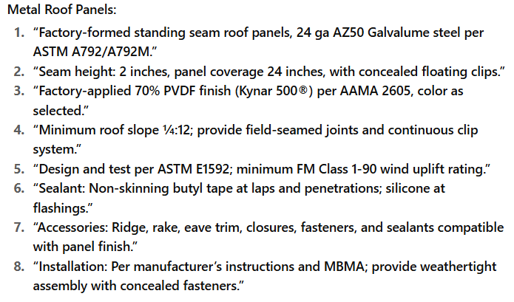

This Article includes examples of standard metal roof panels offered by manufacturers. Revise or add other types of panels as required.

Profile requirements in this article are often better described graphically than verbally. If profiles are indicated on Drawings, omit profile descriptions and retain types of metals and metal thickness.

Retain 1 of the 4 panel-type-callouts below or revise to suit Project.

***************************************************************************************
      - Standing-Seam, Vertical-Rib, Metal Roof Panels<< Insert drawing designation; or None - N/A>>: Formed with vertical ribs at panel edges and << intermediate stiffening ribs symmetrically spaced; or flat pan>> between ribs; designed for sequential installation by mechanically attaching panels to supports using concealed clips located under one side of panels and engaging opposite edge of adjacent panels.

******************************************************************************

Metal thickness options in subparagraph below correspond to obsolete 26, 24, and 22 gages, respectively.

The 1-90 minimum uplift rating in subparagraph “6” below is per LANL ESM Chapter 4 - Architectural, Section B – Shell, Roofing subsection.

******************************************************************************
        - Material: Zinc-coated (galvanized) or aluminum-zinc alloy-coated steel sheet, ​​<< 0.018-inch; 0.024-inch; 0.030-inch; or _______>>​​​ nominal uncoated steel thickness. Pre-painted by the coil-coating process to comply with <<ASTM A755/A755M>>.
          - Color: ​​​<< As indicated by manufacturer's designations; As selected by EOR from manufacturer's full range; or _______>>​​​.
        - Clips: ​​<< One-piece fixed; Two-piece floating; or _______>>​​ to accommodate thermal movement.
        - Joint Type: ​​<< Panels snapped together; Mechanically seamed; or _______>>​​.
        - Panel Coverage: ​​<< 16 inches; or _______>>​​.
        - Panel Height: ​​<< 2 inches; or _______>>​​​.
        - Uplift Rating: Minimum FM Class 1-90.
      - Standing-Seam, Trapezoidal-Rib, Metal Roof Panels<< Insert Drawing Designation; or None - N/A>>: Formed with raised trapezoidal ribs at panel edges and << intermediate stiffening ribs symmetrically spaced; flat pan; or _______>> between ribs; designed for sequential installation by mechanically attaching panels to supports using concealed clips located under one side of panels and engaging opposite edge of adjacent panels.

******************************************************************************

Metal thickness options in subparagraph below correspond to obsolete 26, 24, and 22 gage, respectively.

The 1-90 minimum uplift rating in subparagraph “6” below is per LANL ESM Chapter 4 - Architectural, Section B – Shell, Roofing subsection.

******************************************************************************
        - Material: Zinc-coated (galvanized) or aluminum-zinc alloy-coated steel sheet, ​​​<< 0.018-inch; 0.024-inch; 0.030-inch; or _______>>​​​ nominal uncoated steel thickness. Pre-painted by the coil-coating process to comply with <<ASTM A755/A755M>>.
          - Color: ​​​<< As indicated by manufacturer's designations; As selected by EOR from manufacturer's full range; or _______>>​​​.
        - Clips: ​​<< One-piece fixed; Two-piece floating; or _______>>​​ to accommodate thermal movement.
        - Joint Type: ​​​<< Panels snapped together; Mechanically seamed; or _______>>​​​.
        - Panel Coverage: ​​<< 24 inches; or _______>>​​.
        - Panel Height: ​​<< 3 inches; or _______>>​​.
        - Uplift Rating: Minimum FM Class 1-90.
      - Exposed-Fastener, Tapered-Rib, Metal Roof Panels<< Insert drawing designation; or None - N/A>>: Formed with raised, trapezoidal major ribs and << intermediate stiffening ribs symmetrically spaced; flat pan; or _______>> between major ribs; designed to be installed by lapping side edges of adjacent panels and mechanically attaching panels to supports using exposed fasteners in side laps.

******************************************************************************

Metal thickness options in subparagraph below correspond to obsolete 26, 24, and 22 gage, respectively.

The 1-90 minimum uplift rating in subparagraph “5” below is per LANL ESM Chapter 4 - Architectural, Section B – Shell, Roofing subsection.

******************************************************************************
        - Material: Zinc-coated (galvanized) or aluminum-zinc alloy-coated steel sheet, ​​<< 0.018-inch; 0.024-inch; 0.030-inch; or _______>>​​ nominal uncoated steel thickness. Prepainted by the coil-coating process to comply with <<ASTM A755/A755M>>.
          - Color: ​​​<< As indicated by manufacturer's designations; As selected by EOR from manufacturer's full range; or _______>>​​​.
        - Major-Rib Spacing: ​​​<< 6 inches; 12 inches; or _______>>​​​ o.c.
        - Panel Coverage: ​​​<< 36 inches; or _______>>​​​.
        - Panel Height: ​​​<< 0.75 inches; 1.125 inches; 1.188 inches; 1.25 inches; 1.5 inches; or _______>>​​​.
        - Uplift Rating: Minimum FM Class 1-90.

***************************************************************************************

Retain paragraph below if field-installed insulation is required and insulation must be concealed.

***************************************************************************************
      - Exposed-Fastener, Tapered-Rib, Metal Liner Panels<< Insert Drawing Designation; or None - N/A>>: Formed with raised, trapezoidal major ribs and << intermediate stiffening ribs symmetrically spaced; flat pan; or _______>> between major ribs; designed to be installed by lapping side edges of adjacent panels and mechanically attaching panels to supports using exposed fasteners in side laps.

******************************************************************************

Metal thickness options in subparagraphs below correspond to obsolete 26, 24, and 22 gage, respectively.

******************************************************************************
        - Material: Zinc-coated (galvanized) or aluminum-zinc alloy-coated steel sheet, ​​<< 0.018-inch; 0.024-inch; 0.030-inch; or _______>>​​ nominal uncoated steel thickness. Prepainted by the coil-coating process to comply with <<ASTM A755/A755M>>.
          - Color: ​<< As indicated by manufacturer's designations; As selected by EOR from manufacturer's full range; or _______>>​.
        - Major-Rib Spacing: ​​​​<< 6 inches; 12 inches; or _______>>​​​​ o.c.
        - Panel Coverage: ​​​<< 36 inches; or _______>>​​​.
        - Panel Height: ​​​<< 1.25 inches; 1.5 inches; or _______>>​​​.
      - Fasteners: Manufacturer's standard type<< ____; or None - N/A>>. Size and design to maintain load and weather tightness requirements. Fasteners to be << stainless steel head and shank; stainless steel cap with carbon shank; carbon steel, plated; or _______>> and << stainless steel head and shank; self-tapping; stainless steel cap with carbon shank; self-drilling and tapping; or carbon steel, plated>> .
      - Accessories: Ridge, rake, eave trim, closures, fasteners, and sealants compatible with panel finish.
      - Finishes:
        - Exposed Coil-Coated Finish:

**********************************************************************

Retain 1 of the 3 subparagraphs below or add other finish to suit Project.

Key Features of AAMA 2605:

This specification is the most stringent among the AAMA 2603, 2604, and 2605 standards. It is intended for exterior building products that require maximum durability, such as curtain walls, high-rise buildings, and monumental architectural projects.

Typical Use: Harsh exterior, UV exposure.

Coating Types: Typically 70% PVDF (polyvinylidene fluoride) resin-based coatings (e.g., Kynar 500® or Hylar 5000®). These coatings offer superior resistance to UV radiation, humidity, and airborne pollutants. Durability: 20–30+ yrs.

**********************************************************************
          - Two-Coat Fluoropolymer: <<AAMA 2605>>​​. Fluoropolymer finish containing not less than 70 percent PVDF resin by weight in color coat. Prepare, pretreat, and apply coating to exposed metal surfaces to comply with coating and resin manufacturers’ written instructions.
          - Three-Coat Fluoropolymer: <<AAMA 2605>>. Fluoropolymer finish containing not less than 70 percent PVDF resin by weight in both color coat and clear topcoat. Prepare, pretreat, and apply coating to exposed metal surfaces to comply with coating and resin manufacturers’ written instructions.
          - Siliconized Polyester: Epoxy primer and silicone-modified, polyester-enamel topcoat; with a dry film thickness of not less than 0.2 mil for primer and 0.8 mil for topcoat.

******************************************************************************

Finish in subparagraph below is frequently used as a factory finish for interior surfaces.

******************************************************************************
        - Concealed Finish: Apply pretreatment and manufacturer’s standard white or light-colored acrylic or polyester backer finish, consisting of prime coat and wash coat with a minimum total dry film thickness of 0.5 mil.

***************************************************************************************

Retain the following Article, along with applicable paragraphs and subparagraphs, as required by the project.

***************************************************************************************
    - METAL WALL PANELS

***************************************************************************************

Metal wall panels are factory-formed, thin-gauge steel or aluminum panels used as exterior wall cladding for metal building systems (PEMBs) and conventional structures.

They serve as both architectural enclosure and structural diaphragm, attached to secondary framing (girts, subgirts, or studs).

These panels are available in through-fastened or concealed-fastener (architectural) configurations and can include liner panels, soffits, and trim accessories.

Example Specification

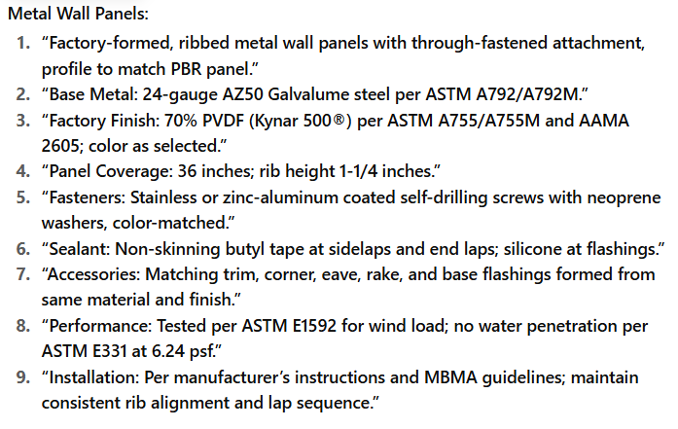

This article includes examples of standard metal wall panels offered by manufacturers. Revise or add other types of panels as required.

Profile requirements in this Article are often better described graphically than verbally. If profiles are indicated on Drawings, omit profile descriptions and retain types of metals and metal thicknesses.

Retain one of the five paragraphs below, or revise as needed to suit the Project.

***************************************************************************************
      - Exposed-Fastener, Tapered-Rib Metal Wall Panels​​<< Insert Drawing Designation; or None - N/A>>​​; Formed with raised, trapezoidal major ribs and ​​<< intermediate stiffening ribs symmetrically spaced; flat pan; or _______>>​​ between major ribs; designed to be installed by lapping side edges of adjacent panels and mechanically attaching panels to supports using exposed fasteners in side laps.

******************************************************************************

Metal thickness options in subparagraph below correspond to obsolete 26, 24, and 22 gage, respectively.

******************************************************************************
        - Material: Zinc-coated (galvanized) or aluminum-zinc alloy-coated steel sheet, ​​<< 0.018-inch; 0.024-inch; 0.030-inch; or _______>>​​​ nominal uncoated steel thickness. Pre-painted by the coil-coating process to comply with <<ASTM A755/A755M>>.
          - Color: ​​​<< As indicated by manufacturer's designations; As selected by EOR from manufacturer's full range; or _______>>​​​.
        - Major-Rib Spacing: ​​​<< 6 inches; 12 inches; or _______>>​​​ o.c.
        - Panel Coverage: ​​​<< 36 inches; or _______>>​​​.
        - Panel Height: ​​​<< 0.75 inches; 1.125 inches; 1.188 inches; 1.25 inches; 1.5 inches; or _______>>​​​.
      - Exposed-Fastener, Reverse-Rib, Metal Wall Panels​<< Insert Drawing Designation; or None - N/A>>​: Formed with recessed, trapezoidal major valleys and ​<< intermediate stiffening ribs symmetrically spaced; flat pan; or _______>>​ between major valleys; designed to be installed by lapping side edges of adjacent panels and mechanically attaching panels to supports using exposed fasteners in side laps.

******************************************************************************

Metal thickness options in subparagraph below correspond to obsolete 26, 24, and 22 gage, respectively.

******************************************************************************
        - Material: Zinc-coated (galvanized) or aluminum-zinc alloy-coated steel sheet, ​​<< 0.018-inch; 0.024-inch; 0.030-inch; or _______>>​​ nominal uncoated steel thickness. Pre-painted by the coil-coating process to comply with <<ASTM A755/A755M>>.
          - Color: ​​​<< As indicated by manufacturer's designations; As selected by EOR from manufacturer's full range; or _______>>​​​.
        - Major-Rib Spacing: ​​​<< 12 inches; or _______>>​​​ o.c.
        - Panel Coverage: ​​​<< 36 inches; or _______>>​​​.
        - Panel Height: ​​​<< 1.125 inches; 1.188 inches; 1.25 inches; 1.5 inches; or ___>>​​​.
      - Concealed-Fastener, Flush-Profile, Metal Wall Panels<< Insert Drawing Designation; or None - N/A>>: Formed with vertical panel edges and << a single wide recess, centered between panel edges; flush surface; or _______>>; with flush joint between panels; with 1-inch- wide flange for attaching interior finish; designed to be installed by lapping and interconnecting side edges of adjacent panels and mechanically attaching through panel to supports using concealed fasteners << and factory-applied sealant; or None - N/A>> in side laps.

******************************************************************************

Metal thickness options in subparagraph below correspond to obsolete 24 and 22 gage, respectively.

******************************************************************************
        - Material: Zinc-coated (galvanized) or aluminum-zinc alloy-coated steel sheet, ​​<< 0.024-inch; 0.030-inch; or _______>>​​ nominal uncoated steel thickness. Prepainted by the coil-coating process to comply with <<ASTM A755/A755M>>.
          - Color: ​​​<< As indicated by manufacturer's designations; As selected by EOR from manufacturer's full range; or _______>>​​​.
        - Panel coverage: ​​<< 16 inches; or _______>>​​.
        - Panel Height: ​​<< 3 inches; or _______>>​​​.

***************************************************************************************

Retain 1 of next 2 Paragraphs below if insulated system is required and insulation must be concealed.

***************************************************************************************
      - Tapered-Rib, Metal Liner Panels​<< Insert Drawing Designation; or None - N/A>>​: Formed with raised, trapezoidal major ribs and ​<< intermediate stiffening ribs symmetrically spaced; flat pan; or _______>>​ between major ribs; designed to be installed by lapping side edges of adjacent panels and mechanically attaching panels to supports using exposed fasteners in side laps.

******************************************************************************

Metal thickness options in subparagraph below correspond to obsolete 26, 24, and 22 gage, respectively.

******************************************************************************
        - Material: Zinc-coated (galvanized) or aluminum-zinc alloy-coated steel sheet, ​​<< 0.018-inch; 0.024-inch; 0.030-inch; or _______>>​​ nominal uncoated steel thickness. Prepainted by the coil-coating process to comply with <<ASTM A755/A755M>>.
          - Color: ​​​​<< As indicated by manufacturer's designations; As selected by EOR from manufacturer's full range; or _______>>​​​​.
        - Major-Rib Spacing: ​​​<< 6 inches; 12 inches; or _______>>​​​​ o.c.
        - Panel Coverage: ​​​<< 36 inches; or _______>>​​​​.
        - Panel Height: ​​​<< 1.25 inches; 1.5 inches; or ___>>​​​.
      - Flush-Profile, Metal Liner Panels​<< Insert Drawing Designation; or None - N/A>>​: ​<< Solid; or Perforated>>​ panels formed with vertical panel edges and ​<< intermediate stiffening ribs symmetrically spaced; flat pan; or _______>>​ between panel edges; with flush joint between panels; designed for interior side of metal wall panel assemblies and installed by lapping and interconnecting side edges of adjacent panels and mechanically attaching through panel to supports using concealed fasteners ​<< and factory-applied sealant; or None - N/A>>​ in side laps.

******************************************************************************

Metal thickness options in 1st subparagraph below correspond to obsolete 24 and 22 gage, respectively.

******************************************************************************
        - Material: Zinc-coated (galvanized) or aluminum-zinc alloy-coated steel sheet, ​​<< 0.024-inch; 0.030-inch; or _______>>​​ nominal uncoated steel thickness. Pre-painted by the coil-coating process to comply with <<ASTM A755/A755M>>.
          - Color: ​​​<< As indicated by manufacturer's designations; As selected by EOR from manufacturer's full range; or _______>>​​​.

******************************************************************************

Retain 1st subparagraph below if required.

******************************************************************************
        - Sound Absorption: NRC not less than ​​<< 0.65; 0.85; 1.00; or _______>>​​ when tested according to <<ASTM C423>>.
        - Panel Coverage: ​​<< 12 inches; or _______>>​​.
        - Panel Height: ​​<< 1.5 inches; or _______>>​​.
      - Finishes
        - Exposed Coil-Coated Finish.

**********************************************************************

Retain 1 of next 3 subparagraphs below, or add other finishes to suit Project.

Key Features of AAMA 2605:

This specification is the most stringent among the AAMA 2603, 2604, and 2605 standards. It is intended for exterior building products that require maximum durability, such as curtain walls, high-rise buildings, and monumental architectural projects.

Typical Use: Harsh exterior, UV exposure.

Coating Types: Typically 70% PVDF (polyvinylidene fluoride) resin-based coatings (e.g., Kynar 500® or Hylar 5000®). These coatings offer superior resistance to UV radiation, humidity, and airborne pollutants. Durability: 20–30+ yrs.

**********************************************************************
          - Two-Coat Fluoropolymer: meet <<AAMA 2605>> requirements. Fluoropolymer finish containing not less than 70 percent PVDF resin by weight in color coat. Prepare, pretreat, and apply coating to exposed metal surfaces to comply with coating and resin manufacturers’ written instructions.
          - Three-Coat Fluoropolymer: meet <<AAMA 2605>> requirements. Fluoropolymer finish containing not less than 70 percent PVDF resin by weight in both color coat and clear topcoat. Prepare, pretreat, and apply coating to exposed metal surfaces to comply with coating and resin manufacturers’ written instructions.
          - Siliconized Polyester: Epoxy primer and silicone-modified, polyester-enamel topcoat; with a minimum dry film thickness of 0.2 mil for primer and 0.8 mil for topcoat.

******************************************************************************

Finish in subparagraph below is frequently used as a factory finish for interior surfaces.

******************************************************************************
        - Concealed Finish: Apply pretreatment and manufacturer’s standard white or light-colored acrylic or polyester backer finish, consisting of prime coat and wash coat with a minimum total dry film thickness of 0.5 mil.

***************************************************************************************

Retain the following Article, along with applicable paragraphs and subparagraphs, as required by the project.

***************************************************************************************
    - FOAMED-INSULATION-CORE METAL WALL PANELS

***************************************************************************************

Foamed-insulation-core metal wall panels are factory-manufactured, composite wall panels consisting of: Two metal facings (steel or aluminum skins), and a continuous rigid foam insulation core (typically polyisocyanurate [PIR] or polyurethane [PUR]) bonded together under controlled heat and pressure.

These panels form a structural, thermally efficient, and weather-resistant enclosure system for metal buildings, industrial, commercial, and cold-storage applications.

Overview Video: Foam Insulated Panels in Metal Buildings

Example Specification

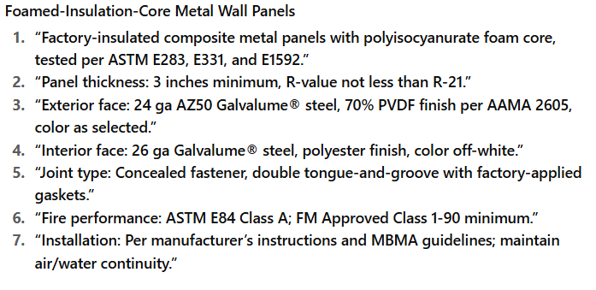

This Article includes examples of’ standard foamed-insulation-core metal wall panels offered by manufacturers. Revise or add other types of panels as required.

Profile requirements in this Article are often better described graphically than verbally. If profiles are indicated on Drawings, omit profile descriptions and retain types of metals, metal thicknesses and insulation cores.

***************************************************************************************
      - Concealed-Fastener, Foamed-Insulation-Core Metal Wall Panels<< Insert drawing designation; or None - N/A>>: Formed with tongue-and-groove panel edges; designed for sequential installation by interlocking panel edges and mechanically attaching panels to supports using concealed clips or fasteners
        - Panel Thermal- Resistance Value (R-Value): << Insert R value>>.

******************************************************************************

Metal thickness options in subparagraph below correspond to obsolete 26, 24, and 22 gage, respectively.

******************************************************************************
        - Facing Material: Fabricate panel with exterior and interior facings of same material and thickness. Zinc-coated (galvanized) or aluminum-zinc alloy-coated steel sheet, << 0.018-inch; 0.024-inch; 0.030-inch; or _______>> nominal uncoated steel thickness. Pre-painted by the coil-coating process to comply with <<ASTM A755/A755M>>.
          - Exterior Surface: << Smooth, flat; Striated; Shallow ribs; Shallow V grooves; or _______>>.
          - Color: ​<< As indicated by manufacturer's designations; As selected by EOR from manufacturer's full range; or _______>>​.
        - Panel Coverage: << 36 inches; 42 inches; or _______>>​ nominal.
        - Panel Thickness: << 2 inches; 2.5 inches; 3 inches; 4 inches; 5 inches; 6 inches; or _______>>.
        - Insulation Core: Modified polyisocyanurate or polyurethane foam using a non-CFC blowing agent, foamed-in-place or board type.
          - Closed-Cell Content: 90 percent when tested according to <<ASTM D6226>>.
          - Density: 2.0 to 2.6 lb/cu.ft. when tested according to <<ASTM D1622>>.
          - Compressive Strength: Minimum 20 psi when tested according to <<ASTM D1621>>.
          - Shear Strength: 26 psi when tested according to <<ASTM C273/C273M>>.
          - Fire-Test-Response Characteristics: Class A according to <<ASTM E108>>.
          - Surface-Burning Characteristics: Flame-spread index of 25 or less and a smoke-developed index of 450 or less, per <<ASTM E84>>​.
      - Finishes
        - Exposed Coil-Coated Finish

**********************************************************************

Retain 1 of next 3 subparagraphs below.

**********************************************************************
          - Two-Coat Fluoropolymer: comply with <<AAMA 2605>> requirements. Fluoropolymer finish containing not less than 70 percent PVDF resin by weight in color coat. Prepare, pretreat, and apply coating to exposed metal surfaces to comply with coating and resin manufacturer’s written instructions.
          - Three-Coat Fluoropolymer: <<AAMA 2605>>. Fluoropolymer finish containing not less than 70 percent PVDF resin by weight in both color coat and clear topcoat. Prepare, pretreat, and apply coating to exposed metal surfaces to comply with coating and resin manufacturer’s written instructions.
          - Siliconized Polyester: Epoxy primer and silicone-modified, polyester-enamel topcoat; with a minimum dry film thickness of 0.2 mil for primer and 0.8 mil for topcoat.

******************************************************************************

Finish in subparagraph below is frequently used as a factory finish for interior surfaces.

******************************************************************************
        - Concealed Finish: Apply pretreatment and manufacturer’s standard white or light-colored acrylic or polyester backer finish, consisting of prime coat and wash coat with a minimum total dry film thickness of 0.5 mil.

***************************************************************************************

Retain the following Article, along with applicable paragraphs and subparagraphs, as required by the project.

***************************************************************************************
    - TRANSLUCENT PANELS

***************************************************************************************

Translucent panels are light-transmitting panels—typically made of fiberglass-reinforced plastic (FRP) or polycarbonate—installed within a metal building’s roof or wall panel system to provide natural daylight inside the building without compromising weather protection. They are engineered to match the profile of the adjacent metal panels, allowing seamless integration with standing seam or through-fastened systems.

Example Specification

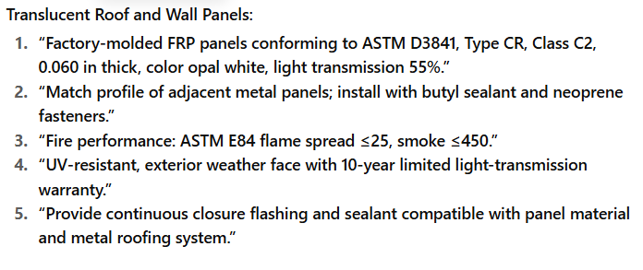

Retain 1 of 1st 2 Paragraphs below. “Limited flammability” is not a fire-hazard classification but indicates material is less flammable than general-purpose material.

***************************************************************************************
      - Uninsulated Translucent Panels: Glass-fiber-reinforced polyester, translucent plastic; complying with <<ASTM D3841>>, << Type CC2 (general purpose); Type CC1 (limited flammability); or _______>>, Grade 1 (weather resistant); smooth finish on both sides. Match profile of adjacent metal panels.

******************************************************************************

Verify, with manufacturers, panel weights in 1st two subparagraphs below.

******************************************************************************
        - Roof Panel Weight: Not less than << 8 oz./sq.ft.; 6 oz./sq.ft.; or _______>> .
        - Wall Panel Weight: Not less than << 8 oz./sq.ft.; 6 oz./sq.ft.; or _______>>
        - Light Transmittance: Not less than << 55; or _______>> percent according to <<ASTM D1494>>.
        - Metal Edge: Fabricate full length of each side of panel with metal edge for seaming into standing-seam roof panel joint.
        - Color: << White; or _______>>.

*** OR ***
      - Insulated Translucent Panels: Fabricate insulating units of two sheets of glass-fiber-reinforced polyester, translucent plastic separated by an air space; complying with <<ASTM D3841>>​, Type CC1 (limited flammability), Grade 1 (weather resistant); smooth finish on both sides. Match profile of adjacent metal panels.

******************************************************************************

Verify, with manufacturers, panel weights in 1st two subparagraphs below.

******************************************************************************
        - Exterior Panel Weight: Not less than << 8 oz./sq.ft.; 6 oz./sq.ft.; or _______>>
        - Interior Panel Weight: Not less than << 8 oz./sq.ft.; 6 oz./sq.ft.; 4 oz./sq.ft; or _______>>
        - Light Transmittance: Not less than << 42; or _______>> percent according to <<ASTM D1494>>.
        - Metal Edge: Fabricate full length of each side of panel with metal edge for seaming into standing-seam roof panel joint.
        - Color: << White; or _______>>​.
      - Mastic for Translucent Panels: Non-staining, saturated vinyl polymer as recommended by translucent panel manufacturer for sealing laps.
      - Surface-Burning Characteristics: As determined by testing identical products according to <<ASTM E84>> by a qualified testing agency. Identify products with appropriate markings of applicable testing agency.
        - Flame-Spread Index: 25 or less.
        - Smoke-Developed Index: 450 or less.

***************************************************************************************

Retain the following Article, along with applicable paragraphs and subparagraphs, as required by the project.

***************************************************************************************
    - METAL SOFFIT PANELS

***************************************************************************************

Metal soffit panels are factory-formed, thin-gauge steel or aluminum panels used to enclose the underside of roof overhangs, canopies, eaves, and building fascias in metal building systems (PEMBs). They provide a finished architectural appearance, protect framing and insulation from weather and pests, and can be vented or solid to support attic or roof cavity ventilation.

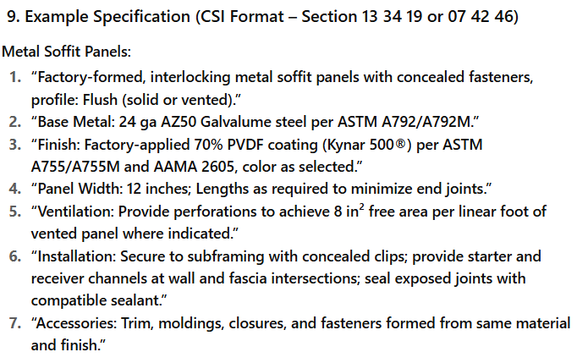

This Article includes examples of standard soffit panels offered by metal building system manufacturers. Revise or add other types of panels as required.

Profile requirements in this Article are often better described graphically than verbally. If profiles are indicated on Drawings, omit profile descriptions and retain types of metals and metal thicknesses.

***************************************************************************************
      - General: Provide factory-formed metal soffit panels designed to be installed by lapping and interconnecting side edges of adjacent panels and mechanically attaching through panel to supports using concealed fasteners << and factory-applied sealant; or None - N/A>> in side laps. Include accessories required for weathertight installation.
      - Metal Soffit Panels: Match profile and material of metal << roof; wall; or _______>>​ panels.
        - Finish: << Match finish and color of metal roof panels; Match finish and color of metal wall panels; As indicated on Drawings; or _______>>.

***************************************************************************************

Retain Paragraph above and/or one of the two paragraphs below. Retain remainder of this Article if not retaining Paragraph above and if metal soffit panels are not required to match metal roof or wall panels.

***************************************************************************************
      - Exposed-Fastener, Tapered-Rib-Profile, Metal Soffit Panels​<< Insert Drawing Designation; or None - N/A>>​: Formed with raised, trapezoidal major ribs and ​<< intermediate stiffening ribs symmetrically spaced; flat pan; or _______>>​ between major ribs; designed to be installed by lapping side edges of adjacent panels and mechanically attaching panels to supports using exposed fasteners in side laps.

******************************************************************************

Metal thickness options in subparagraph below correspond to obsolete 26, 24, and 22 gage, respectively.

******************************************************************************
        - Material: Zinc-coated (galvanized) or aluminum-zinc alloy-coated steel sheet, ​​<< 0.018-inch; 0.024-inch; 0.030-inch; or _______>>​​​ nominal uncoated steel thickness. Pre-painted by the coil-coating process to comply with <<ASTM A755/A755M>>.
          - Exterior Finish: ​​<< Two-coat Fluoropolymer; Three-coat Fluoropolymer; Siliconized polyester; or _______>>​​.
          - Color: ​​<< As indicated by manufacturer's designations; As selected by EOR from manufacturer's full range; or _______>>​​.
        - Major-Rib Spacing: ​​<< 6 inches; 12 inches; or _______>>​​​ o.c.
        - Panel Coverage: ​​<< 36 inches; or _______>>​​.
        - Panel Height: ​​​<< 0.75 inch; 1.125 inches; 1.188 inches; 1.25 inches; 1.5 inches; or ___>>​​​.
      - Concealed-Fastener, Flush-Profile, Metal Soffit Panels​<< Insert Drawing Designation; or None - N/A>>​: Formed with vertical panel edges and ​<< a single wide recess, centered between panel edges; flush surface; or _______>>​; with flush joint between panels; with 1-inch wide flange for attaching interior finish; designed to be installed by lapping and interconnecting side edges of adjacent panels and mechanically attaching through panel to supports using concealed fasteners ​<< and factory-applied sealant; or None - N/A>>​ in side laps.

******************************************************************************

Metal thickness options in subparagraph below correspond to obsolete 24 and 22 gage, respectively.

******************************************************************************
        - Material: Zinc-coated (galvanized) or aluminum-zinc alloy-coated steel sheet, ​​<< 0.024-inch; 0.030-inch; or _______>>​​ nominal uncoated steel thickness. Pre-painted by the coil-coating process to comply with <<ASTM A755/A755M>>.
          - Exterior Finish: ​​​<< Two-coat Fluoropolymer; Three-coat Fluoropolymer; Siliconized polyester; or _______>>​​​.
          - Color: ​​​<< As indicated by manufacturer's designations; As selected by EOR from manufacturer's full range; or _______>>​​​.
        - Panel Coverage: ​​<< 12 inches; 16 inches; or _______>>​​.
        - Panel Height: << 1 inches; 1.5 inches; or _______>>.

***************************************************************************************

Retain the paragraphs and subparagraphs of the following Article that apply to the Project.

***************************************************************************************
    - ACCESSORIES

***************************************************************************************

Metal building accessories are the ancillary components and trim elements that complement the primary framing, secondary framing, roof, and wall systems. They serve functional, protective, and aesthetic purposes—ensuring the building envelope is weathertight, durable, and complete. The following Table summarizes a few typical Metal Building accessories.

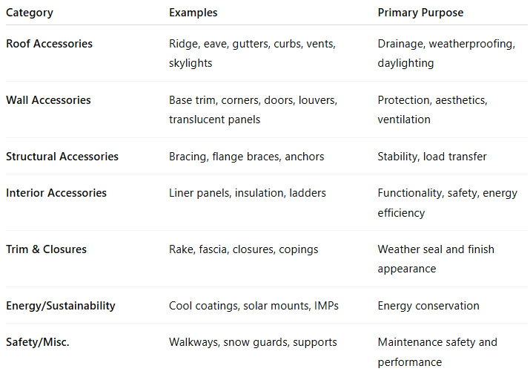

Design and Specification Notes:

Accessories are integral to the building system design and must be supplied or approved by the metal building manufacturer for compatibility.

Material, finish, and thickness should match adjacent panels (same coating system per ASTM A755/A755M and AAMA 2604/2605).

All fasteners, flashings, and sealants should be compatible to prevent galvanic corrosion or finish failure.

Weathertightness warranties depend on proper detailing and use of manufacturer-approved accessories.

This Article includes metal building system manufacturers’ standard accessories. Retain accessories required to suit Project. If more stringent requirements are needed for some accessories, revise descriptions.

***************************************************************************************
      - General: Provide accessories as standard with Metal Building System manufacturer and as specified. Fabricate and finish accessories at the factory to greatest extent possible, by manufacturer’s standard procedures and processes. Comply with indicated profiles and with dimensional and structural requirements.
        - Form exposed sheet metal accessories that are without excessive oil-canning, buckling, and tool marks and that are true to line and levels indicated, with exposed edges folded back to form hems.
        - Provide all accessories, closures, trim, and components required for a complete, weathertight metal building system, fully compatible with adjoining roof and wall panels.
        - Unless otherwise noted, form accessories from the same base metal, gauge, and factory-applied finish as adjacent panels in accordance with <<ASTM A755/A755M>> and <<AAMA 2605>>.
        - Accessories shall include all necessary fasteners, sealants, gaskets, flashings, and supports for proper installation and performance.
      - Roof Panel Accessories: Provide components required for a complete metal roof panel assembly including copings, fasciae, corner units, ridge closures, clips, sealants, gaskets, fillers, closure strips, and similar items. Match material and finish of metal roof panels unless otherwise indicated.
        - Closures: Provide closures at eaves and ridges, fabricated of same material as metal roof panels.

******************************************************************************

Retain "Clips" and "Cleats" subparagraphs below only with standing-seam metal roof panels.

******************************************************************************
        - Clips: Manufacturer’s standard, formed from << steel; stainless-steel; or ______>>​ sheet, designed to withstand negative-load (uplift) requirements and to permit unrestrained expansion and contraction movement of panels. Provide a minimum of two fasteners for each clip.
        - Cleats: Manufacturer’s standard, mechanically seamed cleats formed from ​<< steel; or stainless-steel sheet or nylon-coated aluminum>>​ sheet.
        - Backing Plates: Provide metal backing plates at panel end splices, fabricated from material recommended by manufacturer.
        - Closure Strips: Closed-cell, expanded, cellular, rubber or crosslinked, polyolefin-foam or closed-cell laminated polyethylene; minimum 1-inch-thick, flexible closure strips; cut or pre-molded to match metal roof panel profile. Provide closure strips where indicated or necessary to ensure weathertight construction.

******************************************************************************

Retain subparagraph below if thermal bridging is a concern.

******************************************************************************
        - Thermal Spacer Blocks: Where metal panels attach directly to purlins, provide thermal spacer blocks of thickness required to provide 1-inch standoff; fabricated from extruded polystyrene.

***************************************************************************************

Retain the following paragraph if applicable.

***************************************************************************************
      - Wall Panel Accessories: Provide components required for a complete metal wall panel assembly including copings, fasciae, mullions, sills, corner units, clips, sealants, gaskets, fillers, closure strips, and similar items. Match material and finish of metal wall panels unless otherwise indicated.
        - Closures: Provide closures at eaves and rakes, fabricated of same material as metal wall panels.

******************************************************************************

Retain subparagraph below if required; some manufacturers do not provide backing plates for wall panels.

******************************************************************************
        - Backing Plates: Provide metal backing plates at panel end splices, fabricated from material recommended by manufacturer.
        - Closure Strips: Closed-cell, expanded, cellular, rubber or crosslinked, polyolefin-foam or closed-cell laminated polyethylene; minimum 1-inch-thick, flexible closure strips; cut or premolded to match metal wall panel profile. Provide closure strips where indicated or necessary to ensure weathertight construction.
      - Flashing and Trim: Zinc-coated (galvanized) or aluminum-zinc alloy-coated steel sheet, 0.018-inch nominal uncoated steel thickness, pre-painted with coil coating; finished to match adjacent metal panels.

******************************************************************************

Flashing and trim are essential components in a metal building envelope, used wherever roof and wall panels terminate, intersect, or change direction. Their dual purpose is to: Seal joints against water, air, and debris intrusion, and Provide a neat, durable, and finished appearance to the structure. The following figures show typical flashing and trim locations.

Source: https://primebldg.com/product/house-roof-rake-rpn/

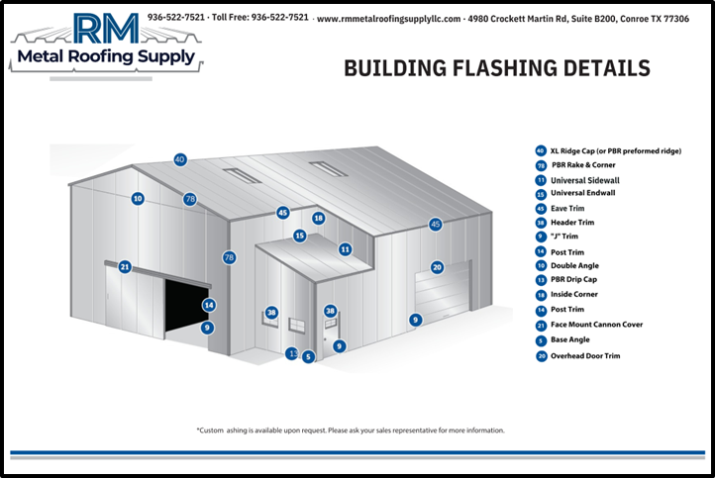

Source: https://rmmetalroofingsupplyllc.com/products/metal-roof-trim-flashing/

******************************************************************************
        - Provide flashing and trim as required to seal against weather and to provide finished appearance. Locations include, but are not limited to, eaves, rakes, hip Lines, sidewalls, corners, bases, framed openings, ridges, fasciae, and fillers.

******************************************************************************

Retain 2nd option in subparagraph below if head and jambs of doors are subject to excessive impact. Painted sub-framing is often more durable. Metal thickness options correspond to obsolete 26 and 22 gage, respectively.

******************************************************************************
        - Opening Trim: Zinc-coated (galvanized) or aluminum-zinc alloy-coated steel sheet, << 0.018-inch; 0.030-inch; or _______>> nominal uncoated steel thickness, pre-painted with coil coating. Trim head and jamb of door openings, and head, jamb, and sill of other openings.

***************************************************************************************

Retain the following paragraph and applicable subparagraphs, as required by the project

***************************************************************************************
      - Gutters: Zinc-coated (galvanized) or aluminum-zinc alloy-coated steel sheet, 0.018-inch nominal uncoated steel thickness, pre-painted with coil coating; finished to match roof fascia and rake trim. Match profile of gable trim, complete with end pieces, outlet tubes, and other special pieces as required. Fabricate in minimum 96-inch-long sections, sized according to<<SMACNA (ASMM)>>.
        - Gutter Supports: Fabricated from same material and finish as gutters.
        - Strainers: Bronze, copper, or aluminum wire ball type at outlets.

***************************************************************************************

Retain the following paragraph and applicable subparagraphs, as required by the project

***************************************************************************************
      - Downspouts: Zinc-coated (galvanized) or aluminum-zinc alloy-coated steel sheet, 0.018-inch nominal uncoated steel thickness, pre-painted with coil coating; finished to match metal wall panels. Fabricate in minimum 10-foot-long sections, complete with formed elbows and offsets.
        - Mounting Straps: Fabricated from same material and finish as gutters.

***************************************************************************************

Retain the following paragraph if required by the project. Service walkways are not available from all manufacturers. Refer to the following figure for a few examples.

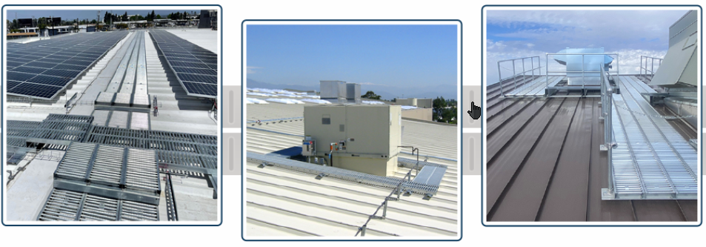

Source: https://www.rsroofproducts.com/

***************************************************************************************
      - Service Walkways: Zinc-coated (galvanized) or aluminum-zinc alloy-coated steel sheet, 0.048-inch nominal uncoated steel thickness, steel plank grating; with slip-resistant pattern; << 18-inch; 24-inch; 36-inch; or _______>>​ overall width. Support walkways on framing system anchored to metal roof panels without penetrating panels; with predrilled holes and clamps or hooks for anchoring.

***************************************************************************************

Roof ventilators are installed in metal building systems to provide natural or mechanical air exchange, removing heat, humidity, fumes, or condensation from the building interior. They help maintain proper indoor air quality, protect insulation and structural components from moisture, and comply with code-required ventilation for certain occupancies. They range from simple passive ridge vents to powered exhaust fans, each chosen based on Building use and heat generation, Required air changes per hour, Climate and building size, and Architectural appearance. The following table summarizes the main types of ventilators used in pre‐engineered metal building system (PEMB).

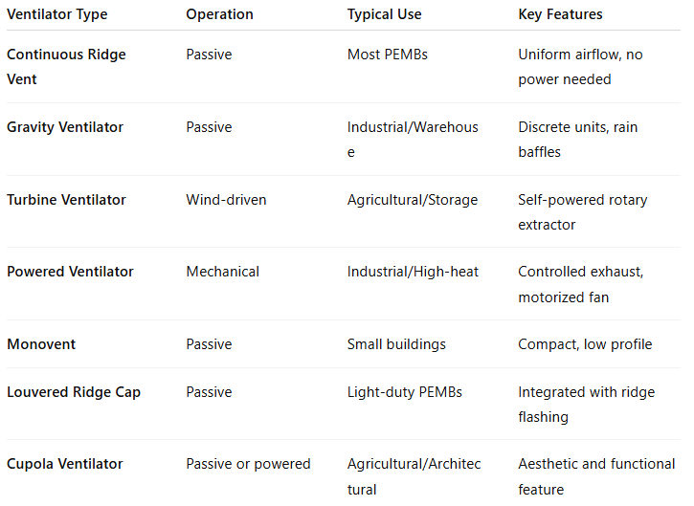

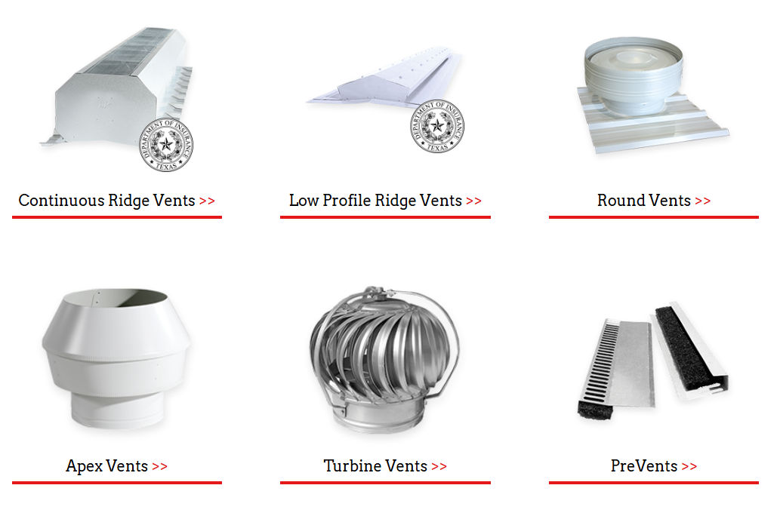

​Source: https://www.mpvent.com/product/ventilators/

Retain the following paragraph and applicable subparagraphs, as required by the project

***************************************************************************************
      - Roof Ventilators: Passive type, complete with hardware, flashing, closures, and fittings.

******************************************************************************

Retain 1 of the next 2 subparagraphs below.

******************************************************************************
        - Circular-Revolving Type: Minimum ​​<< 20-inch; or _______>>​​​ diameter throat opening; zinc-coated (galvanized) - or aluminum-zinc alloy-coated steel sheet, 0.024-inch nominal uncoated steel thickness, with coil coating; finished to match metal roof panels; with matching base and rain cap.

*** OR ***
        - Type: ​​​<< Directional; Stationary; or _______>>​​​ revolving.
          - Bird Screening: Galvanized steel, 1/2-inch square mesh, 0.041-inch wire; or aluminum, 1/2-inch-square mesh, 0.063-inch wire.

**********************************************************************

Retain subparagraph below if dampers are required.

**********************************************************************
          - Dampers: Spring-loaded, butterfly type; pull-chain operation; with pull chain of length required to reach within 36 inches of floor.
          - Reinforce and brace units, with joints properly formed and edges beaded to be watertight under normal positive-pressure conditions.
          - Mount ventilators on square-to-round bases for ridge or on-slope mounting, designed to match roof pitch and roll formed to match metal roof panel profile.
        - Continuous or Sectional-Ridge Type: Factory-engineered and -fabricated, continuous unit; Zinc-coated (galvanized) or aluminum-zinc alloy-coated steel sheet, 0.018-inch nominal uncoated steel thickness, pre-painted with coil coating; finished to match metal roof panels. Fabricated in minimum 10-foot-long sections. Provide throat size and total length indicated, complete with side baffles, ventilator assembly, end caps, splice plates, and reinforcing diaphragms.
          - Bird Screening: Galvanized steel, 1/2-inch-square mesh, 0.041-inch wire; or aluminum, 1/2-inch-square mesh, 0.063-inch wire.

**********************************************************************

Retain subparagraph below if dampers required.

**********************************************************************
          - Dampers: Manually operated, spring-loaded, vertically rising type; chain and worm gear operator; with pull chain of length required to reach within 36 inches of floor.
          - Throat Size: << 9 inches; 12 inches; or _______>>​<< , as standard with manufacturer, and as required to comply with ventilation requirements; or None - N/A>>.

***************************************************************************************

Retain Paragraph below if louvers are required. Manufacturers’ standard sizes are typically 3 by 3 feet, 3 by 4 feet, and 4 by 4 feet. Verify availability with manufacturers.

Louvers are fixed or operable blade assemblies installed in wall openings of metal buildings to allow air movement (intake or exhaust) while restricting rain, snow, birds, and debris from entering the building. They are a standard accessory in pre-engineered metal building systems (PEMBs), used for natural ventilation, air intake for mechanical systems, or pressure relief. Louvers are typically factory-fabricated aluminum or steel units designed to match the building’s wall panels in profile, color, and finish.

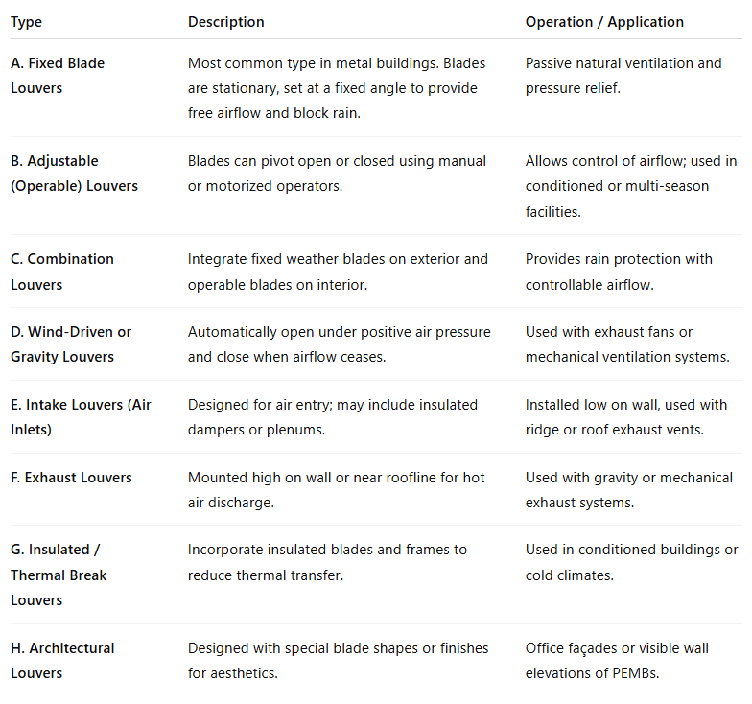

***************************************************************************************
      - Louvers: Size and design indicated; self-framing and self-flashing. Fabricate welded frames from zinc-coated (galvanized) or aluminum-zinc alloy-coated steel sheet, 0.048-inch nominal uncoated steel thickness, finished to match metal wall panels. Form blades from zinc-coated (galvanized) or aluminum-zinc alloy-coated steel sheet, 0.036-inch nominal uncoated steel thickness, folded or beaded at edges, set at an angle that excludes driving rains, and secured to frames by riveting or welding. Fabricate louvers with equal blade spacing to produce uniform appearance.

******************************************************************************

Retain 1 of 2 “Blades” subparagraphs below. If retaining both, indicate location of each on Drawings.

******************************************************************************
        - Blades: Fixed.

*** OR ***
        - Blades: Adjustable type, with weather-stripped edges, and manually operated by hand crank or pull chain.
        - Free Area: Not less than ​​​<< 7.0 sq. ft.; or _______>>​​​ for 48-inch-wide by 48-inch-high louver.
        - Bird Screening: Galvanized steel, 1/2-inch-square mesh, 0.041-inch wire; with re-wireable frames, removable and secured with clips; fabricated of same kind and form of metal and with same finish as louvers.

**********************************************************************

In subparagraph below, interior mounting is for interior face of fixed louvers; exterior mounting is for exterior or interior face of adjustable louvers.

**********************************************************************
          - Mounting: ​​​<< Interior; Exterior; or _______>>​​​ face of louvers.
        - Vertical Mullions: Provide mullions at spacing recommended by manufacturer, or 72 inches o.c., whichever is less.

***************************************************************************************

Pipe flashings are installed wherever a round penetration passes through the roof or side walls, and their job is to: Prevent water leakage around the pipe. Accommodate thermal expansion and vibration of both the roof/side-walls and pipe. Provide a durable, flexible, and maintenance-free seal compatible with metal roof panels. In pre-engineered metal buildings (PEMBs), pipe flashings are essential because the roof panels expand and contract, and rigid flashings would fail quickly.​

Pipe flashing in Paragraph below is not designed for high-temperature applications. This describes a factory-made roof penetration flashing assembly used to seal around round pipes or conduits (such as plumbing vents, electrical conduits, or HVAC lines) that pass through metal roof panels.

***************************************************************************************
      - Pipe Flashing: Pre-molded, EPDM pipe collar with flexible aluminum ring bonded to base.
      - Materials
        - Fasteners: Self-tapping screws, bolts, nuts, self-locking rivets and bolts, end-welded studs, and other suitable fasteners designed to withstand design loads. Provide fasteners with heads matching color of materials being fastened by means of plastic caps or factory-applied coating.

**********************************************************************

Retain 1 of next 2 subparagraphs below. Stainless-steel fasteners in 2nd subparagraph provide additional corrosion resistance. Retain washers if required; washers are usually omitted from wall panels.

**********************************************************************
          - Fasteners for Metal Wall Panels: Self-drilling or self-tapping, zinc-plated, hex-head carbon-steel screws<< , with EPDM sealing washers bearing on weather side of metal panels; or None - N/A>>.

*** OR ***
          - Fasteners for Metal Wall Panels: Self-drilling, Type 410 stainless-steel or self-tapping, Type 304 stainless-steel or zinc-alloy-steel hex washer head<< , with EPDM sealing washers bearing on weather side of metal panels; or None - N/A>>.
          - Fasteners for Flashing and Trim: Blind fasteners or self-drilling screws with hex washer head.
          - Blind Fasteners: High-strength aluminum or stainless-steel rivets.
        - Corrosion-Resistant Coating: Cold-applied asphalt mastic, compounded for 15-mil dry film thickness per coat. Provide inert-type noncorrosive compound free of asbestos fibers, sulfur components, and other deleterious impurities.
        - Nonmetallic, Shrinkage-Resistant Grout: <<ASTM C1107/C1107M>>​, factory-packaged, nonmetallic aggregate grout, noncorrosive, non-staining, mixed with water to consistency suitable for application and a 30-minute working time.
        - Metal Panel Sealants:
          - Provide sealants, tapes, and accessories required for a complete, weathertight installation of metal roof and wall panels, flashings, and trim.
          - Sealants shall be compatible with adjoining substrates including galvanized or Galvalume® steel, aluminum, and factory-applied paint finishes (PVDF/SMP).
          - Use sealant types recommended and approved by the metal building manufacturer to maintain weathertightness warranty.
          - Colors shall match or complement adjacent surfaces where exposed to view.
          - Sealant Tape: Pressure-sensitive, 100 percent solids, gray polyisobutylene-compound sealant tape with release-paper backing. Provide permanently elastic, non-sag, nontoxic, non-staining tape of manufacturer’s standard size.
          - Joint Sealant: Comply with <<ASTM C920>>; one-part elastomeric polyurethane or polysulfide; of type, grade, class, and use classifications required to seal joints in metal panels and remain weathertight; and as recommended by metal building system manufacturer.
    - FABRICATION
      - General:
        - Design and fabricate components and field connections to permit efficient, accurate, and safe field erection.
        - Clearly mark each piece and part of the assembly to correspond with erection drawings and assembly instructions.
        - Fabricate members true to line and shape with clean, smooth cuts and bends; ensure punched and drilled holes are of proper size, shape, and location.
        - Fabricate members free of cracks, tears, warps, laminations, and other defects that impair strength or appearance.
        - Perform welding in accordance with <<AWS D1.1/D1.1M>> and <<AWS D1.8/D1.8M>> for structural steel and <<AWS D1.3/D1.3M>> for sheet steel, as applicable.
        - Tolerances: Comply with <<MBMA (MBSM)>> and <<AISC 303>> for fabrication and erection tolerances, as applicable.
      - Primary Framing: Shop-fabricate framing components to indicated size and section, with baseplates, bearing plates, stiffeners, and other items required for erection welded into place. Cut, form, punch, drill, and weld framing for bolted field assembly.
        - Make shop connections by welding or by using high-strength bolts.
        - Join flanges to webs of built-up members by a continuous, submerged arc-welding process.
        - Brace compression flange of primary framing with steel angles or cold-formed structural tubing between frame web and purlin web or girt web, so flange compressive strength is within allowable limits for any combination of loadings.
        - Weld clips to frames for attaching secondary framing if applicable, or punch for bolts.
        - Shop Priming: Prepare surfaces for shop priming according to <<SSPC-SP 2>>. Shop prime primary framing with specified primer after fabrication.
      - Secondary Framing: Shop fabricate framing components to indicated size and section by roll-forming to break-forming, with baseplates, bearing plates, stiffeners, and other plates required for erection welded into place. Cut, form, punch, drill, and weld secondary framing for bolted field connections to primary framing.
        - Make shop connections by welding or by using non-high-strength bolts in accordance with manufacturer’s standard practice.
        - Shop Priming: Prepare uncoated surfaces for shop priming according to <<SSPC-SP 2>>. Shop prime uncoated secondary framing with specified primer after fabrication.
      - Framed Openings
        - Provide structural shapes of appropriate design and size to reinforce openings and support imposed loads and vibrations, including loads from equipment furnished by others as specified in the Subcontract documents.
        - Securely attach framed openings to the building’s structural framing.
      - Metal Panels: Fabricate and finish metal panels at the factory to greatest extent possible, by manufacturer’s standard procedures and processes, as necessary to fulfill indicated performance requirements. Comply with indicated profiles and with dimensional and structural requirements.
        - Provide panel profile, including major ribs and intermediate stiffening ribs, if any, for full length of metal panel.
        - Protect finished panels during fabrication, shipping, and erection with strippable plastic film or interleaving paper as recommended by manufacturer.
    - SOURCE QUALITY CONTROL

***************************************************************************************

Refer to previous author note pertaining to Article QUALITY ASSURANCE in Part 1.

The content of this Article is based on non-use of Seismic Force-Resisting System consisting of intermediate or special moment frames that have material to be welded > 5/16”.

***************************************************************************************
      - Fabricator is responsible for the performance of the inspections and tests required by the fabricator’s quality control procedures, and for the submission of related reports.
      - Reports shall indicate whether or not fabrication of structural steel members and connections between them are in accordance with <<MBMA (MBSM)>> and, as applicable, <<AISC 360>> and <<AISC 341>>.
      - Products not fabricated in accordance with the aforementioned documents, as applicable, will be considered defective.
  - PART 3 - EXECUTION
    - EXAMINATION
      - Examine substrates, areas, and conditions, with erector present, for compliance with requirements for installation tolerances and other conditions affecting performance of the Work.
      - Before erection proceeds survey elevations and locations of concrete- and masonry- bearing surfaces and locations of anchor rods, bearing plates, and other embedments to receive structural framing, with erector present, for compliance with requirements and Metal Building System manufacturer’s tolerances.
        - Engage land surveyor to perform surveying.
        - Verify that foundation, floor slab, mechanical and electrical utilities, and placed anchors are in correct position and properly squared.
      - Proceed with erection only after unsatisfactory conditions have been corrected.
    - PREPARATION
      - Clean and prepare surfaces to be painted according to manufacturer’s written instructions for each particular substrate condition.
      - Provide temporary shores, guys, braces, and other supports during erection to keep structural framing secure, plumb, and in alignment against temporary construction loads and loads equal in intensity to design loads. Remove temporary supports when permanent structural framing, connections, and bracing are in place unless otherwise indicated.
    - ERECTION OF STRUCTURAL FRAMING
      - Erect metal building system according to manufacturer’s written instructions and drawings.
      - Do not field cut, drill, or alter structural members without written approval from metal building system manufacturer’s professional engineer.
      - Set structural framing accurately in locations and to elevations indicated, according to <<MBMA (CIP)>> and <<AISC 303>>, as applicable. Maintain structural stability of frame during erection.

***************************************************************************************

Insert leveling plates Paragraph below if required.

***************************************************************************************
      - Base and Bearing Plates: Clean concrete and masonry-bearing surfaces of bond-reducing materials, and roughen surfaces prior to setting plates. Clean bottom surface of plates.
        - Set plates for structural members on wedges, shims, or setting nuts as required.
        - Tighten anchor rods after supported members have been positioned and plumbed. Do not remove wedges or shims but, if protruding, cut off flush with edge of plate before packing with grout.
        - Promptly pack grout solidly between bearing surfaces and plates so no voids remain. Neatly finish exposed surfaces; protect grout and allow to cure. Comply with manufacturer’s written installation instructions for shrinkage-resistant grouts.
      - Align and adjust structural framing before permanently fastening. Before assembly, clean bearing surfaces and other surfaces that will be in permanent contact with framing. Perform necessary adjustments to compensate for discrepancies in elevations and alignment.
        - Level and plumb individual members of structure.

******************************************************************************

Revise subparagraph below to suit Project. Omit if not required.

******************************************************************************
        - Make allowances for difference between temperature at time of erection and mean temperature when structure will be completed and in service.
      - Primary Framing and End Walls: Erect framing level, plumb, rigid, secure, and true to line. Level baseplates to a true even plane with full bearing to supporting structures, set with double-nutted anchor rods. Use grout to obtain uniform bearing and to maintain a level base-line elevation. Moist-cure grout for not less than seven days after placement.
        - Make field connections using high-strength bolts installed according to <<RCSC>> for bolt type and joint type specified.

**********************************************************************

See RCSC Spec for definitions of "snug tightened" and "pre-tensioned" in "Joint Type" subparagraph below.

**********************************************************************
          - Joint Type: Snug tightened, pre-tensioned, or slip-critical as required by manufacturer.
      - Secondary Framing: Erect framing level, plumb, rigid, secure, and true to line. Field bolt secondary framing to clips attached to primary framing.
        - Provide rake or gable purlins with tight-fitting closure channels and fasciae.
        - Locate and space wall girts to suit openings such as doors and windows.
        - Provide supplemental framing at entire perimeter of openings, including doors, windows, louvers, ventilators, and other penetrations of roof and walls.

***************************************************************************************

Retain next Paragraph if steel joist purlins or joist girders are required; otherwise, omit.

***************************************************************************************
      - Steel Joists << and Joist Girders; or None - N/A>>: Install joists<< , girders,; or None - N/A>> and accessories plumb, square, and true to line; securely fasten to supporting construction according to <<SJI 100>>specification, joist manufacturer’s written instructions, and requirements in this Section.
        - Before installation, splice-connect joists delivered to Project site in more than one piece.
        - Space, adjust, and align joists accurately in location before permanently fastening.
        - Install temporary bracing and erection bridging, connections, and anchors to ensure that joists are stabilized during construction.

******************************************************************************

Retain 1 of next 3 subparagraphs.

******************************************************************************
        - Joist Installation: Bolt joists to supporting steel framework using carbon-steel bolts unless otherwise indicated.

*** OR ***
        - Joist Installation: Bolt joists to supporting steel framework using high-strength structural bolts unless otherwise indicated. Comply with <<RCSC>> for high-strength structural bold installation and tightening requirements.

*** OR ***
        - Joist Installation: Weld joist seats to supporting steel framework.
        - Install and connect bridging concurrently with joist erection, before construction loads are applied. Anchor ends of bridging lines at top and bottom chords if terminating at walls or beams.
      - Bracing: Install bracing in roof and sidewalls where indicated on erection drawings:
        - Tighten rod bracing to avoid sag.
        - Locate interior end-bay bracing only where indicated.
      - Framing for Openings: Provide shapes of proper design and size to reinforce openings and to carry loads and vibrations imposed, including equipment furnished under mechanical and electrical work. Securely attach to structural framing.
      - Erection Tolerances: Maintain erection tolerances of structural framing within those permitted by <<AISC 303>>​.
    - METAL PANEL INSTALLATION, GENERAL
      - Fabricate and finish metal panels and accessories at the factory, by manufacturer's standard procedures and processes, as necessary to fulfill indicated performance requirements demonstrated by laboratory testing. Comply with indicated profiles and with dimensional and structural requirements.

***************************************************************************************

Retain Paragraph below to permit use of on-site, portable roll-forming equipment.

***************************************************************************************
      - On-Site Fabrication: Subject to compliance with requirements of this Section, metal panels may be fabricated on-site using UL-certified, portable roll-forming equipment if panels are of same profile and warranted by manufacturer to be equal to factory-formed panels. Fabricate according to equipment manufacturer's written instructions and to comply with details shown
      - Examination: Examine primary and secondary framing to verify that structural-panel support members and anchorages have been installed within alignment tolerances required by manufacturer.
        - Examine roughing-in for components and systems penetrating metal panels, to verify actual locations of penetrations relative to seams before metal panel installation.
      - General: Anchor metal panels and other components of the Work securely in place, with provisions for thermal and structural movement.
        - Field cut metal panels as required for doors, windows, and other openings. Cut openings as small as possible, neatly to size required, and without damage to adjacent metal panel finishes.
          - Field cutting of metal panels by torch is not permitted unless approved in writing by manufacturer.
        - Install metal panels perpendicular to structural supports unless otherwise indicated.
        - Flash and seal metal panels with weather closures at perimeter of openings and similar elements. Fasten with self-tapping screws.
        - Locate and space fastenings in uniform vertical and horizontal alignment.
        - Locate metal panel splices over structural supports with end laps in alignment.
        - Lap metal flashing over metal panels to allow moisture to run over and off the material.

***************************************************************************************

Retain the following paragraph if applicable.

***************************************************************************************
      - Lap-Seam Metal Wall Panels: Install screw fasteners using power tools with controlled torque adjusted to compress EPDM washers tightly without damage to washers, screw threads, or metal panels. Install screws in predrilled holes.
        - Arrange and nest side-lap joints so prevailing winds blow over, not into, lapped joints. Lap ribbed or fluted sheets one full rib corrugation. Apply metal panels and associated items for neat and weathertight enclosure. Avoid “panel creep” or application not true to line.
      - Metal Protection: Where dissimilar metals contact each other or corrosive substrates, protect against galvanic action by painting contact surfaces with corrosion-resistant coating, by applying rubberized-asphalt underlayment to each contact surface, or by other permanent separation as recommended by metal roof panel manufacturer.
      - Joint Sealers: Install gaskets, joint fillers, and sealants where indicated and where required for weatherproof performance of metal panel assemblies. Provide types of gaskets, fillers, and sealants indicated; or, if not indicated, provide types recommended by metal panel manufacturer.
        - Seal metal panel end laps with double beads of tape or sealant the full width of panel. Seal side joints where recommended by metal panel manufacturer.

******************************************************************************

Retain subparagraph below if joint-sealant work is part of this Section.

******************************************************************************
        - Prepare joints and apply sealants to comply with requirements per Section ​<< 07 9200 - Joint Sealants>>​.
    - METAL ROOF PANEL INSTALLATION
      - General: Provide metal roof panels of full length from eave to ridge unless otherwise indicated or restricted by shipping limitations.
        - Install all wall and roofing systems in accordance with manufacturer's instructions and details.
        - Install ridge << and hip; or None - N/A>> caps as metal roof panel work proceeds.
        - Flash and seal metal roof panels with weather closures at eaves and rakes. Fasten with self-tapping screws.

***************************************************************************************

Retain the following paragraph and applicable subparagraphs, as required by the project.

***************************************************************************************
      - Standing Seam Metal Roof Panels: Fasten metal roof panels to supports with concealed clips at each standing-seam joint, at location and spacing and with fasteners recommended by manufacturer.
        - Install clips to supports with self-drilling or self-tapping fasteners.
        - Install pressure plates at locations indicated in manufacturer’s written installation instructions.

******************************************************************************

Retain 1 of next 2 subparagraphs below; coordinate with products selected in Part 2.

******************************************************************************
        - Snap Joint: Nest standing seams and fasten together by interlocking and completely engaging factory-applied sealant.

*** OR ***
        - Seamed Joint: Crimp standing seams with manufacturer-approved motorized seamer tool so that clip, metal roof panel, and factory-applied sealant are completely engaged.
        - Rigidly fasten eave end of metal roof panels and allow ridge end free movement for thermal expansion and contraction. Predrill panels for fasteners.
        - Provide metal closures at ​<< peaks; rake edges; rake walls; and _______>>​ ​<< and; or None - N/A>>​ each side of ridge ​<< and hip; or None - N/A>>​ caps.

***************************************************************************************

Retain the following paragraph and applicable subparagraphs, as required by the project.

***************************************************************************************
      - Exposed Fastener Lap-Seam Metal Roof Panels: Fasten metal roof panels to supports with exposed fasteners at each lapped joint, at location and spacing recommended by manufacturer.
        - Provide metal-backed sealing washers under heads of exposed fasteners bearing on weather side of metal roof panels.
        - Provide sealant tape at lapped joints of metal roof panels and between panels and protruding equipment, vents, and accessories.
        - Apply a continuous ribbon of sealant tape to weather-side surface of fastenings on end laps and on side laps of nesting-type metal panels, on side laps of ribbed or fluted metal panels, and elsewhere as needed to make metal panels weatherproof to driving rains.
        - At metal panel splices, nest panels with minimum 6-inch end lap, sealed with butyl-rubber sealant and fastened together by interlocking clamping plates.
      - Metal Fascia Panels: Align bottom of metal panels and fasten with blind rivets, bolts, or self-drilling or self-tapping screws. Flash and seal metal panels with weather closures where fasciae meet soffits, along lower panel edges, and at perimeter of all openings.

***************************************************************************************

Generally retain paragraph below only for highly finished metal roof panel assemblies.

***************************************************************************************
      - Metal Roof Panel Installation Tolerances: Shim and align metal roof panels within installed tolerance of 1/4 inch in 20 feet on slope and location lines as indicated and within 1/8-inch offset of adjoining faces and of alignment of matching profiles.

***************************************************************************************

Retain the following Article, along with applicable paragraphs and subparagraphs, as required by the project.

***************************************************************************************
    - METAL WALL PANEL INSTALLATION
      - General: Install metal wall panels in orientation, sizes, and locations indicated on Drawings. Install panels perpendicular to girts, extending full height of building, unless otherwise indicated. Anchor metal wall panels and other components of the Work securely in place, with provisions for thermal and structural movement.
        - Install all wall systems in accordance with manufacturer's instructions and details.
        - Unless otherwise indicated, begin metal panel installation at corners with center of rib lined up with line of framing.
        - Shim or otherwise plumb substrates receiving metal wall panels.
        - When two rows of metal panels are required, lap panels 4 inches minimum.
        - When building height requires two rows of metal panels at gable ends, align lap of gable panels over metal wall panels at eave height.
        - Rigidly fasten base end of metal wall panels and allow eave end free movement for thermal expansion and contraction. Predrill panels.
        - Flash and seal metal wall panels with weather closures at eaves, rakes, and at perimeter of all openings. Fasten with self-tapping screws.
        - Install screw fasteners in predrilled holes.
        - Install flashing and trim as metal wall panel work proceeds.
        - Apply elastomeric sealant continuously between metal base channel (sill angle) and concrete, and elsewhere as indicated; or, if not indicated, as necessary for waterproofing.
        - Align bottom of metal wall panels and fasten with blind rivets, bolts, or self-drilling of self-tapping screws.
        - Provide weatherproof escutcheons for pipe and conduit penetrating exterior walls.
      - Metal Wall Panels: Install metal wall panels on exterior side of girts. Attach metal wall panels to supports with fasteners as recommended by manufacturer.
      - Insulated Metal Wall Panels: Install insulated metal wall panels on exterior side of girts. Attach panels to supports at each panel joint using concealed clip and fasteners at maximum 42 inches o.c., spaced not more than manufacturer’s recommendation. Fully engage tongue and groove of adjacent insulated metal wall panels.
        - Install clips to supports with self-tapping fasteners.
        - Apply continuous ribbon of sealant to panel joint on concealed side of insulated metal wall panels as vapor seal; apply sealant to panel joint on exposed side of panels as weather seal.

***************************************************************************************

Retain Paragraph below only for highly finished metal wall panel assemblies.

***************************************************************************************
      - Installation Tolerances: Shim and align metal wall panels within installed tolerance of 1/4 inch in 20 feet, noncumulative, level, plumb, and on location lines; and within 1/8-inch offset of adjoining faces and of alignment of matching profiles.

***************************************************************************************

Retain the following Article, along with applicable paragraphs and subparagraphs, as required by the project.

***************************************************************************************
    - FOAMED-INSULATION-CORE METAL WALL PANELS INSTALLATION

***************************************************************************************

Example Installation videos: Horizontal Insulated Metal Panel Installation, Vertical Insulated Metal Panel Installation.

***************************************************************************************
      - ​General
        - Examine substrates and supporting structure before installation. Verify:
          - Alignment and plumbness of girts.
          - Proper spacing and attachment per shop drawings.
          - Framed openings and corners are square and within tolerance (±1/8 in in 20 ft).
          - Substrate surfaces are clean, dry, and free of protrusions or debris.
        - Do not proceed with panel installation until unsatisfactory conditions have been corrected.
        - Coordinate installation with flashing, trim, sealants, insulation, and accessory trades to maintain air, vapor, and weather barrier continuity.
        - Handle and store panels per manufacturer’s recommendations to prevent damage, distortion, or moisture intrusion into panel joints.
      - Preparation and Layout:
        - Establish control lines and benchmarks at building corners and openings to ensure proper panel alignment.
        - Confirm panel direction (vertical or horizontal) and start point per shop drawings.
        - Verify starter tracks, base angles, or channels are installed level, straight, and securely fastened.
        - Install vapor barrier or air barrier membranes behind panels if specified; overlap and seal per manufacturer’s details.
      - Panel Installation:
        - Install panels true to line, level, and plumb within allowable tolerances (±1/8 in in 20 ft). Maintain consistent joint widths (typically 1/8 in–3/16 in).
        - Attach panels to structural framing with concealed fasteners (self-drilling screws or clips) as indicated on shop drawings. Fasteners shall penetrate framing a minimum of three full threads. Tighten to achieve snug fit without over-compression of panel joint gaskets.
        - Engage tongue-and-groove or cam-lock joints fully; ensure insulation cores align without gaps. Use wood blocks and rubber mallet (never metal hammer) to seat panels.
        - Apply manufacturer-supplied butyl sealant or gaskets continuously in joint cavities before panel engagement. Ensure uninterrupted seal at corners, base, and roof transitions. Remove excess sealant after joint closure.
        - Maintain expansion clearances at base, top, and intermediate joints as shown in manufacturer’s details. Do not force panels into position under stress.
        - Field cut openings using power shears or nibblers; do not use abrasive blades. Frame and seal all cut edges per manufacturer’s instructions.
        - Install flashings, reveals, and trims progressively with panel installation to maintain continuous air/water seal. Seal all intersections with manufacturer-approved sealant.
      - Tolerances:
        - Alignment of adjacent panels: ±1/8 in in 20 ft.
        - Panel bow: ≤ L/600 or 1/8 in in 5 ft, whichever is less.
        - Maximum joint width variation: ±1/16 in.
        - Face offset between panels: ≤ 1/32 in.

***************************************************************************************

Retain the following Article, along with applicable paragraphs and subparagraphs, as required by the project.

***************************************************************************************
    - TRANSLUCENT PANEL INSTALLATION
      - Translucent Panels: Attach translucent panels to structural framing with fasteners according to manufacturer’s written instructions. Install panels perpendicular to supports unless otherwise indicated. Anchor translucent panels securely in place, with provisions for thermal and structural movement.
        - Provide end laps of not less than 6 inches and side laps of not less than 1-1/2-inch corrugations for metal roof panels.
        - Provide end laps of not less than 4 inches and side laps of not less than 1-1/2-inch corrugations for metal wall panels.
        - Align horizontal laps with adjacent metal panels.
        - Seal intermediate end laps and side laps of translucent panels with translucent mastic.

***************************************************************************************

Retain the following Article, along with applicable paragraphs and subparagraphs, as required by the project.

***************************************************************************************
    - METAL SOFFIT PANEL INSTALLATION
      - Provide metal soffit panels of full width of soffits. Install panels perpendicular to support framing.
      - Flash and seal metal soffit panels with weather closures where panels meet walls and at perimeter of all openings.

***************************************************************************************

Retain this Article if insulation is required; omit if using only factory-assembled, insulated metal panels. Other insulation options are found in specification Section ​<< 07 2100 - Thermal Insulation>>​.

***************************************************************************************
    - THERMAL INSULATION INSTALLATION
      - General: Install insulation concurrently with metal panel installation, in thickness indicated to cover entire surface, according to manufacturer’s written instructions.

******************************************************************************

Retain 1st 2 subparagraphs below if units are furnished with vapor-retarder faces.

******************************************************************************
        - Set vapor-retarder-faced units with vapor retarder toward warm side of construction unless otherwise indicated. Do not obstruct ventilation spaces except for firestopping.
        - Tape joints and ruptures in vapor retarder, and seal each continuous area of insulation to the surrounding construction to ensure airtight installation.

******************************************************************************

Retain 1 of 2 subparagraphs below. First is for insulation with factory-installed facings; second is for field-installed facings.

******************************************************************************
        - Install factory-laminated, vapor-retarder-faced blankets straight and true in one-piece lengths, with both sets of facing tabs sealed, to provide a complete vapor retarder.

*** OR ***
        - Install blankets straight and true in one-piece lengths. Install vapor retarder over insulation, with both sets of facing tabs sealed, to provide a complete vapor retarder.
      - Blanket Roof Insulation: Comply with the following installation method:

******************************************************************************

Retain 1 of next 4 subparagraphs below.

******************************************************************************
        - Over-Framing Installation: Extend insulation and vapor retarder over and perpendicular to top flange of secondary framing. Hold in place by metal roof panels fastened to secondary framing.

******************************************************************************

Subparagraph below accommodates thicker insulation with no compression at purlins; however, thermal bridging occurs through metal roof panels in direct contact with structure.

******************************************************************************
        - Between-Purlin Installation: Extend insulation and vapor retarder between purlins. Carry vapor-retarder-facing tabs up and over purlin, overlapping adjoining facing of next insulation course and maintaining continuity of retarder. Hold in place with bands and cross bands below insulation.

******************************************************************************

Thermal spacer blocks in next 2 subparagraphs can retard heat transfer at purlins. Blocks are typically used with standing-seam systems attached to structural members by clips instead of lap-seam systems attached by screw fasteners.

1st subparagraph below accommodates thicker insulation with compression occurring at structure.

******************************************************************************
        - Over-Purlin-with-Spacer-Block Installation: Extend insulation and vapor retarder over and perpendicular to top flange of secondary framing. Install layer of filler insulation over first layer to fill space formed by metal roof panel standoffs. Hold in place by panels fastened to standoffs.
          - Thermal Spacer Blocks: Where metal roof panels attach directly to purlins, install thermal spacer blocks.

******************************************************************************

Subparagraph below accommodates thicker insulation with no compression.

******************************************************************************
        - Two-Layers-between-Purlin-with-Spacer-Block Installation: Extend insulation and vapor retarder between purlins. Carry vapor-retarder-facing tabs up and over purlin, overlapping adjoining facing of next insulation course and maintaining continuity of retarder. Install layer of filler insulation over first layer to fill space between purlins formed by thermal spacer blocks. Hold in place with bands and cross bands below insulation.
          - Thermal Spacer Blocks: Where metal roof panels attach directly to purlins, install thermal spacer blocks.
        - Retainer Strips: Install retainer strips at each longitudinal insulation joint, straight and taut, nesting with secondary framing to hold insulation in place.

***************************************************************************************

Retain 1 of 2 Paragraphs below for walls.

***************************************************************************************
      - Blanket Wall Insulation: Extend insulation and vapor retarder over and perpendicular to top flange of secondary framing. Hold in place by metal wall panels fastened to secondary framing.
        - Retainer Strips: Install retainer strips at each longitudinal insulation joint, straight and taut, nesting with secondary framing to hold insulation in place.
        - Sound-Absorption Insulation: Where sound-absorption requirement is indicated for metal liner panels, cover insulation with polyethylene film and provide inserts of wire mesh to form acoustical spacer grid.

*** OR ***
      - Board Wall Insulation: Extend board insulation in thickness indicated to cover entire wall. Hold in place by metal wall panels fastened to secondary framing. Comply with manufacturers’ written instructions.
        - Retainer Strips: Install retainer strips at each longitudinal insulation joint, straight and taut, nesting with secondary framing to hold insulation in place.

***************************************************************************************

Retain the paragraphs and subparagraphs of the following Article that apply to the Project.

***************************************************************************************
    - ACCESSORY INSTALLATION
      - General: Install accessories with positive anchorage to building and weathertight mounting, and provide for thermal expansion. Coordinate installation with flashings and other components.
        - Install components required for a complete metal roof panel assembly, including trim, copings, ridge closures, seams covers, flashings, sealants, gaskets, fillers, closure strips, and similar items.
        - Install components for a complete metal wall panel assembly, including trim, copings, corners, seam covers, flashings, sealants, gaskets, fillers, closure strips, and similar items.
        - Where dissimilar metals contact surfaces each other or corrosive substrates, protect against galvanic action by painting contact surfaces with corrosion-resistant coating, by applying rubberized-asphalt underlayment to each contact surface, or by other permanent separation as recommended by manufacturer.
      - Flashing and Trim: Comply with performance requirements, manufacturer’s written installation instructions, and <<SMACNA (ASMM)>>. Provide concealed fasteners where possible, and set units true to line and level. Install work with laps, joints, and seams that will be permanently watertight and weather resistant.
        - Install exposed flashing and trim that is without excessive oil-canning, buckling, and tool marks and that is true to line and levels indicated, with exposed edges folded back to form hems. Install sheet metal flashing and trim to fit substrates and to result in waterproof and weather-resistant performance.
        - Expansion Provisions: Provide for thermal expansion of exposed flashing and trim. Space movement joints at a maximum of 10 feet with no joints allowed within 24 inches of corner or intersection. Where lapped or bayonet-type expansion provisions cannot be used or would not be sufficiently weather resistant and waterproof, form expansion joints of intermeshing hooked flanges, not less than 1 inch deep, filled with mastic sealant (concealed within joints).

***************************************************************************************

Retain the following two paragraph if required by the project.

***************************************************************************************
      - Gutters: Join sections with riveted-and-soldered or lapped-and-sealed joints. Attach to eave with hangers spaced as required for gutter size, but not more than 36 inches o.c., using manufacturer’s standard fasteners. Provide end closures and seal watertight with sealant. Provide for thermal expansion.
      - Downspouts: Join sections with 1-1/2-inch telescoping joints. Provide fasteners designed to hold downspouts securely 1 inch away from walls; locate fasteners at top and bottom and at approximately 60 inches o.c. in between.
        - Apply bituminous paint on surfaces in contact with cementitious materials.

******************************************************************************

Retain 1 of 2 subparagraphs below.

******************************************************************************
        - Provide elbows at base of downspouts to direct water away from building.
          - Install splash << pans; pads; or _______>> under each downspout.

*** OR ***
        - Tie downspouts to underground drainage system indicated.
      - Circular Roof Ventilators: Set ventilators complete with necessary hardware, anchors, dampers, weather guards, rain caps, and equipment supports. Mount ventilators on flat level base. Install preformed filler strips at base to seal ventilator to metal roof panels.
      - Continuous Roof Ventilators: Set ventilators complete with necessary hardware, anchors, dampers, weather guards, rain caps, and equipment supports. Join sections with splice plates and end-cap skirt assemblies where required to achieve indicated length. Install preformed filler strips at base to seal ventilator to metal roof panels.
      - Louvers: Locate and place louver units level, plumb, and at indicated alignment with adjacent work.
        - Use concealed anchorages where possible. Provide brass or lead washers fitted to screws where required to protect metal surfaces and to make a weathertight connection.
        - Provide perimeter reveals and openings of uniform width for sealants and joint fillers.
        - Protect galvanized- and nonferrous- metal surfaces from corrosion or galvanic action by applying a heavy coating of corrosion-resistant paint on surfaces that will be contact with concrete, masonry, or dissimilar metals.
        - Install concealed gaskets, flashings, joint fillers, and insulation as louver installation progresses, where weathertight louver joints are required. Comply with Section << 07 9200 - Joint Sealants>> for sealants applied during louver installation.

***************************************************************************************

A roof curb is a factory- or field-fabricated framed structure that provides a raised, level mounting surface on a sloped or ribbed metal roof for the installation of roof-mounted equipment or accessories such as: HVAC units, Exhaust fans, Skylights, Vents, Roof hatches or ducts. Roof curbs are typically made of galvanized or aluminum sheet metal, shaped as a rectangular box or frame that integrates with the roof panel profile and flashing system to maintain weathertightness and structural support. Refer to the following image and video for additional details.

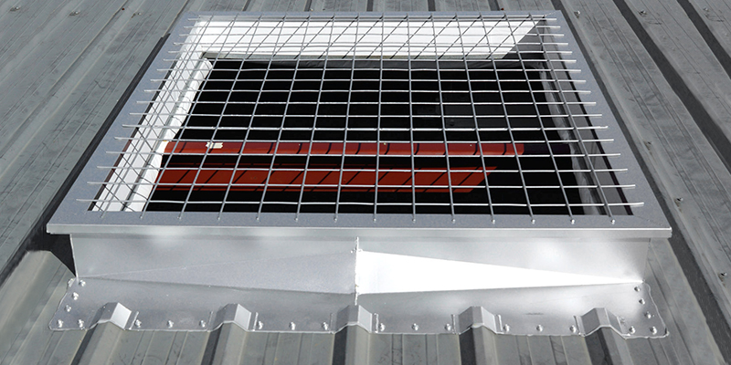

Image source: Nucor building systems

Example installation video: https://www.roofcurb.com/chief-curb-resources

***************************************************************************************
      - Roof Curbs: Install curbs at locations indicated. Install flashing around bases where they meet metal roof panels.
      - Pipe Flashing: Form flashing around pipe penetration and metal roof panels. Fasten and seal to panel as recommended by manufacturer.
    - FIELD QUALITY CONTROL
      - Erector’s QCI: Perform the field tests and inspections required by the erector’s quality control (QC) procedures.
        - Provide QCI with access to places where structural-steel Work is being erected to perform tests and inspections.
      - The QCI shall inspect the following as a minimum, as applicable
        - Field welding, high-strength bolting, and details in accordance with <<AISC 360>>, Section N5, except paragraph N5.5.
        - Steel deck and headed steel stud anchor placement and attachment in accordance with <<AISC 360>>, Section N6.
        - Field-cut surfaces in accordance with <<AISC 360>>, Section M2.2.
        - Tolerances for field erection in accordance with <<AISC 303>>, paragraph 7.13.

***************************************************************************************

Omit the Article below if the Project does not include a Seismic Force-Resisting System (SFRS) or if the Project does not include field erection of the SFRS.

***************************************************************************************
    - SEISMIC FORCE-RESISTING SYSTEM FIELD QC
      - Inspection tasks and documentation for QC for the SFRS shall be as provided in the tables in <<AISC 341>>, Sections J6 – J9. NDT of welded joints (paragraph J6.2) is excluded.
    - ADJUSTING

***************************************************************************************

Doors are specified in Sections << 08 1100 - Metal Doors and Frames>>, << 08 1213 - Hollow Metal Frames>>, << 08 1400 - Wood Doors>>, << 08 3323 - Overhead Coiling Doors>>.

***************************************************************************************
      - Doors: After completing installation, test and adjust doors to operate easily, free of warp, twist, or distortion.

***************************************************************************************

Door hardware is specified in Section << 08 7100 - Door Hardware>>.

***************************************************************************************
      - Door Hardware: Adjust and check each operating item of door hardware and each door to ensure proper operation and function of every unit. Replace units that cannot be adjusted to operate as intended.

***************************************************************************************

Windows are specified in Section << 08 5113 - Aluminum Windows>> .

***************************************************************************************
      - Windows: Adjust operating sashes and ventilators, screens, hardware, and accessories for a tight fit at contact points and at weather stripping to ensure smooth operation and weathertight closure. Lubricate hardware and moving parts.
      - << Roof Ventilators; Adjustable Louvers; and _______>>: After completing installation, including work by other trades, lubricate, test, and adjust units to operate easily, free of warp, twist, or distortion as needed to provide fully functioning units.

******************************************************************************

Retain subparagraph below for adjustable louvers.

******************************************************************************
        - Adjust louver blades to be weathertight when in closed position.
    - CLEANING AND PROTECTION

***************************************************************************************

Retain next Paragraph below if galvanized items are required.

***************************************************************************************
      - Repair damaged galvanized coatings on galvanized items with galvanized repair paint according to <<ASTM A780/A780M>> and manufacturer's written instructions.
      - Remove and replace glass that has been broken, chipped, cracked, abraded, or damaged during construction period.

***************************************************************************************

Retain 1 of next 2 paragraphs.

***************************************************************************************
      - Touchup Painting: After erection, promptly clean, prepare, and prime or re-prime field connections, rust spots, and abraded surfaces of prime-painted structural framing, << bearing plates; or None - N/A>> and accessories.
        - Clean and prepare surfaces by <<SSPC-SP 2>> or <<SSPC-SP 3>>​.
        - Apply a compatible primer of same type as shop primer used on adjacent surfaces.

*** OR ***
      - Touchup Painting: Cleaning and touchup painting are specified in Section ​<< 09 9100 - Painting>>​.
      - Metal Panels: Remove temporary protective coverings and strippable films, if any, as metal panels are installed. On completion of metal panel installation, clean finished surfaces as recommended by metal panel manufacturer. Maintain in a clean condition during construction.
        - Replace metal panels that have been damaged or have deteriorated beyond successful repair by finish touchup or similar minor repair procedures.
      - Doors and Frames: Immediately after installation, sand rusted or damaged areas of prime coat until smooth and apply touchup of compatible air-drying primer.
        - Immediately before final inspection, remove protective wrappings from doors and frames.

***************************************************************************************

Retain the following two paragraphs if applicable.

***************************************************************************************
      - Windows: Clean metal surfaces immediately after installing windows. Avoid damaging protective coatings and finishes. Remove excess sealants, glazing materials, dirt, and other substances. Clean factory-glazed glass immediately after installing windows.
      - Louvers: Clean exposed surfaces that are not protected by temporary covering, to remove fingerprints and soil during construction period. Do not let soil accumulate until final cleaning.
        - Restore louvers damaged during installation and construction period so no evidence remains of corrective work. If results of restoration are unsuccessful, as determined by EOR, remove damaged units and replace with new units.
        - Touch up minor abrasions in finishes with air-dried coating that matches color and gloss of, and is compatible with, factory-applied finish coating.
  - END OF SECTION

**********************************************************************************************

Do not omit the following reference information:

**********************************************************************************************
  - THE FOLLOWING STATEMENT IS FOR LANL USE ONLY
  - THIS PROJECT SPECIFICATION SECTION IS BASED ON LANL MASTER SPECIFICATION SECTION 13 3419, REV. 7, DATED APRIL 15, 2026.

