Section 26 0548.16
Seismic Controls for Electrical Systems

************************************************************************************************************

LANL MASTER SPECIFICATION SECTION
Rev. 5 Summary of Changes: Edited and updated as required for import into SpecLink.

NOTE TO SPECIFIER ON USAGE IN SPECLINK: Activate the Section by turning on Seq #0000, followed by activating paragraphs in PART 1, Article SECTION INCLUDES. This will activate related articles, paras/subparas in the rest of the Section (i.e., SECTION INCLUDES in PART 1 activates articles and paras/subparas in PARTS 2 and 3). If there are choice fields to edit the entire Section (typically in this first author note or beginning of the Section), make selections at those locations, which will filter through the remaining Section. All Articles, paragraphs and subparagraphs must be activated sequentially from top to bottom, unless noted otherwise.

This template must be edited for each project. In doing so, Specifier must add job-specific requirements. Selections and choice fields are used to indicate designer choices or locations where text must be supplied by the designer. The section must also be edited to remove requirements for processes, items, or designs that are not included in the project.

To seek a variance from applicable requirements in this Section, contact the Engineering Standards Manual (ESM) Structural/Electrical POC (LANL access only). Please contact POC with suggestions for improvement as well. LANL personnel should submit here: Suggested Change or Request Clarification; subcontractors via email to engstandards@lanl.gov.

When assembling a specification package, include applicable Sections from all Divisions, especially Division 1, General Requirements.

Section is developed for use with ML-4 projects. For ML-1, 2, and 3 applications, additional requirements and independent reviews should be added if increased confidence in procurement or execution is desired; see ESM Chapter 1 - General, Section Z10 Specifications and Quality sections.

==========================================================

All references to ASCE 7 in the following text and this specification section refer to ASCE 7, unless noted otherwise.

The Section is NOT applicable to systems/components that are seismically exempt per ASCE 7 Ch. 13, or for “non-exempt components” that will comply with ASCE 7 paragraph 13.2.1 via Manufacturer certification.

Per item 5 in ASCE 7 para. 13.1.4, electrical components in Seismic Design Category (SDC) C are exempt provided that (a) the component importance factor, I_{p}, is equal to 1.0 and the component is positively attached to the structure; or (b) The component weighs 20 lb or less.

The Section is NOT applicable to systems/components that are seismically exempt per ASCE 7 Ch. 13, or for “non-exempt components” that will comply with ASCE 7 paragraph 13.2.1 via Manufacturer certification.

This template is not applicable to systems/components that are seismically exempt per ASCE 7 Ch. 13, or to “non-exempt components” that will comply with ASCE 7 (paragraph 13.2.1 in 2010 edition) via Manufacturer certification.

Per item 5 in ASCE 7 para. 13.1.4, electrical components in Seismic Design Category (SDC) C are exempt provided that the component importance factor, Ip, is equal to 1.0.

Refer to ASCE 7 Section 13.1.4, Items 6 and 7, for mechanical components that are exempt in Seismic Design Categories (SDC) D, E, or F.

To properly edit the Section for "non-exempt components," make the following two (2) decisions first:

1. Determine responsibility for preparing Project-specific design and documentation (per ASCE 7 Section 13.2.1):

(a) Project-speciﬁc design and documentation submitted for approval to the LBO.

(b) Submittal of the manufacturer’s certiﬁcation that the component is seismically qualiﬁed.

2. Determine whether the component is a Designated Seismic System (DSS), defined as a component with an importance factor, I_{p} = 1.5.

There are two options for preparation of Project-specific design and documentation:

A. Engineer of Record (EOR), or

B. Construction Subcontractor (i.e., delegated design).

Once it is known whether A or B applies to the Project in question, subsequent seismic-related author notes can be properly interpreted and followed through on.

If a component must function after the design-basis earthquake, it is assigned an Importance Factor (Ip) of 1.5, which makes it a DSS (per ASCE 7 Section 11.2). If the DSS requires special certification per ASCE 7, Paragraph 13.2.2, reference Section << 01 8734 - Seismic Qualification of Nonstructural Components (IBC)>> in this Section; and develop and include a project-specific version of Section << 01 8734 - Seismic Qualification of Nonstructural Components (IBC)>> in the Project Specifications. Per ASCE 7-10, Section 13.2.2; ASCE Section 13.2.2; and ASCE 7-22, Section 13.2.3, only the following components in Seismic Design Categories (SDC) C through F require special certification:

a. Active mechanical and electrical equipment with I_{p} = 1.5.

b. Components containing hazardous substances with I_{p} = 1.5.

Seismic control/restraint is achieved by using devices (e.g., supports and attachments) that limit excessive movement during an earthquake—without compromising the function of vibration isolators, if applicable. Since these devices are included in this section, if a Project Specification package includes this section, only control or restraint devices that differ from those described here (and are required for use) need to be included in the Specification Section for the specific component—or added here if they apply to multiple Specification Sections.

To prevent consequential damage, consider the functional and physical interrelationship of components, their supports, and their effects on one another so that the failure of an essential or nonessential architectural, mechanical, or electrical component does not cause the failure of an essential component. Each nonessential SSC shall meet at least one of the following criteria:

A. Collapse of the nonessential SSC will not cause it to strike an essential SSC

B. Collapse of the nonessential SSC will not impair the integrity of an essential SSC.

C. The nonessential SSC is analyzed and designed to prevent failure under the same conditions as the essential SSC. Therefore, it is designed as a DSS (I_{p} = 1.5) but does not require special certification.

Refer to the following videos for an overview of seismic design requirements related to the restraint of nonstructural components.

Nonbuilding Structures and Nonstructural Components

NZSEE Non-Structural Elements

************************************************************************************************************
  - PART 1 - GENERAL
    - SECTION INCLUDES

***************************************************************************************

Retain the following paragraphs and applicable subparagraphs, as required by the project.

***************************************************************************************
      - Seismic Controls
        - Snubbers.
        - Restraint channel bracings.
        - Restraint cables.
        - Seismic-restraint accessories.
        - Post-installed anchors.
        - Flexible connections.
      - Installation requirements
        - Equipment and Hanger Restraints.
        - Suspended Electrical equipment.
        - Wall-Mounted Electrical Equipment.
        - Equipment with Sheet Metal Housings.
        - Concrete Housekeeping Pads.
        - Seismic Restraint of Conduit.
        - Seismic Restraint of Electrical raceways through penetrations.
        - Seismic Restraint of Lighting Fixtures.
        - Computer and communications racks, cabinets and boards.

***************************************************************************************

Issue Section ​<< 01 8734 - Seismic Qualification of Nonstructural Components (IBC)>>​ for Designated Seismic Systems (DSS) requiring Special Certification, regardless of the method used to comply with ASCE 7 Section 13.2.1. Section ​<< 01 8734 - Seismic Qualification of Nonstructural Components (IBC)>>​ outlines the requirements for manufacturer certification related to the seismic qualification of components, supports, and attachments, as well as the special certification requirements for Designated Seismic Systems.

Subcontractor might expect to find in this Section requirements that are specified in the following Sections.

Section ​​​​​<< 09 5100 - Acoustical Ceilings>>​​​​​, for requirements for seismic restraint of lighting fixtures associated with suspended ceilings.

Section ​​​​<< 26 0529 - Hangers and Supports for Electrical Systems>>​​​​ for commonly used electrical supports and installation requirements.

Section ​​​​<< 26 5200 - Safety Lighting>>​​​​ for product and installation requirements associated with seismic restraint/protection.

***************************************************************************************
    - Related Requirements
      - Section ​​<< 01 4000 - Quality Requirements - Non-Nuclear>>​​.
      - Section ​​​<< 01 4444 - Offsite Welding, Brazing and Joining Requirements>>​​​.
      - Section ​​​<< 01 4455 - Onsite Welding, Brazing and Joining Requirements>>​​​.
      - Section << 01 4525 - Non-Destructive Examination (NDE) Requirements>>
      - Section ​​<< 01 8734 - Seismic Qualification of Nonstructural Components (IBC)>>​​.
      - Section ​<< 03 3001 - Reinforced Concrete>>​.
      - Section ​<< 05 0520 - Post-Installed Concrete and Grouted Masonry Anchors - Normal Confidence>>​.
    - REFERENCE STANDARDS
      - ACI CODE-318 - Building Code for Structural Concrete—Code Requirements and Commentary.
      - ASCE 7 - Minimum Design Loads and Associated Criteria for Buildings and Other Structures.
      - ASTM A492 - Standard Specification for Stainless Steel Rope Wire.
      - ASTM A603 - Standard Specification for Metallic-Coated Steel Structural Wire Rope.
      - FEMA 413 - Installing Seismic Restraints for Electrical Equipment.
      - FEMA E-74 - Reducing the Risks of Nonstructural Earthquake Damage.
      - ICC (IBC) - International Building Code.
      - ICC-ES AC156 - Acceptance Criteria for Seismic Certification by Shake-Table Testing of Nonstructural Components.
      - MFMA-4 - Metal Framing Standards Publication.
      - NECA 1 - Standard for Good Workmanship in Electrical Construction.
      - NFPA 70 - National Electrical Code.
      - SMACNA (SRM) - Seismic Restraint Manual Guidelines for Mechanical Systems.
    - DEFINITIONS
      - For definitions and acronyms, refer to COE Glossary of Terms.
      - Attachments: Means by which nonstructural components or their supports are secured or connected to the seismic force-resisting system of the structure. These attachments include anchor bolts, welded connections, and mechanical fasteners.
      - Designated Seismic System (DSS): Nonstructural components that must be designed in accordance with <<ASCE 7>> Chapter 13 and for which the component Importance Factor, I_{p}, is greater than 1.0.
      - Electrical Component: Where referenced in this section in regards to seismic controls, applies to any portion of the electrical system subject to seismic evaluation in accordance with applicable codes, including distributed systems (e.g., conduit, cable tray).
      - Seismic Deformations: Drifts, deflections and seismic relative displacements determined in accordance with the applicable seismic requirements of the Building Codes currently followed at LANL.
      - Seismic Forces: Forces acting in any direction on a nonstructural component and related system due to the action of an earthquake as defined in the Building Codes currently in effect at LANL.
      - Seismic Restraint: Structural members or assemblies of members or manufactured elements specifically designed and applied for transmitting seismic forces between components and the seismic force-resisting system of the structure.
      - Supports: Structural members, assemblies of members, or manufactured elements—such as braces, frames, legs, lugs, snubbers, hangers, saddles, struts, and their associated fasteners—that transfer loads between nonstructural components and their connections to the main structure.
      - VISCMA: Vibration Isolation and Seismic Control Manufacturers Association.
    - ACTION SUBMITTALS
      - Product Data: For each type of product.
        - Provide manufacturer's standard catalog pages and data sheets, including materials, strength, fastening requirements, fabrication details, dimensions, and finishes.

**********************************************************************

Edit the options in the following subparagraph to reflect the applicable independent third-party evaluator or certifier for the products to be used. Apply the same revisions to all similar paragraphs and subparagraphs throughout this Section.

**********************************************************************
          - Seismic Controls: Tabulate types and sizes of seismic restraints, complete with report numbers and rated strength in tension and shear as evaluated in an << ICC-ES ESR; HCAI (OPM or OSP); and _______>>​.
          - Annotate each submittal to clearly indicate the intended application of each product and confirm compliance with specified requirements.

******************************************************************************

If project-specific design and documentation are not provided, require submittal of the manufacturer’s certification verifying that the component is seismically qualified, in accordance with ASCE 7, Section 13.2.1.

******************************************************************************
        - Certification for seismically qualified equipment; identify basis for certification.
        - Manufacturer's Instructions: Indicate application conditions and limitations of use stipulated by product testing agency. Include instructions for storage, handling, protection, examination, preparation, and installation of product.

***************************************************************************************

Retain the following paragraph only if the seismic restraint details or charts on the Drawings do not describe the restraints in sufficient detail. Retaining this paragraph requires the Subcontractor to submit seismic restraint Shop Drawings prepared by a New Mexico professional engineer.

***************************************************************************************
      - Shop Drawings - ​​​​<< Seismic; and Wind>>​​​​ Controls:
        - Include dimensioned plan views and sections indicating proposed electrical component locations and distributed system routing, with locations and details of gravity supports and seismic restraints and associated attachments.

******************************************************************************

Retain the following three subparagraph if required by the project.

******************************************************************************
        - Identify mounting conditions required per equipment seismic qualification.
        - Identify anchor manufacturer, type, minimum embedment, minimum spacing, minimum member thickness, and minimum edge distance requirements.
        - Indicate proposed arrangement of distributed system trapeze support groupings.

******************************************************************************

Retain the two subparagraph below if applicable. Flexible connections must comply with applicable provisions of ASCE 7, Chapter 13, related to seismic relative displacements and differential motion.

Coordinate with PART 3 Article, “Accommodation of Differential Seismic Motion.”

******************************************************************************
        - Indicate proposed locations for distributed system flexible fittings and/or connections.
        - Indicate locations of seismic separations where applicable.
        - Include point load drawings indicating design loads transmitted to structure at each attachment location.

***************************************************************************************

Retain the following paragraph and applicable subparagraphs when welding, brazing or joining is required.

***************************************************************************************
      - Per the requirements of ​​​<< Section 01 4444 - Offsite Welding, Brazing and Joining Requirements; and Section 01 4455 - Onsite Welding, Brazing and Joining Requirements>>​​​, submit:

******************************************************************************

When offsite only, omit submittals below regarding onsite welding. For high-risk applications such as ML-1 or ML-2, add submittals for “Weld Filler Material Control Procedures” and “Filler Material Certified Material Test Reports (CMTRs)” when required. Add “Post-Weld Heat Treatment Procedures” when required.

For Onsite welding use of LANL WPS/PQR is the default; coordinate usage with the LANL CWI; no submittal required.

For Onsite, welders are tested by LANL who will produce WPQR and track continuity; this includes brazing, bonding, and fusing; no submittal required.

******************************************************************************
        - Welding Procedure Specification (WPS) and supporting Procedure Qualification Record (PQR).
        - Welder Performance Qualification Records (WPQR) including continuity.
        - Weld Filler Material Control Procedure for ML-1 and ML-2 applications.
        - Filler Material Certified Material Test Reports (CMTRs) for ML-1 and ML-2 applications.
        - Post-Weld Heat Treatment Procedures (where applicable).
        - Shop drawings with weld details/symbols.

***************************************************************************************

Retain the following paragraph and applicable subparagraphs when NDE is required for the project. ​

***************************************************************************************
      - Per the requirements of Section << 01 4525 - Non-Destructive Examination (NDE) Requirements>>, submit:
        - Inspector qualification records.
        - Inspection procedures.

***************************************************************************************

Retain Paragraph below if responsibility for design services have been delegated to (construction) Subcontractor.

If retaining, and Project includes equipment mounted outdoors, retain the portions of subparagraphs pertaining to “wind.”

***************************************************************************************
      - Delegated-Design Submittal: For each seismic-restraint device and, as applicable, for each connection type and/or connection detail associated with providing adequate flexibility.
        - Include design calculations and details for selecting ​<< seismic; and wind>>​​ restraints complying with performance requirements. Signed and sealed by the professional engineer, registered in the state of New Mexico, responsible for their preparation.
    - INFORMATIONAL SUBMITTALS

***************************************************************************************

Retain "Coordination Drawings" Paragraph below for situations where limited space necessitates maximum use for efficient installation of different components or if coordination is required for installation of products and materials by separate installers. Coordinate paragraph with other sections specifying products listed below. Preparation of coordination drawings requires the participation of each trade involved in installations within the limited space

***************************************************************************************
      - Coordination Drawings: Show coordination of seismic bracing for electrical components with other systems and equipment in the vicinity, including other supports and seismic restraints. Electrical components include:
        - Control << and monitoring; or None - N/A>> panels.
        - Generators.
        - Luminaires (not associated with suspended ceilings, or Emergency Lighting).
        - Motor control centers.
        - Panelboards.
        - Photovoltaic system components (not associated with ballasted, roof-mounted systems).
        - Substations.
        - Switchboards.
        - Switchgear.
        - Transformers.
        - Unit substations.

***************************************************************************************

Retain the following paragraph if applicable.

***************************************************************************************
      - Qualification Data: For professional engineer.
      - Field quality-control reports.
    - QUALITY CONTROL

***************************************************************************************

Quality Control (QC) is what is contained herein and is the responsibility of the Subcontractor.

Quality Assurance (QA, which is required by IBC Chapter 17) is contained in the EOR’s Statement of Special Inspections (SSI), and is the responsibility of LANL (i.e., execution of the SSI). The SSI template is found in LANL ESM Chapter 16 - Building Code Program, Section IBC-IP, Attachment B.

***************************************************************************************
      - Refer to Section ​<< 01 4000 - Quality Requirements - Non-Nuclear>>​ for general Quality Assurance (QA) requirements applicable to all items, products, and services.
      - Comply with <<NFPA 70>>.
      - Comply with seismic-restraint requirements in the <<ICC (IBC)>> unless requirements in this Section are more stringent.

***************************************************************************************

Retain appropriate subparagraphs(s) under “Welder Qualifications” paragraph if shop and/or field welding is required. If retaining, also retain "WPQR" paragraph in "Action Submittals" Article.

***************************************************************************************
      - Welding Qualifications:
        - Shop: Prior to shop welding, submit WPQR certification for each welder stating the type of welding and positions qualified for, the code and procedure qualified under, date qualified, and the firm and individual certifying the qualification tests. See Section << 01 4444 - Offsite Welding, Brazing and Joining Requirements>>.
        - Field: Refer to Section ​<< 01 4455 - Onsite Welding, Brazing and Joining Requirements>>​.
      - Seismic restraint devices shall undergo horizontal and vertical load testing and analysis. Devices shall have preapproval from one of the following:
        - HCAI (i.e., OSHPD Preapproval of Manufacturer’s Certification (OPM) Number, or OSHPD Special Seismic Certification Preapproval (OSP) Number)
        - ICC-ES (i.e., ICC-ES Evaluation Report (ESR) Number)
        - A recognized agency providing equivalent preapproval

Preapprovals shall indicate maximum seismic restraint ratings. Ratings based on independent testing are preferred over those based on calculations. If preapproved ratings are unavailable, provide submittals supported by independent testing. Calculations used to justify seismic restraint designs—including combined shear and tensile loads—shall be signed and sealed by a professional engineer licensed in the State of New Mexico.
    - DELIVERY, STORAGE AND HANDLING
      - Receive, inspect, handle, and store products in accordance with manufacturer's instructions.
    - FIELD CONDITIONS
      - Coordination:
        - Coordinate selection and arrangement of seismic control components with the actual equipment to be installed.
        - Coordinate the work with other trades to provide additional framing and materials required for installation.
        - Coordinate compatibility of support and attachment components with mounting surfaces at the installed locations.
        - Seismic Controls:
          - Coordinate the arrangement of seismic restraints with piping, conduit, equipment, and other potential conflicts installed under other sections or by others.
          - Coordinate the work with other trades to accommodate relative positioning of essential and nonessential components in consideration of seismic interaction.
        - Notify EOR of any conflicts with or deviations from Subcontract Documents. Obtain direction before proceeding with work.
      - Sequencing:
        - Do not install products on or provide attachment to concrete surfaces until concrete has fully cured in accordance with Section ​​<< 03 3001 - Reinforced Concrete>>​​.
  - PART 2 - PRODUCTS
    - MANUFACTURERS

***************************************************************************************

The manufacturers listed below are representative of those offering the products of this section. Verify each manufacturer's ability to provide product(s) specified for each project.

***************************************************************************************
      - External Seismic Snubber Assemblies:
        - Kinetics Noise Control, Inc​​​​<< ; ____; or None - N/A>>​​​​: www.kineticsnoise.com/.
        - Mason Industries​​<< ; ____; or None - N/A>>​​​: www.mason-ind.com/.
        - Vibration Eliminator Company, Inc​​<< ; ____; or None - N/A>>​​​: www.veco-nyc.com/.
        - ​​<< __________>>​​.
        - Source Limitations: Furnish external seismic snubber assemblies and associated accessories produced by ​​​​<< a single manufacturer; the same manufacturer as the vibration isolators; or ______>>​​​​ and obtained from a single supplier.
      - Seismic Restraint Systems:
        - B-Line, a brand of EATON​​<< ; ______; or None - N/A>>​​: www.eaton.com/.
        - Unistrut, a brand of Atkoe​​​<< ; ______; or None - N/A>>​​​: www.atkore.com/.
        - Lindapter​​<< ; ______; or None - N/A>>​​: www.lindapter.com/.
        - Gripple​​​<< ; ______; or None - N/A>>​​​​: www.gripple.com/.
        - AFCON, a brand of Anvil International​​​<< ; ______; or None - N/A>>​​​: www.anvilintl.com/#sle.
        - Kinetics Noise Control, Inc​​<< ; ______; or None - N/A>>​​: www.kineticsnoise.com/.
        - Mason Industries​​<< ; ______; or None - N/A>>​​: www.mason-ind.com/.
        - Vibro-Acoustics​​<< ; ______; or None - N/A>>​​​: www.vibro-acoustics.com/.
        - ​​<< __________>>​​.
        - Source Limitations: Furnish seismic restraint system components and accessories produced by a single manufacturer and obtained from a single supplier.
    - PERFORMANCE REQUIREMENTS
      - General:
        - Design and detail all anchorage/bracing and their load path to structure, including edge distances and embedment.
        - Adhesive/expansion anchors: ICC-ES listed for cracked concrete and Seismic Categories C–F; design per <<ACI CODE-318>>, Chapter 17.
        - Calculations and drawings shall be prepared and sealed by a professional engineer licensed in the State of New Mexico.

***************************************************************************************

Retain the following paragraph if required by the project.

***************************************************************************************
      - Wind Restraint: Consider wind loads for outdoor electrical components, determine wind design loads in accordance with <<ICC (IBC)>> Section 1609 and the following parameters:
        - Building Risk Category: ​​<< I; II; III; IV; or ______>>​​​.
        - Basic Design Wind Speed, V, miles per hour (mph): ​<< _______>>​.
        - Exposure Category: Exposure C.
      - Seismic Restraint:
        - << Provide; Design and provide; or __________>> electrical component restraints, supports, and attachments to resist seismic loads in accordance with applicable codes, as well as gravity, operating loads, and other structural requirements specific to the installation location. Include wind loads for outdoor electrical components.
        - Design seismic restraints to ensure position retention of the component or system and, where applicable¹, to maintain full operational capability.

¹Refer to <<ASCE 7>> paragraph 13.6.4, and the applicable portions of Paragraph 13.6.5 pertaining to components with Ip = 1.5 and certified equipment..
        - Comply with applicable general recommendations of the following, where not in conflict with applicable codes, seismic design criteria, or other specified requirements:
          - <<FEMA 413>>.
          - <<FEMA E-74>>.
          - <<SMACNA (SRM)>>.
        - Determine seismic design loads in accordance with <<ICC (IBC)>> Section 1613 and the following:
          - Building Risk Category: ​​​​<< I; II; III; IV; or ______>>​​​​.
          - Site Class: ​<< D; or _______>>​.
          - Design Spectral Response Acceleration at Short Periods, S_{DS}, gravity (g): ​​​​​<< ____>>​​​​​.
          - Design Spectral Response Acceleration at 1.0-Sec. Period, S_{D1}, gravity (g): ​​​​​<< ____>>​​​​​.
          - Seismic Design Category (SDC): ​​<< D; C; or ___>>​​.

**********************************************************************

Select one of the following two subparagraphs.

**********************************************************************
          - Seismic design parameters for supports and attachments of electrical components are specified in Tables 2.1(a) and 2.1(b).

*** OR ***
          - Seismic design parameters for supports and attachments of mechanical components are specified on drawings.

**********************************************************************

Edit the following tables to include all components requiring seismic design. Add or remove rows as necessary. For components where the seismic parameters for the support and the attachment differ, use two separate rows (e.g., C-1A for the support and C-1B for the attachment).

Regarding the “I_{p} subparagraph" below, per ASCE 7 paras. 13.2.3 and 13.6.6, design and detailing as DSS (i.e., I_{p} = 1.5) might be required for components that otherwise seem/appear to be unessential/noncritical (i.e., I_{p} = 1.0).

As indicated early on herein, if SDC = C & I_{p} = 1.0, the component is exempt from seismic design & detailing

For components with an R_{p} value greater than 6.0, limit the value of R_{p} to 6.0 when determining forces in attachments, in accordance with ASCE 7 Section 13.1.4. This provision applies only to components with R_{p} > 6.0.

**********************************************************************

Table 2.1(a): Electrical Components (EC)
ID | I_{p} | Description
EC-1 | 1.0
EC-2 | 1.0

Table 2.1(b): Qualification Requirements
ID | h  (feet) | z  (feet) | a_{p} | LS | R_{p}
EC-1
EC-2

******************************************************************************

Include the following subparagraph if the project involves Designated Seismic Systems (DSS) that require special certification—specifically, active mechanical and electrical equipment with an Importance Factor (I_{p}) of 1.5, or components containing hazardous substances with an I_{p} of 1.5.

Active equipment, described in ASCE 7 commentary as “equipment that has parts that rotate, move mechanically, or are energized during operation” must be certified to remain operable following a design level earthquake. It is important to note that this certification must be based on shake table testing of equipment (previous code versions allowed certification by analysis).

Components that contain hazardous substances must be certified to maintain containment following a design level earthquake.

Seismic certificates of compliance document conditions for which the certification is valid. This typically includes specific values of five-percent damped design spectral response acceleration at short periods (SDS) at specified elevations within the building (z/h) as well as mounting restrictions. Seismic certification labels must be placed on components referencing the certificate of compliance and associated restrictions.

******************************************************************************
        - Special Certification of Designated Seismic Systems:
          - Provide special certification for electric equipment assigned a component importance factor (I_{p}) of 1.5. Certify that the equipment will remain operable after the design-level earthquake.

**********************************************************************

Select one of the following two subparagraphs as applicable. Active components with an Ip = 1.5 shall be certified exclusively on the basis of approved shake-table testing in accordance with ASCE 7 Section 13.2.5 or on documented experience data in accordance with ASCE 7 Section 13.2.6.

**********************************************************************
          - Seismic qualification to be in accordance with Section << 01 8734 - Seismic Qualification of Nonstructural Components (IBC)>>.

*** OR ***
          - Seismic qualification to be by shake table testing in accordance with recognized testing standard procedure, such as <<ICC-ES AC156>>, acceptable to LBO.
          - Notify EOR and obtain direction where mounting restrictions required by conditions of seismic certification conflict with specified requirements.
          - Seismically qualified equipment to be furnished with factory-installed labels referencing certificate of compliance and associated mounting restrictions.
        - Seismic Interactions:
          - Include provisions to prevent seismic impact between electrical components and other structural or nonstructural components.
          - Include provisions such that failure of a component, either essential or nonessential, does not cause the failure of an essential component.

******************************************************************************

Seismic relative displacements—the independent movement of adjacent structures or different portions of the same structure relative to one another—shall be considered to ensure that supported nonstructural components are not subjected to damaging stresses. This is typically addressed through the use of properly detailed and located flexible connections.

Special consideration shall be given to maintaining continuity of utility services in Risk Category IV facilities (e.g., fire stations and other mission-critical facilities), where seismic relative displacements could otherwise result in service interruption.

******************************************************************************
        - Seismic Relative Displacement Provisions:
          - Use suitable fittings or flexible connections to accommodate:
            - Relative displacements at connections between components, including distributed systems (e.g., cable trays); do not exceed load limits for equipment utility connections.
            - Relative displacements between component supports attached to dissimilar parts of structure that may move differently during an earthquake.
            - Design displacements at seismic separations.
            - Anticipated drifts between floors.

***************************************************************************************

Retain the following six Articles, along with applicable paragraphs and subparagraphs, as required by the project.

Refer to the following resources for an overview of seismic restraint products and design requirements.

Tauby, J. R., Lloyd, R., Noce, T., & Tünnissen, J. (2012). Practical guide to seismic restraint. New York: ASHRAE.

American Society of Heating, Refrigerating and Air-Conditioning Engineers. (2023). 2023 ASHRAE® Handbook: HVAC Applications. ASHRAE. (Chapters 49 and 56)

Seismic Design Manual | Kinetics Noise Control

Vibration Isolation Product and Selection Guide - Kinetics Noise Control

The following are limited examples of seismic restrain products available in the market.

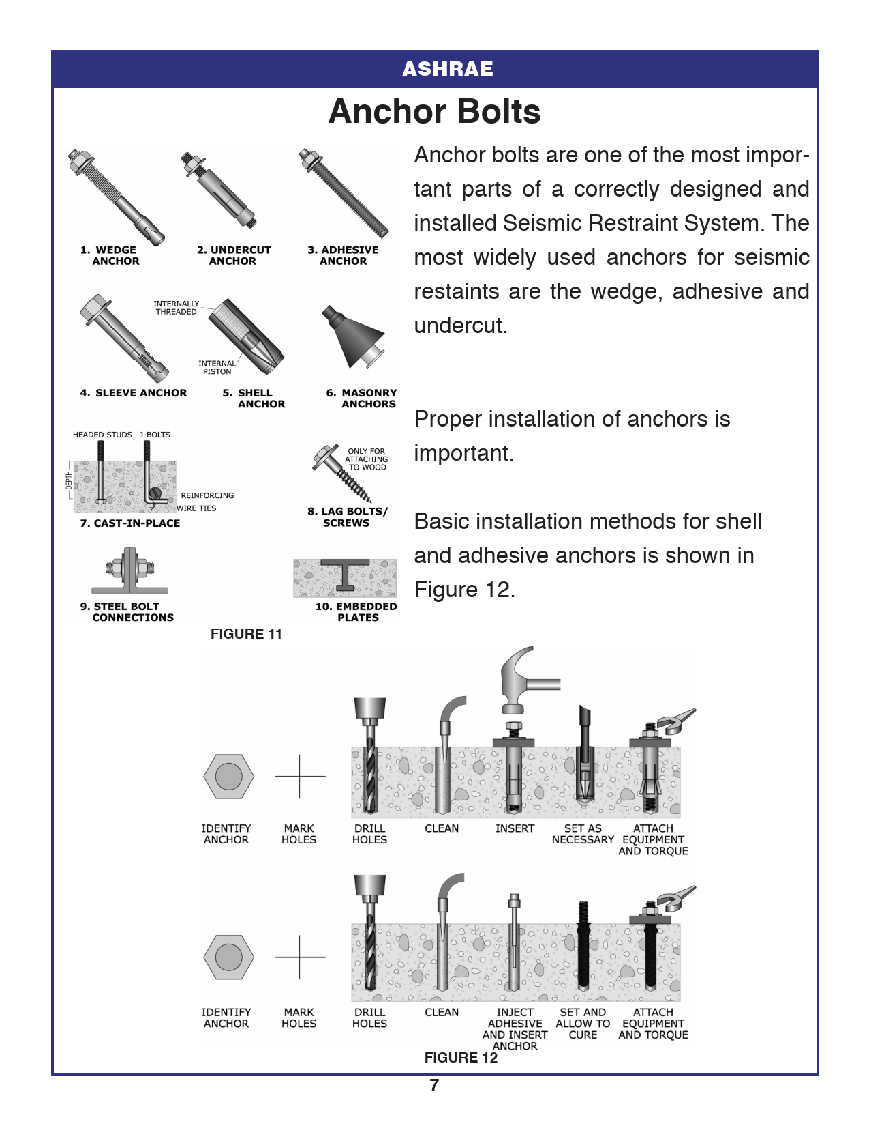

Source: ASHRAE Earthquake Protection Bulleting

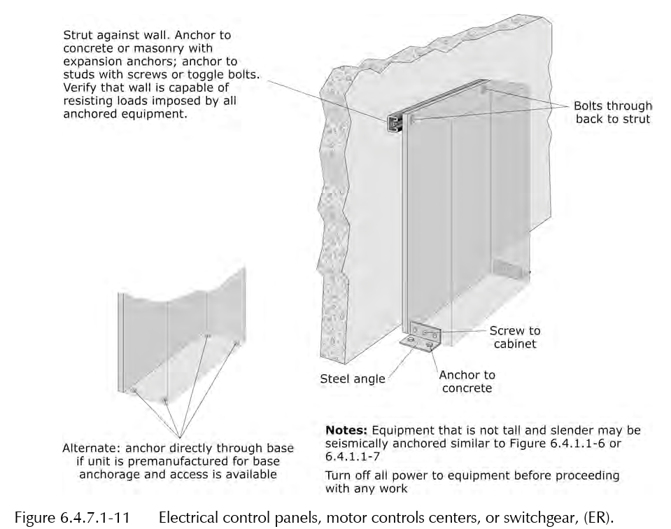

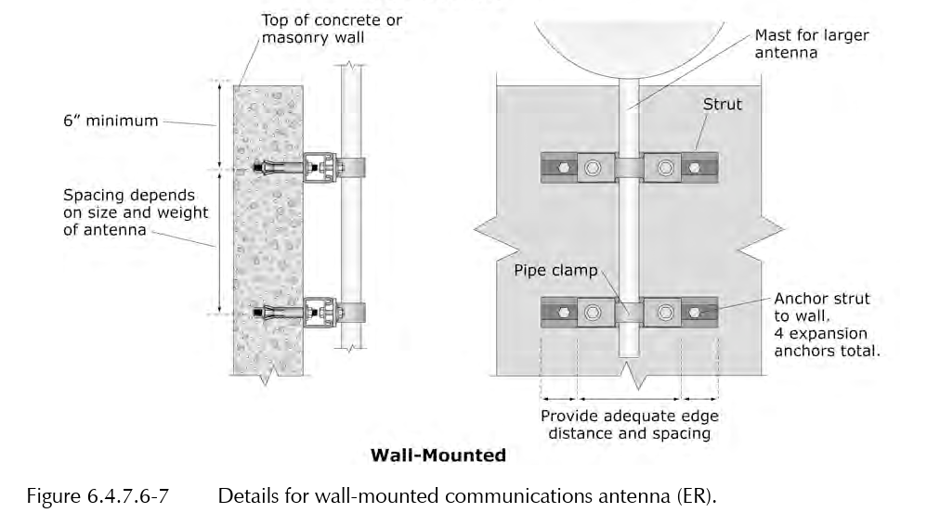

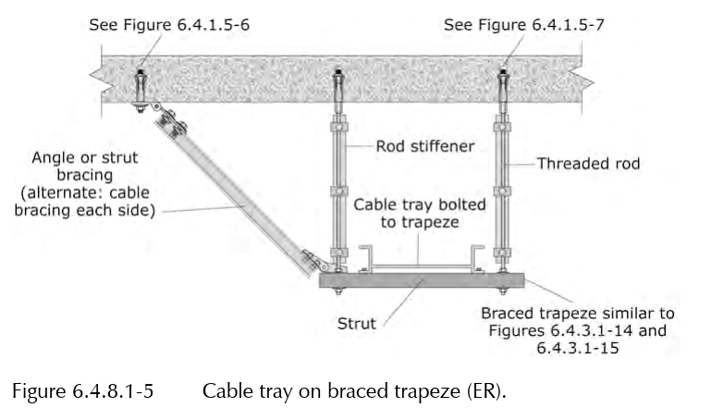

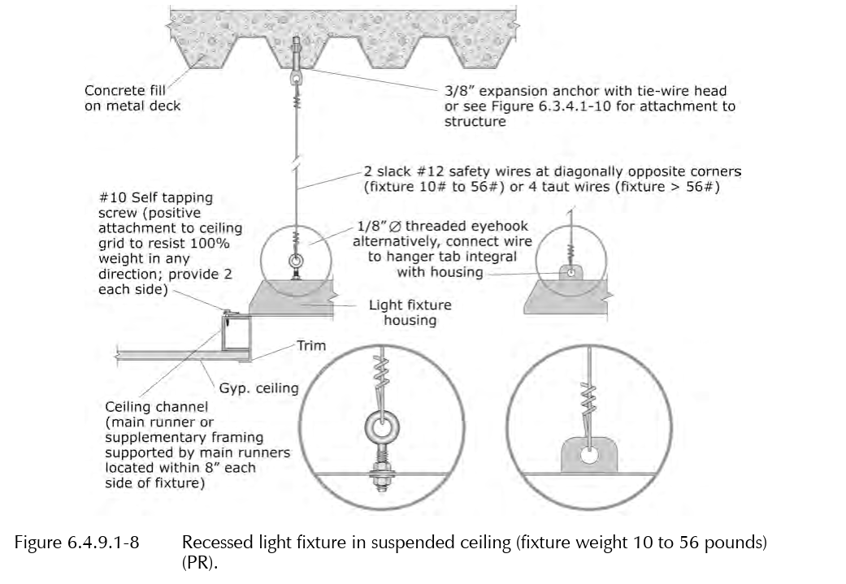

Source: FEMA E-74 Reducing the Risks of Nonstructural Earthquake Damage – A Practical Guide

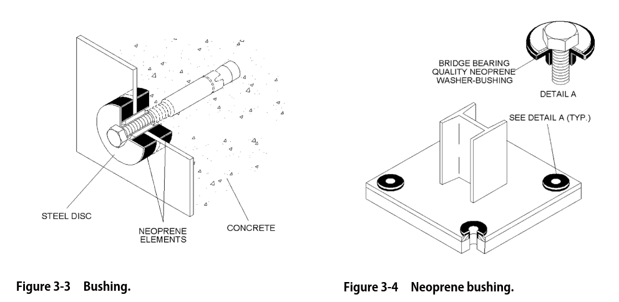

Source: ASHRAE 90316 - Practical Guide to Seismic Restraint - Second Edition (2012)

Retain the following Article, along with applicable paragraphs and subparagraphs, as required by the project.

***************************************************************************************
    - SNUBBERS
      - Description: Factory fabricated using welded structural-steel shapes and plates, anchors, and replaceable resilient isolation washers and bushings.

******************************************************************************

Omit the following subparagraph if post-installed (P-I) anchors are not required to install the snubbers.

******************************************************************************
        - Use post-installed anchors for attachments to concrete as specified in PART 2 Article Post-Installed Anchors.
        - Resilient Isolation Washers and Bushings: Oil- and water-resistant neoprene.
        - Maximum 1/4-inch air gap, and minimum 1/4-inch-thick resilient cushion.

***************************************************************************************

Retain the following Article and paragraph, as required by the project.

***************************************************************************************
    - RESTRAINT CHANNEL BRACINGS
      - Description: <<MFMA-4>>, shop- or field-fabricated bracing assembly made of slotted steel channels with accessories for attachment to braced component at one end and to building structure at the other end, with other matching components, and with corrosion-resistant coating; rated in tension, compression, and torsion forces.

***************************************************************************************

Retain the following Article and paragraph, as required by the project.

***************************************************************************************
    - RESTRAINT CABLES
      - Restraint Cables: ​​​<< ASTM A603; or ASTM A492>>​​​ steel cables with end connections made of steel assemblies with thimbles, brackets, swivel, and bolts designed for restraining cable service; with a minimum of two clamping bolts for cable engagement.

***************************************************************************************

Retain the following Article and applicable paragraphs, as required by the project.

***************************************************************************************
    - SEISMIC-RESTRAINT ACCESSORIES

***************************************************************************************

Retain "Hanger-Rod Stiffener" paragraph below for strengthening resistance of hanger rods against seismic forces that may cause buckling of rods; omit if detailed on Drawings. Use with either channel- or cable-type bracing assemblies when required to counter seismic forces. Detail fabrication and indicate locations on Drawings.

***************************************************************************************
      - Hanger-Rod Stiffener: << Steel tube or steel slotted-support-system sleeve with internally bolted connections; Reinforcing steel angle clamped; or _______>>​ to hanger rod.
      - Hinged and Swivel Brace Attachments: Multifunctional steel connectors for attaching hangers to ​<< rigid channel bracings; or restraint cables>>​.
      - Bushings for Floor-Mounted-Equipment Anchorage: Neoprene bushings designed for rigid equipment mountings, matched to type and size of anchors and studs.
      - Bushing Assemblies for Wall-Mounted-Equipment Anchorage: Assemblies of neoprene elements and steel sleeves designed for rigid equipment mountings, matched to type and size of attachment devices used.
      - Resilient Isolation Washers and Bushings: One-piece, molded, oil- and water-resistant neoprene, with a flat washer face.

***************************************************************************************

Retain the following Article and paragraph, as required by the project.

***************************************************************************************
    - POST-INSTALLED ANCHORS
      - Furnish post-installed expansion, adhesive, and undercut concrete and grouted-masonry anchors as indicated on the Drawings and in Section << 05 0520 - Post-Installed Concrete and Grouted Masonry Anchors - Normal Confidence>>, as applicable.

***************************************************************************************

Retain the following Article and paragraph, as required by the project.

***************************************************************************************
    - FLEXIBLE CONNECTIONS

***************************************************************************************

For information/education on flexible connections, refer to the following:

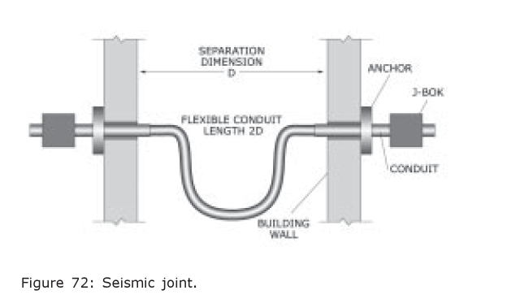

Per ASCE 7-16 "C13.2.4 Flexibility. In many cases, ﬂexibility is more important than strength in the performance of distributed systems, such as piping and ductwork. A good understanding of the displacement demand on the system, as well as its displacement capacity, is required. Components or their supports and attachments must be ﬂexible enough to accommodate the full range of expected differential movements; some localized inelasticity is permitted in accommodating the movements. Relative movements in all directions must be considered. For example, even a braced branch line of a piping system may displace, so it needs to be connected to other braced or rigid components in a manner that accommodates the displacements without failure (Fig. C13.2-1)."

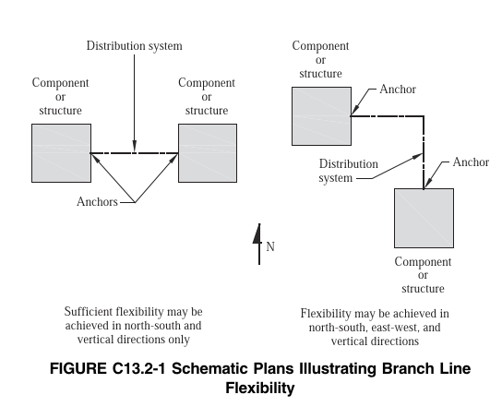

***************************************************************************************
      - Permissible products include those that permit rotational and/or translational movement without degradation of performance. Examples include flexible metallic conduit.
  - PART 3 - EXECUTION
    - EXAMINATION
      - Examine areas and equipment to receive seismic-control devices for compliance with requirements for installation tolerances and other conditions affecting performance of the Work.

***************************************************************************************

Include the following two paragraphs, if applicable.

***************************************************************************************
      - Examine roughing-in for reinforcement and cast-in-place anchors to verify actual locations before installation.
      - Coordinate the location of embedded connection hardware with supported equipment attachment and mounting points and with requirements for concrete reinforcement and formwork specified in Section ​<< 03 3001 - Reinforced Concrete>>​​.
      - Proceed with installation only after unsatisfactory conditions have been corrected.

***************************************************************************************

Retain the following Article, along with applicable paragraphs and subparagraphs, as required by the project.

IBC/ASCE 7 Special inspection and testing are typically required for designated seismic systems, defined as nonstructural components with an importance factor (I_{p}) of 1.5 (e.g., life-safety systems). This may include periodic inspection of the installation and anchorage, as well as verification that the labeling, anchorage, and mounting of seismically qualified equipment conform to the approved Certificate of Compliance. For additional details refer to 2021 IBC Section 1705.13 and 1705.14.

IBC/ASCE 7 Special inspection is also required for some noncritical electrical components as detailed in 2021 IBC Sections 1705.13.5 and 1705.13.6.

***************************************************************************************
    - CODE-REQUIRED SPECIAL INSPECTIONS
      - Arrange work to accommodate tests and/or inspections performed by Special Inspection Agency employed by Owner in accordance with statement of special inspections.
      - Frequency of Special Inspections: Where special inspections are designated as continuous or periodic, arrange work accordingly.
        - Continuous Special Inspections: Special Inspection Agency to be present in the area where the work is being performed and observe the work at all times the work is in progress.
        - Periodic Special Inspections: Special Inspection Agency to be present in the area where work is being performed and observe the work part-time or intermittently and at the completion of the work.
      - Seismic special inspections include, but are not limited to:
        - Seismically Qualified Equipment: Verification that label, anchorage, and mounting comply with the certificate of compliance.
        - Anchorage of electric equipment for emergency and standby power systems for Seismic Design Categories C, D, E, and F; periodic inspection.
        - Anchorage of electrical equipment other than for emergency and standby power systems for Seismic Design Categories E and F; periodic inspection.
        - Installation and anchorage of vibration isolation systems for Seismic Design Categories C, D, E, and F where the approved Subcontract Documents require a nominal clearance of << 1/4 inch>> or less between equipment support frame and seismic restraint; periodic inspection.
        - Verification of required clearances between electrical equipment, distribution systems, and associated supports and fire protection sprinkler system drops and sprigs for Seismic Design Categories C, D, E, and F; periodic inspection.

***************************************************************************************

This paragraph represents a specific requirement of ICC (IBC).

***************************************************************************************
      - Prior to starting work, Subcontractor to submit written statement of responsibility to LBO acknowledging awareness of special requirements contained in the statement of special inspections.
      - Special Inspection Agency services do not relieve Subcontractor from performing inspections and testing specified elsewhere.
    - GENERAL INSTALLATION REQUIREMENTS
      - Strength of Support and Seismic-Restraint Assemblies: Where not indicated, size support and seismic-restraint components to safely carry specified static and seismic loads.
      - Install products in accordance with manufacturer's instructions.
      - Install products in accordance with applicable requirements of <<NECA 1>> (general workmanship).
      - Install anchors and fasteners in accordance with <<ICC-ES>> evaluation report conditions of use where applicable.
      - Secure fasteners according to manufacturer's recommended torque settings.

***************************************************************************************

Retain the following paragraph if required by the project.

***************************************************************************************
      - Field-Welding (where approved by EOR): Comply with Section ​<< 01 4455 - Onsite Welding, Brazing and Joining Requirements>>​.
      - Equipment: Each equipment item shall be installed such that it is entirely located and attached on one side only of a building expansion or seismic-control joint.
      - Maintain the fire-resistance ratings of assemblies as specified in the drawings or elsewhere in the Subcontract documents, in addition to meeting seismic requirements.
      - Install flexible conduit and cable connections to provide sufficient slack for vibration isolation and/or seismic relative displacements as indicated or as required.
      - Multiple Raceways or Cables: Secure raceways and cables to trapeze member with clamps approved for application in an << ICC-ES ESR; HCAI (OPM or OSP); and _______>> .

***************************************************************************************

Indicate on Drawings, by details, schedules, or a combination of both, the locations where hanger rods for individual raceways, bus duct, cable trays, and hanger rods for trapeze hangers require hanger-rod stiffeners.

***************************************************************************************
      - Hanger-Rod Stiffeners: Install hanger-rod stiffeners as indicated or scheduled on Drawings, and where required to prevent buckling of hanger rods caused by seismic forces.

***************************************************************************************

Retain the following paragraph and subparagraph only if applicable to the Project. If Delegated Design does not apply to the project, the Engineer of Record (EOR) is responsible for providing the calculations and drawing details required to address relative displacement design per ASCE 7 Section 13.3.2.

***************************************************************************************
      - Distribution/Distributed Systems: Install flexible connections at all locations where raceways—such as conduits, cable trays, or busways—cross building expansion joints, seismic-control joints, transition between buildings or floors, or connect to nonstructural components that are not braced or rigidly mounted.
        - For feeders passing from one building to another, or between portions of the same building that may move independently, flexibility shall be provided per the associated drawing detail(s).
    - SEISMIC-RESTRAINT DEVICE INSTALLATION
      - Use only specified components, anchorage, and hardware evaluated by seismic design. Comply with conditions of seismic certification where applicable.
      - Install seismic restraint devices using methods approved in the applicable << ICC-ES ESR; HCAI (OPM or OSP); and _______>> for the device.
      - Install cables so they do not bend across edges of adjacent equipment or building structure, and such that they are taught (i.e., without slack) when the component they are to control/restrain is “at rest.”

***************************************************************************************

Retain the following two paragraphs if required by the project.

***************************************************************************************
      - Install bushing assemblies for anchors for floor-mounted equipment, arranged to provide resilient media between anchors and mounting hole in concrete base.
      - Install bushing assemblies for mounting bolts/anchors for wall-mounted equipment, arranged to provide resilient media where equipment or equipment-mounting channels are attached to wall.

***************************************************************************************

The following are a few examples of Cable and rigid brace attachments to structure (ER) taken from FEMA E-74 Reducing the Risks of Nonstructural Earthquake Damage – A Practical Guide (2012):

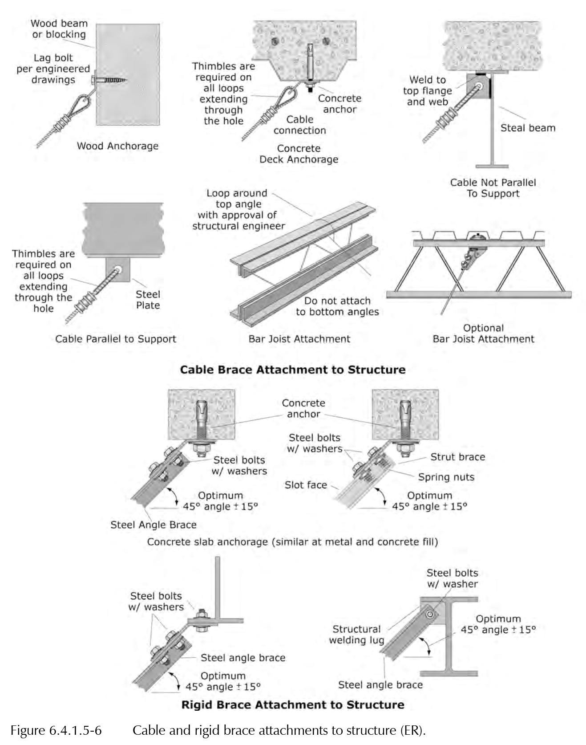

***************************************************************************************
      - Attachment to Structure: If specific attachment is not indicated, anchor bracing to structure at flanges of beams, at upper truss chords of bar joists, or at concrete members.

***************************************************************************************

Retain the following two paragraph if required by the project.

***************************************************************************************
      - Post-Installed Anchors: Install post-installed anchors as specified in Section ​​<< 05 0520 - Post-Installed Concrete and Grouted Masonry Anchors - Normal Confidence>>​​.
      - Where the concrete floor thickness is insufficient for expansion anchor installation per << ICC-ES ESR; HCAI (OPM or OSP); and _______>> requirements, provide through-bolts in place of expansion anchors.

***************************************************************************************

Retain the following paragraph if required by the project. Refer to FEMA 412 for details related to the requirement in the following paragraph.

***************************************************************************************
      - Where mounting hole diameter exceeds bolt diameter by more than ​​​​​<< 0.125 inch>>​​​​​, use epoxy grout, elastomeric grommet, or welded washer to reduce clearance to ​​​​​<< 0.125 inch>>​​​​​ or less.

***************************************************************************************

Retain the following paragraph and applicable subparagraphs, as required by the project.

***************************************************************************************
      - Equipment and Hanger Restraints:

******************************************************************************

The following are a few examples of hanger attachment to structure taken from FEMA E-74 Reducing the Risks of Nonstructural Earthquake Damage – A Practical Guide (2012):

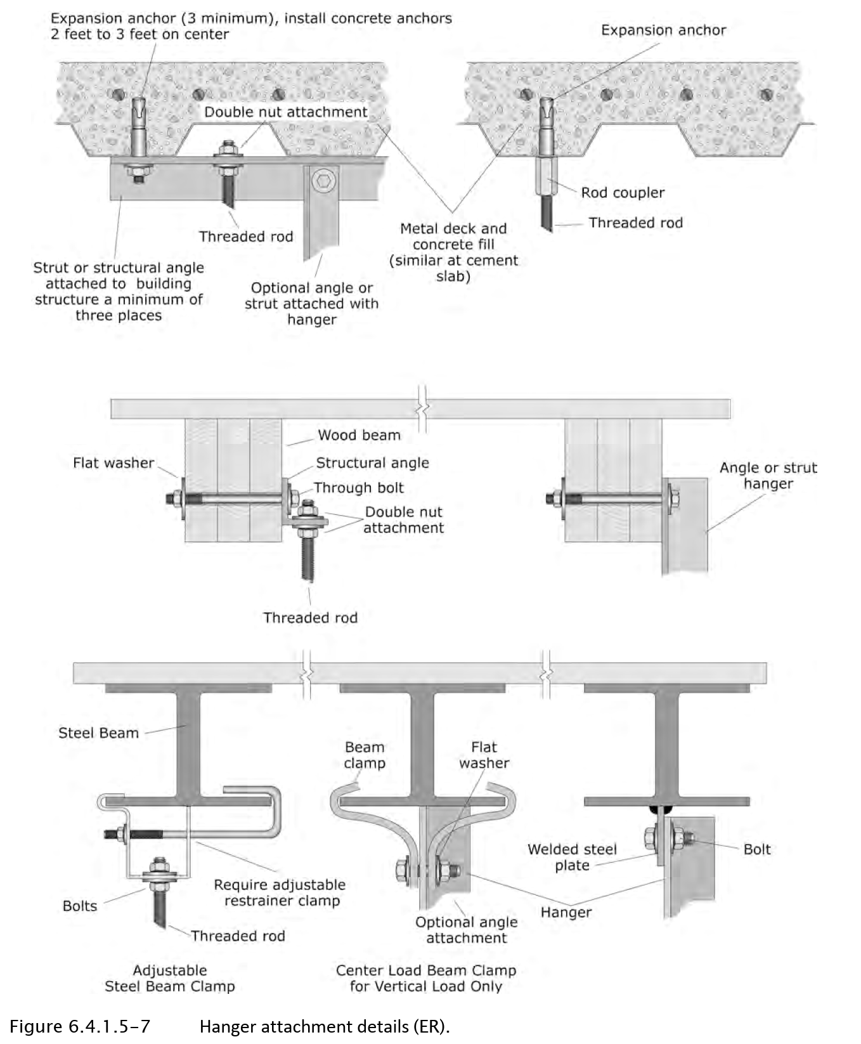

The following are a few examples of seismic resistant battery racks taken from FEMA E-74 Reducing the Risks of Nonstructural Earthquake Damage – A Practical Guide (2012):

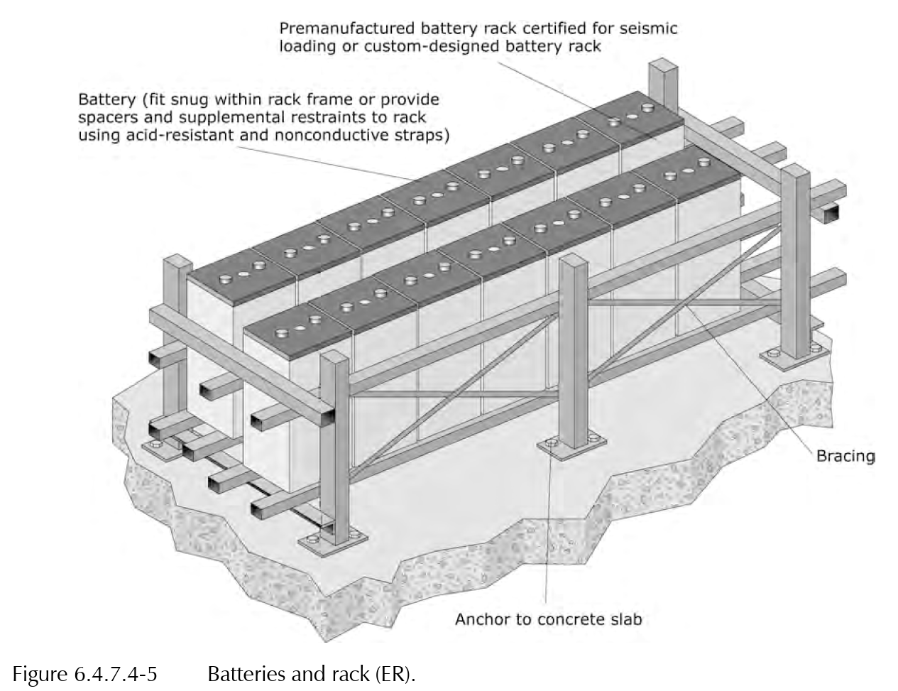

Seismic resistant battery racks are available from a number of vendors; these may be directly bolted to the floor or wall. Check the internet for available products. For existing battery racks, check that the batteries are secured to the rack and that the rack is properly braced and anchored.

Retain any or all the following three subparagraphs if applicable.

******************************************************************************
        - Provide acid-resistant and corrosion-resistant wrap-around restraints for batteries on racks, or otherwise secure them to prevent movement within the rack. Design battery racks to resist the applicable seismic design forces.
        - Design electrical cabinets in accordance with applicable National Electrical Manufacturers Association (NEMA) standards.
        - Where equipment is mounted on vibration isolators and restraints, use components designed for amplified code-level forces. Ensure they are capable of resisting gravity, operational, and seismic loads, with performance verified for all required force conditions.

******************************************************************************

Retain the following subparagraph if applicable.

Indicate type and quantity of snubbers on Drawings or in the applicable Vibration-Control and Seismic-Restraint Device Schedule on Drawings.

******************************************************************************
        - Install seismic snubbers on equipment mounted on vibration isolators. Provide specified snubbing element air gap; remove any factory-installed spacers, debris or other obstructions.
        - Do not attach seismic restraints and gravity supports to dissimilar parts of structure that may move differently during an earthquake.
        - Install restraints within permissible angles in accordance with seismic design.
        - Install cable restraints straight between component/run and structural attachment; do not bend around other nonstructural components or structural elements.

******************************************************************************

Retain the following subparagraph if applicable.

******************************************************************************
        - Install cable restraints for vibration-isolated components slightly slack to prevent short-circuiting of isolation.
        - Install hanger rod stiffeners where indicated using only specified clamps; do not weld stiffeners to hanger rod.

***************************************************************************************

Retain the following paragraph and subparagraphs, as required by the project.

***************************************************************************************
      - Suspended Electrical equipment:

******************************************************************************

The following are a few examples of suspended equipment restrain taken from FEMA E-74 Reducing the Risks of Nonstructural Earthquake Damage – A Practical Guide (2012):

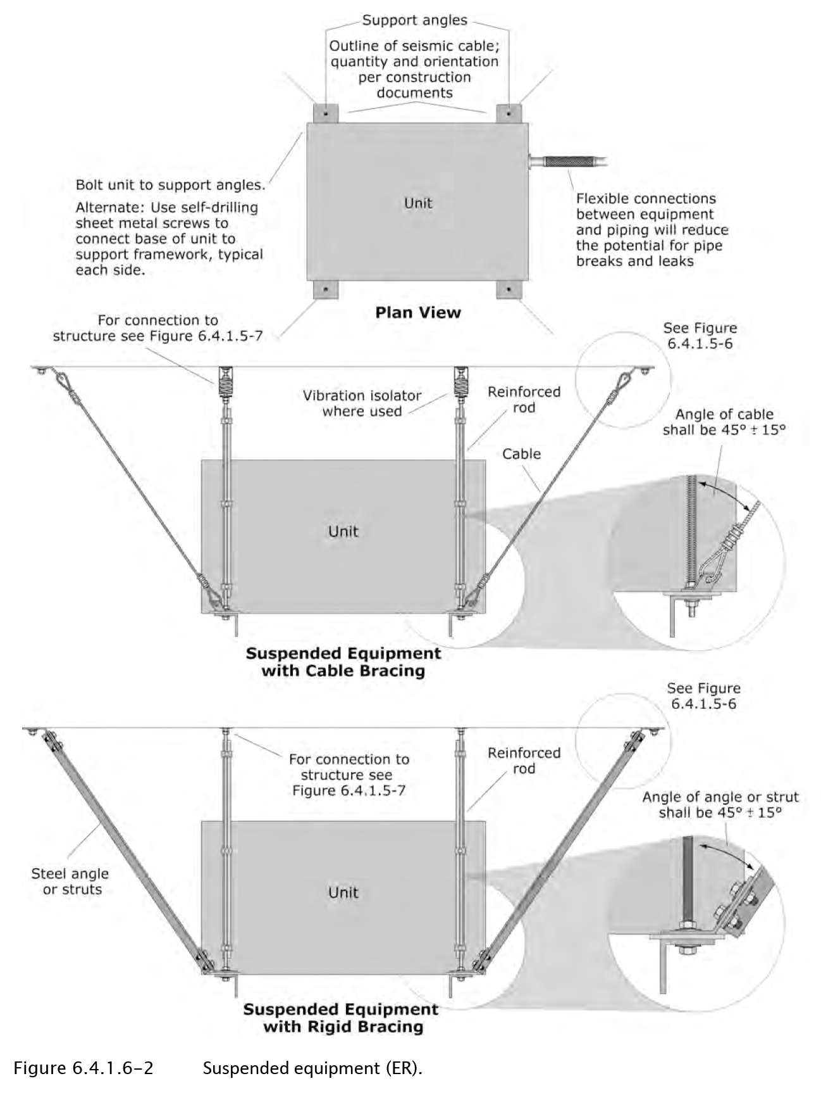

******************************************************************************
        - Provide flexible connections between equipment and associated piping.
        - Brace equipment suspended from spring mounts using cables or other bracing materials that do not transmit vibration to the structure.

***************************************************************************************

Retain the following paragraph and subparagraphs, as required by the project.

***************************************************************************************
      - Wall-Mounted Electrical Equipment:
        - Install backing plates or blocking as needed to transfer loads to primary wall framing members. Do not anchor to gypsum wallboard, plaster, or other non-structural finishes not engineered to resist imposed loads.

***************************************************************************************

Retain the following paragraph and subparagraphs, as required by the project.

***************************************************************************************
      - Equipment with Sheet Metal Housings:

******************************************************************************

Belleville washers are conical-shaped spring washers. Unlike flat washers, they can compress slightly under load, which helps in: (a) Evenly distributing pressure (b) Maintaining tension in bolted joints (c) Reducing the risk of deformation or damage to the sheet metal

Refer to ASCE 7-16 Commentary section C13.6.4.5. for additional details

******************************************************************************
        - Use Belleville washers to distribute stress over a larger surface area of the sheet metal connection interface as approved by manufacturer.

******************************************************************************

Refer to FEMA 413 for additional details regarding the following.

******************************************************************************
        - Attach additional steel as approved by manufacturer where required to transfer loads to structure.

******************************************************************************

Refer to FEMA 413 for additional details regarding the following.

******************************************************************************
        - Where mounting surface is irregular, do not shim housing; reinforce housing with additional steel as approved by manufacturer.

***************************************************************************************

Retain the following paragraph and subparagraphs, as required by the project.

***************************************************************************************
      - Concrete Housekeeping Pads:

******************************************************************************

The following are a few examples of Floor-mounted equipment taken from FEMA E-74 Reducing the Risks of Nonstructural Earthquake Damage – A Practical Guide (2012):

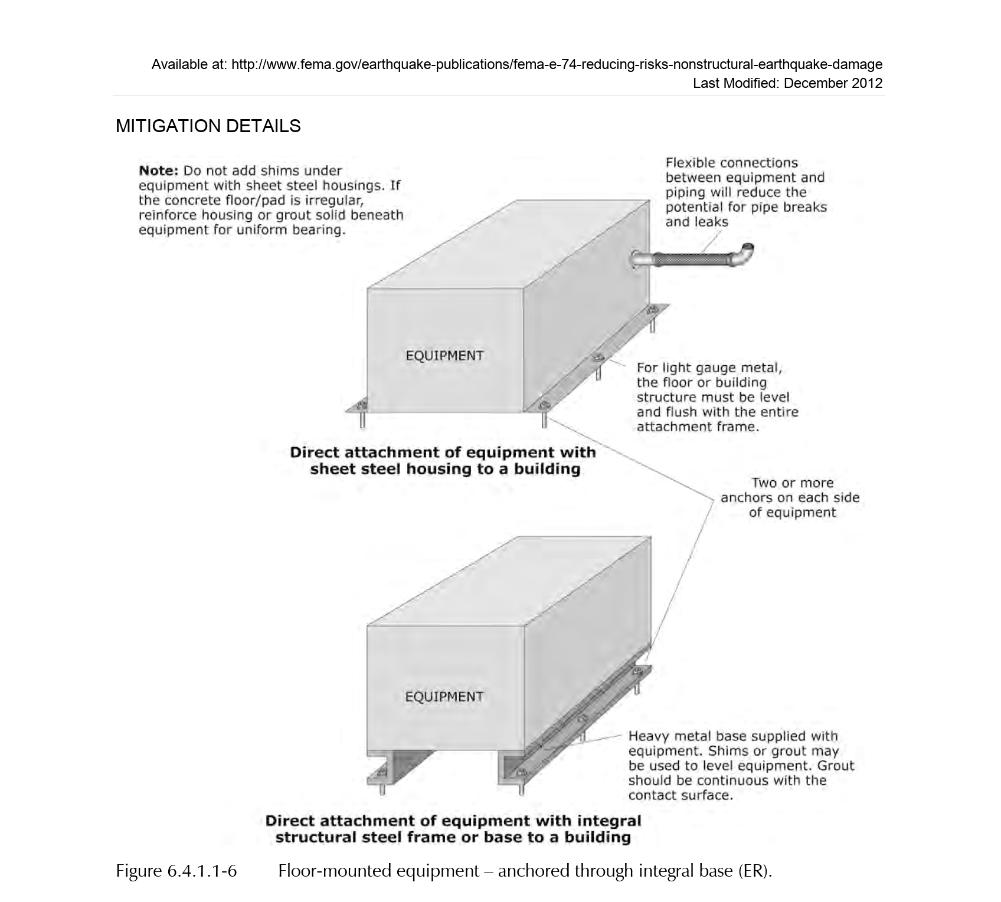

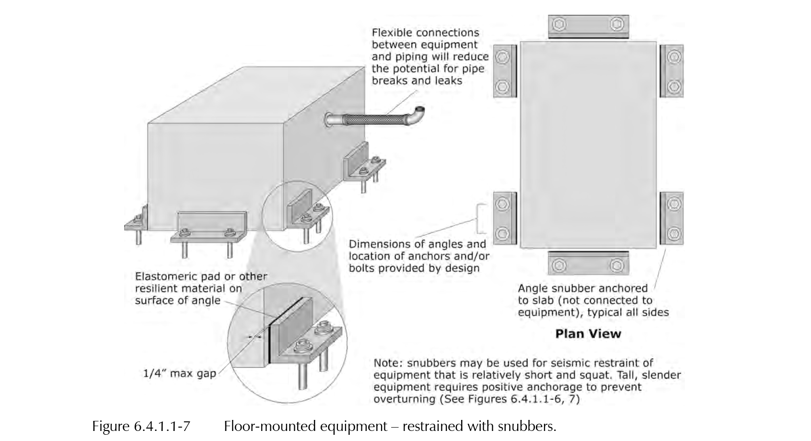

******************************************************************************
        - Size in accordance with seismic design to meet anchor requirements.
        - Install pad reinforcement and doweling in accordance with seismic design to ensure integrity of pad and associated connection to slab.

***************************************************************************************

Retain the following paragraph and applicable subparagraphs, as required by the project.

***************************************************************************************
      - Seismic Restraint of Conduit:

******************************************************************************

The following are a few examples of Pipe, Cable Trays, Bus Ducts & Conduit Bracing Details taken from ASHRAE Earthquake Protection Bulleting, and FEMA E-74 Reducing the Risks of Nonstructural Earthquake Damage – A Practical Guide (2012):

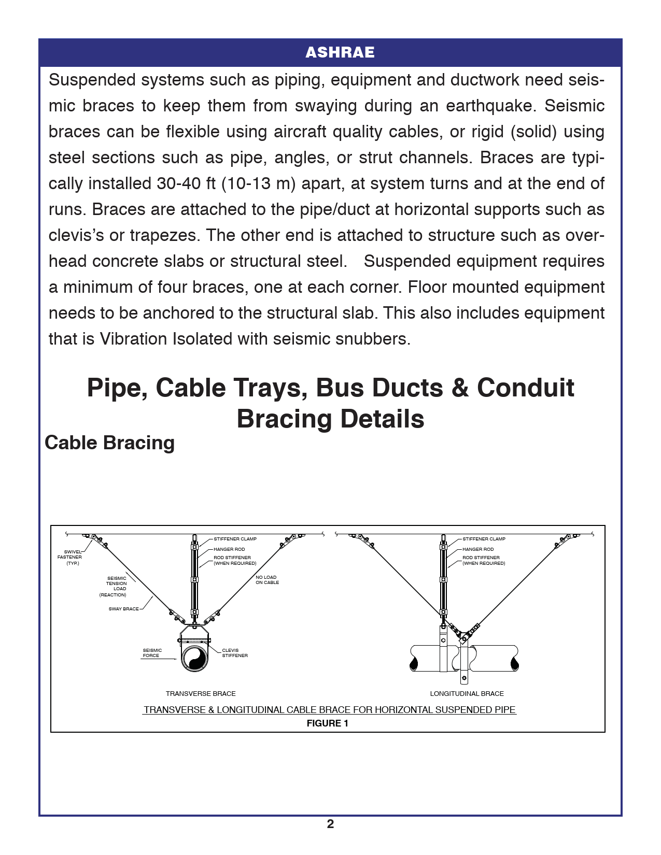

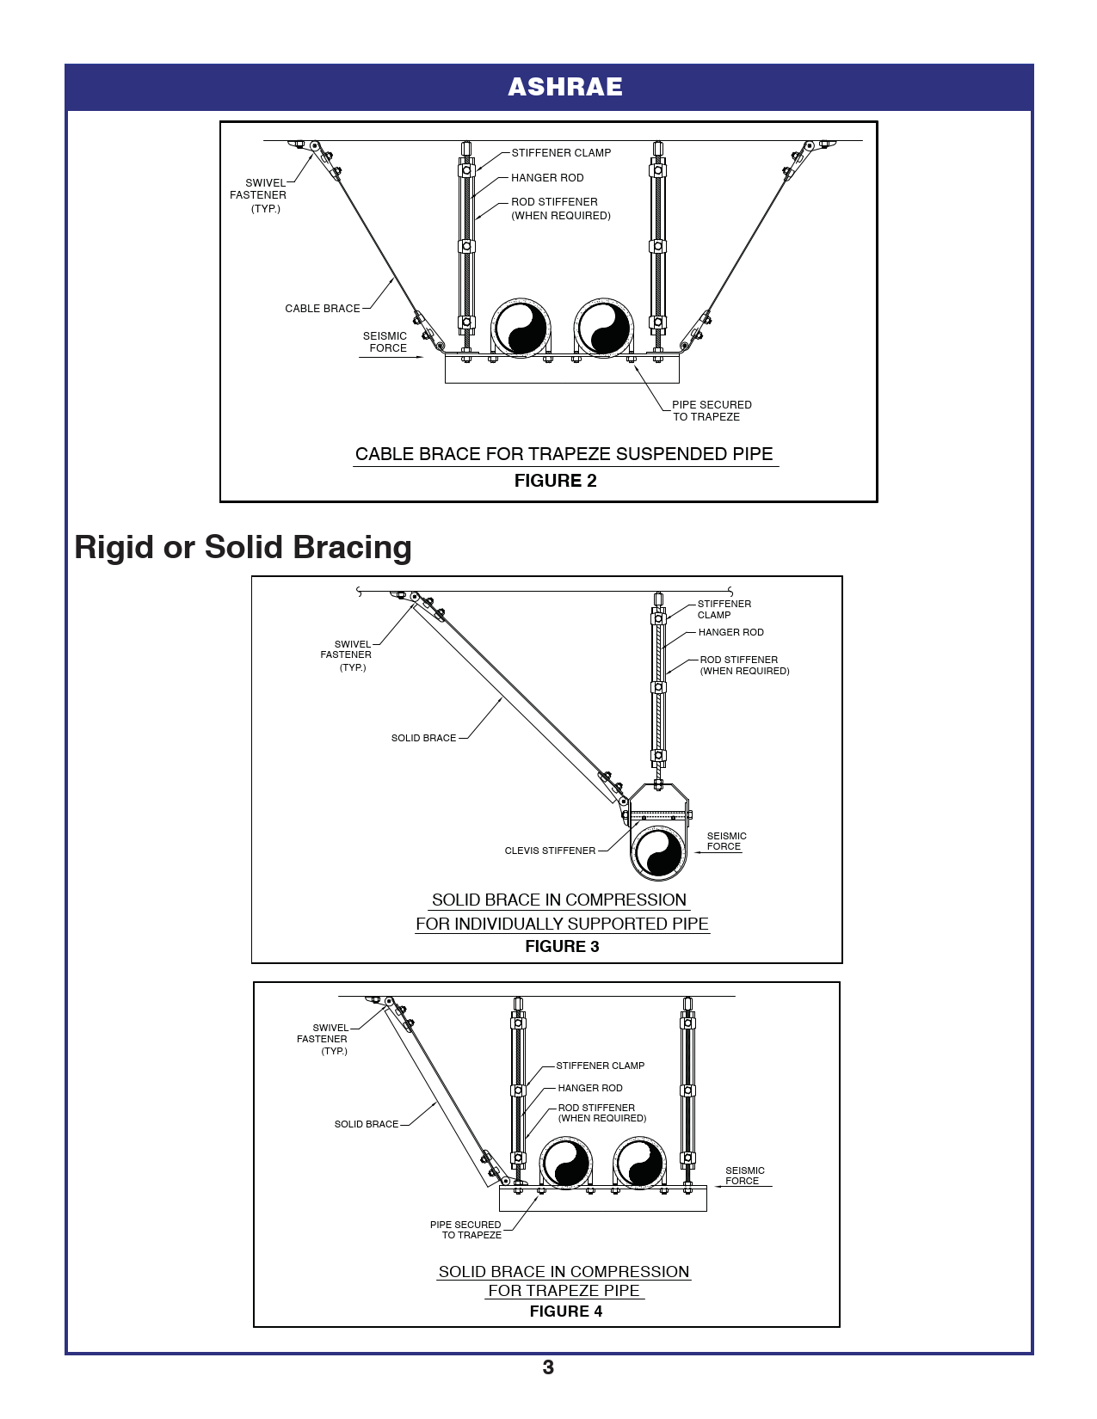

******************************************************************************
        - Conduit offsets, loops, anchors, and guides shall be installed as required to provide specified motion capability and limit motion of adjacent distribution systems.
        - Provide appropriately-sized openings in walls, floors, and ceilings for anticipated seismic movement. Provide fire seal systems in fire-rated walls where applicable.

***************************************************************************************

Retain the following paragraph and subparagraph, as required by the project.

***************************************************************************************
      - Seismic Restraint of Electrical raceways through penetrations.
        - Provide appropriately-sized openings in walls, floors, and ceilings for anticipated seismic movement. Provide fire seal systems in fire-rated walls where applicable.

***************************************************************************************

Retain the following paragraph and applicable subparagraphs, as required by the project.

***************************************************************************************
      - Seismic Restraint of Lighting Fixtures:

******************************************************************************

The following are a few examples of Seismic Restraint of Lighting Fixtures taken from FEMA E-74 Reducing the Risks of Nonstructural Earthquake Damage – A Practical Guide (2012):

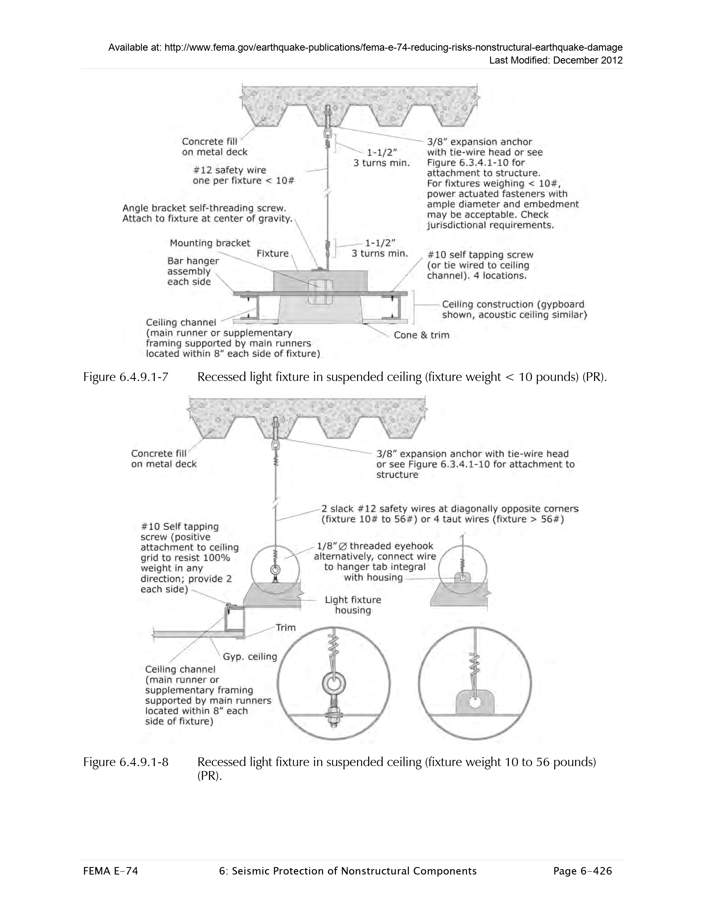

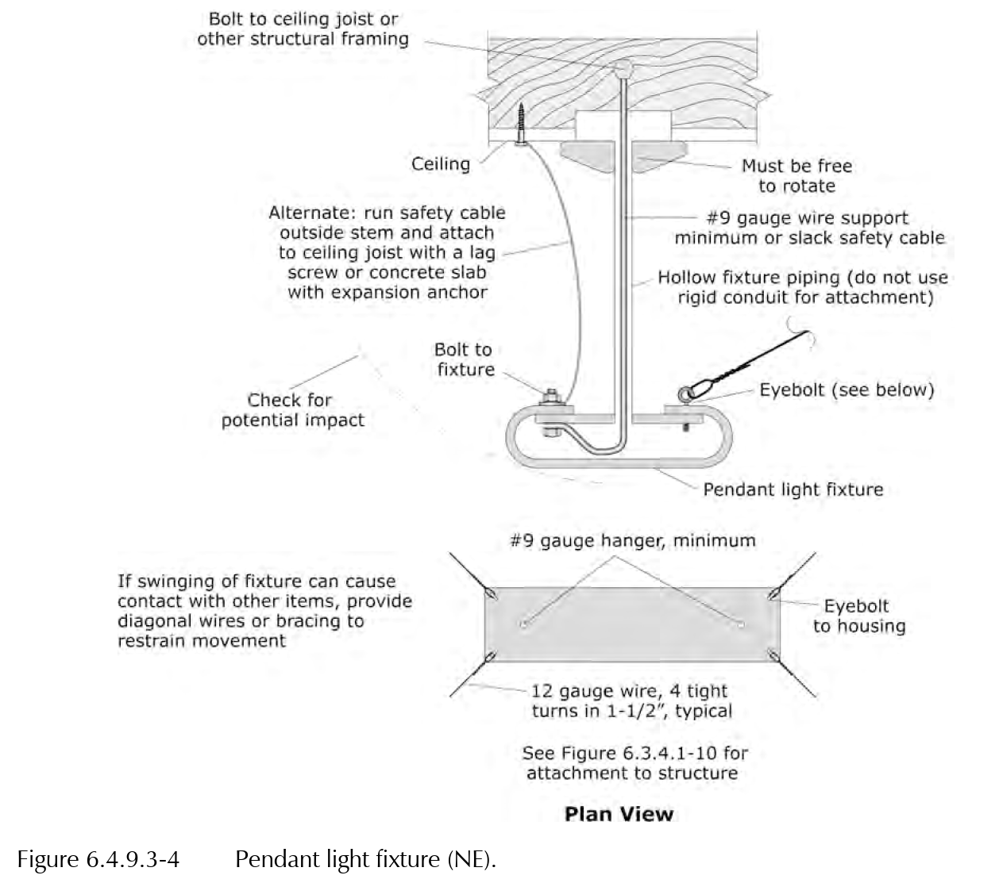

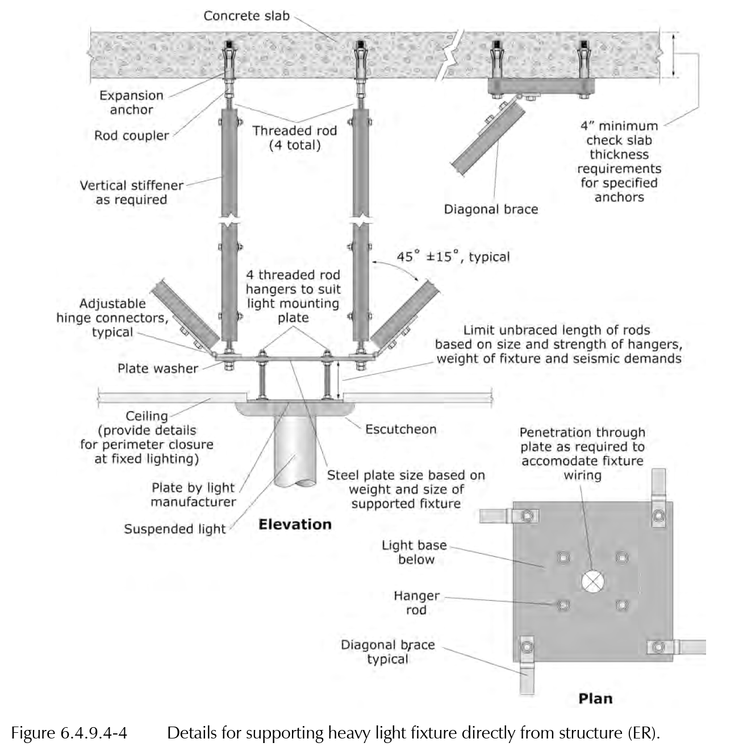

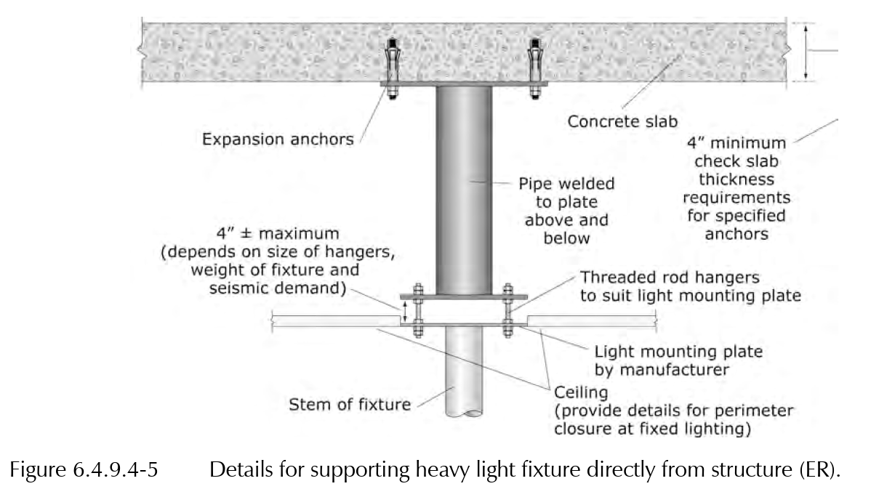

******************************************************************************
        - Lights in suspended ceilings:
          - For fixtures weighing 56 pounds or less, provide a positive mechanical connection to the ceiling framing to resist both seismic forces and gravity loads. Install two independent support wires at diagonally opposite corners, secured to the structural framing.
          - For fixtures weighing more than 56 pounds, provide independent support and seismic bracing.
        - Lights in light framed ceilings and walls:
          - Provide a positive mechanical connection to the ceiling or wall framing capable of resisting both gravity and seismic loads. Ensure the ceiling and wall framing can transfer these loads from the fixture to the building structure.
        - Pendant mounted fixtures:
          - Verify that the fixture cannot swing or displace in a way that causes contact with adjacent lighting, architectural elements, or other suspended items.
          - The connection to the structure must allow 360-degree movement.
          - If the fixture could contact another item when swinging within a 45-degree arc from vertical in any direction, provide bracing to limit movement and prevent interaction.
          - Design for a vertical load of 1.4 times the operating weight, combined with a simultaneous horizontal load of 1.4 times the operating weight.
        - Computer and communications racks, cabinets and boards:

**********************************************************************

There are multiple acceptable methods for providing seismic restraint for computer and communications equipment. When specific design solutions are required—such as isolation bases or independent support frames—clearly specify these requirements in the project documents.

The following are a few examples of Seismic Restraint of seismic restrains of computer and communications racks taken from FEMA E-74 Reducing the Risks of Nonstructural Earthquake Damage – A Practical Guide (2012):

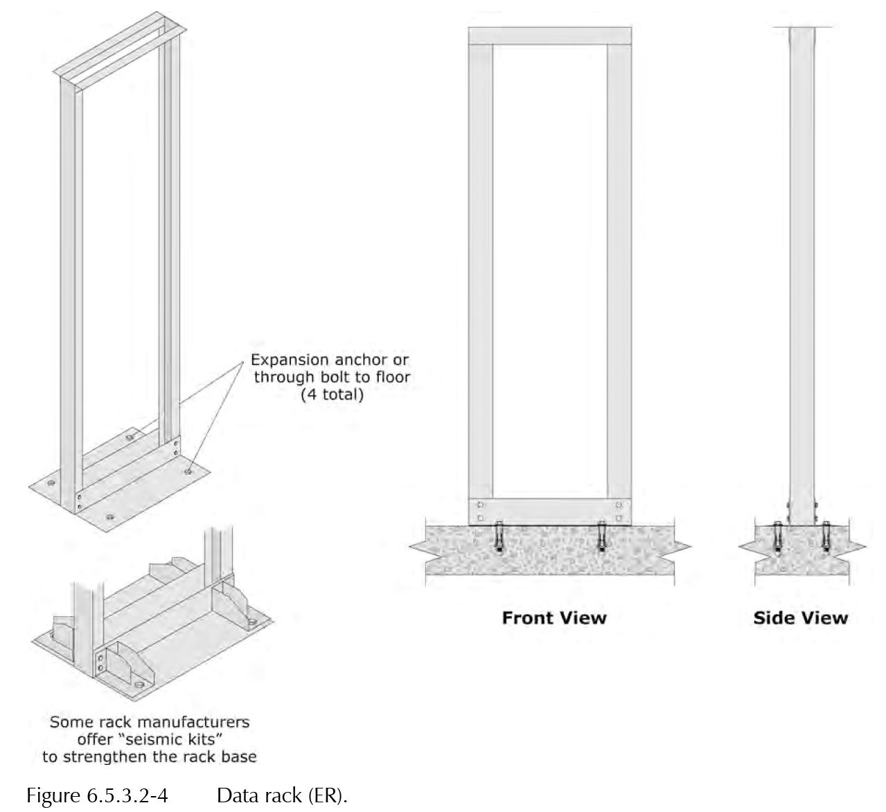

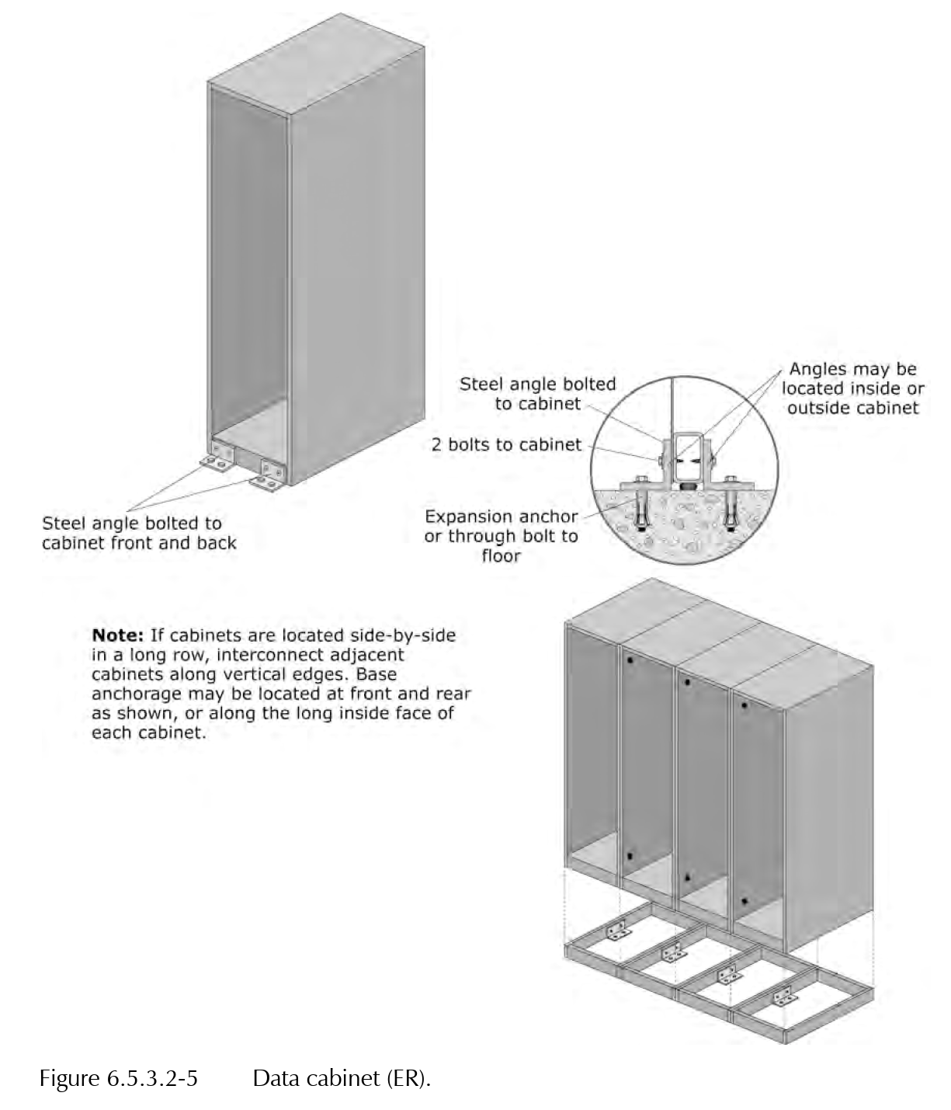

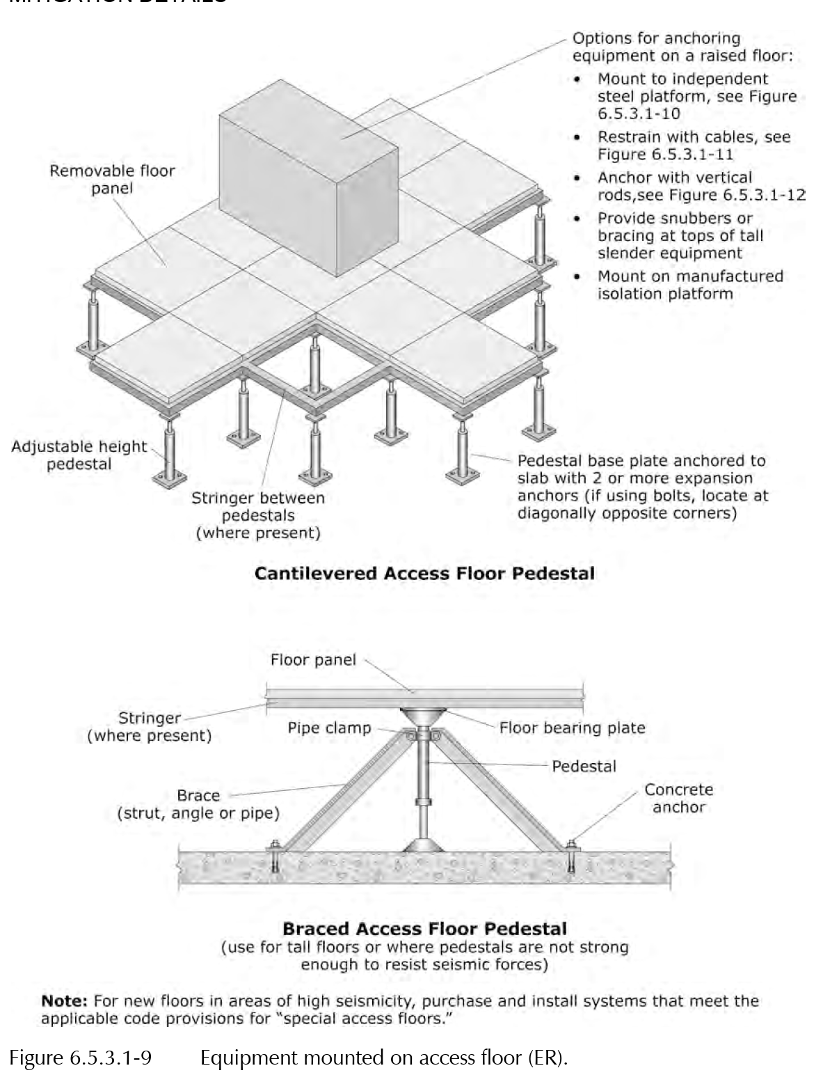

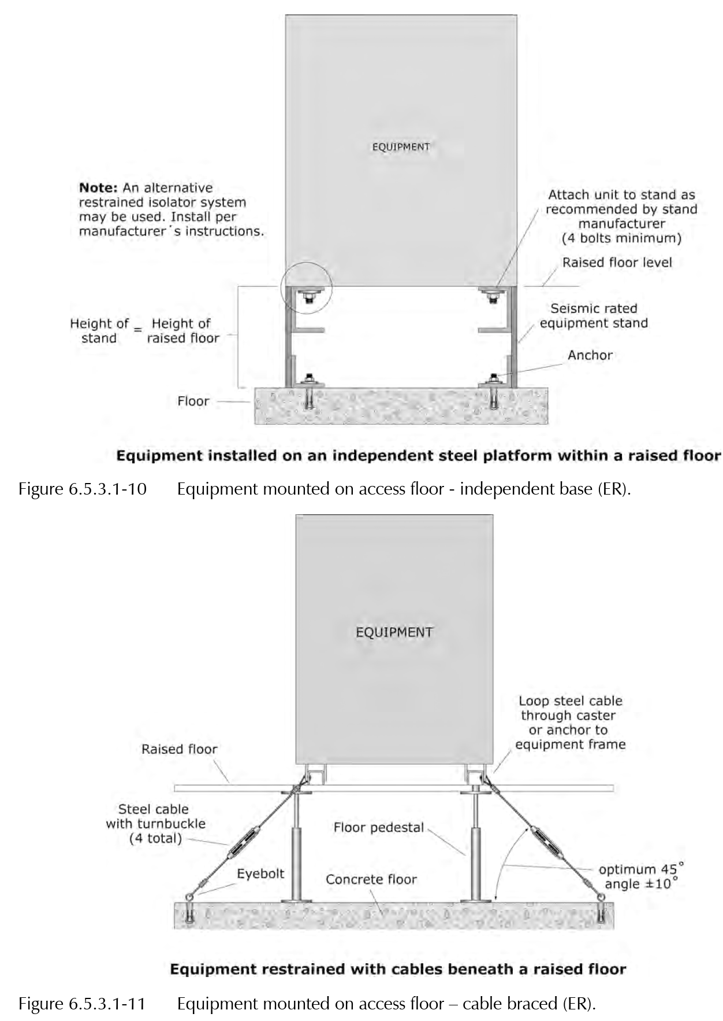

**********************************************************************
          - Where cable trays connect to the tops of racks or cabinets, include the tributary weight of the trays and components in the seismic restraint design.
          - Interconnect adjacent cabinets to ensure unified response to lateral seismic forces.
          - For equipment supported on raised access flooring, provide bracing and anchorage to the structural floor below.
    - ACCOMMODATION OF DIFFERENTIAL SEISMIC MOTION

***************************************************************************************

Coordinate and edit this Article to align with the 'Delegated-Design Submittal' paragraph in Part 1, the Drawings, and, if applicable, other relevant Project Specification Sections.

All applicable seismic relative displacements and seismic drift ratios shall be determined and designed/detailed for in accordance with the Seismic Performance Requirements in PART 2 and the specifics of the Project.

***************************************************************************************
      - Install flexible connections in runs of raceways, cables, wireways, cable trays, and busways to accommodate differential movement and maintain system integrity during seismic events at the following locations:
        - where they cross seismic joints
        - where adjacent sections or branches are supported by different structural elements
        - Where they connect to equipment anchored to a different structural element than the one supporting the raceway system
      - Ensure all flexible connections are properly rated and installed in accordance with seismic design requirements.
    - FIELD QUALITY CONTROL

***************************************************************************************

The primary purpose of the section is to alert the Subcontractor that he/she is responsible for quality control (QC) and that, in addition to QC, the component is subject to the quality assurance (QA) indicated in the Project’s Statement of Special Inspections.

***************************************************************************************
      - Inspection Agency: Engage a qualified inspection agency to perform inspections.
      - Perform inspections, with the assistance of a factory-authorized service representative(s) as necessary/required, during the installation (to include anchorage where applicable) of the systems and equipment associated with/ affected by this Section as necessary to ensure that the applicable provisions of <<ASCE 7>> Chapter 13 are met.
      - Prepare an inspection report.
      - Seismic restraints/controls will be considered defective if the affected systems, equipment, etc. do not pass the inspections indicated in the Project’s Statement of Special Inspections.
    - ADJUSTING
      - Adjust restraints to permit free movement of equipment within normal mode of operation.
  - END OF SECTION

**********************************************************************************************

Do not omit the following reference information:

**********************************************************************************************
  - THE FOLLOWING STATEMENT IS FOR LANL USE ONLY
  - THIS PROJECT SPECIFICATION SECTION IS BASED ON LANL MASTER SPECIFICATION SECTION 26 0548.16, REV. 5, DATED APRIL 15, 2026.

